**Name :** T.B.Madhan **Reg No :** 23BCE1087

**Web Programming Lab (BCSE203E)  
LAB – 1 HTML – Text, Image, Links**

1. **Design a webpage (home.html) with the following features**

a. Display your name in blue color using the Verdana font in the screen. Set the webpage title as "Welcome to my page - [Your Registration Number]".

b. Print alphabets from A to F on the screen from the smallest to largest font, each letter styled with a different font and color.

c. Display your first name in bold, middle name in italics and last name in underlined font format.

d. Write and display two paragraphs that describes your ambition and hobbies.

Highlight the ambition text with a yellow background.

Italicize and bold the hobbies text.

b. Add a comment line in your HTML code. Ensure it does not appear on the webpage.

c. Display the following equations on the page:

(a-b)²=a²-2ab+b²

2H2+O2=2H2O

d. Display a C program that prints your account number and balance (include the (Rs.) symbol.)

e. Set an image as the background of the webpage

f. Apply marquee to display your roll number

g. Insert a passport sized image aligned to the right side of the screen

h. Use a <div> tag to display two separate paragraphs.

i. Create the link at the bottom of the page and move from bottom to top onclick

j. Create a "mailto" link to any email-id

k. Use acronym, meter, progress bar and summary tags on your page

**Code:**

***Home.html***

<!DOCTYPE html>

<html lang="en">

<head>

    <meta charset="UTF-8">

    <meta name="viewport" content="width=device-width, initial-scale=1.0">

    <style>

        body {

          background-image: URL("../Assets/abstract-blurred-multi-colored-background-generative-ai_169016-30200.avif");

          background-attachment: fixed;

          background-size: 100% 100%;

        }

        </style>

    <title>23BCE1087</title>

</head>

<body>

    <a id="top"></a>

    <font face = "Verdana" color = "Blue" > Madhan </font>

    <h6><font face = "Verdana" color = "Red" > A </font></h6>

    <h5><font face = "Verdana" color = "Orange" > B </font></h5>

    <h4><font face = "Verdana" color = "Yellow" > C </font></h4>

    <h3><font face = "Verdana" color = "Green" > D </font></h3>

    <h2><font face = "Verdana" color = "Blue" > E </font></h2>

    <h1><font face = "Verdana" color = "Purple" > F </font></h1>

    <B> Victor </B><i> Alius </i><u> Valtore </u>

    <p> My ambition is to become an aspiring <mark> cybersecurity analyst</mark></p>

    <p> My hobbies are <i>listening to music</i> and <i>Playing music</i></p>

    <!--This line will not appear in the website-->

    <P>(a-b)<sup>2</sup>=a<sup>2</sup>-2ab+b<sup>2</sup></P>

    <p>2H<sub>2</sub>+O<sub>2</sub>=2H<sub>2</sub>O</p>

    <pre>

    <code>

#include &ltstdio.h&gt

int main(){

    printf("Account number : %d",AccNo);

    printf("Account balance : %f",Bal);

}

    </code>

    </pre>

    <marquee> Roll number : 1087 </marquee> <br>

    <img src = "../Assets/be9da804-63a0-4d5c-8a09-af29209133ce.avif" alt = "passport" align = "right" height="200" width="200" >

    <div>This is paragraph 1. This is some random lines inserted after the first line to make it look like a paragraph</div>

    <div>This is paragraph 2. Again random lines blah blah blah</div>

    <br>

    <br>

    <br>

    <br>

    <a href="mailto:tbmadhan2005@gmail.com">Contact us</a>

    <a href="#top">Click here</a>

    <br>

     <ul>

         <li><abbr title="HyperText Markup Language">HTML</abbr></li>

         <li><abbr title="Cascading Style Sheets">CSS</abbr></li>

         <li><abbr title="JavaScript">JS</abbr></li>

     </ul>

     <details>

         <summary>Click on that arrow button to see more</summary>

         <p>you have unlocked the secret passage. here is your key "hcxa9q6hsi2" </p>

     </details>

     <p>You've successfully completed 75% of the puzzle</p>

     <meter min="0" max="100" value="75">75%</meter>

     <p>HTML learning progress bar</p>

     <progress value="20" max="100"></progress>

<br>

     <a href = "Greetings.html">Click me to go to Greeting page</a>

</body>

</html>

**Output:**

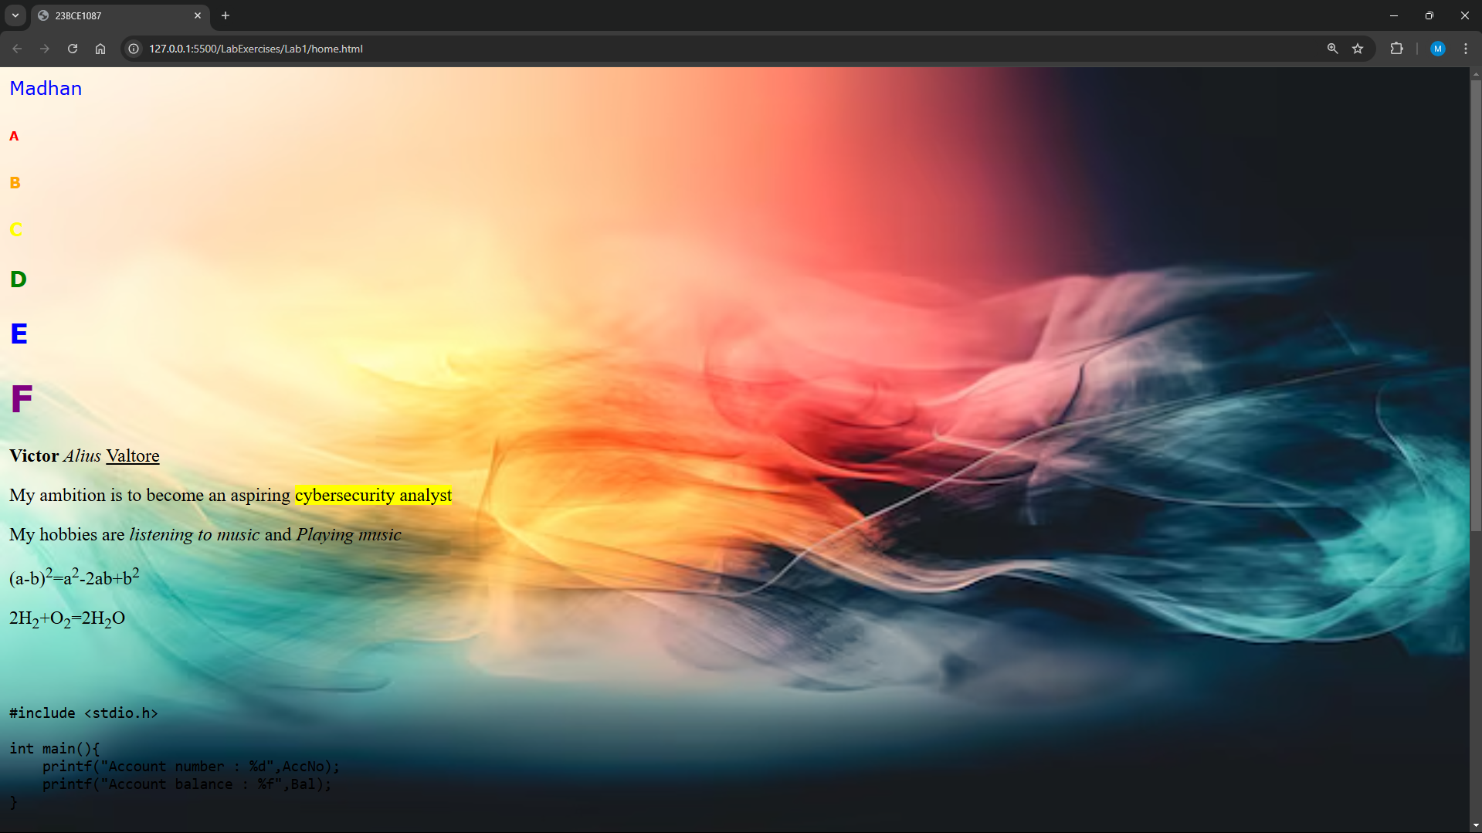

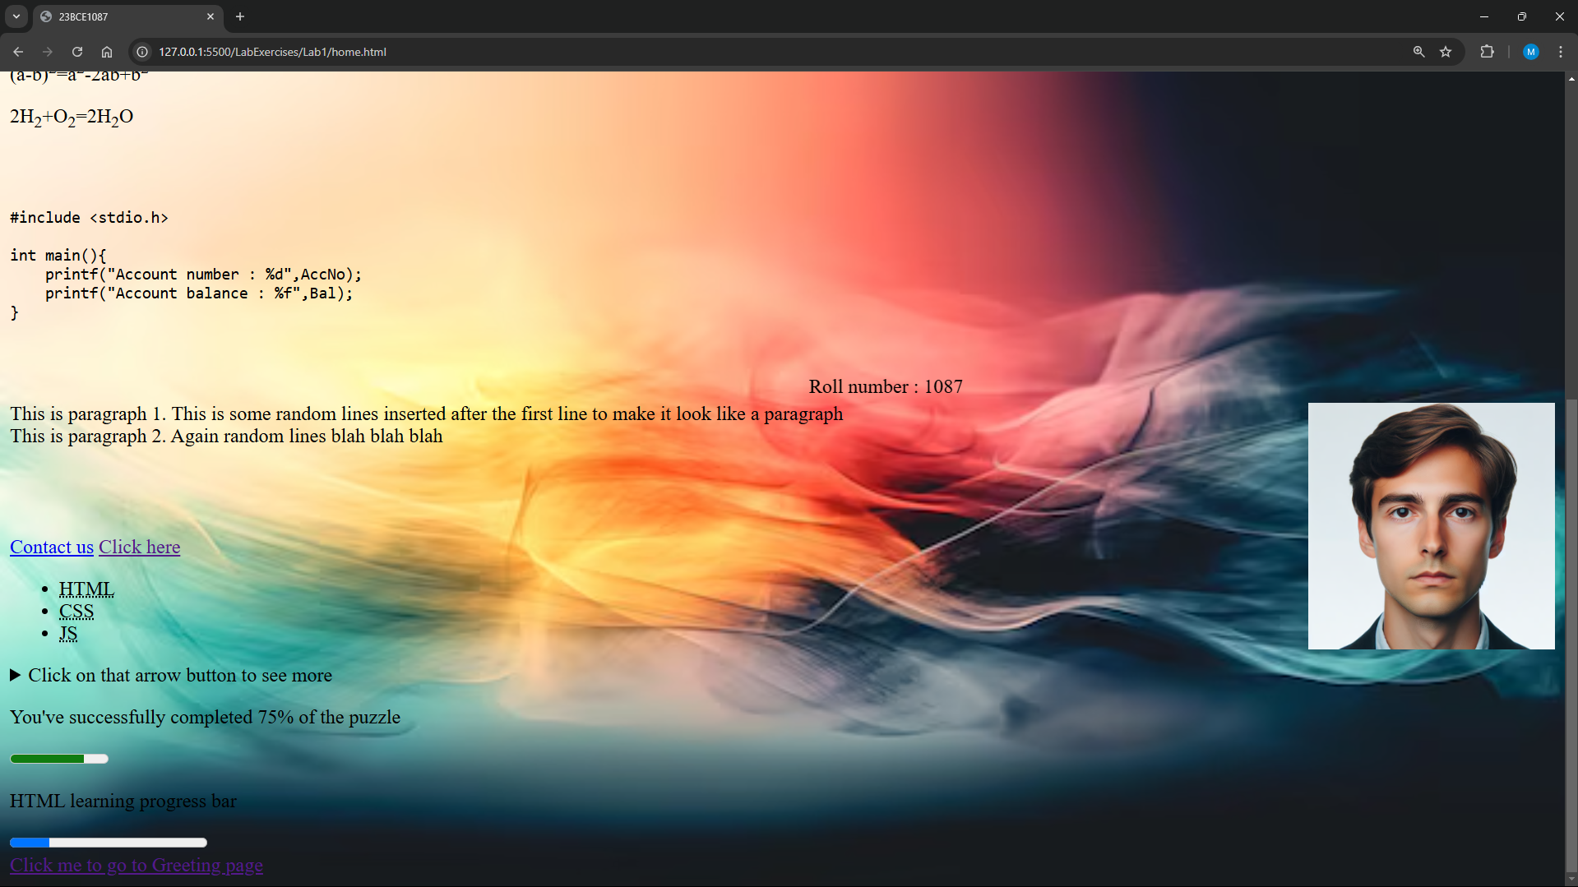

1. **Design an E-Greeting page (greeting.html) that is properly aligned using semantic tags. Provide links from the home page to the greeting page and vice versa**

**Code:**

***Greeting.html***

<!DOCTYPE html>

<html lang="en">

<head>

    <meta charset="UTF-8">

    <meta name="viewport" content="width=device-width, initial-scale=1.0">

    <title>23BCE1087</title>

</head>

<body>

    <center>

    <main>

        <header>

            <h1>Welcome!</h1>

        </header>

        <section>

            <p>Wishing you a day filled with happiness and a year filled with joy!</p>

            <p>Keep going with the spirits always being high!! :)</p>

        </section>

        <footer>

            <a href="home.html">Go back to the Home Page</a>

        </footer>

    </main>

    </center>

</body>

</html>

**Output:**

