**Name :** T.B.Madhan **Reg No :** 23BCE1087

**Web Programming Lab (BCSE203E)  
LAB – 10 JavaScript Functions and Form Selection Methods**

1. **Assume that you are appointed as Data Analytics Engineer for a hospital. Ages for 8 patients are given below.**

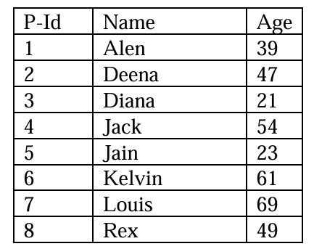

**Write a JavaScript program using appropriate functions to**

(i) sort the data in descending order according to the patient’s age and display the same

(ii) check whether a particular P-Id is presented in the list

(iii) filter the patients by age range.

**Code:**

***Lab10Q1.html***

<!DOCTYPE html>

<html lang="en">

<head>

    <meta charset="UTF-8">

    <meta name="viewport" content="width=device-width, initial-scale=1.0">

    <title>23BCE1087</title>

    <style>

        #Buttons{

            display: flex;

            justify-content: space-evenly;

            margin-top: 10px;

            margin-bottom: 30px;

        }

        #Frame{

            justify-self: center;

            align-items: center;

        }

    </style>

</head>

<body>

    <div id = "Buttons">

        <button type="submit" onclick="dispSorted()">Reverse Sort</button>

        <button type="submit" onclick="fetchRecord()">Find Record</button>

        <button type="submit" onclick="findRange()">Find Range</button>

    </div>

    <div id = "Frame">

    </div>

    <script src = "./Lab10Q1.js" defer></script>

</body>

</html>

***Lab10Q1.js***

Data = [

    [1,"Alen",39],

    [2,"Deena",47],

    [3,"Diana",21],

    [4,"Jack",54],

    [5,"Jain",23],

    [6,"Kelvin",61],

    [7,"Louis",69],

    [8,"Rex",49]

];

function dispSorted(){

    let arr = [...Data].sort((a,b)=>b[2]-a[2]);

    table_frame = document.getElementById("Frame")

    table_frame.innerHTML   =""

    table = document.createElement("table")

    table.border = 1

    let header = table.createTHead();

    headerRow = header.insertRow();

    let Params = ["PID","Name","Age"];

    Params.forEach(element => {

        let th = document.createElement("th")

        th.textContent=element

        headerRow.appendChild(th)

    });

    let tbody = table.createTBody();

    arr.forEach((row)=>{

        let tr = tbody.insertRow()

        row.forEach((element)=>{

            let td = tr.insertCell();

            td.textContent=element;

        })

    })

    table_frame.appendChild(table);

}

function fetchRecord() {

    let frame = document.getElementById("Frame");

    frame.innerHTML = `

        <div>

            <form id="searchForm">

                <fieldset>

                    <label for="PID">Enter the PID to search:</label>

                    <input type="number" name="PID" id="pid" min="0">

                    <button type="submit">Search</button>

                    <div id="result"></div>

                </fieldset>

            </form>

        </div>`;

    document.getElementById("searchForm").addEventListener("submit", function(event) {

        event.preventDefault();

        let user_PID = parseInt(document.getElementById("pid").value);

        let record = Data.find((record) => record[0] === user_PID);

        let resultDiv = document.getElementById("result");

        if (record) {

            let name = record[1];

            let age = record[2];

            resultDiv.innerHTML = `<p>Record Found!<br>Name: ${name}<br>Age: ${age}</p>`;

        } else {

            resultDiv.innerHTML = `<p>No records found</p>`;

        }

    });

}

function findRange(){

    let frame = document.getElementById("Frame")

    frame.innerHTML=`

        <div>

            <form id = "rangeInput">

                <fieldset>

                    <label for="Range">Enter start and end Values:</label>

                    <input type="number" name="start" id="start" min="0" max="100"> -

                    <input type="number" name = "end"  id = "end" min="0" max="100">

                    <button type = "submit" name = "Submit">Submit</button>

                    <div id="result"></div>

                </fieldset>

            </form>

        </div>

    `

    document.getElementById("rangeInput").addEventListener("submit",function(event){

        event.preventDefault();

        let start = parseInt(document.getElementById("start").value);

        let end = parseInt(document.getElementById("end").value);

        let resultDiv = document.getElementById("result");

        resultDiv.innerHTML=""

        let record = Data.filter((record)=>record[2]>=start && record[2]<=end);

        if (record) {

            for(let i = 0;i<record.length;i++){

                let row = record[i];

                let pid = row[0]

                let name = row[1];

                let age = row[2];

                resultDiv.innerHTML += `<p>Record Found!<br>Pid: ${pid}<br>Name: ${name}<br>Age: ${age}</p>`;

            }

        } else {

            resultDiv.innerHTML = `<p>No records found</p>`;

        }

    })

}

**Output:**

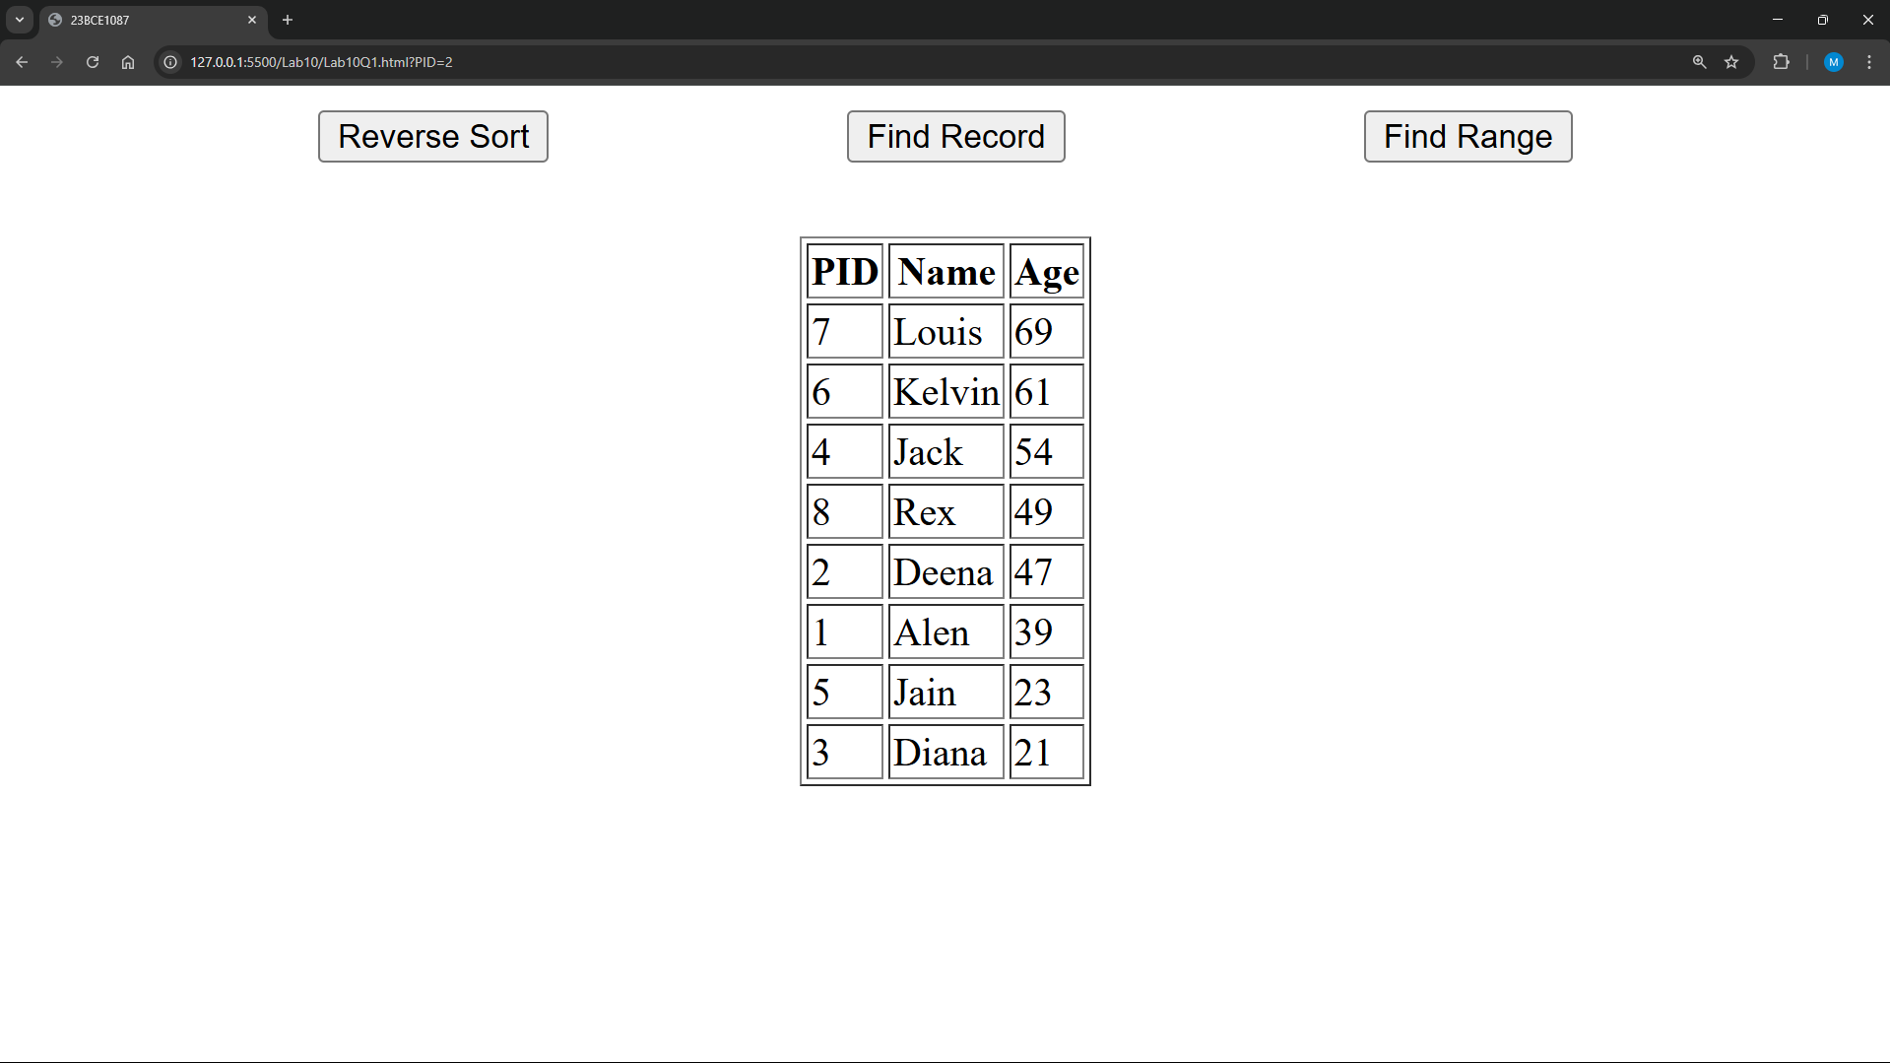

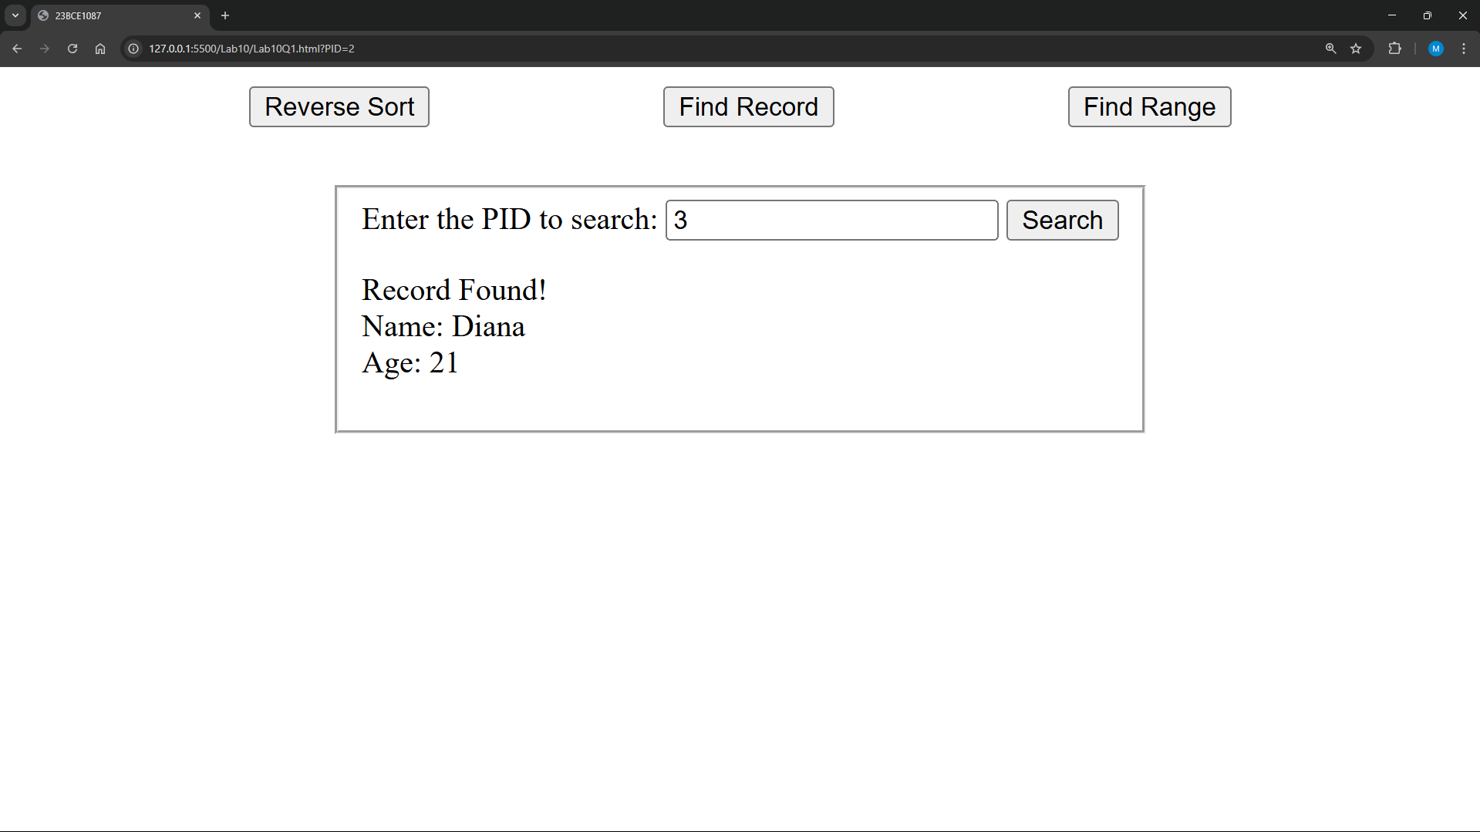

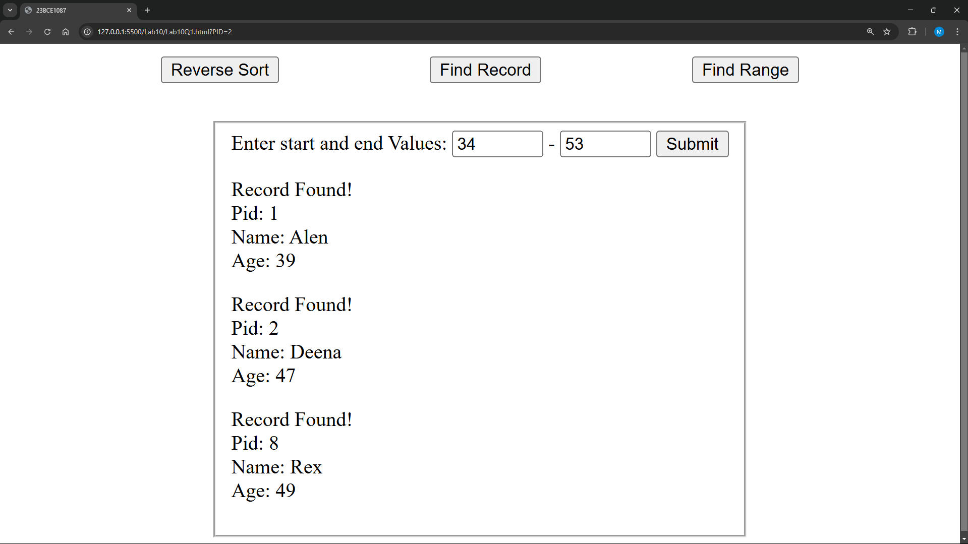

1. **Write a JavaScript program that performs the following actions using different DOM selection methods:**
2. Using getElementById:

Select the <h1> element and change its text to "Updated Title".

1. Using getElementsByName:

Select the input field with the name="username" and set its value to "John Doe". Select all radio buttons with the name gender and print the value of the selected radio button.

1. Using getElementsByTagName:

Count and print the total number of <p> elements on the page. Select all <li> elements inside the <ul> and print their text content to the console.

1. Using getElementsByClassName:

Change the background color of all elements with the class input-field to lightblue.

1. Using querySelector:

Select the first <p> element with the class info and update its text to "This is the first info paragraph".

Select the first radio button with the name gender and check it programmatically.

1. Using querySelectorAll:

Select all elements with the class info, loop through them, and print their text content. Select all checkboxes with the class hobby, loop through them, set them as checked and print the checked values.

**Code:**

***Lab10Q2.html***

<!DOCTYPE html>

<html lang="en">

<head>

    <meta charset="UTF-8">

    <meta name="viewport" content="width=device-width, initial-scale=1.0">

    <title>23BCE1087</title>

</head>

<body>

    <h1 id="title">Original Title</h1>

    <input type="text" name="username" class = "input-field" placeholder="Enter name">

    <p class="info">Lorem ipsum, dolor sit amet consectetur adipisicing elit. Quisquam, dolorum hic, aliquid facilis rem fugit molestiae debitis esse harum dicta ducimus vel incidunt aspernatur in aut vero culpa minus quo?</p>

    <p class="info">Lorem ipsum dolor, sit amet consectetur adipisicing elit. Sit, eius. Consectetur dolores aperiam aliquid. Pariatur quia obcaecati iusto sunt consequuntur molestias expedita, dicta, impedit vero, recusandae voluptates eum ratione nesciunt!</p>

    <ul>

        <li>Item 1</li>

        <li>Item 2</li>

        <li>Item 3</li>

    </ul>

    <br>

        <p>Paragraph 1</p>

        <p>Paragraph 2</p>

        <p>Paragraph 3</p>

    <br>

    <div class = "input-field">

        <input type="radio" name="gender" value="Male"> Male

        <input type="radio" name="gender" value="Female"> Female

        <br>

        <input type="checkbox" class="hobby" value="Reading"> Reading

        <input type="checkbox" class="hobby" value="Gaming"> Gaming

        <input type="checkbox" class="hobby" value="Traveling"> Traveling

    </div>

    <br><br>

    <button onclick="makeChanges()">Apply Changes</button>

    <script src="Lab10Q2.js"></script>

</body>

</html>

***Lab10Q2.js***

function makeChanges() {

    let title = document.getElementById("title");

    title.textContent = "Updated Title";

    let usernameField = document.getElementsByName("username")[0];

    usernameField.value = "John Doe";

    let genderRadios = document.getElementsByName("gender");

    for (let radio of genderRadios) {

        if (radio.checked) {

            console.log("Selected Gender:", radio.value);

        }

    }

    let paragraphs = document.getElementsByTagName("p");

    console.log("Total <p> elements:", paragraphs.length);

    let listItems = document.getElementsByTagName("li");

    for (let item of listItems) {

        console.log("List Item:", item.textContent);

    }

    let inputFields = document.getElementsByClassName("input-field");

    for (let field of inputFields) {

        field.style.backgroundColor = "lightblue";

    }

    let firstInfoPara = document.querySelector(".info");

    firstInfoPara.textContent = "This is the first info paragraph";

    let firstRadio = document.querySelector("input[name='gender']");

    firstRadio.checked = true;

    let allInfoParas = document.querySelectorAll(".info");

    allInfoParas.forEach(para => console.log("Info Text:", para.textContent));

    let checkboxes = document.querySelectorAll(".hobby");

    checkboxes.forEach(checkbox => {

        checkbox.checked = true;

        console.log("Checked Hobby:", checkbox.value);

    });

}

**Output:**

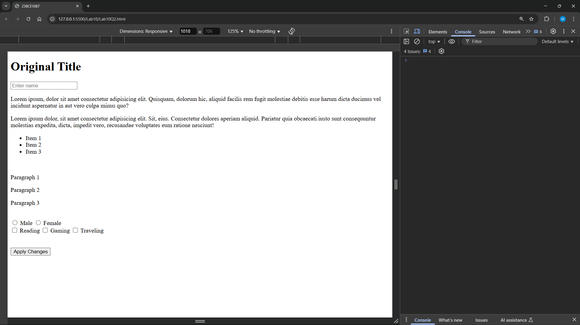

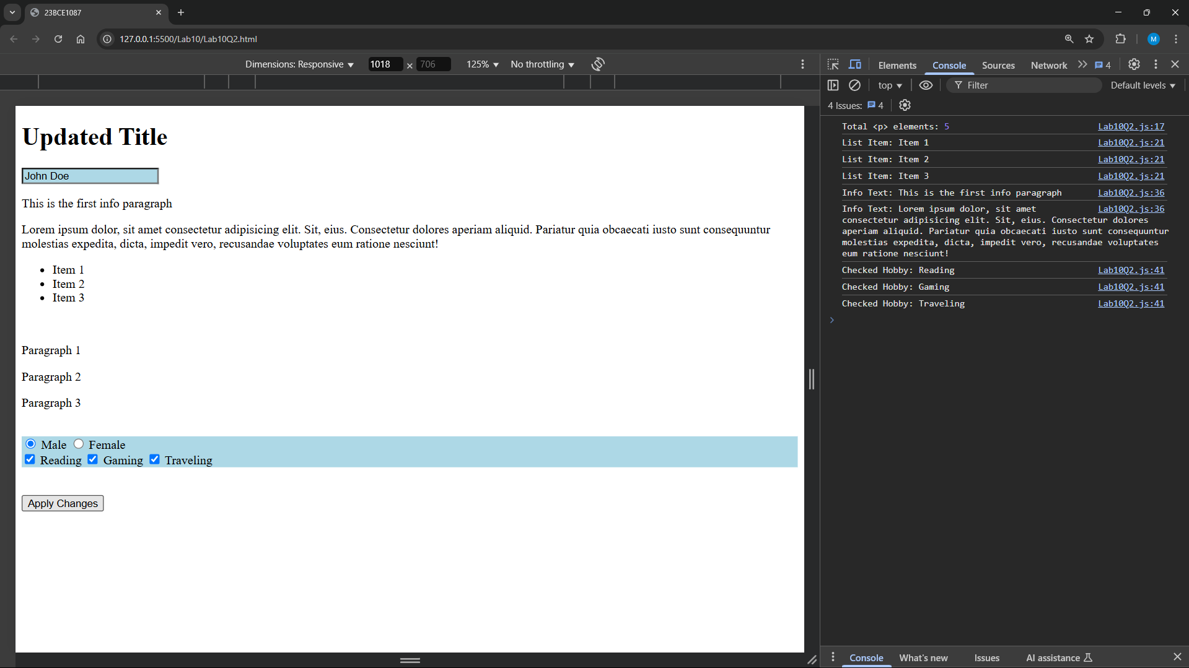

1. **Design an order form as below and implement a JavaScript program to pass the entries to another page and display the receipt.**

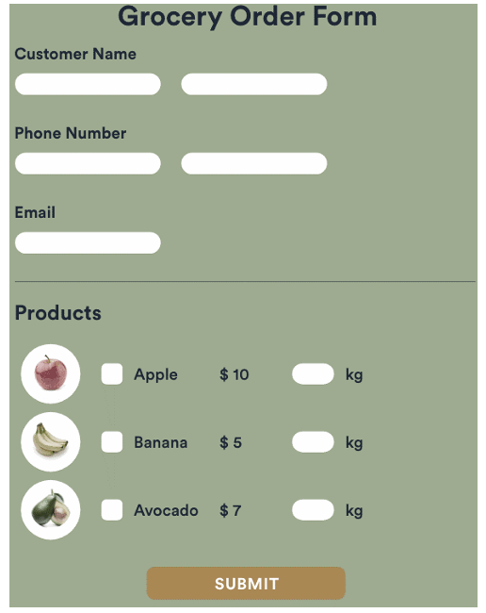

**Code:**

***Lab10Q3Customer.html***

<!DOCTYPE html>

<html lang="en">

<head>

    <meta charset="UTF-8">

    <meta name="viewport" content="width=device-width, initial-scale=1.0">

    <title>23BCE1087</title>

    <link rel="stylesheet" href="Lab10Q3.css">

</head>

<body>

    <div class="container">

        <h2>Grocery Order Form</h2>

        <form id="orderForm">

            <label>Customer Name</label>

            <div id = "name">

                <input type="text" id="Firstname" required>

                <div id = "spacer"></div>

                <input type="text" id="Lastname" required>

            </div>

            <label>Phone Number</label>

            <input type="text" id="phone" required>

            <label>Email</label>

            <input type="email" id="email" required>

            <h3>Products</h3>

            <div class="product">

                <input type="checkbox" class="item" value="Apple" data-price="10">

                <img src="https://w7.pngwing.com/pngs/399/447/png-transparent-red-apple-illustration-juice-apple-fruit-graphy-red-apple-natural-foods-food-leaf-thumbnail.png" alt="Apple">

                <span>Apple - $10/kg</span>

                <input type="number" class="qty" min="1" max="10">

            </div>

            <div class="product">

                <input type="checkbox" class="item" value="Banana" data-price="5">

                <img src="https://w7.pngwing.com/pngs/955/492/png-transparent-banana-powder-fruit-cavendish-banana-banana-yellow-banana-fruit-food-image-file-formats-banana-leaves-thumbnail.png" alt="Banana">

                <span>Banana - $5/kg</span>

                <input type="number" class="qty" min="1" max="10">

            </div>

            <div class="product">

                <input type="checkbox" class="item" value="Avocado" data-price="7">

                <img src="https://w7.pngwing.com/pngs/455/522/png-transparent-slice-avocado-fruit-avocado-avocado-food-photography-desktop-wallpaper-thumbnail.png" alt="Avocado">

                <span>Avocado - $7/kg</span>

                <input type="number" class="qty" min="1" max="10">

            </div>

            <button type="submit">Submit</button>

        </form>

    </div>

    <script src="Lab10Q3.js"></script>

</body>

</html>

***Lab10Q3Receipt.html***

<!DOCTYPE html>

<html lang="en">

<head>

    <meta charset="UTF-8">

    <meta name="viewport" content="width=device-width, initial-scale=1.0">

    <title>23BCE1087</title>

    <link rel="stylesheet" href="Lab10Q3.css">

</head>

<body>

    <div class="container">

        <h2>Order Receipt</h2>

        <div id="receipt"></div>

    </div>

    <script src="Lab10Q3Receipt.js"></script>

</body>

</html>

***Lab10Q3.css***

body {

    font-family: Arial, sans-serif;

    background-color: #a5a987;

}

#name{

    display: flex;

}

#spacer{

    width: 10px;

}

.container {

    background-color: #f4f4f4;

    padding: 20px;

    width: 50%;

    margin: 5%;

    border-radius: 10px;

    justify-self: center;

}

.container h2{

    justify-self: center;

}

form {

    display: flex;

    flex-direction: column;

}

input, button {

    margin: 10px 0;

    padding: 10px;

    border-radius: 10px;

}

input {

    width: 70%;

}

#name input{

    width: 30%;

}

.product input{

    width : 10%;

}

.product {

    display: flex;

    align-items: center;

    margin: 10px 0;

    justify-content: space-around;

}

img {

    width: 40px;

    margin-right: 10px;

}

button {

    background-color: #b88b58;

    color: white;

    font-size: 18px;

    cursor: pointer;

}

***Lab10Q3.js***

document.getElementById("orderForm").addEventListener("submit", function(event) {

    event.preventDefault();

    let Firstname = document.getElementById("Firstname").value;

    let Lastname = document.getElementById("Lastname").value;

    let phone = document.getElementById("phone").value;

    let email = document.getElementById("email").value;

    let items = document.querySelectorAll(".item");

    let orderDetails = [];

    items.forEach((item, index) => {

        if (item.checked) {

            let quantity = document.getElementsByClassName("qty")[index].value || 1;

            let price = item.getAttribute("data-price");

            orderDetails.push({

                name: item.value,

                quantity: quantity,

                price: price

            });

        }

    });

    let orderData = {

        Firstname: Firstname,

        Lastname: Lastname,

        phone: phone,

        email: email,

        items: orderDetails

    };

    localStorage.setItem("order", JSON.stringify(orderData));

    window.location.href = "Lab10Q3Receipt.html";

});

***Lab10Q3Receipt.js***

let orderData = JSON.parse(localStorage.getItem("order"));

let receiptDiv = document.getElementById("receipt");

if (orderData) {

    receiptDiv.innerHTML = `

        <p><strong>Name:</strong> ${orderData.Firstname} ${orderData.Lastname}</p>

        <p><strong>Phone:</strong> ${orderData.phone}</p>

        <p><strong>Email:</strong> ${orderData.email}</p>

        <h3>Ordered Items:</h3>

    `;

    let total = 0;

    orderData.items.forEach(item => {

        let cost = item.quantity * item.price;

        total += cost;

        receiptDiv.innerHTML += `<p>${item.quantity} kg of ${item.name} - $${cost}</p>`;

    });

    receiptDiv.innerHTML += `<h3>Total: $${total}</h3>`;

}

**Output:**

