**Name :** T.B.Madhan **Reg No :** 23BCE1087

**Web Programming Lab (BCSE203E)  
LAB – 3 HTML - Image Mapping**

1. **Map the images using HTML image mapping with the proper title such as**

Sun: Ball of Fire

Venus: Morning Star

Earth: Blue planet

Jupiter: Largest planet

Saturn: Ring Planet

Pluto: Dwarf Planet

My Space: Your Name and Register No.

**Note: Use title property for <area> tag**

**Code:**

***Lab3Q1.html***

<!DOCTYPE html>

<html lang="en">

<head>

    <meta charset="UTF-8">

    <meta name="viewport" content="width=device-width, initial-scale=1.0">

    <style>

        body{

            padding:0;

            margin:0;

        }

        H1{

            position:absolute;

            margin-left: 6%;

            margin-top: 2%;

            background-image: linear-gradient(to right,rgb(255, 255, 212),rgb(255, 120, 120));

            color:rgb(152, 13, 13);

        }

    </style>

    <title>23BCE1087</title>

</head>

<body>

    <a href="Me.html"><h1> My space </h1></a>

    <map name = "Nothing">

        <area shape="circle" coords="0,500,254" href="https://science.nasa.gov/sun/" title="Sun" alt="Sun">

       <area shape="circle" coords="319,542,24" href="https://science.nasa.gov/mercury/" title="Mercury">

        <area shape="circle" coords="467,542,53" href="https://science.nasa.gov/venus/" title = "Venus">

        <area shape="circle" coords="644,537,63" href="https://science.nasa.gov/earth/" title="Earth">

        <area shape="circle" coords="829,548,51" href="https://science.nasa.gov/mars/" title="Mars">

        <area shape="circle" coords="1041,533,82" href="https://science.nasa.gov/jupiter/" title="Jupiter">

        <area shape ="circle" coords = "1340,550,146" href="https://science.nasa.gov/saturn/" title = "Saturn">

        <area shape ="circle" coords = "1613,544,45" href = "https://science.nasa.gov/uranus/" title = "Uranus">

        <area shape = "circle" coords = "1807,544,61" href = "https://science.nasa.gov/neptune/" title = "Neptune">

    </map>

    <img src="../Assets/Planets.jpg" usemap="#Nothing">

</body>

</html>

**Output:**

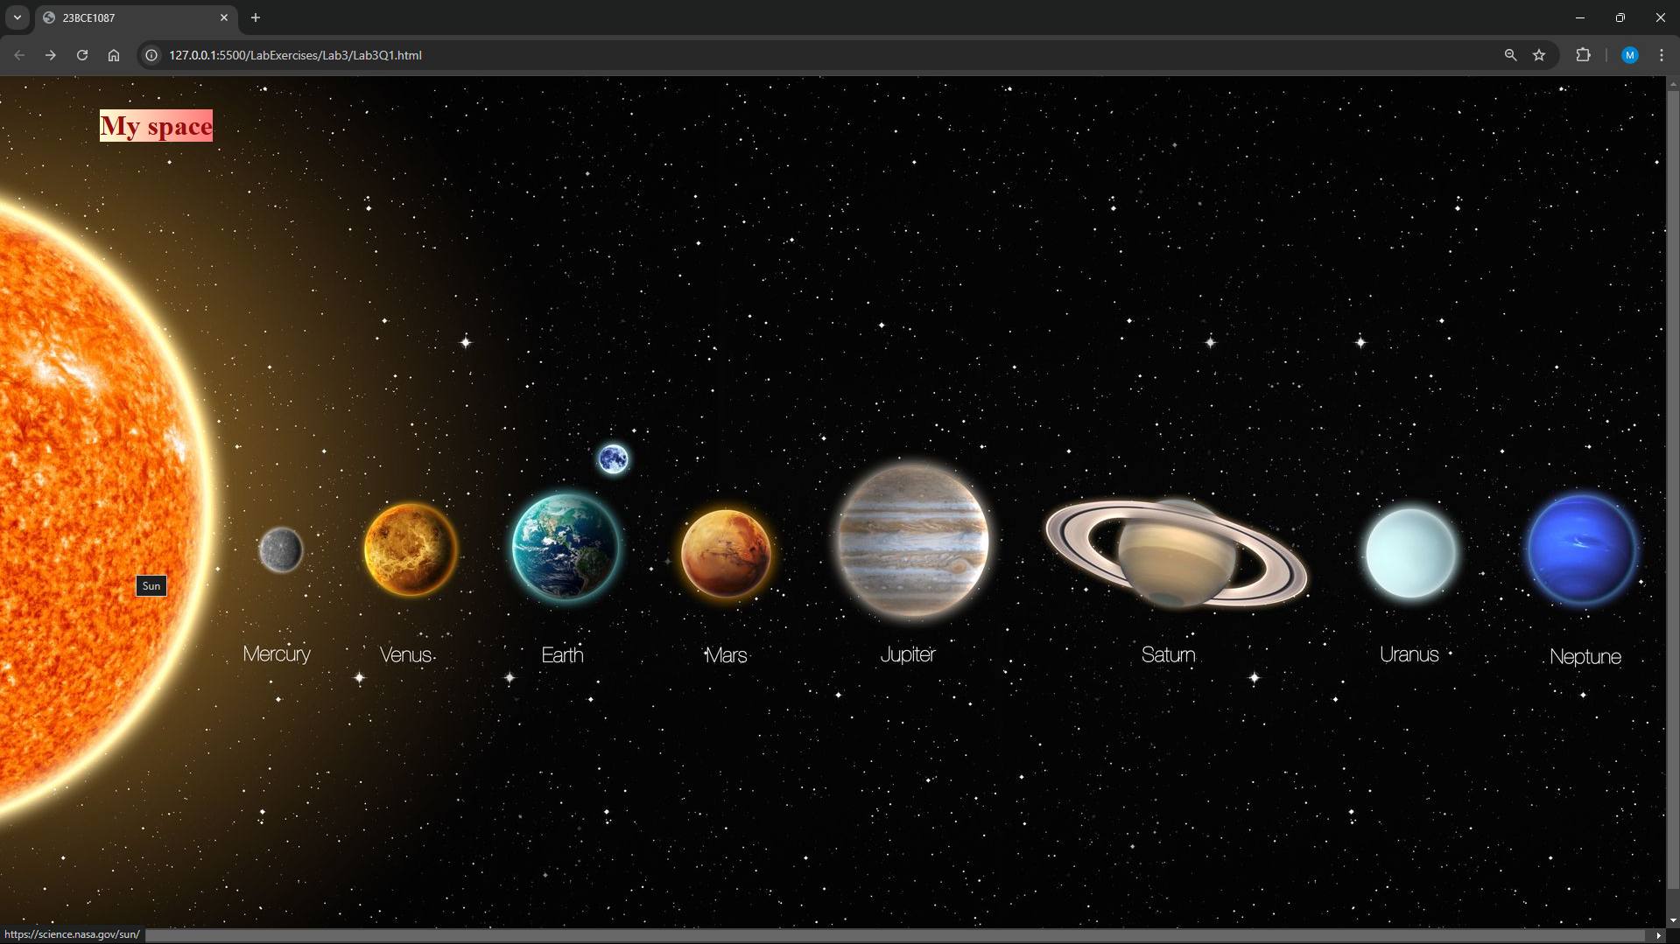

1. **Display your image when clicking on 'MySpace' and provide two sentences about yourself using lists and semantic tags. Spot a portion of your face and attach your signature using image mapping.**

**Code:**

***Me.html:***

<!DOCTYPE html>

<html lang="en">

<head>

    <meta charset="UTF-8">

    <meta name="viewport" content="width=device-width, initial-scale=1.0">

    <style>

        img{

            height: 500px;

        }

    </style>

    <title>23BCE1087</title>

</head>

<body>

    <section>

    <map name = "head">

        <area shape = "circle" coords="54,181,30" href="./sign.html">

    </map>

    <img src = "../Assets/20230915_182507-01.jpeg" usemap = "#head"/>

    </section>

    <section>

        <ul>

          <li>Name : Madhan</li>

          <li>Age : 19</li>

          <li>Roll Number : 23BCE1087.</li>

          <li>I like to eat biriyani :)</li>

          <li>I solve puzzles for fun</li>

        </ul>

      </section>

</body>

</html>

***sign.html:***

<!DOCTYPE html>

<html lang="en">

<head>

    <meta charset="UTF-8">

    <meta name="viewport" content="width=device-width, initial-scale=1.0">

    <title>23BCE1087</title>

</head>

<body>

    <img src = "../Assets/Sign.png"/>

</body>

</html>

***Greeting.html***

<!DOCTYPE html>

<html lang="en">

<head>

    <meta charset="UTF-8">

    <meta name="viewport" content="width=device-width, initial-scale=1.0">

    <title>23BCE1087</title>

</head>

<body>

    <center>

    <main>

        <header>

            <h1>Welcome!</h1>

        </header>

        <section>

            <p>Wishing you a day filled with happiness and a year filled with joy!</p>

            <p>Keep going with the spirits always being high!! :)</p>

        </section>

        <footer>

            <a href="home.html">Go back to the Home Page</a>

        </footer>

    </main>

    </center>

</body>

</html>

**Output:**

