**Name :** T.B.Madhan **Reg No :** 23BCE1087

**Web Programming Lab (BCSE203E)  
LAB – 4 HTML – Forms**

1. **Write an HTML program to design the form below**

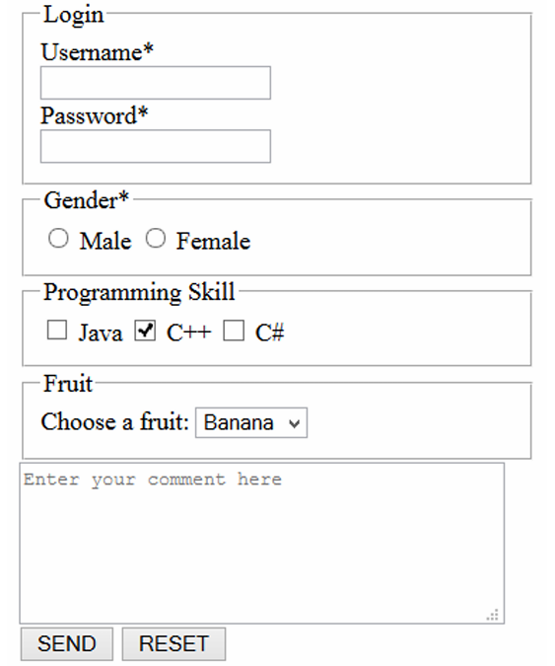

**Grouping the fruits (combo box) under**

* **Pome - Apples and pears**
* **Citrus - oranges, grapefruits, mandarins and limes**
* **Stone - nectarines, apricots, peaches and plums**
* **Exotic - bananas and mangoes**
* **Berries - strawberries, raspberries, blueberries, kiwifruit and passionfruit**
* **Melons - watermelons, rock melons and honeydew melons**

**Code:**

***Lab4Q1.html***

<!DOCTYPE html>

<html lang="en">

<head>

    <meta charset="UTF-8">

    <meta name="viewport" content="width=device-width, initial-scale=1.0">

    <title>Q1-23BCE1087</title>

</head>

<body>

    <form>

    <fieldset value = "Login">

        <legend>Login</legend>

        <label for="Username">Username*</label><br>

        <input type="text"><br>

        <label for="Password">Password*</label><br>

        <input type="password">

    </fieldset>

    <fieldset>

        <legend>Gender*</legend>

        <input type="radio" name = "gender" id = "male"> Male

        <input type="radio" name = "gender" id = "female"> Female

    </fieldset>

    <fieldset>

        <legend>Programming Skill</legend>

        <input type="checkbox" name="prog" id ="Java"> Java

        <input type="checkbox" name="prog" id = "C++" checked> C++

        <input type="checkbox" name="prog" id = "C#"> C#

    </fieldset>

    <fieldset>

        <legend>Fruit</legend>

        <label for = Fruit>Choose A Fruit: </label>

        <select id="fruits" name="fruits">

            <optgroup label="Pome">

                <option value="apple">Apple</option>

                <option value="pear">Pear</option>

            </optgroup>

            <optgroup label="Citrus">

                <option value="orange">Orange</option>

                <option value="grapefruit">Grapefruit</option>

                <option value="mandarin">Mandarin</option>

                <option value="lime">Lime</option>

            </optgroup>

            <optgroup label="Stone">

                <option value="nectarine">Nectarine</option>

                <option value="apricot">Apricot</option>

                <option value="peach">Peach</option>

                <option value="plum">Plum</option>

            </optgroup>

            <optgroup label="Exotic">

                <option value="banana" selected>Banana</option>

                <option value="mango">Mango</option>

            </optgroup>

            <optgroup label="Berries">

                <option value="strawberry">Strawberry</option>

                <option value="raspberry">Raspberry</option>

                <option value="blueberry">Blueberry</option>

                <option value="kiwifruit">Kiwifruit</option>

                <option value="passionfruit">Passionfruit</option>

            </optgroup>

            <optgroup label="Melons">

                <option value="watermelon">Watermelon</option>

                <option value="rockmelon">Rock-melon</option>

                <option value="honeydew">Honeydew melon</option>

            </optgroup>

        </select>

    </fieldset>

    <fieldset>

        <textarea rows="7" cols = "40">Enter your comment here</textarea>

        <br>

        <button value="Send">SEND</button>

        <button value="Reset">RESET</button>

    </fieldset>

    </form>

</body>

</html>

**Output:**

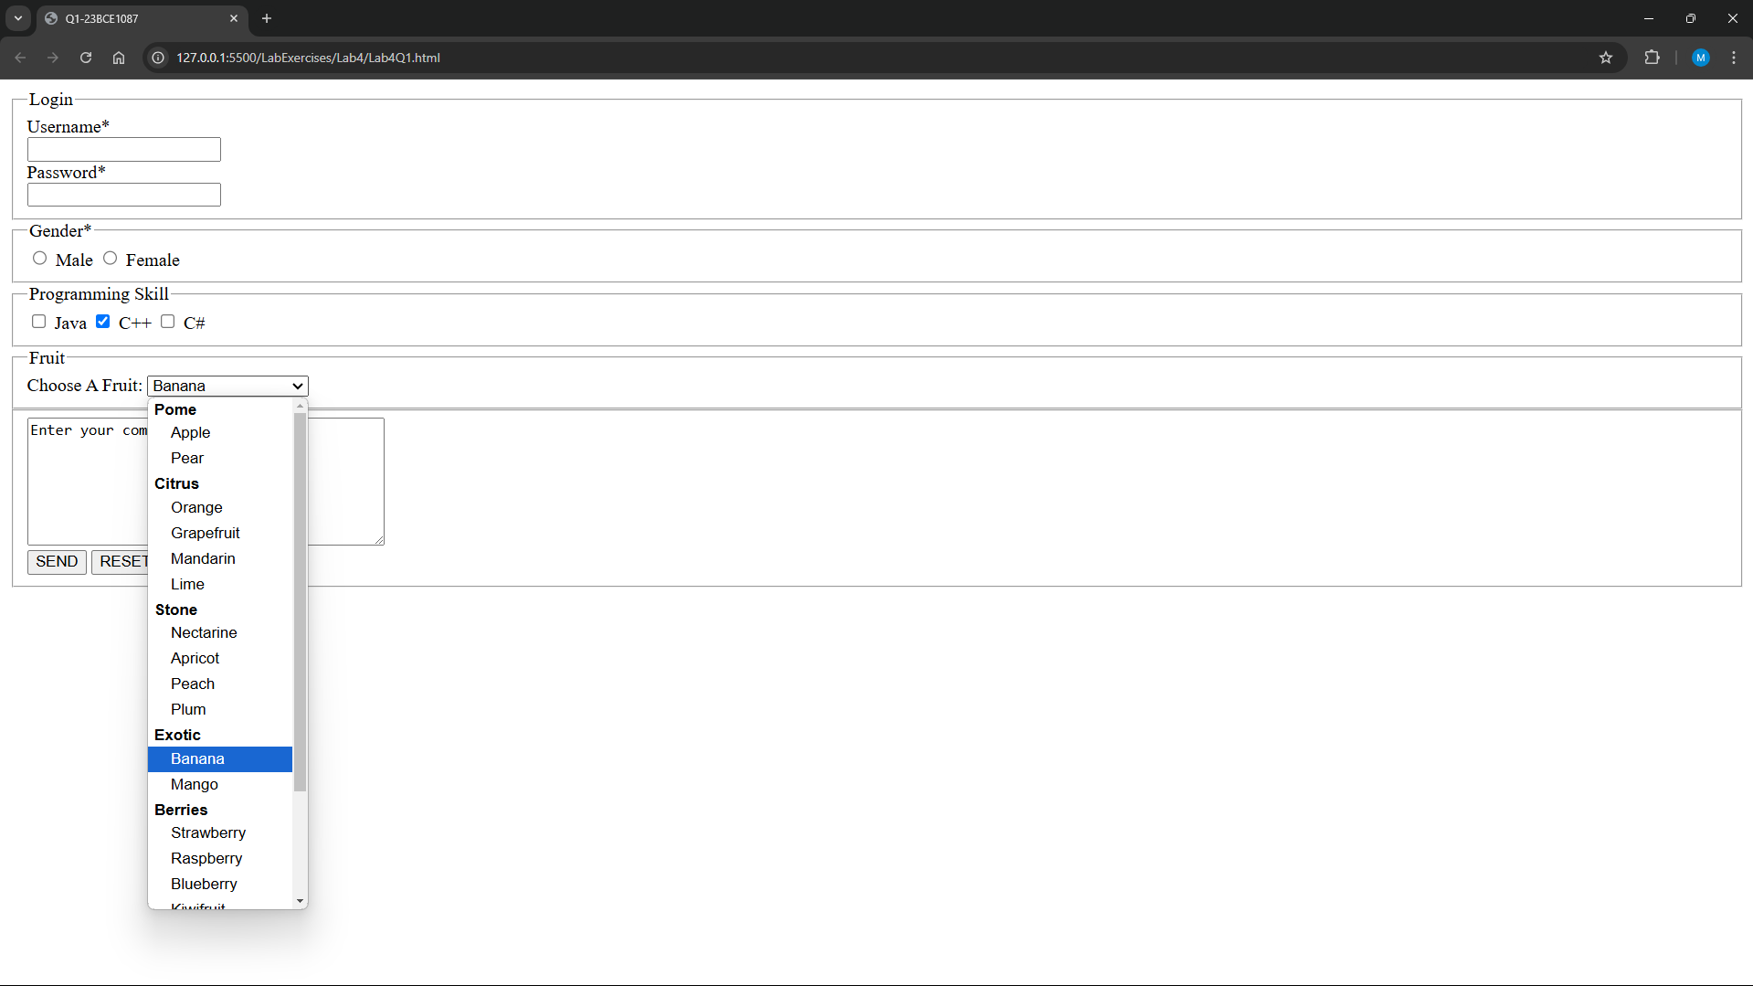

1. **Create a resume page below using HTML5 extended form elements**

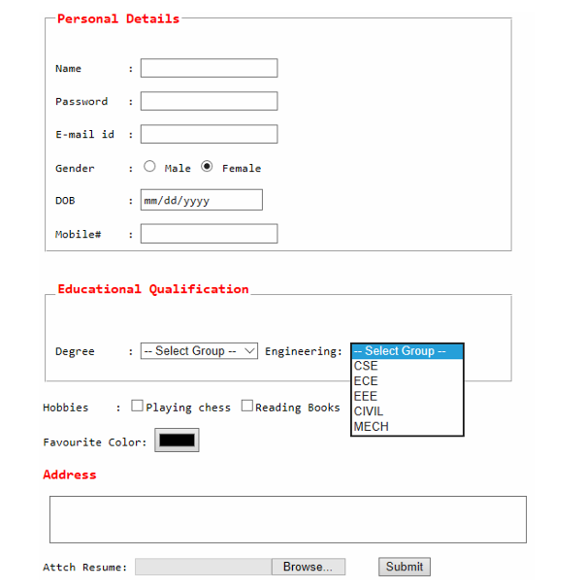

**Code:**

***Lab4Q2.html***

<!DOCTYPE html>

<html lang="en">

<head>

    <meta charset="UTF-8">

    <meta name="viewport" content="width=device-width, initial-scale=1.0">

    <title>Q2-23BCE1087</title>

</head>

<body style="font-family: Courier New, Courier, monospace;">

    <form>

        <fieldset>

            <Legend style="color: red;">Personal details</Legend>

            <br>

            <label for="name">Name:&ensp;&ensp;&ensp;&ensp;</label>

            <input type = "text" name = "name" id = "name"> <br><br>

            <label for="Password">Password:&ensp;&ensp;&ensp;&ensp;</label>

            <input type="password" name = "Password" id ="Password"> <br><br>

            <label for="email">Email-Id:&ensp;&ensp;&ensp;&ensp;</label>

            <input type="email" name="email" id="email">        <br><br>

            <label for="gender">Gender:&ensp;&ensp;&ensp;&ensp;</label>

            <input type="radio" name="gender" id="male"> male

            <input type="radio" name="gender" id="female"> female <br><br>

            <label for="DOB">DOB:&ensp;&ensp;&ensp;&ensp;&ensp;&ensp;</label>

            <input type="date" name="DOB" id="DOB"> <br><br>

            <label for="Mobile">Mobile#:&ensp;&ensp;&ensp;&ensp;</label>

            <input type="tel" name="Mobile" id="Mobile" pattern="[0-9]{10}"> <br><br>

        </fieldset>

        <fieldset>

            <legend  style="color: red;">Educational Qualification</legend> <br>

            <label for="Degree"> Degree:  </label>

            <Select>

                <option selected>--select group--</option>

                <optgroup label = "UG" >

                    <option value="BE">BE</option>

                    <option value="BTech">BTECH</option>

                    <option value="BSc">Bsc</option>

                    <option value="BA">BA</option>

                    <option value="BCA">BCA</option>

                    <option value="BBA">BBA</option>

                </optgroup>

                <optgroup label = "PG">

                    <option value="ME">ME</option>

                    <option value="MTech">MTech</option>

                    <option value="MSc">MSc</option>

                    <option value="MA">MA</option>

                    <option value="MCA">MCA</option>

                    <option value="MBA">MBA</option>

                </optgroup>

                <optgroup label = "PhD">

                    <option value="Engineering">Engineering</option>

                    <option value="Science">Science</option>

                    <option value="Management">Management</option>

                </optgroup>

                <optgroup label = "Other">

                    <option value="Other">Other</option>

                </optgroup>

            </Select>

            <label for="Degree">&ensp;Engineering: </label>

            <select>

                <optgroup>

                    <option selected>--select group--</option>

                    <option value="CSE">CSE</option>

                    <option value="ECE">ECE</option>

                    <option value="EEE">EEE</option>

                    <option value="CIVIL">CIVIL</option>

                    <option value="MECH">MECH</option>

                </optgroup>

            </select>

            <br><br>

            <label for="Hobbies">Hobbies: </label>

            <input type="checkbox" name="chess" id="chess"> Playing  chess

            <input type="checkbox" name="book" id="book"> Reading Books

            <br><br>

            <label for="Color">Favourite color: </label>

            <input type="color" name="Color" id="color">

        </fieldset>

        <label for="Address" style="color:red"> Address </label> <br>

        <textarea name="Address" id="Add" cols="150" rows="15"></textarea>

        <br>

        <label for="File">Attach Resume: </label>

        &emsp;

        <input type="file" name="File" id="resume">

        <input type = "submit" value = "Submit">

    </form>

</body>

</html>

**Output:**

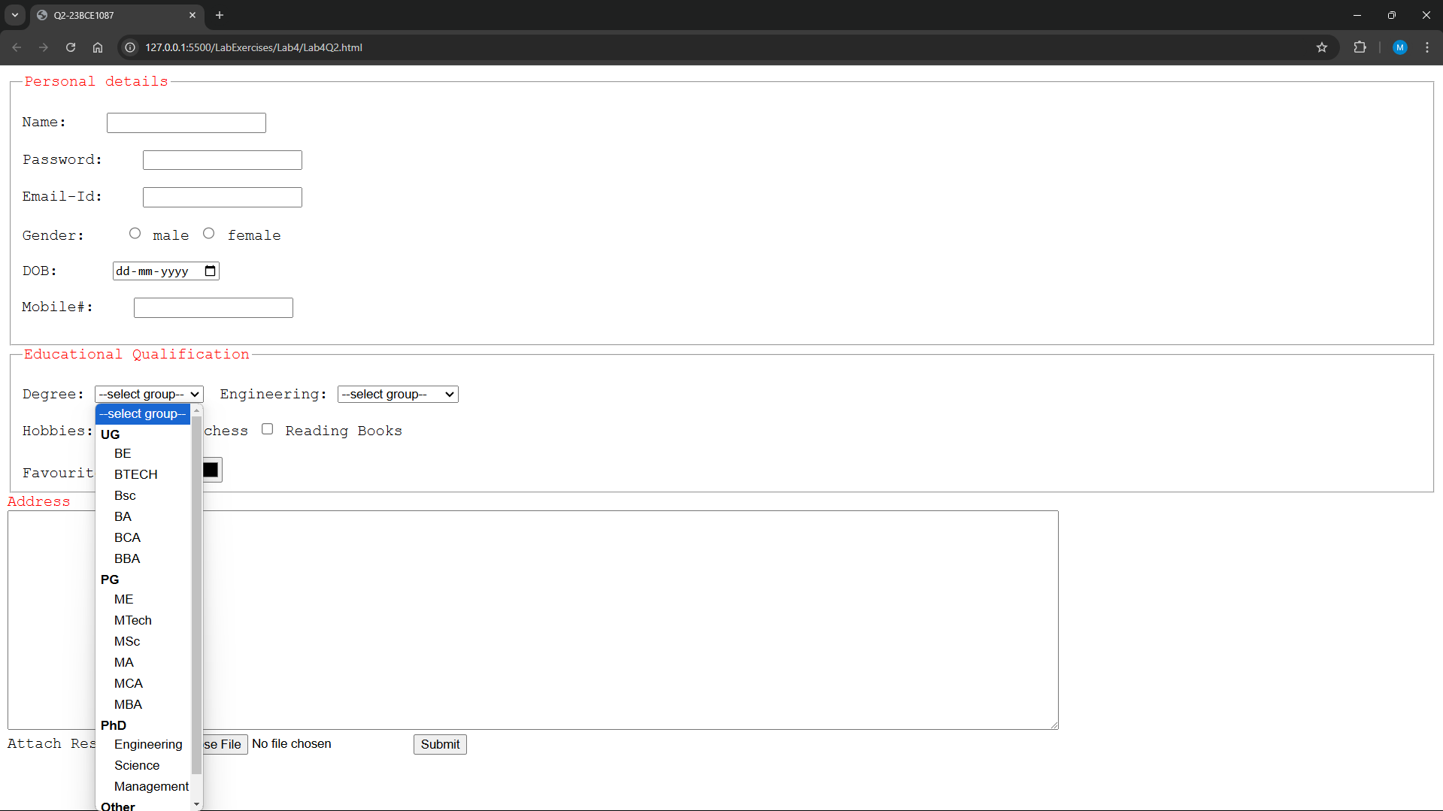

1. **Get feedback of a product using HTML slider control (three sliders) and add the total value using output element and oninput form attribute**

**Code:**

***Lab4Q3.html***

<!DOCTYPE html>

<html lang="en">

<head>

    <meta charset="UTF-8">

    <meta name="viewport" content="width=device-width, initial-scale=1.0">

    <title>Q3-23BCE1087</title>

</head>

<body>

    <form oninput = "x.value=(parseInt(a.value)+parseInt(b.value)+parseInt(c.value))/3">

        <label for="Quality"><h3>Quality:</h3> </label>

        1<input type="range" name="Quality" id="a" min = "1" max="5">5

        <br>

        <label for="Service"><h3>Service:</h3> </label>

        1<input type="range" name="Service" id="b" min="1" max="5">5

        <br>

        <label for="Perf"><h3>Performance:</h3></label>

        1<input type="range" name="Perf" id="c" min="1" max="5">5

        <br>

        <h3> Overall Rating:<output id = "x" for="a b c" value = "0"> </h3>

    </form>

</body>

</html>

**Output:**

