**Name :** T.B.Madhan **Reg No :** 23BCE1087

**Web Programming Lab (BCSE203E)  
LAB – 6 CSS - 1**

1. **Apply styles using INLINE CSS to the below table (3 marks) Add pseudo-class to make initial cap using internal CSS**



**Code:**

***Lab6Q1.html***

<!DOCTYPE html>

<html lang="en">

<head>

  <meta charset="UTF-8" />

  <meta name="viewport" content="width=device-width, initial-scale=1.0" />

  <title>23BCE1087</title>

  <style>

    *{

      margin: 0;

      padding:0;

    }

    td ul li::marker {

      color: #CCCCCC;

    }

    td li::first-letter {

      text-transform: capitalize;

    }

  </style>

</head>

<body>

  <div id = "box" style="padding: 3px;">

    <table style="border: 2px solid #F69446; width: 300px">

      <tr>

        <td style="background-color: #F69446; color: white; font-weight: bold; font-size: 20px; padding-left:6px; border:2px solid #F69446;">

        LEARN DATA SCIENCE!

        </td>

      </tr>

      <tr>

        <td style="padding: 10px">

          <ul style="list-style-type: disc; text-align: left; color: #5A85B7; padding-left: 9px; margin-left:9px; font-weight: bold; font-size: 16px;">

            <li>&emsp;unlimited jobs</li>

            <li>&emsp;best benefits anywhere</li>

            <li>&emsp;call now for an appointment</li>

          </ul>

        </td>

      </tr>

    </table>

  </div>

</body>

</html>

**Output:**



1. **Design a calculator as the image shown below. Create an EXTERNAL file “calc.css” using class and ID selector for table to apply style using font and background. Link the “calc.css” file to the “calculator.html” file. Also, use suitable property to change the color of the buttons when mouse over the buttons. (4 marks)**

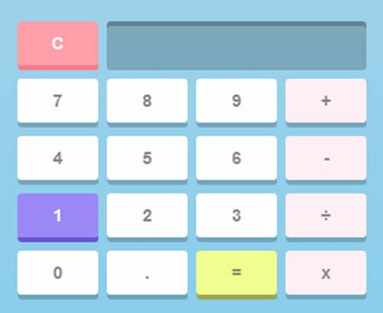

**Code:**

***Calculator.html***

<!DOCTYPE html>

<html lang="en">

  <head>

    <meta charset="UTF-8" />

    <meta name="viewport" content="width=device-width, initial-scale=1.0" />

    <title>23BCE1087</title>

    <link rel="stylesheet" href="calc.css" />

  </head>

  <body>

    <div class="calculator">

      <button class="button" id="clear">C</button>

      <div class="display" id="display"></div>

      <button class="button" id="seven">7</button>

      <button class="button" id="eight">8</button>

      <button class="button" id="nine">9</button>

      <button class="button operator" id="add">+</button>

      <button class="button" id="four">4</button>

      <button class="button" id="five">5</button>

      <button class="button" id="six">6</button>

      <button class="button operator" id="subtract">-</button>

      <button class="button" id="one">1</button>

      <button class="button" id="two">2</button>

      <button class="button" id="three">3</button>

      <button class="button operator" id="divide">/</button>

      <button class="button" id="zero">0</button>

      <button class="button" id="decimal">.</button>

      <button class="button equal" id="equals">=</button>

      <button class="button operator" id="multiply">x</button>

    </div>

  </body>

</html>

***Calc.css***

body {

  justify-content: center;

  height: 100px;

  width: 400px;

  margin: 0;

}

.calculator {

  display: grid;

  grid-template-columns: repeat(4, 1fr);

  gap: 10px;

  background-color: #91cde9;

  padding: 20px;

}

.display {

  grid-column: span 3;

  box-shadow: 0 -5px 0 0 #5D8192;

  background-color: #7DA7BD;

  border-radius: 5px;

  font-size: 24px;

}

.button {

  background-color: #ffffff;

  border: none;

  box-shadow: 0 5px 0 0 #76a4bd;

  border-radius: 5px;

  height: 50px;

  font-size: 18px;

  cursor: pointer;

  transition: background-color 0.3s;

}

.button:hover {

  box-shadow: 0 5px 0 0 #927cff;

  background-color: #dbd4ff;

}

#clear {

  box-shadow: 0 5px 0 0 #FE7684;

  background-color: #FE9FAA;

  color: #ffffff;

}

.operator {

  background-color: #fef0f1;

}

.equal {

  box-shadow: 0 5px 0 0 #9ea353;

  background-color: #f1fe92;

}

**Output:**

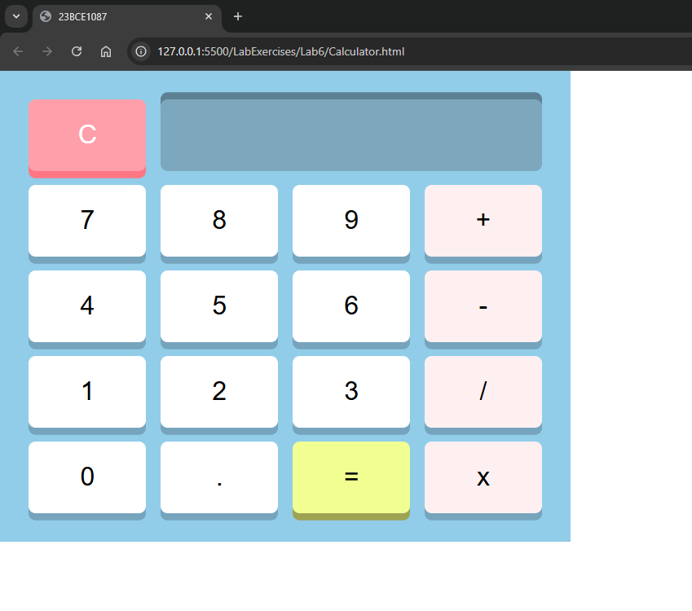

1. **Include your favourite singer's photo as an image. Add an INTERNAL CSS class named "myphoto" that fulfils the following requirements:**

* The image border is rounded, so that it appears as a circle.
* The image width and height should both be 150px.
* The image should have a solid border with a width of 2px and be colored with your favourite color.
* Add a title to the image and apply a font change and color-change animation effect. Use percentage to apply different colors and change the font size.

**For example, the image should look like Fig1:**



*(Fig. 1. Photo)*

**Code:**

***Lab6Q3.html***

<!DOCTYPE html>

<html lang="en">

  <head>

    <meta charset="UTF-8" />

    <meta name="viewport" content="width=device-width, initial-scale=1.0" />

    <title>23BCE1087</title>

    <style>

      body{

        padding: 20px;

      }

      h1{

        text-align: center;

      }

      .myphoto {

        width: 150px;

        height: 150px;

        border-radius: 50%;

        border: 2px solid #2f00b0;

      }

      .title {

        animation: titleAnimation 2s infinite;

      }

      @keyframes titleAnimation {

        0% {

          color: #00137e;

          font-family:monospace;

          font-size: 16px;

        }

        50% {

          color: #4682b4;

          font-family:cursive;

          font-size: 30px;

        }

        100% {

          color: #bb1c00;

          font-family:cursive;

          font-size: 16px;

        }

      }

    </style>

  </head>

  <body>

    <center>

    <figure>

    <img src="../Assets/SPB.jpg" name ="Singer" alt="Favorite Singer" class="myphoto" />

    <figcaption class ="title" for="Singer">SPB</figcaption>

    </figure>

    </center>

  </body>

</html>

**Output:**

