**Name :** T.B.Madhan **Reg No :** 23BCE1087

**Web Programming Lab (BCSE203E)  
LAB – 7 CSS**

1. **Write three sentences about your college life in VIT using a paragraph with division tag. Apply box model style to the div tag using embedded CSS. The specification of the box model is given below**

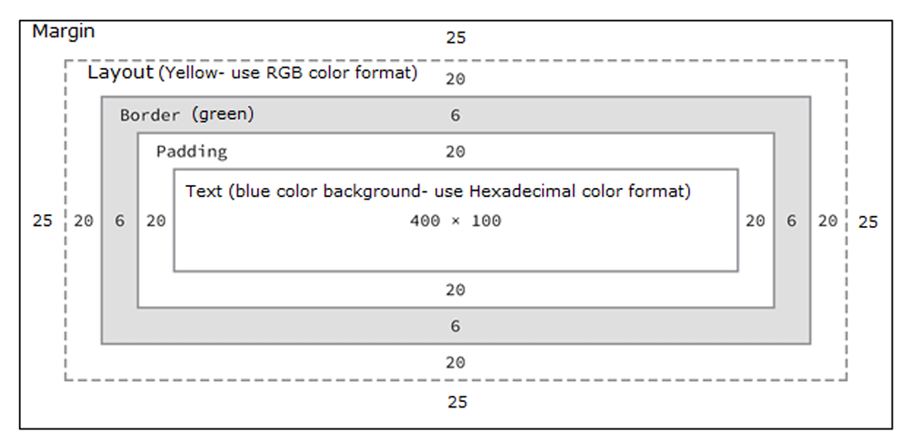

**Code:**

***Lab7Q1.html***

<!DOCTYPE html>

<html lang="en">

<head>

    <meta charset="UTF-8">

    <meta name="viewport" content="width=device-width, initial-scale=1.0">

    <title>23BCE1087</title>

    <style>

        *{

            margin: 0;

            padding: 0;

        }

        #out {

            padding: 20px;

            margin: 25px;

            background-color: rgb(255, 255, 0);

            display: inline-block;

        }

        #in {

            background-color: rgb(0, 153, 255);

            display: inline-block;

            border: 6px solid green;

            padding: 20px;

        }

        #VIT {

            background-color: skyblue;

            color: #0000FF;

            width: 400px;

            height: 100px;

            display: inline-block;

        }

    </style>

</head>

<body>

    <div id="out">

        <div id="in">

            <p id="VIT">

                My College life in VIT is a good mix of learning, exploring more things,

                getting better in whatever we do and making a lot of friends along the way.

                It has a good campus and a lot of events and people along with it making a

                memorable experience.

            </p>

        </div>

    </div>

</body>

</html>

**Output:**

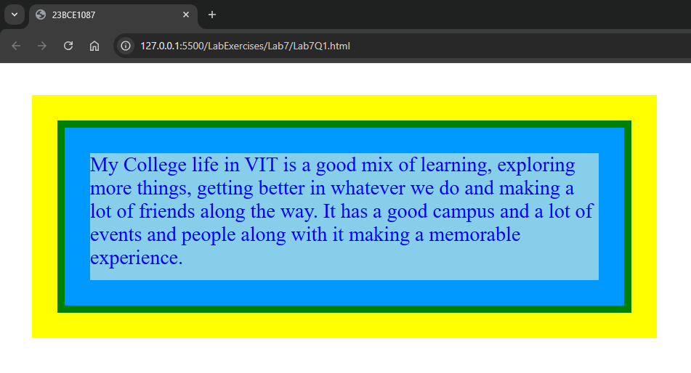

1. **Design a webpage for Pet animals and apply style using External CSS**

* Apply a rainbow effect to any heading.
* Ensure the descriptions are displayed in a multi-column format, with a line height of 30pt.
* Use a background image and align it to the center.
* Insert a ball using SVG, and create an effect to illustrate "a dog playing with a ball." Apply translation, rotation, and shearing effects to the ball.

**Code:**

***Lab7Q2.html***

<!DOCTYPE html>

<html lang="en">

<head>

    <meta charset="UTF-8">

    <meta name="viewport" content="width=device-width, initial-scale=1.0">

    <title>23BCE1087</title>

    <link rel="stylesheet" href="Lab7Q2.css">

</head>

<body>

    <div class="grid">

        <h1 class="title">Welcome to the World of Pets</h1>

        <div class="row_grid">

            <div class="pets_outer">

                <h3 class="pet_name">Dog</h3>

                <img src="https://imgcdn.stablediffusionweb.com/2024/10/19/01ec4a92-f38a-47ce-a07e-58d5dcf7976a.jpg" alt="A dog" class="pet_photo">

                <p class="pet_description">

                    Dogs are loyal and social animals, known for their playful energy and unwavering companionship. They are highly adaptable and thrive in a variety of living environments. With their natural instincts for protection and exploration, dogs love outdoor activities and bonding with their owners. Their affectionate nature and ability to form deep connections make them wonderful additions to any family.

                    Owning a dog can bring immense joy, encourage an active lifestyle, and provide endless love and loyalty.

                </p>

            </div>

            <div class="pets_outer">

                <h3 class="pet_name">Cat</h3>

                <img src="https://imgcdn.stablediffusionweb.com/2024/9/16/86cbcc4a-3430-42ba-af5c-233ccd545b22.jpg" alt="A cat" class="pet_photo">

                <p class="pet_description">

                    Cats are inquisitive and self-reliant animals, celebrated for their playful antics and soothing purrs. They’re low-maintenance pets that thrive in both indoor and outdoor settings. With their innate hunting instincts, cats enjoy exploring and interacting with their environment. They can be loving companions who find happiness basking in sunny spots. Having a cat in your life can be a wonderful way to relieve stress and add happiness to your home.

                </pp>

            </div>

            <div class="pets_outer">

                <h3 class="pet_name">Rabbit</h3>

                <img src="https://easy-peasy.ai/cdn-cgi/image/quality=80,format=auto,width=700/https://fdczvxmwwjwpwbeeqcth.supabase.co/storage/v1/object/public/images/5f8e98d5-41c8-4913-a54b-5cb258e13b89/dc648c59-d96f-49e1-955b-c5f378d04823.png" alt="A rabbit" class="pet_photo">

                <p class="pet_description">

                    Rabbits are gentle and adorable animals, known for their soft fur and playful hops. They are social creatures that enjoy the company of their owners and other rabbits. With their curious nature, rabbits love exploring their environment and nibbling on fresh vegetables. They make excellent pets, being relatively low-maintenance and easy to care for.

                    Their affectionate demeanor and quiet presence bring a sense of calm and joy to any home, making them wonderful companions.

                </p>

            </div>

        </div>

        <div class="row_grid">

            <div class="pets_outer">

                <h3 class="pet_name">Parrot</h3>

                <img src="https://imgcdn.stablediffusionweb.com/2024/9/19/090a1eae-02df-4b14-940e-004d810cdb33.jpg" alt="A parrot" class="pet_photo">

                <p class="pet_description">

                    Parrots are intelligent and vibrant birds, known for their playful personalities and ability to mimic sounds. They thrive in social environments and enjoy interacting with their owners. With their colorful feathers and curious nature, parrots love exploring their surroundings and engaging in mental stimulation. These affectionate companions can form strong bonds with their caretakers, bringing energy and joy to any home.

                    Caring for a parrot can be a rewarding experience, adding a splash of color and a lively spirit to your life.

                </p>

            </div>

            <div class="pets_outer">

                <h3 class="pet_name">Fish</h3>

                <img src="https://encrypted-tbn0.gstatic.com/images?q=tbn:ANd9GcQDCW80MUvKsFKj6TEtI2Qj2ghB0vs8Jj6ZjQ&s" alt="A fish" class="pet_photo">

                <p class="pet_description">

                    Fish are serene and fascinating pets, admired for their vibrant colors and graceful movements.

                    They are low-maintenance companions that thrive in well-maintained aquariums, adding beauty and tranquility to any space.

                    Watching fish swim can have a calming effect, making them perfect for reducing stress and enhancing relaxation. With a wide variety of species to choose from, each with unique patterns and behaviors, fish make captivating and peaceful additions to your home.

                </p>

            </div>

            <div class="pets_outer">

                <h3 class="pet_name">Hamster</h3>

                <img src="https://easy-peasy.ai/cdn-cgi/image/quality=80,format=auto,width=700/https://fdczvxmwwjwpwbeeqcth.supabase.co/storage/v1/object/public/images/37a52899-6a2d-4c80-8cfd-aeb1dbccbcb0/f50ce4ff-497c-4a0c-96ae-28526963ad4c.png" alt="A hamster" class="pet_photo">

                <p class="pet_description">

                    Hamsters are small, playful, and charming pets known for their curious nature and adorable antics. They are easy to care for, making them a great choice for first-time pet owners. Hamsters enjoy exploring tunnels, running on wheels, and burrowing in soft bedding. With their gentle temperament and low space requirements, they are perfect for small living spaces.

                    These furry little companions bring joy and entertainment to any home with their endearing behavior and lively energy.

                </p>

            </div>

        </div>

    </div>

    <div id="dog_svg_div">

        <h3 class="svg_title">Catch the ball with the dog :)</h3>

        <img src="../Assets/Pets/dog-icon.svg" alt="Dog svg"  width="200px">

            <svg width="150px" height="150" viewbox="0 0 100 100" id="svg_ball" >

                <circle cx="20" cy="70"  r="15" fill="red" id="ball"/>

            </svg>

    </div>

</body>

</html>

***Lab7Q2.css***

body {

    color: rgb(250, 250, 250);

    font-family: cursive;

    background-image: url("../Assets/Background.jpg");

    background-position: center;

    background-size:cover;

    background-color: #cccccc;

}

.title {

    display: block;

    background: linear-gradient(to left ,violet , indigo, blue, green, yellow, orange, red);

    background-clip: text;

    color: transparent;

    align-self: center;

}

.grid

{

    display: flex;

    flex-direction: column;

    justify-content: space-evenly;

    gap: 0.5em;

}

.row_grid {

    display: flex;

    flex-direction: row;

    flex-wrap: wrap;

    gap: 0.5em;

}

.pets_outer {

    flex: 1 ;

    transition: 0.5s;

    background-color: #BB7B79;

    border: 2px solid rgb(117, 117, 117);

    border-radius: 10px;

    padding: 1em;

}

.pets_outer:hover

{

    transition-delay: 0.2s;

    flex-basis: 1.3%;

    font-size: 1.05em;

}

.pet_name {

    color: rgba(92, 12, 47,0.9);

    font-size: 1.5em;

    text-align: center;

}

.pet_photo {

    max-width: 15em;

    display: block;

    border-radius: 5px;

    margin: 0.5em auto;

}

.pet_description {

    color: rgb(245, 245, 220);

    line-height: 30pt;

    margin-left: 2%;

    font-size: 0.9em;

}

#dog_svg_div

{

    justify-self: center;

}

.svg_title

{

    color: rgba(92, 12, 47,0.9);

    font-size: 1.5em;

    margin-top: 5%;

    text-align: center;

}

#svg_ball

{

    animation: bounce 3s infinite ease-out;

}

@keyframes bounce {

    0% {

        transform: translate3d(0, 0, 0) skewY(0) rotateZ(0deg);

    }

    50% {

        transform: translate3d(0, -50px, 0) skewY(10deg) rotateZ(-180deg);

    }

    100% {

        transform: translate3d(0, 0, 0) skewY(0) rotateZ(-360deg);

    }

}

**Output:**

