**Name :** T.B.Madhan **Reg No :** 23BCE1087

**Web Programming Lab (BCSE203E)  
LAB – 8 JavaScript Basics**

1. **Create a basic calculator that takes two numbers from the user and performs basic mathematical operations (addition, subtraction, multiplication, division and mod) using prompt and alert.**

**Code:**

***Lab8Q1.html***

<!DOCTYPE html>

<html lang="en">

<head>

    <meta charset="UTF-8">

    <meta name="viewport" content="width=device-width, initial-scale=1.0">

    <title>23BCE1087</title>

    <script>

        let x = parseInt(prompt("Enter operand 1: "))

        let oper = prompt("Enter operator: ")

        let y = parseInt(prompt("Enter operand 2: "))

        switch(oper){

            case "+":

                alert("Sum : " + (x+y))

                break;

            case "-":

                alert("Difference : ", (x-y))

                break;

            case "*":

                alert("Product : ",(x*y))

                break;

            case "/":

                alert("Quotient: ",(x/y))

                break;

        }

    </script>

</head>

<body>

</body>

</html>

**Output:**

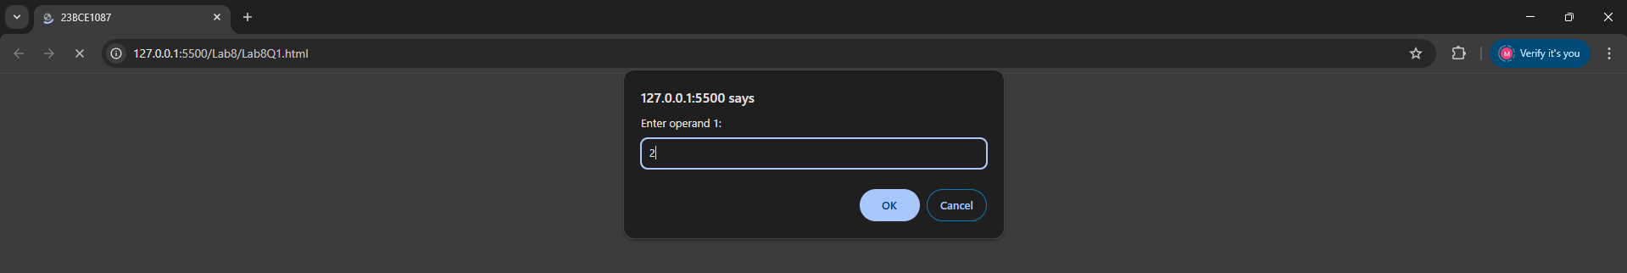

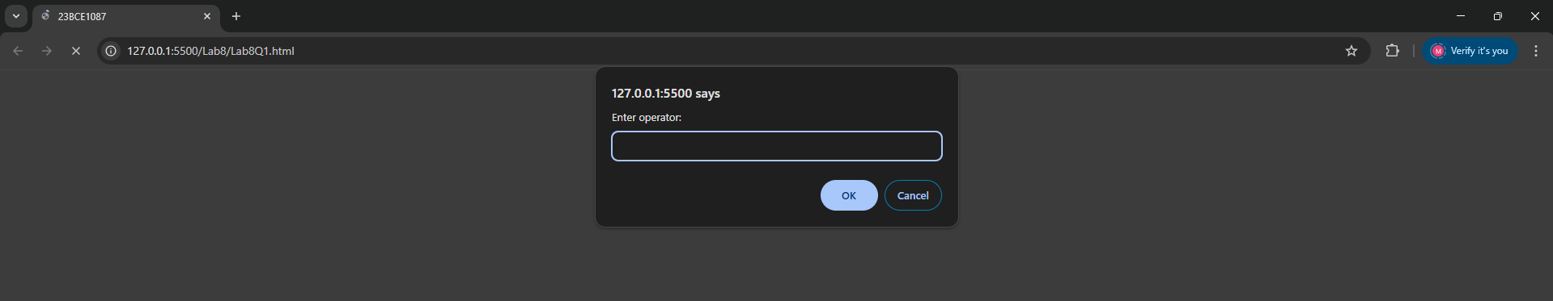

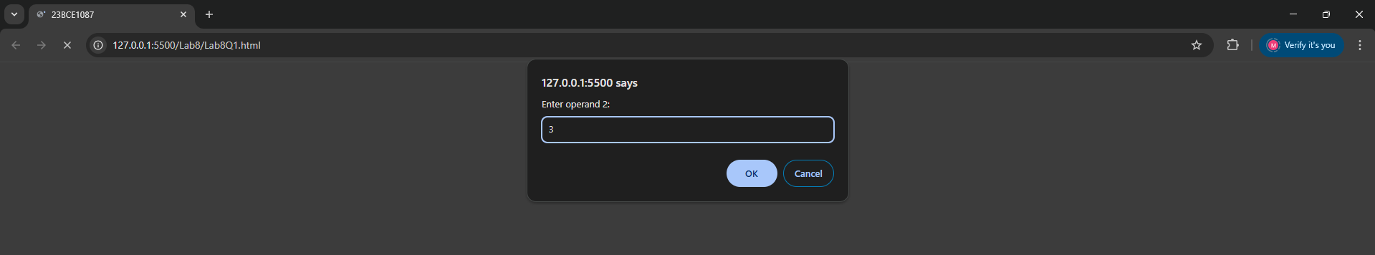

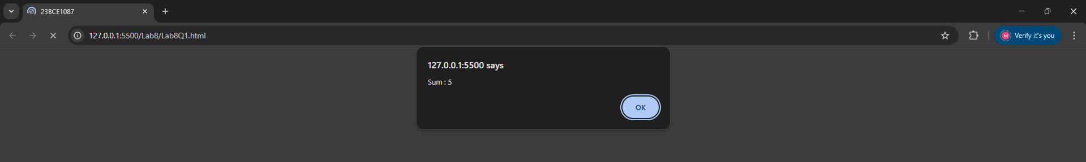

1. **Write a JavaScript program to use prompt() to ask for the user's age and alert() to confirm whether the user is eligible to drive.**

**Code:**

***Lab8Q2.html***

<!DOCTYPE html>

<html lang="en">

<head>

    <meta charset="UTF-8">

    <meta name="viewport" content="width=device-width, initial-scale=1.0">

    <title>23BCE1087</title>

    <script>

        let age = parseInt(prompt("Enter your age "))

        if(age>=18){

            alert("You are eligible to drive")

        }

        else{

            alert("You are not eligible to drive")

        }

    </script>

</head>

<body>

</body>

</html>

**Output:**

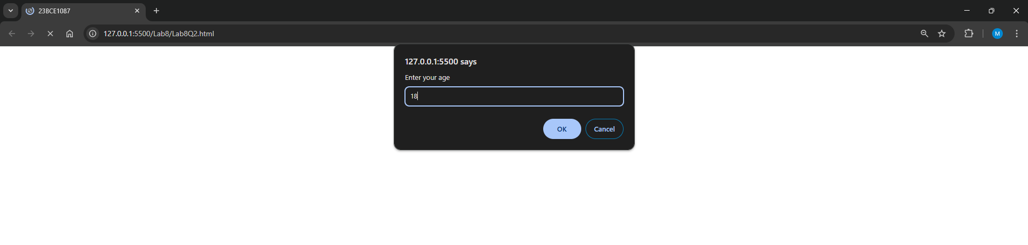

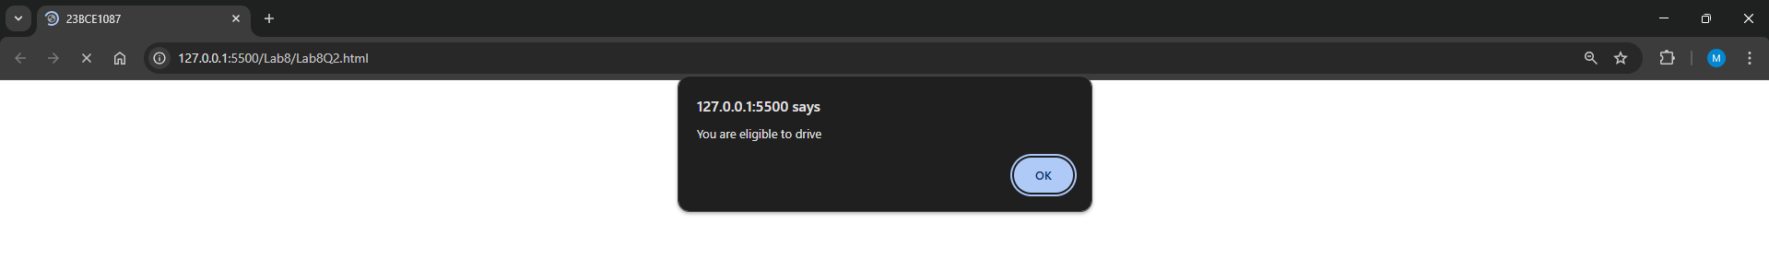

1. **Write a JavaScript program to use confirm() to ask the user for confirmation whether he is a student while entering his registration number**

**Code:**

***Lab8Q3.html***

<!DOCTYPE html>

<html lang="en">

<head>

    <meta charset="UTF-8">

    <meta name="viewport" content="width=device-width, initial-scale=1.0">

    <title>23BCE1087</title>

    <script>

        let isStud = confirm("Are you a student? ")

        if (isStud) {

            let x = prompt("Enter your register number","__|||xxxx")

        }

        else{

            alert("Get the hell out bro")

        }

    </script>

</head>

<body>

</body>

</html>

**Output:**

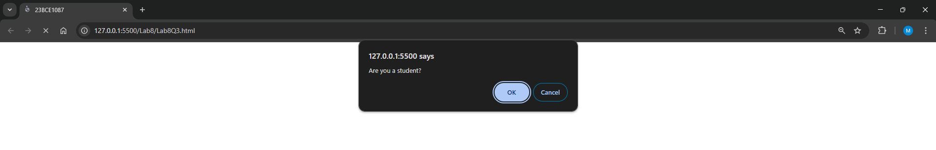

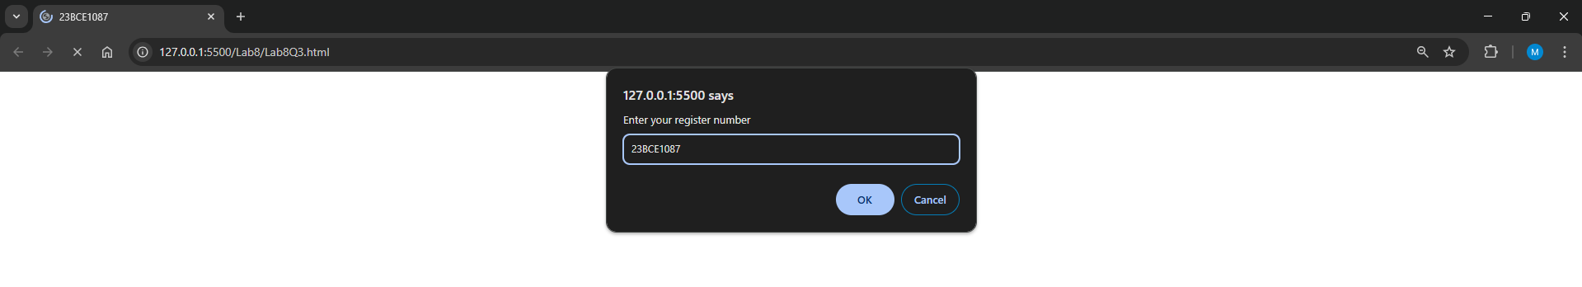

1. **A General Service company hired you to calculate the labour cost and total charge for the services rendered to their client based on the formula given below: Rate per hour : Rs.45/- Labour cost : Rate per hour * hours work Total Charge : Labour cost + Cost of Materials. Write a JavaScript program (Internal) using suitable pop-up boxes to read the necessary inputs and display the output.**

**Code:**

***Lab8Q4.html***

<!DOCTYPE html>

<html lang="en">

<head>

    <meta charset="UTF-8">

    <meta name="viewport" content="width=device-width, initial-scale=1.0">

    <title>23BCE1087</title>

    <script>

        let rateOfHour = 45

        let hours = parseInt(prompt("Enter the number of hours worked: "))

        let costOfMaterials = parseFloat(prompt("Enter the cost of the materials"))

        let totalCost = (hours * rateOfHour) + costOfMaterials

        alert("Labour cost : " + (hours * rateOfHour) + "\nThe total cost is: " + totalCost)

    </script>

</head>

<body>

</body>

</html>

**Output:**

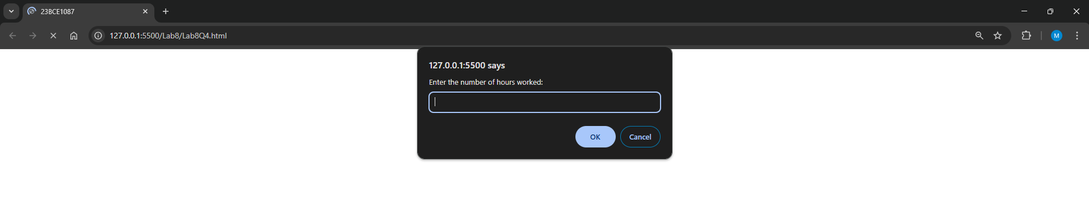

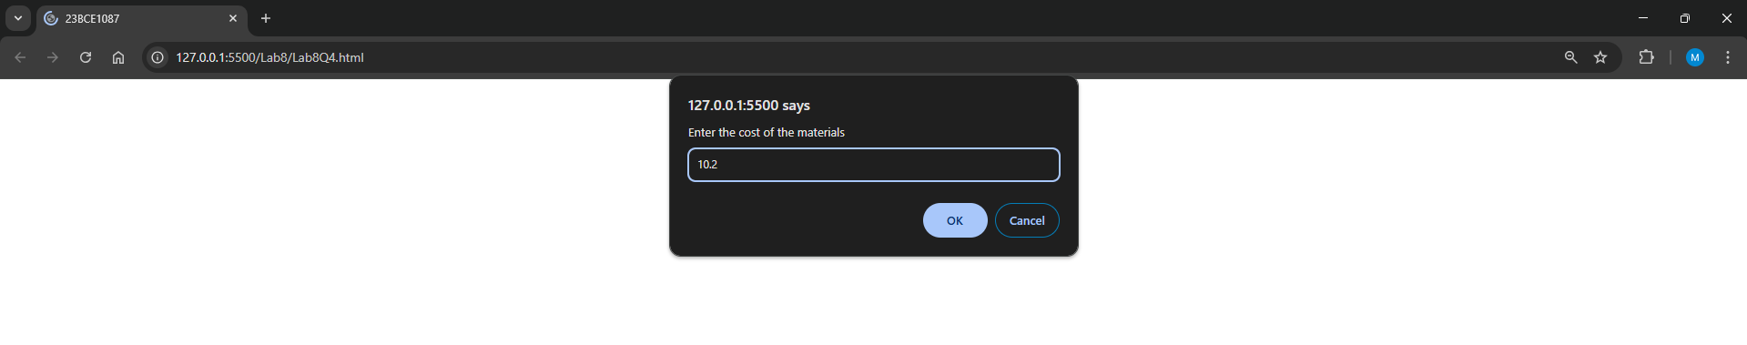 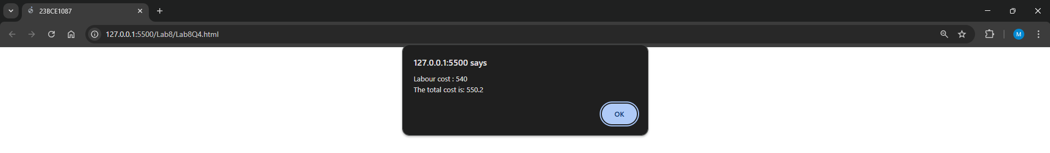

1. **Write a JavaScript program to accept reg.no and name. Display your registration number as shown below by applying inline style using document.write.**



**Display your name as shown below by applying inline style using innerHTML.**

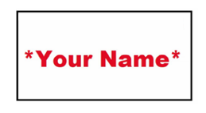

**Code:**

***Lab8Q5.html***

<!DOCTYPE html>

<html lang="en">

<head>

    <meta charset="UTF-8">

    <meta name="viewport" content="width=device-width, initial-scale=1.0">

    <title>23BCE1087</title>

    <script>

        document.write("<div style=\"background-color: azure;\n padding: 10px;\n border: 10px solid red;display: flex;\njustify-content: center;\n align-items: center;\nflex-direction: column;\nwidth: 200px;\">\n<p style=\"text-align: center;\nfont-size: 30px;\">23BCE1087</p>\n</div>")

    </script>

</head>

<body>

    <div id = "Name" style="background-color: azure;

            margin:10px;

            padding: 10px;

            border: 2px solid rgb(0, 0, 0);

            display: flex;

            justify-content: center;

            align-items: center;

            width: 200px;">

        <p style="

        text-align: center;

        font-size: 30px;">One</p>

    </div>

    <script>

         document.getElementById("Name").innerHTML ="Madhan"

    </script>

</body>

</html>

**Output:**

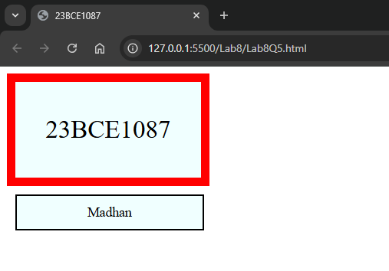

1. **A circus has an entry ticket booth. Visitors come to the booth, and order tickets for adults and children. The booth attendant collects the entry fee, and prints out the tickets. Write a JavaScript program (External) to display the total amount in a given text box on clicking ‘Total’ button.**

**Code:**

***Lab8Q6.html***

<!DOCTYPE html>

<html lang="en">

<head>

    <meta charset="UTF-8">

    <meta name="viewport" content="width=device-width, initial-scale=1.0">

    <title>23BCE1087</title>

    <style>

        #f1{

            width: 300px;

        }

        #outputBox{

            display:flex;

            margin-top: 10px;

        }

        .Boxes{

            box-shadow: -1px 1px 2px black;

        }

    </style>

    <script src="./Lab8Q6.js"></script>

</head>

<body>

    <form id = "f1">

        <fieldset>

            <legend>TicketBooth</legend>

            <label for = "Adults" style = "font-size: 20    px;">Adults(&#8377 10 each)</label><br>

            <input type="number" id="Adults" name="Adults" min="0" value = "0" required class="Boxes"><br>

            <label for = "Children" style = "font-size: 20    px;">Children(&#8377 5 each)</label><br>

            <input type="number" id="Children" name="Children" min="0" value = "0" required class="Boxes"><br>

            <div id="outputBox">

                <button type="button" onclick="updateVal()" style="margin-right:5%" class="Boxes">Total</button>

                <textarea cols="14" rows = "1" id = "output" readonly></textarea>

            </div>

        </fieldset>

</body>

</html>

***Lab8Q6.js***

function updateVal(){

    let x = document.getElementById("Adults").value

    let y = document.getElementById("Children").value

    let total = parseInt(x)*10 + parseInt(y)*5

    console.log(total)

    document.getElementById("output").value = total

}

**Output:**

