**Name :** T.B.Madhan **Reg No :** 23BCE1087

**Web Programming Lab (BCSE203E)  
LAB – 9 JavaScript - 2**

1. **The following are the daily temperature recordings of NEWYORK city (In Fahrenheit) 55,62,68,74,59,45,41,58,60,67,65,78,82,88,91,92,90,93,87,80,78,79,72,68,61,59,55,65 Your JavaScript program should count and print the number of HOT days (High Temperature: 85 or higher), the number of PLEASANT days (High temperature: 60-84) and the number of COLD days (High temperature<60) in the city. It should also display the category of each temperature in an HTML Table.**

**Code:**

***Lab9Q1.html***

<!DOCTYPE html>

<html lang="en">

<head>

    <meta charset="UTF-8">

    <meta name="viewport" content="width=device-width, initial-scale=1.0">

    <title>23BCE1087</title>

    <style>

        #box{

            display:flex;

        }

    </style>

</head>

<body>

    <div id = "box">

    <div>

        <table border="1">

        <thead>

            <tr>

                <th>S.No</th>

                <th>Temperature</th>

                <th>Catergory</th>

            </tr>

        </thead>

        <tbody id="table_insert">

        </tbody>

        </table>

    </div>

    <div id = "count_box">

        <table border="1" id="count">

            <tr>

                <td>Hot Days</td>

                <td></td>

            </tr>

            <tr>

                <td>Pleasant days</td>

                <td></td>

            </tr>

            <tr>

                <td>Cold days</td>

                <td></td>

            </tr>

        </table>

    </div>

</div>

    <script src="./Lab9Q1.js"></script>

</body>

</html>

***Lab9Q1.js***

data = [55,62,68,74,59,45,41,58,60,67,65,78,82,88,91,92,90,93,87,80,78,79,72,68,61,59,55,65]

console.log(data.length)

tbodyElement = document.getElementById("table_insert");

let Hot = 0,Cold = 0,Pleasant=0

for(i = 0;i<data.length;i++){

    let row = document.createElement("tr");

    tbodyElement.appendChild(row);

    let td1 = document.createElement("td");

    row.appendChild(td1)

    let td2 = document.createElement("td");

    row.appendChild(td2)

    let td3 = document.createElement("td");

    row.appendChild(td3)

    td1.textContent = i+1;

    td2.textContent = data[i];

    if(data[i]>=85){

        td3.textContent = "Hot"

        Hot++;

    }else if(data[i]>=60 && data[i]<=84){

        td3.textContent = "Pleasant"

        Pleasant++;

    }else{

        td3.textContent = "Cold"

        Cold++;

    }

    tbodyElement.appendChild(row);

}

table2 = document.getElementById("count");

table2.rows[0].cells[1].textContent=Hot;

table2.rows[1].cells[1].textContent=Pleasant;

table2.rows[2].cells[1].textContent=Cold;

**Output:**

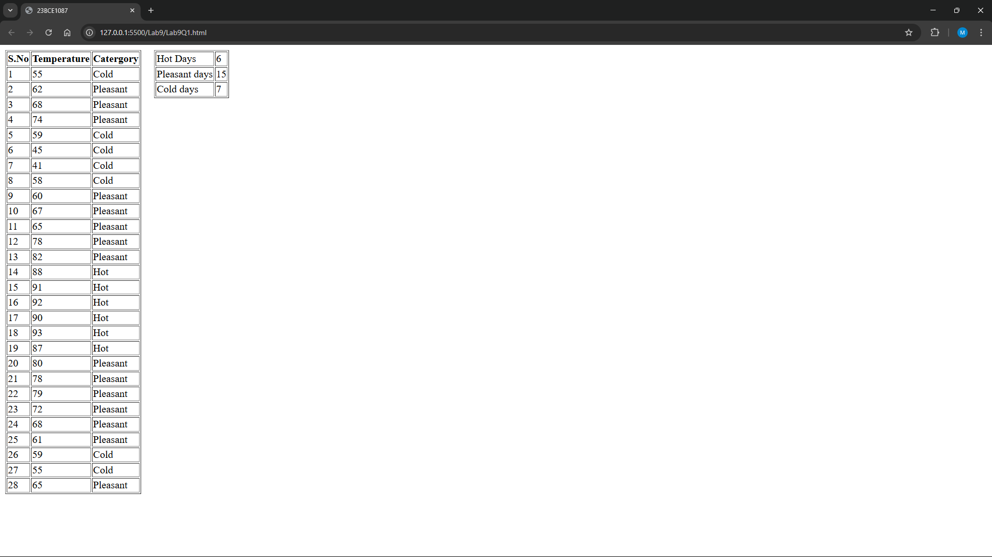

1. **A small airline has just purchased a computer for its newly automated reservations system. Write a JavaScript program to assign seats on each flight (capacity: 10 seats). Your program should display the following:**

• If the person types 1, assign a seat in the first-class section (seats 1–5).

• If the person types 2, assign a seat in the economy section (seats 6–10).

• When the first-class section is full, your program should ask the person if it is acceptable to be placed in the economy section (and vice versa)

**Allot the seats based on the above choices. Print a boarding pass indicating the person’s name, seat number and class.**

**Use one-dimensional array to represent the seating chart of the plane. Initialize all the elements of the array to 0 to indicate that all the seats are empty. As each seat is assigned, set the corresponding elements of the array to 1 to indicate that the seat is no longer available.**

**Code:**

***Lab9Q2.html***

<!DOCTYPE html>

<html lang="en">

    <head>

        <meta charset="UTF-8" />

        <meta name="viewport" content="width=device-width, initial-scale=1.0" />

        <title>23BCE1087</title>

        <style>

            table,th,td {

                border: 1px solid black;

                border-collapse: collapse;

            }

            th,td {

                padding: 15px;

            }

        </style>

    </head>

    <body>

        <h1>Flight Reservation System</h1>

        <fieldset id="Passenger">

            <legend><h3>Passenger</h3></legend>

            <label><b>Name:</b></label>

            <input type="text" id="Name"><br><br>

            <label><b>Class:</b></label>

            <input type="number" id="Class" min="1" max ='2'><br><br>

            <input type="button" value="Book" id="Book" onclick="book()">

        </fieldset>

        <br>

        <div id="table"></div>

        <script src="Lab9Q2.js"> </script>

    </body>

</html>

***Lab9Q2.js***

const seats = [0, 0, 0, 0, 0, 0, 0, 0, 0, 0];

let s1 = 0;

let s2 = 5;

let table = `<table padding="10px" border="2"> <tr><th>&emsp;Name&emsp;</th><th>&emsp;Class&emsp;</th><th>&emsp;Seat Number&emsp;</th></tr>`;

function book() {

    let Name = document.getElementById(`Name`).value;

    let Class = document.getElementById(`Class`).value;

    if (Class == 1) {

        if (seats[4] == 0) {

            seats[s1] = 1;

            s1++;

            table += `<tr><td>${Name}</td><td>First-Class</td><td>${s1}</td></tr>`;

            document.getElementById("table").innerHTML = table;

        } else if (seats[4] == 1 && seats[9] == 0) {

            let choice = prompt("Seats are full in First Class. Do you accept to be placed in Economy Class?");

            if (choice.toLowerCase() === "yes") {

                seats[s2] = 1;

                s2++;

                table += `<tr><td>${Name}</td><td>Economy</td><td>${s2}</td></tr>`;

                document.getElementById("table").innerHTML = table;

            }

        } else {

            alert("Sorry! All seats are full.");

        }

    }

    if (Class == 2) {

        if (seats[9] == 0) {

            seats[s2] = 1;

            s2++;

            table += `<tr><td>${Name}</td><td>Economy</td><td>${s2}</td></tr>`;

            document.getElementById("table").innerHTML = table;

        } else if (seats[4] == 0 && seats[9] == 1) {

            let choice = prompt("Seats are full in Economy Class. Do you accept to be placed in First Class?");

            if (choice.toLowerCase() === "yes") {

                seats[s1] = 1;

                s1++;

                table += `<tr><td>${Name}</td><td>First-Class</td><td>${s1}</td></tr>`;

                document.getElementById("table").innerHTML = table;

            }

        } else {

            alert("Sorry! All seats are full.");

        }

    }

}

**Output:**

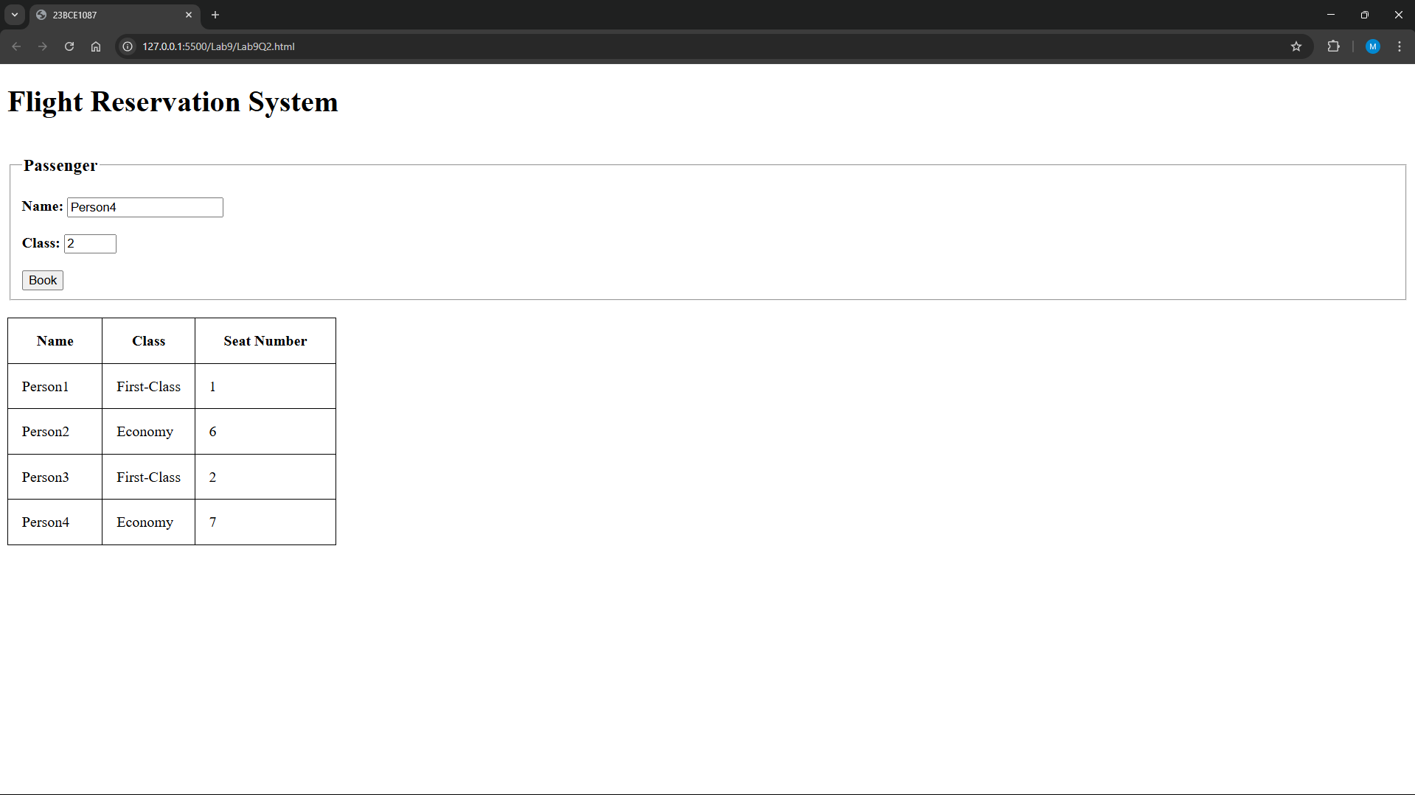

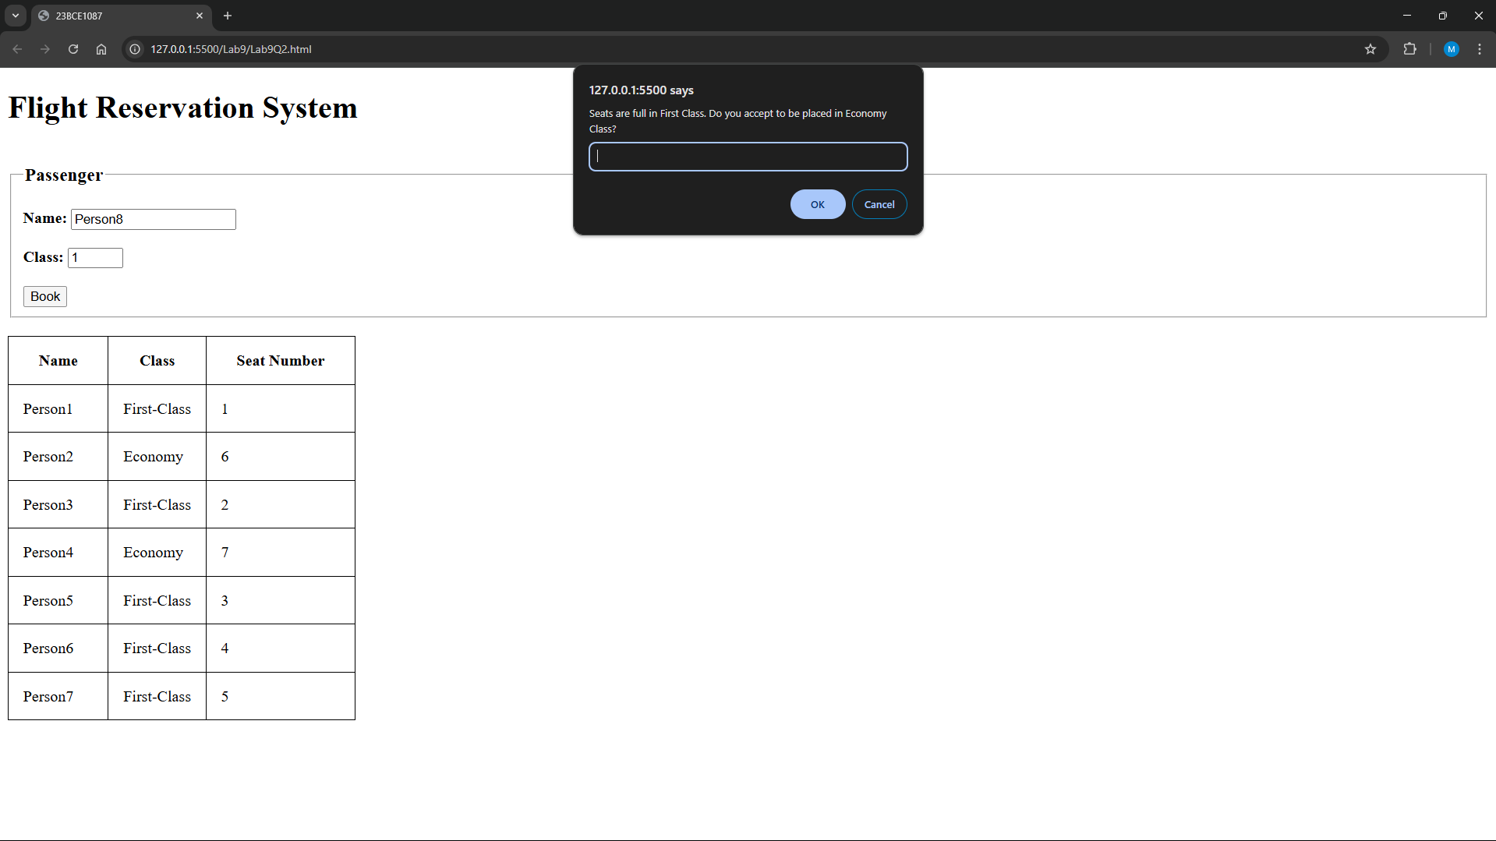

1. **Use Javascript to develop the web page as given in Fig.1 to calculate the Body Mass Index (BMI) and display the adult’s status through appropriate popup boxes. For example, the BMI rate of the men is 21, and then prints the status through a popup box as “Ideal Range” by triggering the event on a “Calculate” button.**

**Note: Refer Table.1 to get the BMI criteria information.**

*BMI=703*weight/Height2*

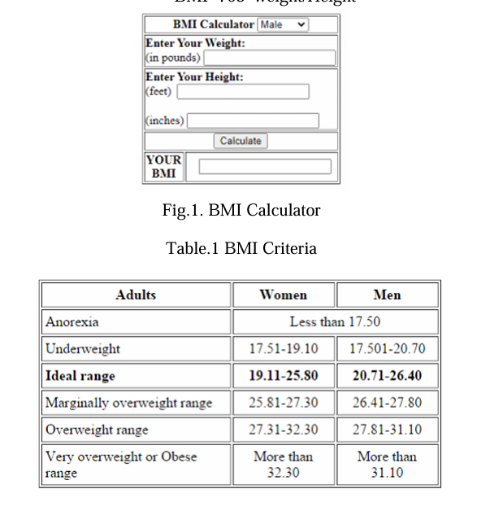

**Code:**

***Lab9Q3.html***

<!DOCTYPE html>

<html lang="en">

<head>

    <meta charset="UTF-8">

    <meta name="viewport" content="width=device-width, initial-scale=1.0">

    <title>23BCE1087</title>

    <style>

        body {

            justify-self: center;

        }

        #calculate{

            justify-self: center;

        }

    </style>

</head>

<body>

    <table border="2" style="width: 350px;">

        <tr>

        <th colspan="2">

            BMI Calculator

            <select id="gender">

                <option value="male">Male</option>

                <option value="female">Female</option>

            </select>

        </th>

        </tr>

        <tr>

            <td colspan="2">

                <strong>Enter Your Weight:</strong><br>

                (in pounds) <input type="text" id="weight">

            </td>

        </tr>

        <tr>

            <td colspan="2">

                <strong>Enter Your Height:</strong><br>

                (feet) <input type="text" id="feet"><br><br>

                (inches) <input type="text" id="inches">

            </td>

        </tr>

        <tr>

            <td colspan="2" >

                <center>

                <button id="calculate" onclick="calculateBMI()">Calculate</button>

                </center>

            </td>

        </tr>

    <tr >

        <td>

            <center>

            <strong>YOUR</strong><br>

            <strong>BMI</strong>

            </center>

        </td>

        <td>

            <center>

            <div style="width: 200px;border: 2px solid black;height:20px" id="BMI">

            </div>

            </center>

        </td>

    </tr>

    </table>

    <script src="Lab9Q3.js"></script>

</body>

</html>

***Lab9Q3.js***

function calculateBMI() {

    let gender = document.getElementById('gender').value;

    let weight = parseFloat(document.getElementById('weight').value);

    let feet = parseFloat(document.getElementById('feet').value);

    let inches = parseFloat(document.getElementById('inches').value);

    let heightInches = (feet * 12) + inches;

    let heightInchesSquared = Math.pow(heightInches, 2);

    let bmi;

    bmi = (703 * weight) / heightInchesSquared;

    document.getElementById('BMI').innerHTML = bmi.toFixed(2);

    if (gender === "male") {

       if (bmi<17.50){

        alert("Anorexia");

       }

       else if(bmi>17.50 && bmi<=19.10){

        alert("Underweight");

       }

       else if(bmi>19.10 && bmi<=25.80){

        alert("Ideal Range");

       }

       else if(bmi>25.80 && bmi<=27.30){

        alert("Marginally Overweight Range");

       }

       else if(bmi>27.30 && bmi<=32.30){

        alert("Overweight Range");

       }

       else if(bmi>32.30){

        alert("Obese range");

       }

    } else if (gender === "female") {

        if (bmi<17.50){

        alert("Anorexia");

       }

       else if(bmi>17.50 && bmi<=20.70){

        alert("Underweight");

       }

       else if(bmi>20.70 && bmi<=26.40){

        alert("Ideal Range");

       }

        else if(bmi>26.40 && bmi<=27.80){

        alert("Marginally Overweight Range");

       }

       else if(bmi>27.80 && bmi<=31.10){

        alert("Overweight Range");

       }

       else if(bmi>31.10){

        alert("Obese range");

       }

    }

}

**Output:**

