SiftPlace
The decision layer for a lease you cannot undo.
Live: https://www.siftplace.com· Long-stay accommodation matching for exchange and internship students.

1. Problem
Booking a hotel is reversible. Committing to a three-to-six month lease in a country you have never lived in is not. Both decisions are currently served by the same tools.
Travel platforms rank on whatever a property chose to advertise: nightly price, star rating, distance to a city centre nobody actually commutes to. General AI assistants rank on what was popular in their training data. Neither knows the user is a student starting a three-month internship in Bangkok, commuting to one building five days a week, who trains Muay Thai and needs a desk big enough to work at.
So the highest-stakes accommodation decision a student ever makes is the one with the least support. They compensate with days of manual research across Facebook groups, Reddit and listing sites, cross-referencing maps by hand, and still get it wrong, because the number that breaks the budget is rarely rent. It is the commute and living cost nobody modelled.
Success criteria, fixed before we wrote the scoring engine:
1. Specificity: return named, bookable listing with true monthly cost, not an area and a price range. If the student still has to go and search, we’ve helped, but failed.
2. Reproducibility: identical input, identical ranking. An irreversible decision cannot rest on an answer that changes between runs.
3. Traction by month six: 3-5 cities covered, 50+ validated users.

2. Approach
We rejected the obvious build first: an LLM wrapper that prints whatever a model returns. A ranking that differs across two identical runs cannot be defended to somebody signing a three-month lease. So the ranking is a transparent formula, and the LLM is confined to the one task it is genuinely better at, reading messy free text.
Students allocate weights across Cost, Location and Living, and we sharpen them, so someone who says cost dominates gets a ranking that visibly bends toward cost rather than a diluted average.
Cost score models true cost: rent + commute fare + the time cost of commuting. Rent alone is the figure every other platform shows, and the figure that misleads.
Location score = 0.7 x POI proximity + 0.2 x safety + 0.1 x vibe, measured against the amenities the student actually named, a 24-hour gym for one and a supermarket for another.
Living score = 0.35 amenity + 0.25 type + 0.15 space + 0.25 quality. No mainstream platform lets you filter for a study desk, never mind a punching bag.
Penalties demote rather than delete: exceeding a maximum commute or falling short of a minimum stay pushes a listing down the list, not out of it, so a strong near-miss stays visible and the student decides.
Final score = 100 x (Cost x Wc + Location x Wl + Living x Wv) x Penalty.
Two alternatives we priced and dropped. LLM parsing at intake adds cost and latency to the critical path, so we use a free regex-plus-classifier parser, narrower but deterministic. Grab and Bolt publish no free endpoint, so fares come from a Bangkok-calibrated model of base price plus distance and time, with the working shown so students verify rather than trust.

3. Evidence
We benchmarked against the strongest free alternative a student actually has: prompting ChatGPT or Claude directly. One fixed brief, both tools, ten decision-relevant criteria.
Raw LLM: 7/20. SiftPlace: 17/20.
The LLM named three neighbourhoods and price ranges, then told the student to go and search Facebook groups. It computed no commute cost, applied none of the stated weights, and named nothing bookable. SiftPlace returned ranked listings each carrying a single true monthly cost, ฿16,580 for the top match (฿14,000 rent + ฿2,580 commute), and stated the trade-off outright: the cheaper-rent option saves ฿3,010 but adds 4.4 hours a month on the road.
Reproducibility was the sharpest gap. Across three runs of the same brief the LLM changed its areas, ordering and emphasis every time, and can invent a building or a price outright. Ours: zero variance.
The LLM won three rows, free-text nuance, orientation and speed to a first answer. We do not dispute that, we exploit it: an LLM reads the “Anything else?” field, the deterministic filter does the ranking. Judges can reproduce this live, on stage. Full scorecard in Appendix A.

4. Constraints
At current scale Vercel, Render, Supabase, OpenStreetMap and Open-Meteo all sit inside free tiers. The only fixed cost is $7 a year for the domain. Embedding calls are the sole variable line and are capped three ways: a free Agnes AI allowance, aggressive caching, and a local fallback so the product still ranks when the quota is gone. However, our projected earning in the initial phase can be seen in Appendix B (Fig 1).

The trade-offs we took knowingly:
– Commute fares are modelled, not live quotations from Grab, Bolt, BTS, MRT or taxi meters, and public-transport routing is not yet integrated.
– Utilities, deposits, internet, maintenance and agent fees sit outside the true-cost figure today.
– We cannot verify landlords, ownership documents or tenancy agreements, and community comments are unverified: a review may be from anyone.
– Maps, geocoding and routing are external services, so their uptime and latency are ours to inherit and not to control.
Our answer to all four is disclosure rather than concealment: every input behind a score, including the map, is shown so a student can check it.

5. Honesty & Trajectory
The clearest break is missing data. Where a listing carries no safety information we default to 3/5, which quietly lifts the final score, and until now nothing told the user that number was a guess. We are shipping estimate flags on every sub-score derived from a default, so a 92% match resting on three assumptions says so on its face. Flagging is honesty, not accuracy: the roadmap replaces defaults with real data rather than better-labelled guesses.
Second, a student commuting to two fixed places can enter only one, so their true cost is understated. And an informal place name that geocoding cannot resolve falls back silently to Bangkok city centre, the worst failure mode of all because it still looks like an answer.
We built deployable infrastructure rather than a hackathon prototype: the platform is live on its own domain today. Partnership conversations with Horga (Thailand) and GII (SMU) are going well; nothing is signed and we will not imply otherwise.
Next: ship estimate flags and multi-destination commute, integrate public-transport fares, convert one partnership, and expand out of Bangkok toward the month-six target of 3-5 cities and 50+ validated users.

Appendix A — SiftPlace vs. raw LLM prompting
Not counted toward the 1,000-word limit.
Claim under test: SiftPlace's weighted filter produces better housing decisions for an exchange student than asking a general LLM the same question. Method: one fixed student brief, run through both, scored 0–2 on ten decision-relevant axes. Reproducible on stage.
The brief: “I'm an exchange student at Chulalongkorn University (Samyan). Rent budget ~฿15,000/month. I commute to campus 5 days a week, care most about cost, then location, and I want somewhere fairly quiet, near a Muay Thai gym, with a real desk. Staying 4 months.”
Raw LLM answer, representative: three areas (Samyan, Siam/Ratchathewi, Ari) with price ranges, plus an instruction to check Facebook groups and RentHub and to “search Muay Thai near Samyan”. Areas, not listings. Ranges, not a price. No commute cost, no gym distance, no map. (Done on a new chat)
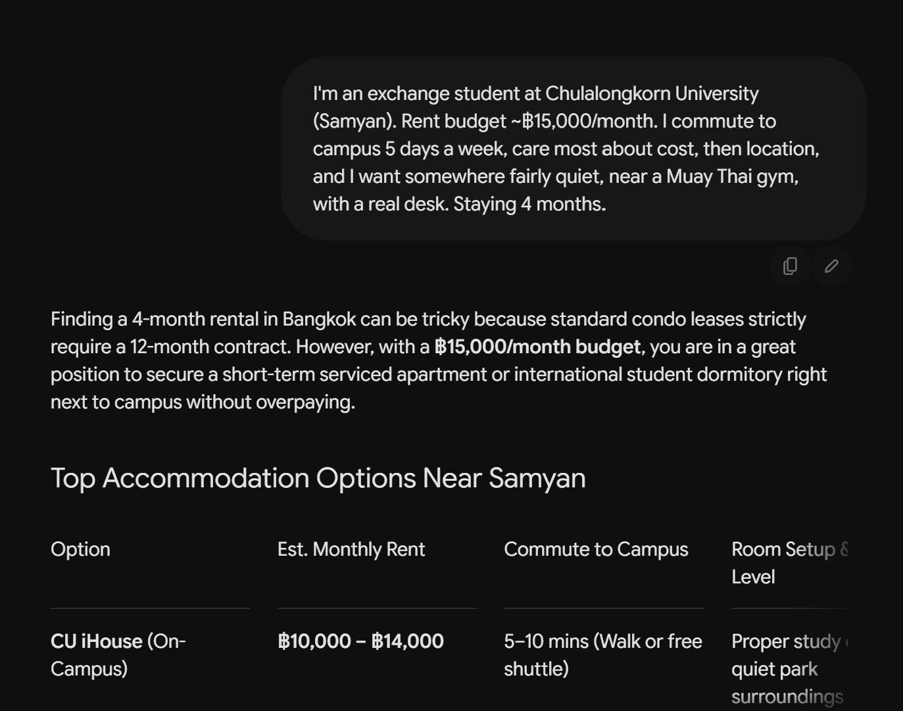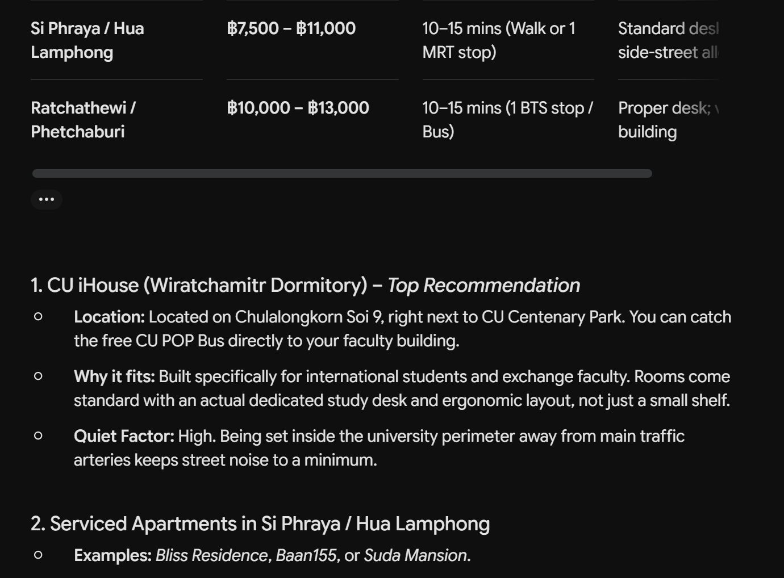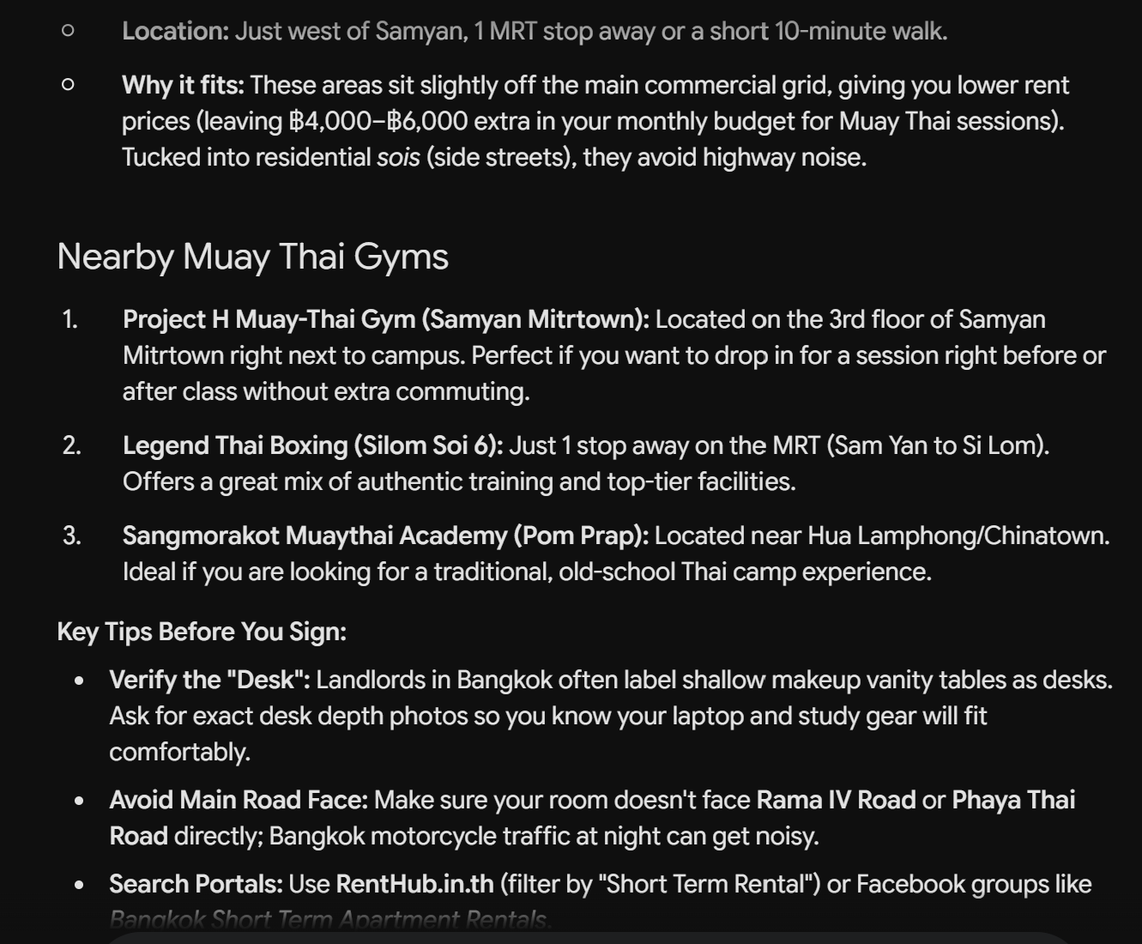
SiftPlace answer: #1 Samyan Campus Studio — ฿16,580/mo (฿14,000 rent + ฿2,580 commute), ~2.1 h/mo on the road, 92% match, quiet, gym 400 m, desk, 3 min to campus. #2 Phrom Phong Social Pod — ฿13,085/mo (฿8,900 rent + ฿4,185 commute), ~6.5 h/mo, 76% match. Plus the trade-off in plain terms: living near campus costs ~฿3,495/mo more but saves ~6.5 h/mo — break-even if your time is worth ≥฿540/h.
Criterion (what actually decides a good stay) | Raw LLM | SiftPlace
Personalised to the user's stated weights (cost > location > living) | 0 | 2
True monthly cost = rent + commute fare | 0 | 2
Time cost (hours per month on the road) | 0 | 2
Live, verifiable data (real coordinates, distances, map) | 0 | 2
Reproducible (same input, same output) | 0 | 2
Transparent (sub-scores, what was met and unmet) | 1 | 2
Actionable (a specific place you can open and book) | 0 | 2
Free-text nuance (“quiet, Muay Thai, real desk”) | 2 | 1
Newcomer orientation (explains the city conversationally) | 2 | 1
Speed to a first answer, zero setup | 2 | 1
TOTAL (of 20) | 7 | 17

Result: 17 vs 7 — a 2.4× gap on the axes that decide a good stay. The LLM wins only rows 8–10, where language and conversation matter, which is exactly why we embed an LLM in the “Anything else?” field and the mascot and use the deterministic filter for the ranking.
Reproducibility test: ask the LLM the same brief three times and the area list, ordering and emphasis change each run; it can also invent a building or a price. Run SiftPlace three times and the ranking and the ฿ figures are identical. LLM variance across runs: high. SiftPlace variance: zero. For a decision you make once and cannot undo, reproducibility is not a nicety, it is trust.
Being fair to the baseline: browsing-enabled LLMs improve rows 2–4 a little, but still will not consistently compute true monthly cost plus time, will not apply the student's weights, are not reproducible, and give no one-click booking. Our edge is a formula over live geodata, not a bigger model.

Appendix B — Tables
