Implementation & Deployment Guide
Windows-first local demonstration runbook
Real-Time Financial Fraud Detection Platform
Prepared by: Arham Kelkar | Institution: Dr. D.Y. Patil School of Science and Technology | Date: 26 October 2026
Scope note This guide documents the previously verified Windows Docker Compose demonstration. It does not claim production deployment or Kubernetes/Minikube verification.

1. What the system demonstrates
The platform scores label-free transaction events, stores scored cases, exposes an analyst review queue, and generates data-drift reports. The demonstration uses a chronological replay of 1,000 historical transactions from the IEEE-CIS workflow; it is not a live bank feed.
- Offline modelling: class-weighted XGBoost and a GraphSAGE model built from card/device profile relationships, blended at 95% XGBoost and 5% GraphSAGE.
- Streaming demo: JSONL replay producer → Kafka topic transactions.raw → consumer → FastAPI scoring service → transactions.scored and case database.
- Human review: Streamlit dashboard displays higher-risk cases and supports analyst status, label, and note feedback.
- Monitoring: Evidently HTML report plus a separate custom PSI trigger check; a retraining marker is only a request, not an automatic model replacement.
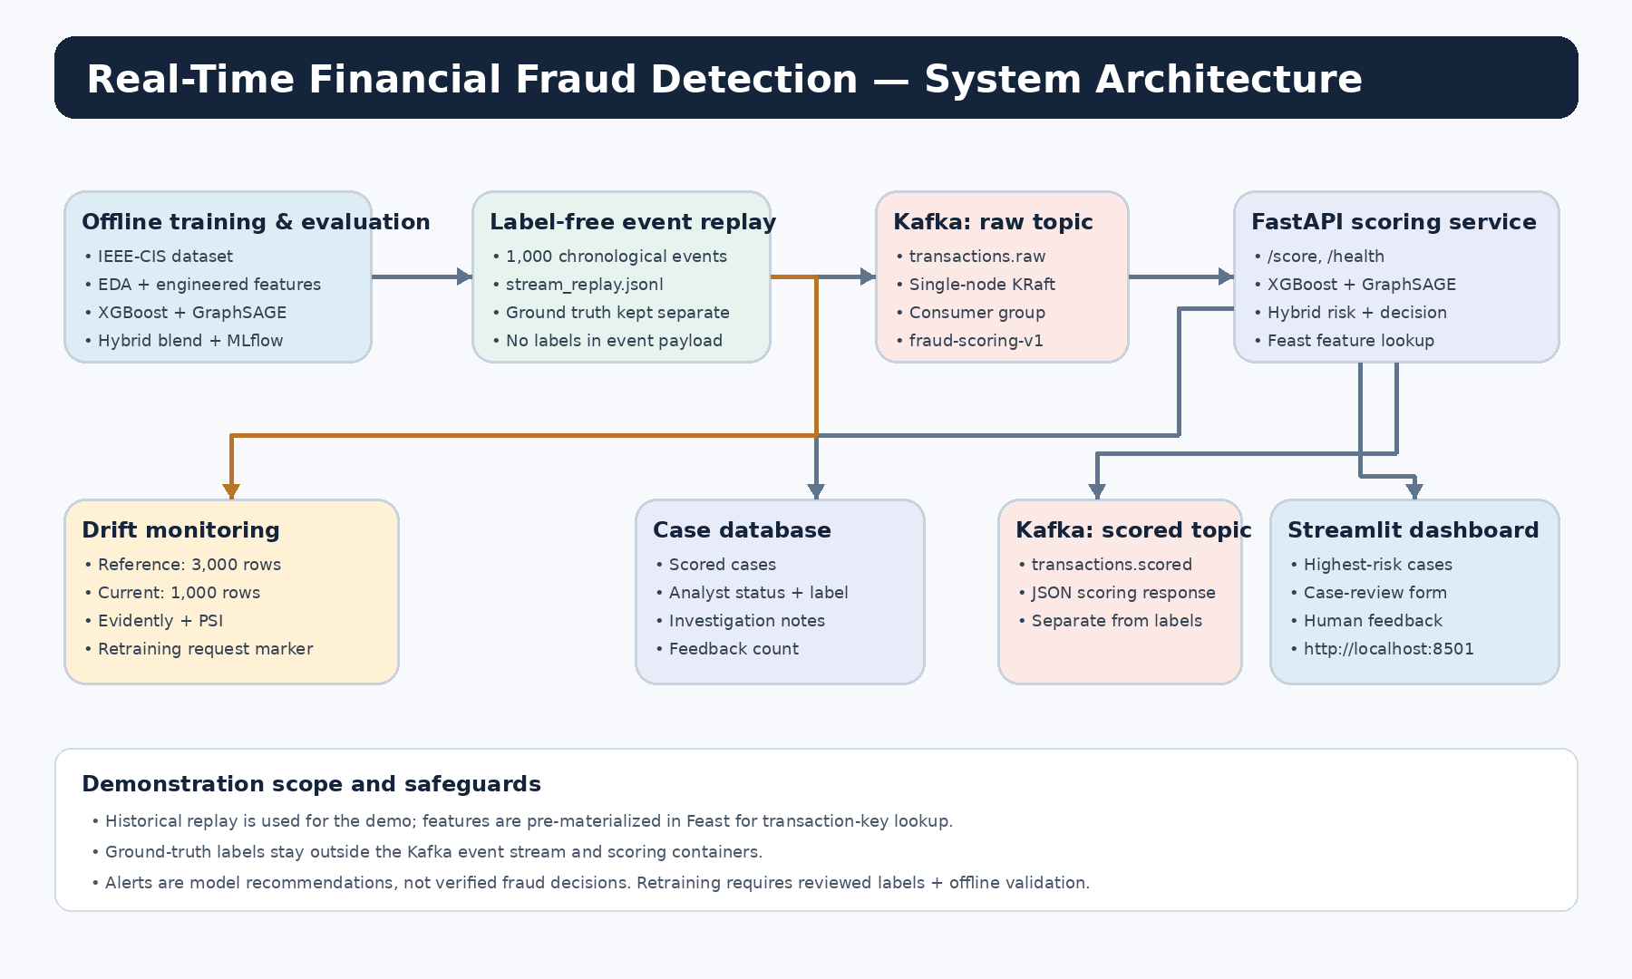
Figure 1. Verified local-demo architecture and data flow.

2. Verified environment and prerequisites
Item | Recorded environment / status
Operating system | Windows 10/11 environment; PowerShell used for commands.
Docker | Docker Desktop 4.96.3; Docker Engine 29.9.2; Docker Compose v5.6.1 recorded during verification.
Container runtime | Virtualization/WSL support was enabled; docker run hello-world completed successfully.
Project path | C:\Users\admin\Documents\AIML-01\fraud-detection-platform
Resource note | Docker reported about 3.77 GiB available memory in the recorded environment. First dependency build was slow; avoid rebuilding unless files changed.
Existing source backup | fraud_detection_submission_backup.zip was created locally and verified as 78 files / about 103.7 MB, with critical paths checked.

Before you start Keep the original project folder intact. Keep fraud_detection_submission_backup.zip as a separate backup. Do not delete Docker volumes or project data before your evidence and submission have been copied.

3. Start the local deployment

3.1 Open the project deployment directory
cd "C:\Users\admin\Documents\AIML-01\fraud-detection-platform\deployment"
docker version
docker compose version
docker compose config

The configuration command should finish without a YAML or interpolation error. If Docker Desktop is not running, open it and wait until the engine reports that it is ready.

3.2 Start services on a first build
docker compose up --build -d kafka feast-init api consumer dashboard

The first build may take a while because the image includes Python, machine-learning, FastAPI, Kafka, Feast, and dashboard dependencies. A later run with unchanged code can use the already-built images:
docker compose up -d kafka feast-init api consumer dashboard

3.3 Check service state and API health
docker compose ps -a
Invoke-RestMethod http://localhost:8000/health | ConvertTo-Json -Depth 5
Invoke-RestMethod http://localhost:8000/summary | ConvertTo-Json -Depth 5

In the verified run, the health endpoint returned status=ok and models_loaded=true. Feast initialization can show as exited with code 0 after it completes; that is a successful one-time initialization task, not necessarily a failed service. Kafka should be healthy, the API should be available, and the consumer/dashboard should be running.

4. Replay the 1,000-event demonstration
docker compose --profile tools run --rm producer

Expected producer confirmation from the recorded run: “Published 1000 transactions to transactions.raw via kafka:9092”. The consumer should then log scored transaction records. This is a historical, label-free replay; do not include offline ground-truth labels in Kafka payloads or scoring containers.
docker compose logs --tail 60 consumer
Invoke-RestMethod http://localhost:8000/summary | ConvertTo-Json -Depth 5

Recorded demo outcome After the replay, the dashboard/summary showed 1,000 transactions scored and 33 cases to review. One analyst feedback record was saved and remained present after the service restart. Confirmed-fraud and marked-legitimate counts were both zero; the model did not automatically adjudicate those cases.

5. Open the dashboard and review a case
- Open http://localhost:8501 in a browser. Wait for the Streamlit dashboard to load and confirm that the API is reachable.
- Show the summary cards: transactions scored, cases for review, confirmed fraud, marked legitimate, and feedback count.
- Open the highest-risk cases table. Choose one record from the displayed queue; use a non-sensitive demo record only.
- Use the dashboard review controls to record the available analyst status/label and a brief note. Save the feedback.
- Refresh the dashboard or call the summary endpoint and confirm the feedback count increments. The previous verified run showed feedback_count=1 after restart.
# Optional: confirm the API summary after saving a review
Invoke-RestMethod http://localhost:8000/summary | ConvertTo-Json -Depth 5
# Interactive API documentation
# Open this address in your browser:
http://localhost:8000/docs

API endpoints documented for the project: GET /health, GET /summary, POST /score, GET /cases?limit=500, PATCH /cases/{transaction_id}, and GET /docs. Use the Swagger UI at /docs to inspect the exact request schema for POST /score; do not invent a JSON payload.

6. Run drift monitoring
docker compose --profile tools run --rm drift-monitor

The recorded run compared a 3,000-row reference sample with a 1,000-row current replay sample over 435 features. It generated the Evidently HTML report and the custom PSI CSV successfully (evidently_error=null).
Monitor output | Recorded result | Interpretation
Evidently | 98 / 435 columns flagged (22.529%); dataset-level drift was not detected at the configured 0.5 threshold. | Column-level flags and dataset-level drift are separate outputs.
Custom PSI | 37 / 435 features had PSI ≥ 0.25; share = 8.51%. Trigger share = 10%. | The retraining trigger did not activate: retraining_requested=false.
Artifacts | reports/models/evidently_data_drift_report.html; reports/models/feature_drift_psi.csv; deployment/runtime/retrain_trigger.json | Open the HTML report in a browser and retain all three files as evidence.

Interpret the two drift results separately Evidently statistical drift and the custom PSI trigger use different tests and thresholds. Do not combine their percentages into one number. Non-fatal SciPy divide-by-zero RuntimeWarnings appeared, but report generation completed and evidently_error was null.

7. Model results to report
Model | Test Average Precision | Test ROC-AUC | Precision | Recall | F1
XGBoost | 0.2333 | 0.7763 | 0.3374 | 0.2413 | 0.2814
GraphSAGE | 0.1810 | 0.7970 | 0.2136 | 0.3789 | 0.2732
Hybrid (0.95 / 0.05) | 0.2452 | 0.8155 | 0.2325 | 0.4093 | 0.2965

Average Precision is used as the PR-AUC summary. Precision, recall, and F1 are measured at thresholds selected using validation data. The hybrid improved test Average Precision by about 5.1% relative to XGBoost alone. These are offline test results, not a guarantee of future or production performance.

8. Evidence capture checklist
- ☐ Docker Compose service list showing Kafka healthy, API healthy, consumer and dashboard running; note Feast init may have exited successfully.
- ☐ API /health response with models_loaded=true and /summary response after the replay.
- ☐ Producer terminal output showing 1,000 events published, followed by consumer logs showing scored transaction records.
- ☐ Streamlit dashboard showing 1,000 scored transactions and 33 review cases.
- ☐ One analyst review interaction and a subsequent summary showing the feedback count.
- ☐ Evidently HTML report header/summary and the custom PSI results showing 37/435 features and 8.51% below the 10% trigger.
- ☐ Model comparison table or slide containing the held-out test metrics and validation-threshold note.

9. Troubleshooting and safe shutdown
Symptom | What to do
Kafka is not healthy | Run docker compose ps -a and docker compose logs --tail 100 kafka. Wait for health check, then re-check before replay.
Consumer exits/restarts | Inspect docker compose logs --tail 100 consumer. The previously observed restart issue was traced to a zero consumer_timeout_ms setting; it was removed from deployment/app/consumer.py and the consumer image was rebuilt. Only repeat that code fix if the same issue is present.
API models_loaded=false | Check model artifact paths and API logs. Do not claim scoring is operational until /health reports the expected model-load state.
Dashboard cannot reach API | Confirm API container is healthy and open http://localhost:8000/health from the host browser.
Slow or failed image build | Check Docker Desktop memory/disk availability and build logs. Avoid rebuilding all images when no code/dependency files changed.

# Stop containers but preserve project files and named volumes
docker compose stop

Do not use docker compose down -v or prune commands before the submission evidence and backup are secured. The named Kafka volume can contain demo state. When finished, quit Docker Desktop only after containers have stopped.

10. Boundaries and claims you must not make
- This is a local Docker Compose demonstration, not a production-grade payment system.
- The 1,000 events are a historical replay, not live traffic. Ground truth was kept separate from the scoring stream.
- A risk score or “review” decision is a prioritization recommendation, not a confirmed fraud finding or calibrated probability.
- GraphSAGE relationships use card/device profile proxies and are not verified fraud-ring identities.
- Feast online features in the demo were materialized from label-free replay feature rows; production should compute and write features as events arrive.
- The PSI monitor can write a retraining request marker, but reviewed labels, offline validation, approval, and rollback are required before model promotion.
- Kubernetes manifests are starter materials only. Kubernetes/Minikube deployment was not verified.
- Authentication, authorization, secrets management, high availability, load testing, production latency, and security hardening were outside the verified demo scope.
End of implementation guide.

