AIML-01 / PROJECT SUBMISSION

System Architecture & API Documentation
Real-Time Financial Fraud Detection Platform
Prepared by: Arham Kelkar • Date: 26 October 2026
Institution: Dr. D.Y. Patil School of Science and Technology

1. Executive summary
This project demonstrates a research-oriented fraud-risk scoring workflow built with the IEEE-CIS Fraud Detection dataset. A class-weighted XGBoost model is blended with a GraphSAGE graph model. A FastAPI service serves scores; Kafka carries label-free transaction events; Feast provides the demo feature lookup; a Streamlit dashboard supports analyst review; and Evidently plus a custom Population Stability Index (PSI) threshold provide drift monitoring.
Scope statement Model alerts are recommendations for investigation, not confirmed fraud determinations. The current demo is a local, single-node setup and is not production-hardened.

2. Dataset and preparation
Audit item | Observed value
Transaction rows | 590,540
Identity rows | 144,233
Transaction columns | 394
Identity columns | 41
Fraud records | 20,663
Legitimate records | 569,877
Fraud rate | 3.499%
Transaction-to-identity coverage | 24.424%
Scoring/replay features | 435

EDA identified a highly imbalanced binary classification task. Feature engineering includes transaction amount and velocity-related fields and entity/profile fields used by the graph component. The event stream is chronological and label-free. The offline ground-truth CSV is kept separate for evaluation and must not be passed into the scoring containers or Kafka events.

3. Modeling approach
- XGBoost baseline: class weighting addresses fraud-class imbalance; validation data is used for threshold selection.
- GraphSAGE baseline: PyTorch Geometric implementation over a graph built from card/device profile relationships. These are relationship proxies, not definitive fraud-ring labels.
- Hybrid detector: validation-set average-precision selection chose a blend of 95% XGBoost and 5% GraphSAGE.
- MLflow tracking: XGBoost baseline, GraphSAGE baseline, and hybrid runs were logged; configuration and metrics are retained under the project reports/model artifacts.

4. Offline model evaluation
Model | Test Average Precision | Test ROC-AUC | Precision | Recall | F1
XGBoost | 0.2333 | 0.7763 | 0.3374 | 0.2413 | 0.2814
GraphSAGE | 0.1810 | 0.7970 | 0.2136 | 0.3789 | 0.2732
Hybrid blend | 0.2452 | 0.8155 | 0.2325 | 0.4093 | 0.2965

Precision, recall and F1 above are reported at thresholds selected on validation data, then evaluated on the held-out test set. Average Precision is used as the PR-AUC summary. The hybrid improved test Average Precision by about 5.1% relative to XGBoost alone and increased recall, while the precision/recall trade-off remains a model-selection decision rather than a production policy.
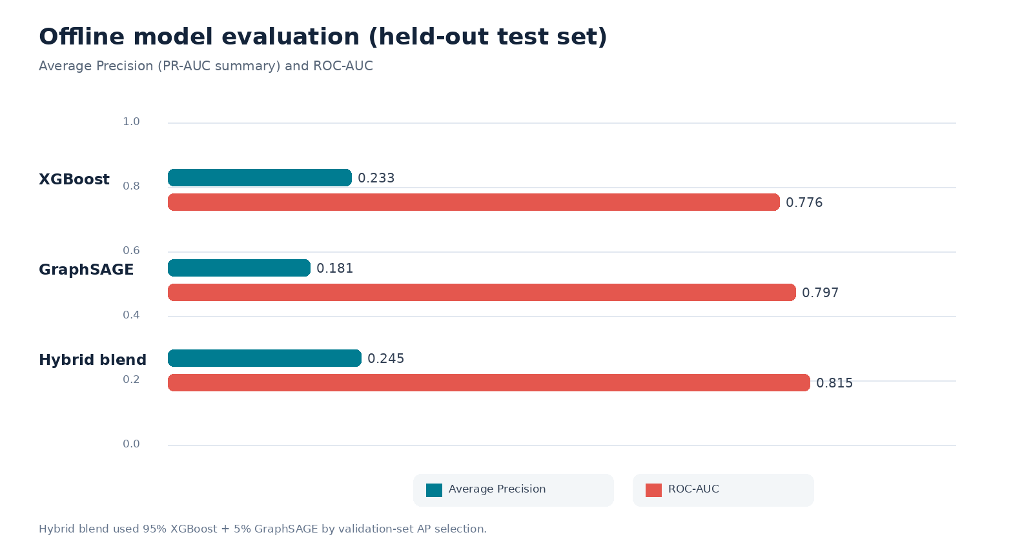

5. System architecture and data flow
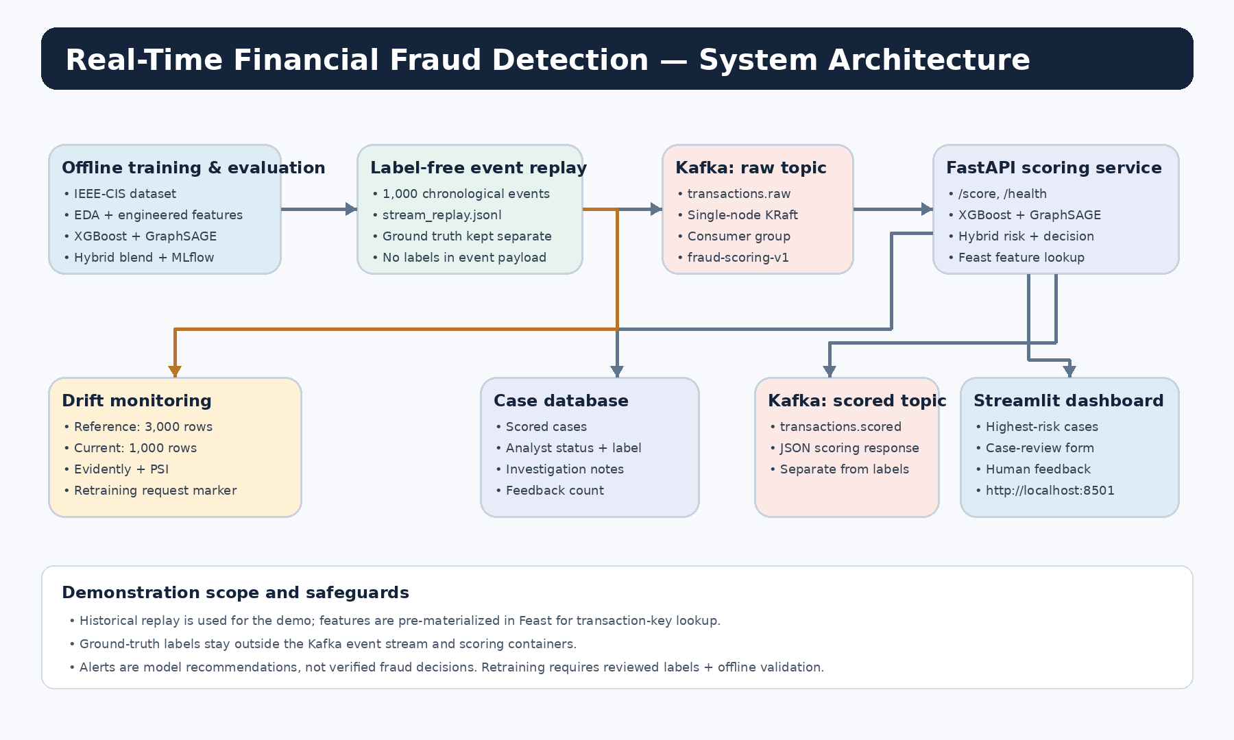
The local pipeline is: label-free JSONL replay producer → Kafka topic transactions.raw → consumer → FastAPI /score → scored event to transactions.scored and persisted case record → Streamlit analyst dashboard. The drift-monitor tool compares a baseline reference sample with the current replay sample, writes an Evidently HTML report and PSI table, and saves a retraining-request marker when the configured threshold is crossed.

6. Local API endpoints
Method / endpoint | Purpose | Validation/use
GET /health | Service health and model-load state | Expected status ok and models_loaded true
GET /summary | Aggregate scored/case/feedback counts | Used after replay and feedback
POST /score | Score one transaction event | Returns risk scores and decision; request schema available at /docs
GET /cases?limit=500 | List stored cases for review | Dashboard loads the highest-risk cases
PATCH /cases/{transaction_id} | Update case review metadata | Dashboard saves case status, analyst label, and notes
GET /docs | Interactive OpenAPI docs | Open http://localhost:8000/docs

7. Local setup and repeatable demo
- Open PowerShell in the deployment directory: <project-root>\deployment.
- Validate Compose: docker compose config.
- Build and start services on first run: docker compose up --build -d kafka feast-init api consumer dashboard.
- Check: docker compose ps -a; then call http://localhost:8000/health and http://localhost:8000/summary.
- Replay 1,000 events: docker compose --profile tools run --rm producer.
- Open dashboard: http://localhost:8501; API docs: http://localhost:8000/docs.
- Run drift check: docker compose --profile tools run --rm drift-monitor.
- Stop services without removing project files: docker compose stop. Do not remove the named Kafka volume until its data is no longer required.

8. Feature store and deployment caveats
- For this demonstration, Feast online features are materialized from the same label-free replay feature rows keyed by transaction ID. Production ingestion should compute features when each transaction arrives and write them to Feast before scoring.
- The graph uses card/device profiles as relationship proxies. These edges can create leakage or overgeneralization if used without careful temporal validation in a real setting.
- The drift monitor can request retraining but must not automatically replace a model. Reviewed labels, offline validation, approval, and rollback are needed before model promotion.
- Docker Compose and single-node Kafka KRaft are local demo infrastructure. Authentication, authorization, secrets management, HA, resource limits, and production observability are outside the current verified scope.

9. Repository / deliverable map
Path group | Contents
models/baseline/ | XGBoost JSON model, GraphSAGE weights, feature schemas, graph preprocessing/state
reports/models/ | Model metrics, predictions/comparison, drift PSI CSV, Evidently HTML, serving config, MLflow artifacts
reports/eda/ | Exploratory analysis outputs
data/processed/ | Label-free stream replay, Feast features, reference features; ground truth for offline evaluation only
deployment/ | Docker Compose, API/consumer/producer, dashboard, Feast bootstrap, drift monitor, starter Kubernetes manifests
01_Screenshots in evidence pack | Runtime proof: dashboard, case-review scores, API summary, and drift report

