/Home/ Page
Meta Title: ITAD & Refurbished IT Equipment Supplier Malaysia | EasyConnect
Meta Description: Easy Connect Solutions offers refurbished enterprise IT equipment and ITAD and e-waste recycling solutions to multiple industries in Malaysia.



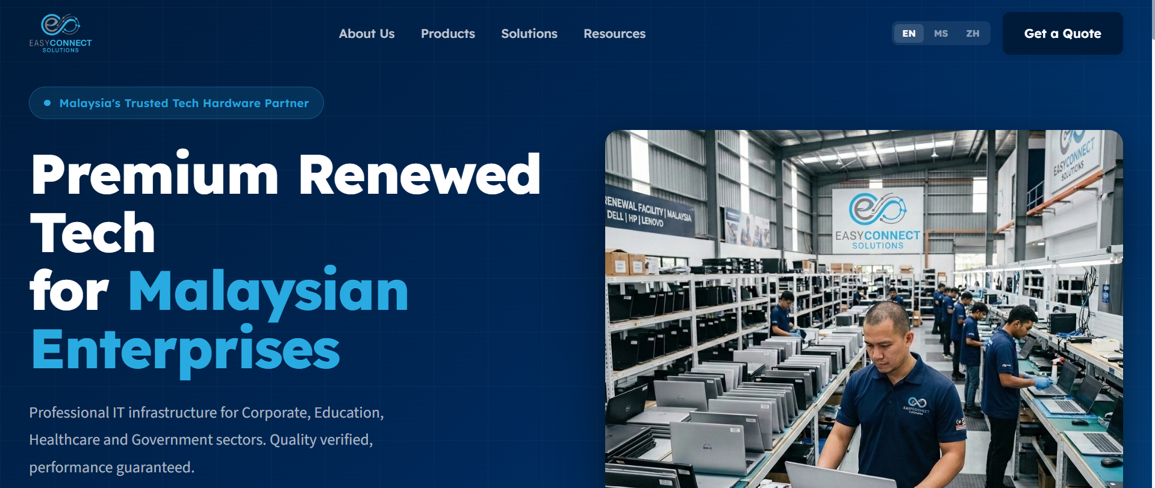
Malaysia's Trusted IT Equipment Partner


Premium Refurbished Laptops & IT Infrastructure Solutions for Malaysian Enterprises
Malaysia’s qualified IT hardware supplier, providing refurbished laptops, desktops, workstations and enterprise IT equipment to corporate, education, healthcare, government and public sectors.
Button: Explore product range
Button: Explore IT Solutions

Enterprise IT Lifecycle Management Solutions
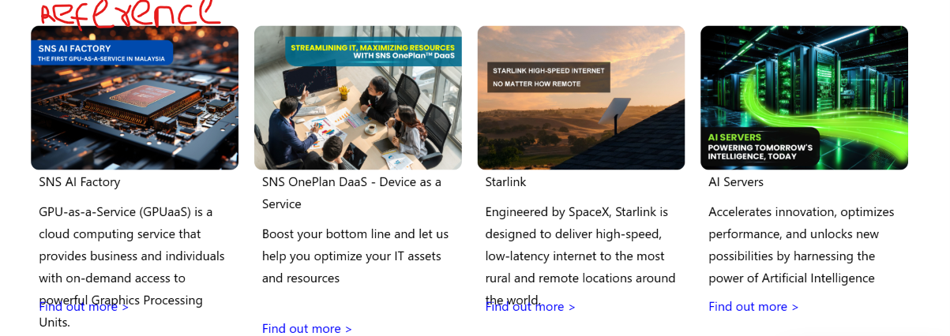

Data Wiping & IT Asset Disposition (ITAD) by Certified Partners
Secure data destruction and compliant IT asset disposal services that protect sensitive information while maximizing asset recovery value.

Sustainable E-Waste Management
Responsible electronic waste recycling solutions that help organizations create environmental impact and support sustainability goals.

Corporate IT Equipment Leasing
Flexible device rental options that provide access to enterprise-grade equipment without significant upfront investment.

Bulk IT Equipment Procurement
Cost-effective sourcing of Grade A enterprise hardware in Malaysia for organizations of all sizes.

IT Asset Buyback & Value Recovery
Recover value from retired IT equipment through secure buyback programs and asset lifecycle management.

Industries We Serve
Helping organizations across Malaysia reduce IT costs without compromising performance.
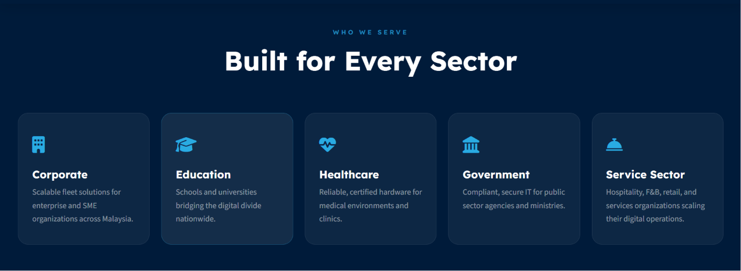

Corporate
Large-scale device procurement for SMEs across Malaysia.

Education
Educational institutions' device solution to bridge the digital divide nationwide.

Healthcare
Specialized IT equipment for a healthcare IT infrastructure relying on high-speed computing.

Government
Compliant and secure government hardware for agencies and ministries.

Service Sector
Retail checkout devices, hospitality IT equipment and much more for organizations scaling their digital operations.

The EasyConnect Difference


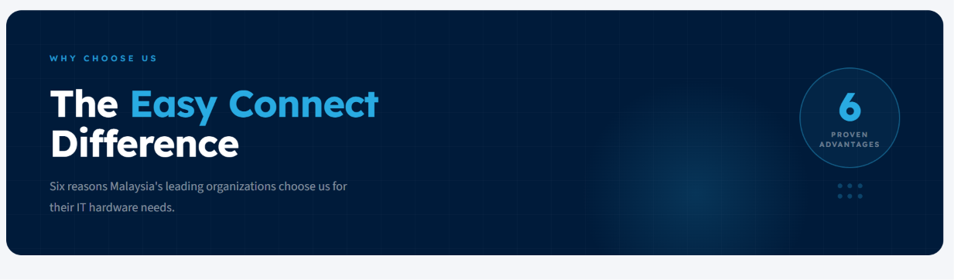
2 circles:
-worked with 46 companies
-359 satisfied customers
Reasons Malaysia's leading organizations choose us for their IT hardware needs.
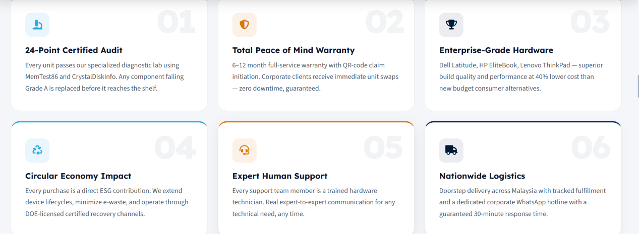

Reviews
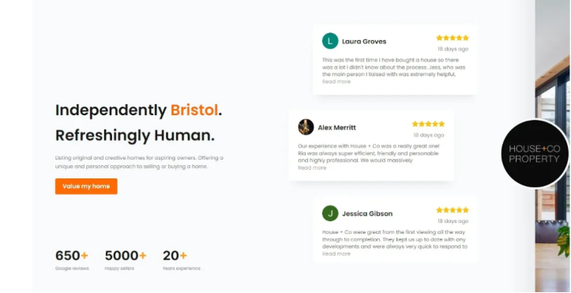
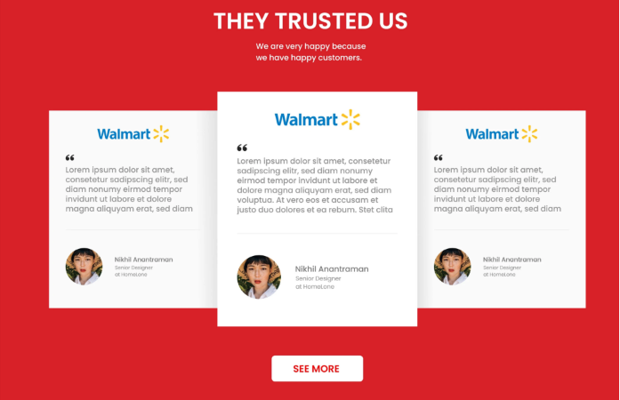

Let's Build a Smarter IT Strategy for Your Organization
From bulk procurement to secure data disposal, our specialists are ready to help you reduce costs and stay compliant.
Button: Contact Us Today

/About Us/ Page
Meta Title: Malaysia’s warranted IT equipment and sustainability specialist
Meta Description: Refurbished IT hardware supplier in Malaysia offering ITAD and e-waste management solutions, helping industries reach their sustainability goals.



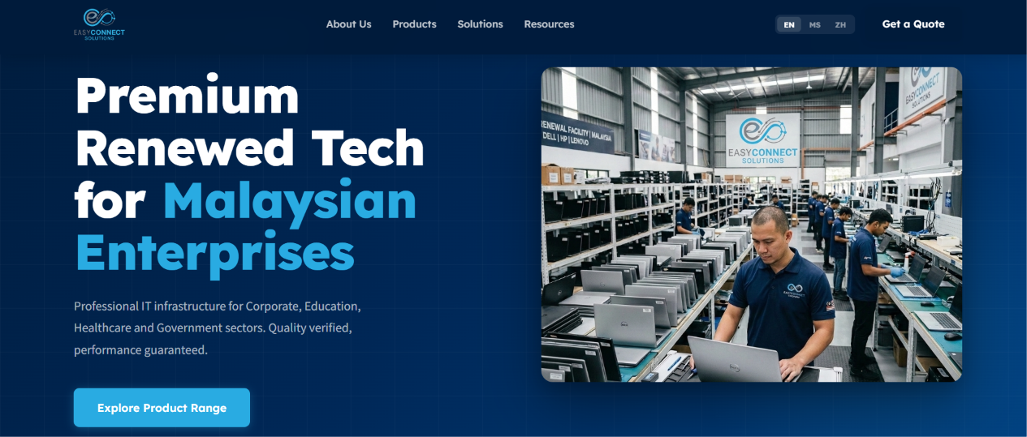


Malaysia’s Enterprise IT Hardware Specialists
End-to-end IT lifecycle solutions, with secure data wiping and disposal carried out through certified partners, helping businesses extend asset value through secure, compliant and sustainable lifecycle solutions.
Button: Explore our Services

Who We Are

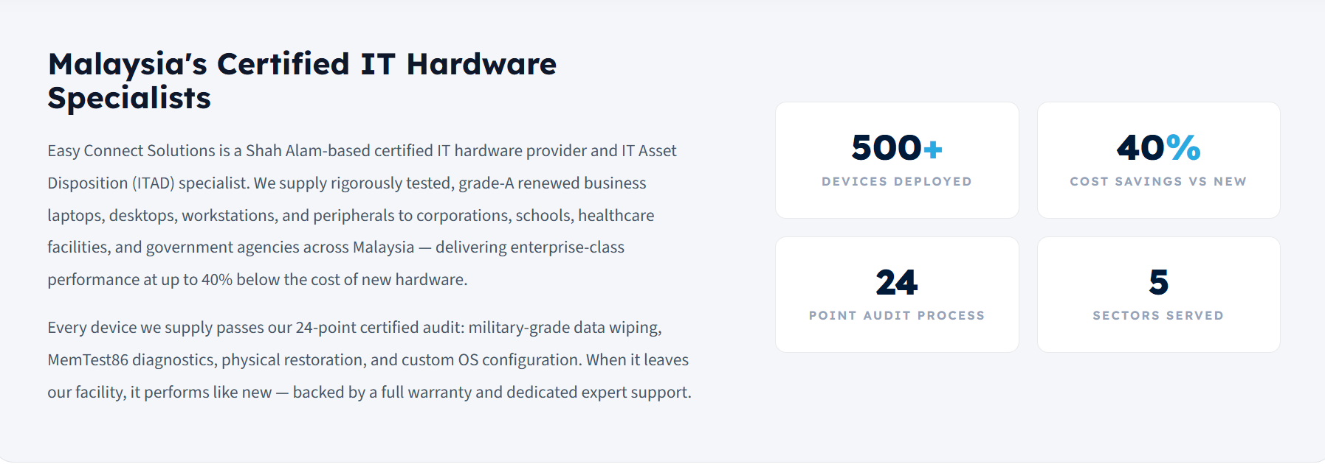
Easy Connect Solutions is a Kuala Lumpur-based qualified IT hardware supplier and IT Asset Disposition (ITAD) service specialist. We provide rigorously tested, grade-A refurbished laptops, desktops, workstations and peripherals.
Every device we supply passes our 24-point verified audit: military-grade data wiping, MemTest86 diagnostics, physical restoration and custom OS configuration before deployment. When it leaves our facility, it performs like new - backed by a full warranty and dedicated expert support, helping organizations reduce IT costs while supporting sustainability goals.

Vision, Mission & Values


Leading Malaysia's circular technology economy - where premium IT hardware meets sustainable business practices.


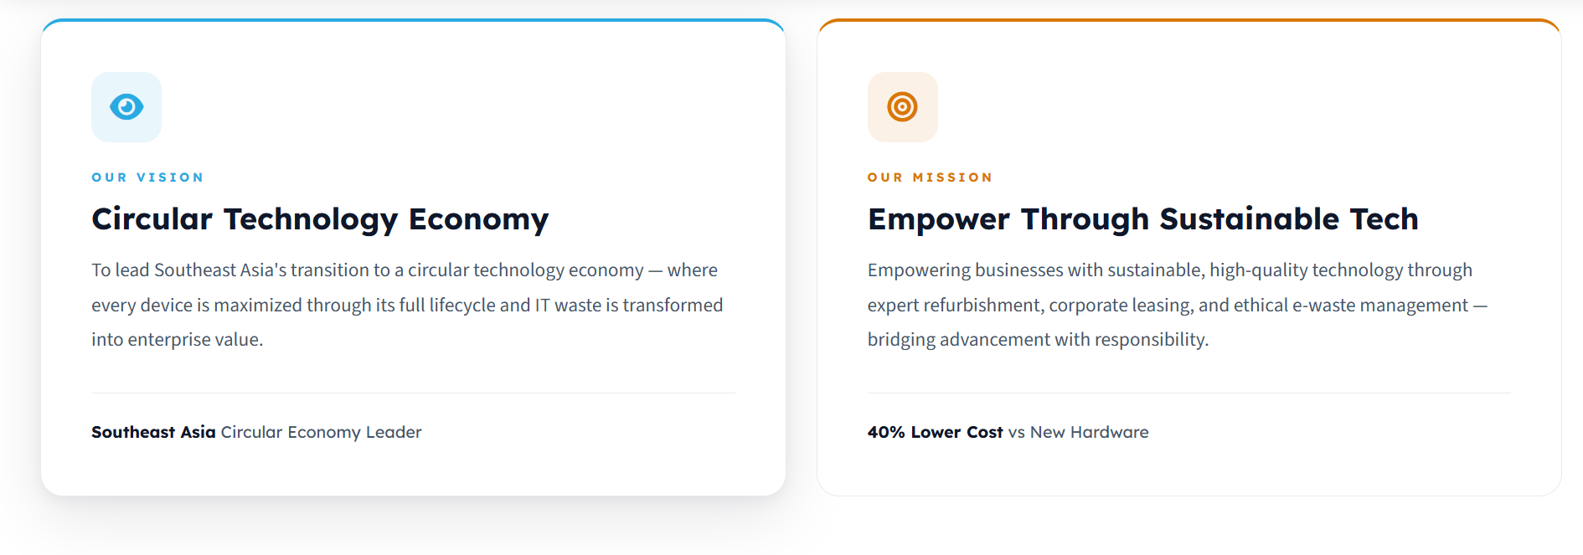

Our Vision

Building a Smarter Circular Technology Future

To lead Southeast Asia's transition toward a circular technology economy, where enterprise IT assets are continuously reused, refurbished and repurposed to maximize value, reduce e-waste and support sustainable transformation for businesses and institutions.

Our Mission

Empowering Organizations Through Sustainable Technology
To deliver reliable, enterprise-grade technology solutions through extending the lifecycle of technology assets, protecting data integrity and supporting circular economy principles responsible for e-waste management.
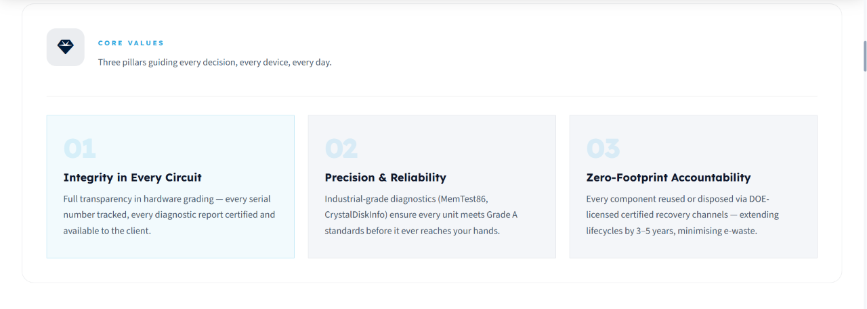

Core Values

Integrity in Every Circuit
Complete transparency in grading hardware - every serial number tracked, every diagnostic report verified and made available to the client.

Precision & Reliability
Industrial-grade diagnostics (MemTest86, CrystalDiskInfo) to ensure every unit meets Grade A standards before it ever reaches you.

Zero-Footprint Accountability
Every component reused via DOE-licensed recovery channels extending the device’s lifespan by 3-5 years, promoting e-waste recycling.

Brands We Carry

Audit Standard Process
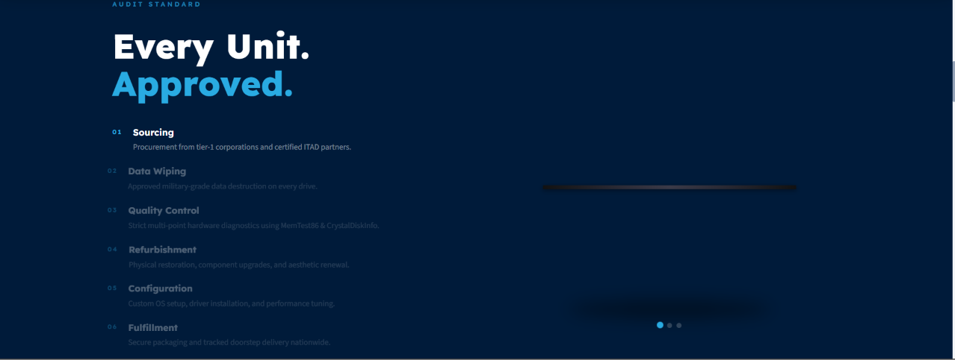




Whether you’re looking for the best corporate leasing solutions, need refurbished IT equipment, secure IT asset disposal, or require sustainable e-waste management, our team is ready to help.
Contact us today to discuss your organization's technology requirements and receive a tailored solution.
Button: Get in Touch

/Products/ Page
Meta Title: Warranted Refurbished Laptops Malaysia | Grade A Business Hardware
Meta Description: Equip your business with Grade A refurbished hardware in Malaysia. Buy or rent for a cost-effective solution without compromising performance.






Certified Refurbished Hardware for Malaysian Businesses
Supply your organization with Grade A refurbished IT equipment. From 10-unit office deployments to 500+ unit IT Refresh Cycles across Malaysia, we will take care of it all.
Button: Buy or Rent

Whether you need a single laptop or a fleet of devices, we offer flexible purchase and rental options to suit every requirement. Our professionally refurbished laptops, desktops, workstations and accessories are available for bulk deployments or individual purchases through our retail and e-commerce brand, TechRevelo. We also help organizations recover value from retiring IT assets through our buyback services. Where supported, devices can be customized to your requirements, including RAM and storage upgrades, operating system deployment and other configuration services. Every device is thoroughly tested, professionally restored and backed by an extendable warranty of 6-12 months.

Why Malaysian Businesses Choose Refurbished
Grade A refurbished hardware is not a compromise; it is a strategic procurement decision. Here's why Malaysian organizations across corporate, education, healthcare and government sectors are making the switch:

Cost Efficiency Without Performance Compromise
Enterprise-grade business laptops from major brands like Dell, HP and Lenovo, Acer and Toshiba retain 60-80% of their performance capability for 5-7 years of operation. That means you acquire proven hardware with stronger build quality, better keyboards and longer security patch lifecycles at prices up to 40% lower than new alternatives with equivalent specifications.

Predictable Quality
Every device in our product range passes a documented 24-point diagnostic audit: CPU stress testing, RAM validation via MemTest86, storage health verification through CrystalDiskInfo, physical inspection for cosmetic condition and battery health assessment. This diagnostic trail is your quality assurance. Units that fail any criteria are rejected or replaced before they reach you.

Responsibility
Buying refurbished directly extends device lifecycles by 3-4 years, displacing the manufacturing carbon cost of new hardware production. This contribution is observable and significant for companies that comply with ESG goals or Bursa Malaysia sustainability reporting requirements.

Browse by Organizational Needs
From corporate laptops to specialized engineering workstations.
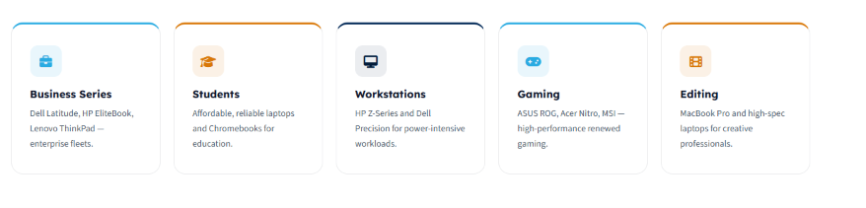

Business Series
MIL-SPEC tested, enterprise-standard security features and multi-year support lifecycles. Designed for corporate office deployments, remote workforce expansion and simplified IT asset management.

Education & Students
Affordable refurbished laptops and managed Chromebooks for schools, universities and training centres across Malaysia.

Workstations
HP Z-Series, Lenovo P-Series and Dell Precision and XPS workstations for engineering, architecture, 3D rendering and data science workloads. Xeon processors, ECC RAM and ISV-certified NVIDIA Quadro GPUs - laboratory-grade hardware at 30-40% below new list prices.

Gaming & High-Performance
Stress-tested and verified GPUs for esports training centres, game development studios and GPU-intensive research workloads. RTX CUDA - capable for machine learning and data science applications.

Creative & Editing
MacBooks and high-spec Windows alternatives for video production, graphic design and content creation teams. Accurate color displays, verified battery health and optimized performance under immense rendering loads.

Our Product Range
Categories of warranted, refurbished hardware - sourced, audited and ready to deploy.
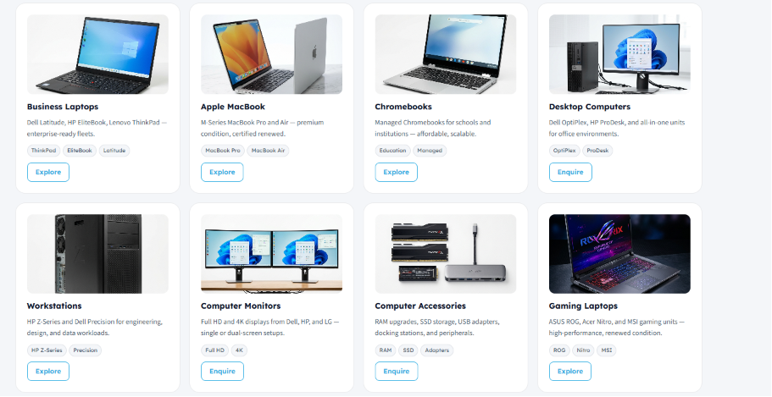

Our Multi-Point Audit Process
Every device passes a rigorous 24-point quality gate before certification. Here is what we verify:

Step 1 - Hardware Diagnostics
Processor stress-testing to verify sustained clock speeds under load. RAM validation using MemTest86 for data integrity. Storage health assessed via CrystalDiskInfo, checking for SMART failures and bad sectors. Motherboard BIOS POST verification.

Step 2 - Data Security
All data is securely wiped by our certified data destruction partners before any device leaves your premises, ensuring no information remains on the hardware.

Step 3 - Physical Inspection
Screen tested for dead pixels, brightness uniformity and color accuracy. Chassis and hinges checked for structural integrity. Keyboard and trackpad function validated. All ports tested (USB, HDMI, audio jack). Battery tested for capacity and charge retention.

Step 4 - Configuration & Deployment
Windows 11 Pro or an appropriate OS installed and licensed. All drivers downloaded and verified. Device benchmarked to confirm performance baseline. Asset tag applied for fleet tracking. Ready to deploy upon arrival at your premises.

Pricing That Makes the Business Case Clear
Refurbished hardware pricing varies by brand, generation, hardware configuration, cosmetic condition and stock availability. On average, organizations save 30-40% compared to new equivalent hardware:

Category | Typical Specifications | Renewed Price (Approx.) | New Price (Approx.) | Estimated Savings
Entry-Level Business Laptop | Intel Core i5, 10th Gen, 8GB RAM, 256GB SSD | RM 1,000-1,200 | RM 1,500-1,700 | Up to 33%
Mid-Range Business Laptop | Intel Core i7, 11th Gen, 16GB RAM, 512GB SSD | RM 1,800-2,200 | RM 2,800-3,400 | Up to 35-36%
Executive Level Laptops | Intel Core Ultra 5, 16GB RAM, 1TB SSD | RM 3,000-3,500 | RM 5,000+ | Up to 40%+
Premium Workstation | Intel Xeon, Intel Core i9, 32GB / 64GB RAM, 1TB / 2TB SSD. | RM 4,000+ | RM 6,000+ | Up to 33%+

Ready to Equip Your Organization?
Tell us your team size, required specifications, or device model preference. We provide a formal quotation within 3 business days, with delivery available anywhere across Malaysia.
Button: Request a Quotation
If you’re unsure about your requirements, Speak with a Hardware Specialist.

/products/business-series/ Page
Meta Title:
Refurbished Business Laptops Malaysia | Dell HP Lenovo Grade A
Meta Description:
Dell Latitude, HP EliteBook, Lenovo ThinkPad - Grade A refurbished laptops for Malaysian corporate fleets. MIL-SPEC tested, bulk pricing starting from 10 units.



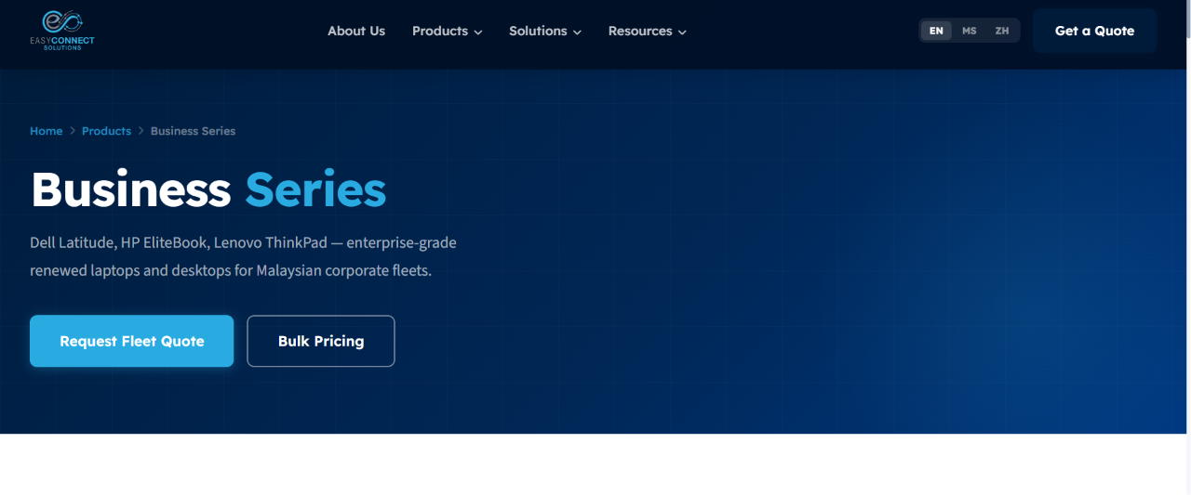

Refurbished Business Laptops for Malaysian Corporate Fleets
Dell Latitude, HP EliteBook, Lenovo ThinkPad, Acer Travelmate and Toshiba Dynabook - bulk business laptop supply to survive corporate deployments, at 30% less cost compared to new.

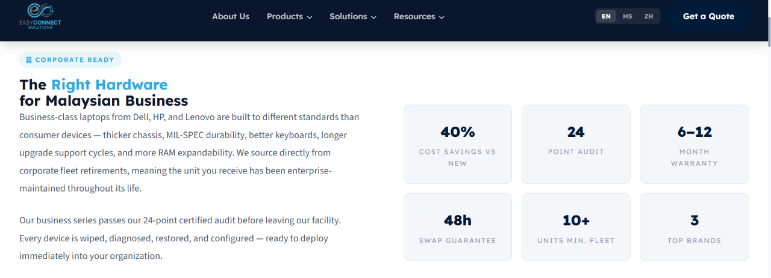
Corporate laptops are engineered to a different standard than consumer devices. Robust body structure for drop resistance, premium keyboards rated for a 10-year lifespan, TPM 2.0 security chips, vPro management capabilities and multi-year support availability. Our bulk business laptop supply in Malaysia is sourced from retired enterprise laptops that have been maintained by IT experts throughout their operational life. After passing our 24-point audit, they are ready to integrate into your organization's IT infrastructure.

Why Business-Grade Hardware Matters for Your Fleet

Built to Survive Daily Corporate Use
MIL-STD-810G tested for vibration, humidity and drop resistance. For organizations with mobile workforces, field-based roles, or training environments where devices move frequently, this durability translates directly to lower failure rates and longer fleet lifecycles. A business laptop simply lasts longer under operational stress than consumer alternatives.

Enterprise Security Integrated From Factory
TPM 2.0 (Trusted Platform Module) for encrypted credential storage. Intel vPro or AMD Pro management for remote IT administration. BIOS-level security features for malware resistance. Consumer laptops lack these capabilities; their deployment into managed environments becomes an after-purchase configuration challenge.

Consistent Fleet Specification = Manageable IT
One of the highest costs in fleet IT is managing variance in different RAM configurations, different BIOS versions and different processor generations all behaving unpredictably under your MDM policies. We source to a single defined specification for your entire fleet and reject units that do not match.

Warranty & Professional Support
All refurbished business laptops carry a 6-12 month full-service extendable warranty. More importantly, for fleet clients, we offer a 72-hour swap guarantee: if a device develops a fault, we deliver a replacement unit before retrieving the failed device. Zero downtime for your organization.

Business Laptop Lines We Supply
Each series offers a distinct combination of performance, portability and durability for different business needs.


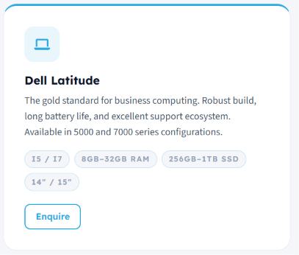

Dell Latitude
Dell has excellent keyboard and trackpad quality, superior display options (many with IPS or OLED) and Dell’s ProSupport ecosystem for enterprise clients.



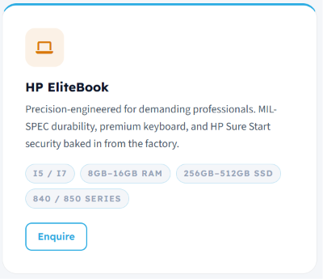

HP EliteBook
HP offers MIL-SPEC durability, premium keyboard quality (often rated higher than Dell), HP Sure Start BIOS protection and HP Wolf Security bundled on many models. The EliteBook 840 and 850 series remain popular across finance, legal and consulting sectors.

HP Elite Dragonfly
The HP Elite Dragonfly delivers ultra-light portability, all-day battery life and premium collaboration features for executives, remote professionals and frequent business travellers.

HP Spectre
HP Spectre is also available for professionals seeking premium design, high-resolution displays and strong performance for executive and creative business workloads.

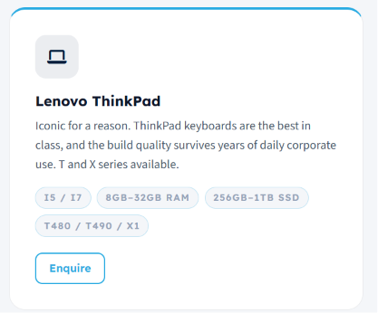

Lenovo ThinkPad
Lenovo ThinkPad devices survive years of daily corporate use without performance degradation. Build quality is exceptional.
T-series for mainstream business, X-series for ultraportable executive deployments, L-series for value-conscious large fleets.

Acer TravelMate - Reliable Business Performance
Lightweight, durable business laptops with dependable performance, long battery life and enterprise security features for everyday productivity.

FAQs

Which laptop screen size should I choose?
Choosing the right screen size depends on your daily workflow:
- 10"-12.5": Ultra-portable for travel and field work.
- 13"-14": Perfect for office professionals, hybrid workers and corporate deployments.
- 15"-16": More comfortable for extended work sessions and multitasking.
- 17": Ideal for creative professionals and users running demanding applications who rarely travel with their laptop.

What is the difference between a business laptop and a consumer laptop?
Business laptops are designed for professional use, offering stronger build quality, enhanced security features, longer product lifecycles, better serviceability and enterprise management capabilities. Consumer laptops prioritize entertainment and lower prices over durability and manageability.

Which business laptop brand is best: Dell, HP, Lenovo, Acer or Toshiba?
There is no single "best" brand. Dell Latitude, HP EliteBook/ProBook, Acer Travelmate, Toshiba Dynabook and Lenovo ThinkPad are all trusted business laptop families. The right choice depends on your budget, performance requirements, portability needs and preferred enterprise features.

Which processor should I choose for office work?
For everyday productivity, Intel Core i5 or AMD Ryzen 5 processors are ideal. Users running virtual machines, engineering software, programming tools or large spreadsheets may benefit from Intel Core i7/i9 or AMD Ryzen 7 processors.

How much RAM and SSD storage do I need?
For light use, 8GB RAM and a 256GB SSD is enough, but most business users need 16GB RAM and a 512GB SSD to provide excellent performance. Power users running multiple applications, virtual machines or creative software may require 32GB RAM or higher.

Can refurbished business laptops be upgraded?
Many Dell, HP, Acer, Toshiba and Lenovo models allow RAM and SSD upgrades, making them easy to customize as your business grows. Upgrade options vary by model.

Do refurbished business laptops come with a warranty?
Reputable refurbished IT suppliers provide warranties on Grade A devices. Warranty duration varies by supplier and model, so always check the coverage before purchasing.





Ready to refresh your corporate fleet?

Contact us with your specifications, unit count and timeline. We'll return a formal quotation within one business day.
Button: Reach Our Procurement Team

/products/students/ Page
Meta Title:
Refurbished Student Laptops Malaysia | Bulk School Supply
Meta Description:
Affordable Grade A refurbished laptops for schools, universities and institutions in Malaysia. Bulk pricing from 10 units, on-site delivery, institution invoicing available.



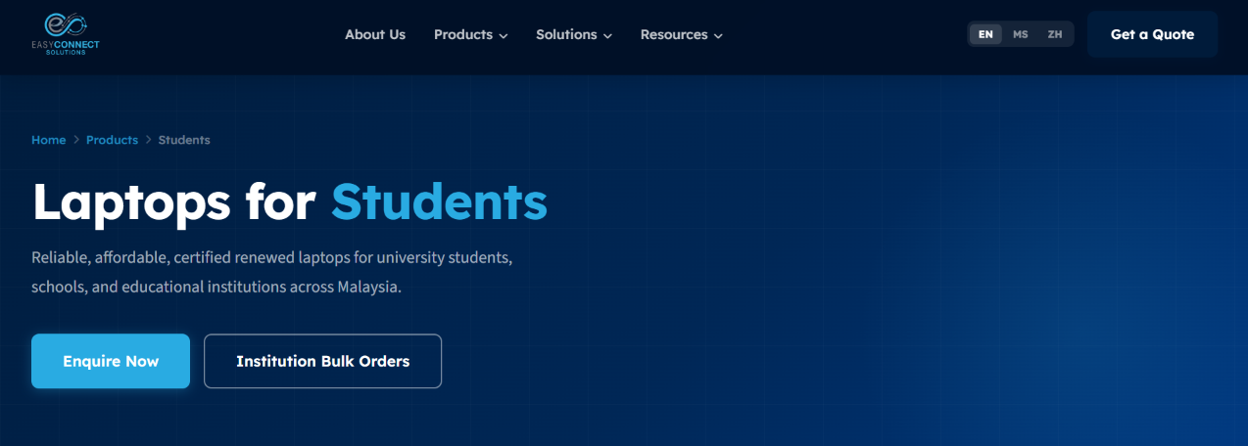

Affordable Refurbished Laptops for Malaysian Schools & Universities
Grade A refurbished devices at 30-40% below new cost, configured for educational institutions nationwide.


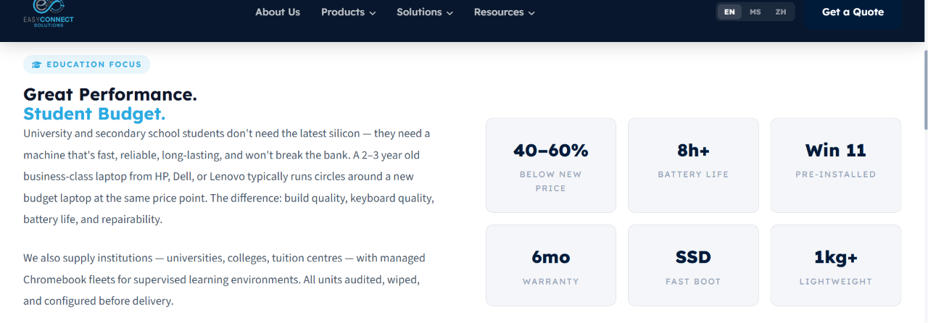


Educational institutions face a recurring challenge: equipping classrooms, labs and students with reliable and capable devices while respecting constrained technology budgets. A 5-year-old business laptop from brands like Dell, HP, or Lenovo, when grade A refurbished and professionally restored, delivers the performance students need for coursework, research, coding and video conferencing at a fraction of new device cost.
We supply bulk education laptops to schools, colleges, universities and training centres across Malaysia with refurbished hardware and managed Chromebook fleets.

Why Malaysian Educational Institutions Choose Refurbished

Budget Efficiency
Device budgets in education are constrained. Grade A refurbished laptops offer reliable quality at 30-40% reduced costs relative to the new devices that provide the same specifications. This provides extra money for software licensing, networking, or teacher training.

Consistent Classroom Specification
When it comes to equipping a lab or installing a technological system in a classroom, consistent specifications across all devices are essential. We set up computer labs where each computer has the same memory, storage and processing power.

Managed Chromebook Fleets for Google Workspace
Managed Chromebooks work best for schools that are utilizing Google Classroom and Google Workspace for Education. We prepare the devices according to your Google Admin Console domain prior to shipment, meaning that the device is all set once it arrives at your school.

Institutional Procurement Support
We know the procurement process of the education sector and we provide formal quotations that are acceptable for the finance committee. We help with the ordering process and the deliveries are made according to the school calendar.

Institution Laptops We Supply


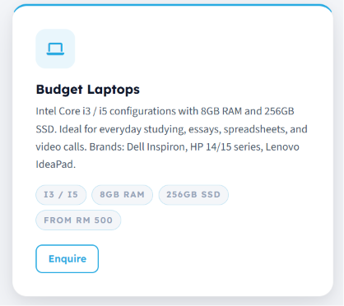

Core Student Laptops
Suitable for Microsoft Office, Google Workspace, research, writing assignments and light coding. Brands include Dell Inspiron, HP 240/250 series and Lenovo IdeaPad, each Grade A with a 6-month warranty. Battery life of 2+ hours.



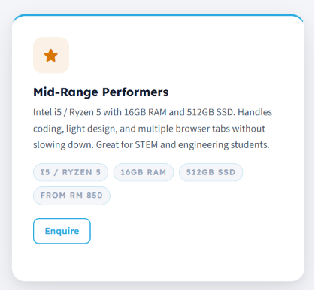

STEM & Technical Specification
For engineering, computer science and design students. These handle coding environments (VS Code, PyCharm android Studio), light CAD and load simultaneous applications without performance issues. Popular with universities equipping computer science labs.


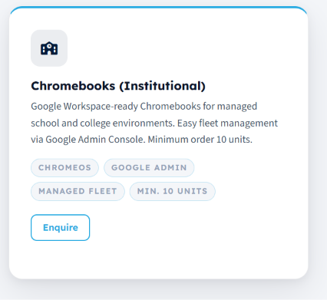

Chromebook Fleets
Google Workspace-ready Chromebooks for supervised learning environments. Fleet management via Google Admin Console - centralized device policy, app deployment and usage monitoring. Ideal for computer labs, standardized assessments and bring-your-own-device programs. All devices pre-enrolled before delivery.

FAQs

What should I look for when buying a student laptop?
A good student laptop should balance performance, portability, battery life and affordability. Look for at least an Intel Core i5 or AMD Ryzen 5 processor, 16GB RAM, a 512GB SSD, a Full HD display and a battery that lasts for sufficient time.

Is a refurbished laptop a good choice for students?
Yes. Grade A refurbished laptops offer excellent value, providing reliable performance at 30-40% below the cost of new devices. When professionally tested and backed by a warranty, they are an ideal option for students on a budget.

Should I buy a Windows laptop or a MacBook for university?
It depends on your course requirements. Windows laptops offer wider software compatibility and excellent value, while MacBooks are popular for creative disciplines such as graphic design, photography and video editing. Always check your university's software requirements before purchasing.






Equipping your school, college, or university?
Contact us with your specifications, unit count and timeline. We'll return a formal quotation within one business day.
Button: Request Institution Quotation

/products/workstations/ page
Meta Title:
Refurbished Workstations Malaysia | HP Z-Series Dell Precision
Meta Description:
Grade A HP Z-Series and Dell Precision workstations for Malaysia. Xeon CPUs, ECC RAM, NVIDIA Quadro for engineering, CAD, rendering. 30-40% below new cost.

Refurbished Professional Workstations for Malaysian Engineering & Design Teams
HP Z-Series and Dell Precision - Xeon processors, ECC RAM, ISV-certified GPUs - at much lower cost comparatively.
Button: Get a Custom Quote

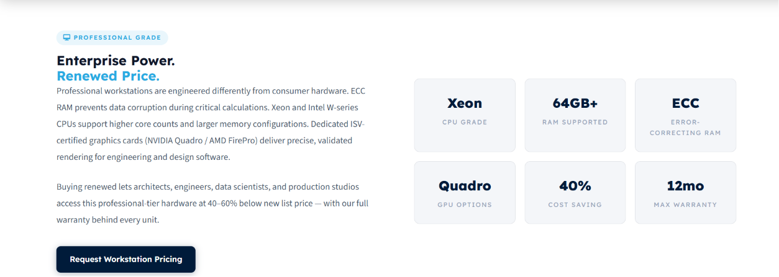
Professional workstations are not expensive because of branding. They are expensive because of what is inside: ECC RAM that prevents data corruption during critical engineering calculations, Xeon processors that sustain higher core counts and memory configurations than desktop CPUs and dedicated ISV-certified graphics cards validated by Autodesk, ANSYS and SolidWorks for professional accuracy.
For organizations that need structural engineers, architects, data scientists, visual effects studios, computational researchers need certified refurbished laboratory-grade workstation hardware at 30-40% below new list prices, backed by full warranty.

What Organizations Use Professional Workstations For

Structural & Civil Engineering
ANSYS, AutoCAD Civil 3D, ETABS and SAP2000 demand high core counts, ECC memory for data integrity and sustained CPU performance during multi-day simulation runs. HP Z4 and Z6 Xeon configurations support engineering workloads that consumer business laptops cannot sustain. We supply engineering consultancies, construction firms and infrastructure design practices across Malaysia.

Architecture & 3D Rendering
Autodesk Revit, 3ds Max, SketchUp Pro and V-Ray rendering require high VRAM GPUs and multi-core CPU performance. Dell Precision workstations with NVIDIA Quadro P4000 or RTX 4000 deliver ISV-validated rendering accuracy at sustained clock speeds. Popular with architecture firms and design studios.

Data Science & Machine Learning
Large dataset processing, Python/R environment compilation and local model training benefit from Xeon core counts, ECC RAM reliability and high NVMe storage throughput. HP Z6 dual-Xeon configurations support data science workflows at scale for research institutions and analytics teams.

Video Post-Production
4K and 6K video editing in DaVinci Resolve, Adobe Premiere Pro and Avid Media Composer requires fast NVMe RAID, GPU acceleration and RAM headroom for multi-layer timelines. HP ZBook Fury and Dell Precision mobile workstations bridge studio and on-location production requirements.

Professional Workstations We Supply


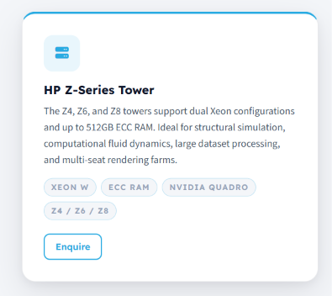

HP Z-Series Towers
Support Xeon processors (up to dual-socket configurations) and multiple PCIe GPU slots for GPU clustering. Ideal for simulation, rendering farms and large-scale data processing.
Available models depending on current stock: Z4 G4/G5, Z6 G4/G5, Z8 G4/G5.


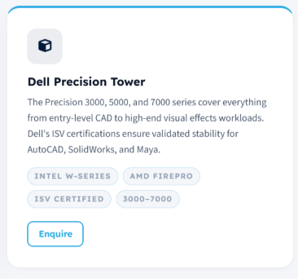

Dell Precision Towers
The Precision 3000 (entry-level), 5000 (mainstream) and 7000 (high-end) series. All support Xeon W-series processors, ECC RAM configurations up to 256GB+ and ISV-certified AMD Radeon or NVIDIA RTX GPUs.


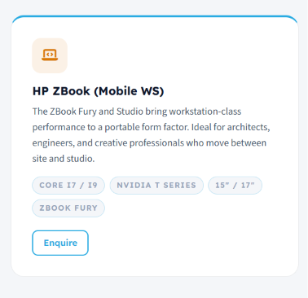

Mobile Workstations
Dell Precision, HP ZBook Fury and Lenovo ThinkPad P Series - the mobile workstations built for site-based engineers, architects and creative professionals. Equipped with high-VRAM discrete GPUs and fast NVMe SSD storage, they deliver workstation-grade performance wherever your work takes you.

FAQs

What is the difference between a workstation and a desktop PC?
Workstations typically feature more powerful processors, professional graphics cards (such as NVIDIA RTX Professional), higher memory capacities, ECC memory support on some models and ISV-certified hardware for professional software. They are engineered to run intensive applications continuously without compromising stability.

Who should buy a workstation?
Workstations are ideal for architects, engineers, graphic designers, video editors, 3D artists, data scientists, software developers and professionals using applications such as AutoCAD, SolidWorks, Revit, Adobe Creative Cloud and Blender.

Can I upgrade the GPU or RAM after purchase?
Most refurbished workstations are upgradeable. We'll advise on compatibility during the quotation process. Some components (CPU) are not user-upgradeable; others (RAM, SSD storage, GPU) typically are. This allows businesses to extend the system's lifespan as performance requirements grow.

Why choose a refurbished workstation instead of buying new?
Refurbished workstations can cost 40-60% less than new systems while delivering comparable performance for professional workloads. They also support sustainable IT practices by extending the lifecycle of enterprise hardware and reducing electronic waste.

Specify your Requirements and Get a Professional Workstation
Tell us:
- Your primary software: AutoCAD, ANSYS, DaVinci Resolve, Blender, Adobe Suite, custom applications
- Your current bottleneck: CPU-bound (long renders), memory-bound (large datasets), GPU-bound (complex simulations)
- Your team size and concurrent user load
- Your budget range
Workstation requirements are specific to software and workload. We recommend a brief consultation to understand your application stack and performance bottleneck.
Button: Get a Workstation Recommendation

/products/gaming/ Page
Meta Title: Refurbished Gaming Laptops Malaysia | ASUS ROG MSI Nitro
Meta Description: ASUS ROG, MSI, Acer Nitro, Lenovo Legion; Grade A gaming laptops for Malaysia. RTX 3060/3070, 144Hz+. GPU stress-tested. Bulk pricing for esports centres & training labs.






Professionally Refurbished Affordable High-Performance Gaming Laptops in Malaysia
High-performance laptops for esports training centers, game development studios, university esports teams and organizations that require GPU-intensive research.
Button: Power Up Your Game


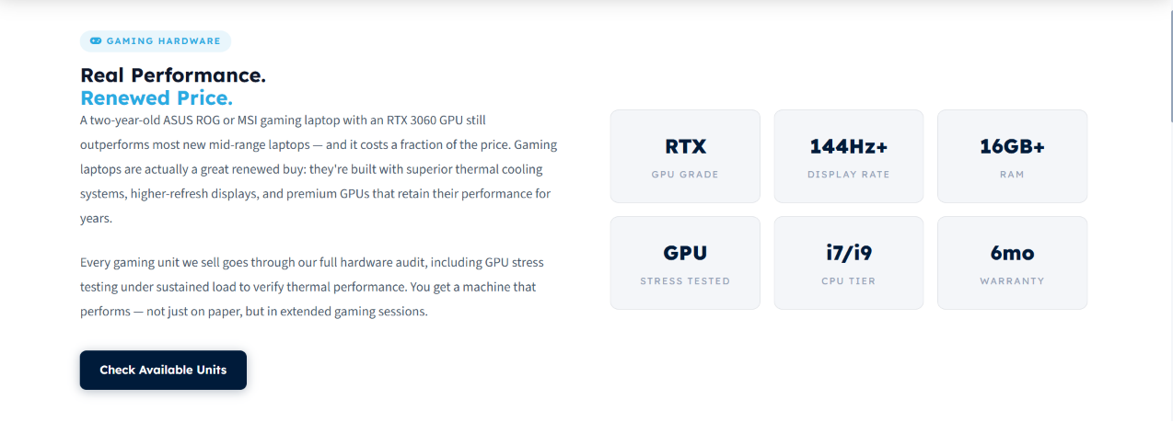

A two-year-old ASUS ROG Strix or MSI GF65 with an RTX 3060 GPU outperforms most new mid-range laptops at its refurbished price point. Gaming laptops age well: high-refresh IPS panels remain vibrant, thermal solutions sustain performance across GPU driver generations and discrete GPUs retain capability across multiple game titles and resolution targets.
Every gaming unit we supply is subjected to sustained GPU load testing, not just a spec check. We verify thermal performance under extended load, display refresh rate consistency and battery capacity for portable deployments.

GPU Stress-Testing & Thermal Performance Verification
Standard refurbished laptop testing checks CPU and RAM. Gaming devices demand more: we run sustained GPU load tests to verify:
- Thermal performance under extended load (no thermal throttling observed)
- Display refresh rate consistency (144Hz actually achieves 144fps, not variable refresh)
- GPU memory bandwidth under sustained rendering
- Battery capacity and power delivery stability during gaming sessions
- Cooling fan noise and thermal management
Every gaming unit we supply has passed these verification steps. This is not marketing; it is engineering validation.

Gaming Laptop Brands We Supply

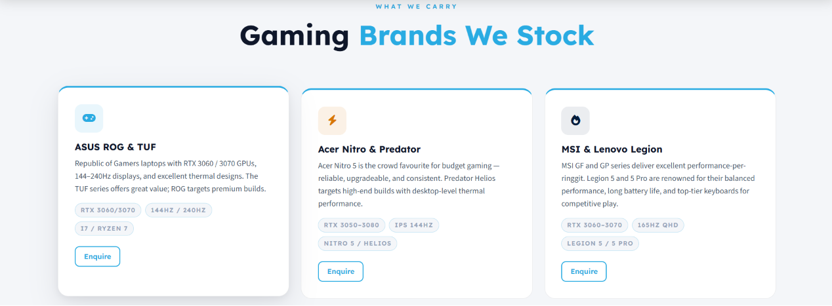



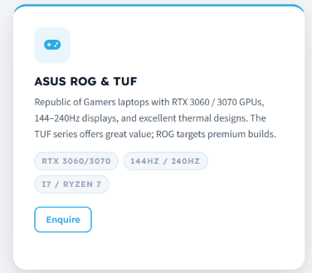

ASUS ROG & TUF
ROG Strix G15/G17 models are particularly popular for their sustained performance during extended gaming sessions. TUF Gaming series offers excellent value-for-cost. Both lines are highly upgradeable; RAM and NVMe storage can typically be expanded post-purchase.



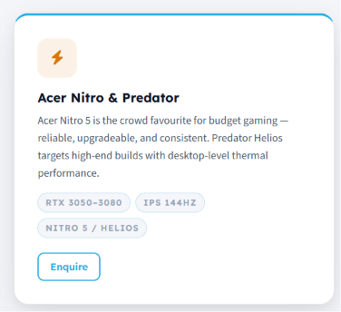

Acer Nitro & Predator
Acer Nitro 5 is one of the most popular gaming laptops in the refurbished market; reliable, widely available, highly upgradeable and consistently good thermal performance. Predator Helios targets premium builds with desktop-level cooling and QHD displays.



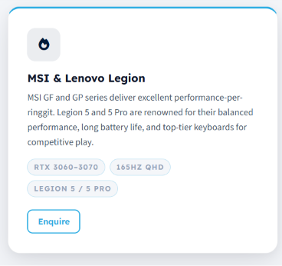

MSI Gaming Series
MSI GF and GP series deliver strong performance per ringgit. MSI's thermal design sustains GPU boost clocks well during extended sessions, important for both gaming and GPU-accelerated professional workloads.

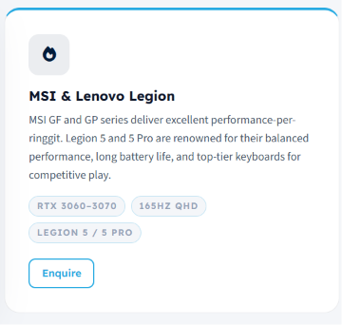

Lenovo Legion
Legion 5 and Legion 5 Pro are renowned for balanced performance, competitive thermal design and market-leading keyboards for extended use. Pro variant features QHD 165Hz displays that distinguish it for visual fidelity. Popular with development studios and creative teams alongside gaming organizations.

FAQs

What specifications should I look for in a gaming laptop?
The ideal gaming laptop depends on the types of games you play and your performance expectations. For a smooth gaming experience, look for a modern Intel Core i7/Core Ultra or AMD Ryzen 7 processor, a dedicated NVIDIA GeForce RTX graphics card, at least 16GB RAM, a 512GB SSD or larger and a 144Hz or higher refresh rate display. For competitive gaming or multitasking while streaming and recording, 32GB RAM is recommended. An RTX 4060 or RTX 4070 is an excellent choice for 1080p and 1440p gaming, while an RTX 4080 or higher is better suited for ultra settings, high refresh rates and 4K gaming.

Can gaming laptops be used for work or school?
Absolutely. Gaming laptops are powerful enough for programming, engineering software, video editing, graphic design, CAD and everyday productivity, making them suitable for both work and entertainment.

Is it normal for a gaming laptop to heat up?
Yes. Gaming laptops generate significant heat during intensive workloads. Quality cooling systems help maintain performance and reduce thermal throttling.

Can I upgrade a gaming laptop?
Many gaming laptops allow upgrades to RAM and SSD storage. GPU and CPU upgrades are generally not possible because they are integrated into the motherboard.

What FPS (frames per second) can I expect on popular games?
RTX 3060 typically achieves 100-144fps on demanding titles (Cyberpunk, Elden Ring) at 1080p high settings. RTX 3070 achieves 120-165fps at 1440p. We can provide specific FPS benchmarks for popular titles during quotation.

Can a gaming laptop be used for video editing?
Yes. Gaming laptops with powerful CPUs and RTX GPUs perform exceptionally well for video editing, 3D rendering, animation and creative applications.






Looking to Equip a Gaming or Esports Facility?
Tell us how many units you need, your game titles/use case and target GPU tier. We'll provide a bulk quotation.
Button: Get a Gaming Hardware Quote

/products/editing/ Page
Meta Title: Refurbished MacBook Pro & Editing Laptops Malaysia
Meta Description: Grade A MacBook Pro M1/M2, Dell XPS, HP Spectre; color-accurate displays, 32GB+ RAM, verified battery. For video editors, designers & creative professionals in Malaysia.


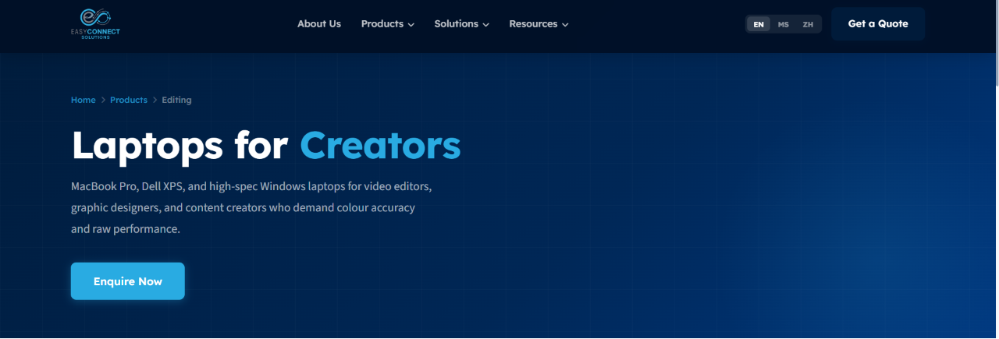



Refurbished MacBooks & iMacs for Content & Video Editing in Malaysia
Color-accurate displays, sustained performance under extensive rendering loads and verified battery health for video editors, graphic designers and content creators at 30-40% below new cost.
Button: Find Your Creative Apple

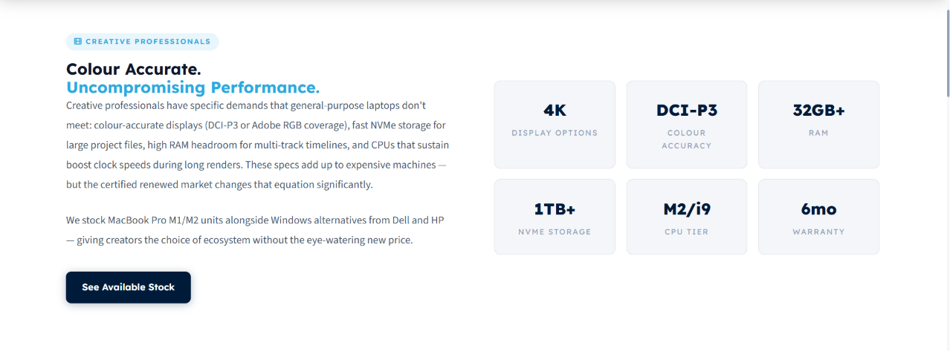

Creative professionals have specific hardware demands: color-accurate displays (DCI-P3 or Adobe RGB gamut for grading), fast NVMe storage for 4K/6K media scrubbing, RAM headroom for multi-track timelines and CPUs that sustain boost clocks during long renders without thermal throttling.
Apple Silicon has transformed creative workflows across both MacBook Pro and iMac, delivering exceptional performance for video editing, graphic design, photography, music production, and 3D content creation. Unified memory, fast SSD storage, and optimized software enable smooth editing of high-resolution media while maintaining excellent power efficiency.

Why Creative Professionals Choose Refurbished

Color Accuracy Matters
Display color accuracy (DCI-P3 or Adobe RGB gamut) is essential for video grading, photo retouching and graphic design. Consumer laptop displays are sRGB only, inadequate for professional color work. Every creative laptop we supply has a color-accurate display.

Performance Under Sustained Load
Rendering a 10-minute 4K timeline, exporting a high-resolution image sequence, or compiling a complex effects session takes hours. During these operations, CPU and GPU must sustain boost clocks without thermal throttling. That's why professional-grade thermal design is essential for consistent performance and reliable productivity.

Reliable Hardware for Professional Work
Whether you're working on location or from a studio, reliability is essential. Every MacBook Pro includes verified battery health and cycle count, while every iMac undergoes comprehensive hardware testing to ensure dependable long-term performance.

Storage Speed for Media Workflows
NVMe storage speed directly impacts 4K/6K media responsiveness. Slow storage means timeline scrubbing lags, effects rendering stalls and proxy creation delays. Every creative device we supply has fast NVMe (256GB or larger) verified for media performance.

Professional Apple Devices We Supply



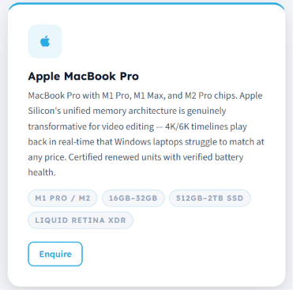

Apple MacBook Pro M-Series
Apple Silicon's unified memory options deliver transformative performance for video editing - 4K/6K timelines play back in real time that Intel platforms struggle to match at any price. Every unit has verified battery cycle count (typically 200-400 cycles on refurbished units), screen inspection for dead pixels and brightness uniformity and MagSafe port verification.

iMac - Designed for Creative Professionals
High-resolution Retina displays, powerful Apple Silicon processors and an elegant all-in-one design make the iMac ideal for graphic designers, photographers, video editors and modern business workspaces.

FAQs

Which Apple MacBook is best for video editing?
For professional video editing, the MacBook Pro with Apple M-series chips (M1 Pro, M1 Max, M2 Pro, M2 Max, M3 Pro, M3 Max, or newer) offers the best performance. Choose 16GB RAM or more and at least 512GB SSD storage, with 1TB recommended for larger projects and 4K workflows.

Can a refurbished Apple MacBook handle professional video editing?
Yes. A Grade A refurbished MacBook Pro with an Apple M-series processor, sufficient memory and SSD storage can comfortably handle professional editing.

Is Apple Silicon better than Intel Macs for video editing?
In most cases, yes. Apple Silicon (M-series) delivers significantly better performance, power efficiency and battery life than Intel-based Macs. It is also optimized for professional creative applications, particularly Final Cut Pro.

Does video editing affect MacBook battery life?
Yes. Video editing is a demanding workload that uses more CPU and GPU resources than everyday tasks, resulting in faster battery consumption. For long editing sessions and maximum performance, many professionals prefer working with their MacBook connected to power.

Can Apple MacBooks run Adobe Premiere Pro, DaVinci Resolve and Final Cut Pro?
Yes. Apple MacBook Pro models with M-series processors are designed for demanding creative workflows and deliver excellent performance in Final Cut Pro, Adobe Premiere Pro, DaVinci Resolve, After Effects, Photoshop, Lightroom, Blender, Logic Pro, and other professional creative applications.

We Match Workflows to Hardware
Tell us:
- Primary software: Premiere Pro, Final Cut Pro, DaVinci Resolve, Lightroom, After Effects, Blender
- Media specifications: 1080p, 4K, 6K; frame rate; codec (ProRes, DNxHD, H.264)
- Timeline complexity: typical number of video tracks, audio tracks, effects
- File storage: local NVMe only, or network-attached storage available
- Budget constraints
Button: Find Your Creative Device

/solutions/ Page
Meta Title: IT Lifecycle Solutions Malaysia | ITAD, Rental, Procurement
Meta Description: End-to-end IT lifecycle management for Malaysian organizations. ITAD & data wiping, corporate rental, bulk procurement, asset buyback. PDPA compliant. Single provider.

Complete IT Lifecycle Solutions for Malaysian Organizations
Simplifying IT operations across your organization - one partner for hardware procurement, lifecycle management and responsible asset retirement. Explore our IT services to:
Button: Transform Your IT Operations

Most organizations manage their IT lifecycle through multiple vendors: one for hardware, another for support, a third for data wiping and informal arrangements for asset disposal. This fragmentation creates operational complexity, compliance risk and missed value recovery opportunities.
Easy Connect Solutions manages your entire IT lifecycle under a single relationship: hardware supply at the front end, lifecycle support throughout operational use and data destruction and asset recovery at retirement. This integrated approach reduces complexity, ensures consistent data security practices and recovers maximum value from retiring hardware.
Whether you are a 50-person SME equipping your first office or a multinational corporation refreshing 500+ device fleets across multiple locations, we manage every stage.

Why A Single IT Lifecycle Provider Matters

Consistency in Data Security
Different vendors = different data wiping standards, different documentation, different compliance claims. One provider using consistent NIST 800-88 methods across all engagements eliminates this variance.

Simplified Procurement
Instead of Request for Quotation (RFQ) to hardware vendor, RFQ to ITAD vendor, RFQ to disposal vendor, you have one point of contact, one quotation and one invoice. Faster decision-making, simplified approvals.

Value Recovery
Multiple vendors create conflicts of interest, while a single IT lifecycle partner evaluates each asset to determine whether it should be refurbished, remarketed, bought back, or responsibly recycled, recommending the option that delivers the best financial return.

Continuity
Working with one IT lifecycle partner means they already understand your hardware standards, procurement cycles and operational requirements. This eliminates repeated onboarding, speeds up decision-making and ensures consistent service throughout your IT asset lifecycle.

End-to-End IT Lifecycle Management Solutions
Whether you need to retire old hardware responsibly, procure at scale, or rent equipment for a project, we have a managed solution for all.

Bulk Hardware Procurement
Supply your organization with premium refurbished laptops, desktops, workstations and peripherals. Grade A condition, custom configuration and bulk pricing from 10 units. We handle sourcing, audit, configuration and delivery across Malaysia.

Corporate IT Rental & Leasing
Scale IT capacity without capital expenditure. Rental from single-day event support to multi-year operational leases. Configured, delivered & collected nationwide. Ideal for training, project teams and CapEx-to-OpEx conversion.

ITAD & Data Wiping
Third-party certified IT Asset Disposition with NIST 800-88 compliant data destruction. Certificate of Data Destruction issued per device. Chain of custody documentation for audit and compliance purposes.

E-Waste & Sustainability
Responsible e-waste disposal through DOE-licensed recovery channels. Zero-landfill policy. ESG impact documentation for Bursa Malaysia sustainability reporting.

IT Asset Buyback
Turn your IT assets into working capital by selling your retiring hardware to us at fair market valuation. Fast payment with verified data wiping. Certificates are issued before any device leaves your premises.

Sectors We Serve
Trusted by organizations across Malaysia for Industry-specific IT solutions that improve performance, reduce costs, simplify lifecycle management and align with the operational and compliance requirements of every sector.

Corporate & Enterprise
Keep your workforce productive with scalable IT solutions for organizations of every size. From bulk procurement and project-based rentals to IT refresh cycles and responsible asset retirement, we help simplify IT fleet management through a single, reliable partner.

Educational Institutions
Equip classrooms, computer labs and campuses with reliable technology. We provide bulk laptops and Chromebooks, customized to meet academic requirements. Affordable IT equipment with an extendable warranty of 6-12 months, including timely delivery aligned with academic schedules.

Healthcare
Reliable IT infrastructure for hospitals, clinics and healthcare providers where security and uptime are critical. We support secure hardware deployment, compliant data handling and rapid device replacement to keep essential services running.

Government & Public Sector
Supporting government agencies with dependable IT procurement, large-scale deployments and formal tender processes. Our services are designed to ensure secure and compliant handling of retired equipment through data wiping and chain-of-custody documentation by our certified partners.

Professional & Financial Services
Protect sensitive business information with secure ITAD services that include documentation that satisfies internal audit and regulatory requirements of law firms, accounting & finance institutions and consultancies. From hardware procurement to secure asset retirement, we help you maintain productivity while safeguarding confidential data.

How We Work With You

Assessment Before Commitment
Before any engagement, we understand your situation: current fleet age and condition, your timeline, your budget constraints, your compliance requirements. We then recommend which services (or combination) makes most sense for you.

Formal Quotations
Detailed specifications, pricing, timeline, warranty terms and service conditions in black and white. No hidden fees. Quotations that justify budget and are suitable for internal approvals.

Dedicated Contact
A single point of contact manages your engagement from specification description to availing warranty services. No need to juggle with multiple vendors. Only one team member who owns the relationship.

Transparent Pricing
We explain how our pricing is structured: per-unit for hardware, per-day for rental, per-device for ITAD. Volume discounts are disclosed. Pricing is consistent and auditable.

Discuss Your IT Lifecycle
Tell us what stage of the IT lifecycle you are managing right now and get expert recommendations based on your current IT requirements and future plans. No obligation to proceed.
Button: Get an Assessment

/solutions/itad/ Page
Meta Title: Quality ITAD & Data Wiping Service Malaysia | PDPA Compliant
Meta Description: Third-party-certified IT Asset Disposition with PDPA 2010 compliant data destruction. Certificate of Data Destruction and Chain of custody available to the client.

Certified ITAD & Data Destruction Facility in Malaysia
Military-grade data destruction compliant to PDPA(2010) and other international standards with certificates and chain of custody documents made available to the client.
Button: Request a Data Destruction Quote

When organizations retire IT hardware, the data stored on those drives does not disappear because the device is formatted or physically damaged. Hard drives and SSDs retain data even after formatting, which can be recovered using widely available forensic tools. For organizations subject to Malaysia's Personal Data Protection Act 2010 (PDPA), failing to properly destroy data on retired hardware is a compliance failure with serious legal and reputational consequences.
Our certified ITAD service partners mitigate this risk. Every storage device is sanitized using NIST SP 800-88 compliant methods. You receive a signed Certificate of Data Destruction for every device, serially referenced and suitable for internal audit, regulatory inspection, and compliance documentation.

Why ITAD Compliance Matters in Malaysia

PDPA Malaysia 2010 Requirements
The Personal Data Protection Act 2010 imposes explicit obligations on data processors to prevent unauthorized access, disclosure, or loss of personal data, including at end-of-life. A device retired without certified data destruction is a data breach waiting to happen. MCMC and JPDP enforcement activity has intensified since 2024.

Reputational Risk
A single data breach from improperly retired hardware damages brand trust, customer confidence, and market valuation. The cost of breach notification, remediation, and regulatory fines far exceeds the cost of certified ITAD upfront.

Contractual Compliance
Organizations supplying multinationals or large corporates often face contractual data security requirements. Our ITAD documentation from certified partners satisfies these requirements, reducing supplier risk and protecting your business relationships.

Our Six-Stage ITAD Process

Stage 1 - Asset Inventory
Before any device moves, we build a complete asset register: make, model, serial number, storage type and capacity. Nothing is processed without logging. You receive an inventory copy at engagement start.

Stage 2 - Secure Collection
Assets collected from your premises using tamper-evident packaging and tracked logistics. For large volume collections across Malaysia, we coordinate phased schedules. Devices do not leave your premises without a signed collection manifest.

Stage 3 - Certified Data Destruction
All HDD and SSD storage is sanitized using NIST SP 800-88 (Clear, Purge, or Destroy as appropriate to storage type) and DoD 5220.22-M overwrite methods. Physically failed drives and optical media are shredded. Results verified and logged per device.

Stage 4 - Certificate of Data Destruction
Our partners issue a formal Certificate per device, showing serial number, sanitization method applied, verification pass status, and date of destruction. Acceptable for PDPA compliance documentation, internal audit, regulatory inspection, and client due diligence.

Stage 5 - Downstream Handling
Hardware assessed for refurbishment potential. Units suitable for resale are restored. Hardware beyond reuse is transferred to our Corporate E-Waste Disposal service through DOE-licensed recycling partners. Landfill disposal never occurs.

Stage 6 - Final Report
Complete final engagement report: all assets processed, sanitization methods applied, certificates issued, downstream outcomes. This report is your complete documentation trail.

FAQs

What is IT Asset Disposition (ITAD)?
IT Asset Disposition (ITAD) is the secure process of retiring outdated IT equipment. It includes inventory management, secure data destruction, refurbishment, recycling, and environmentally responsible disposal while ensuring compliance with data protection regulations and sustainability goals.

What data destruction method is mandatory in Malaysia?
There is no single "mandatory" method specified in PDPA. NIST 800-88 and DoD 5220.22-M are both widely accepted. We use NIST 800-88 as the primary standard with DoD 5220.22-M as supplementary.

What is NIST SP 800-88 compliant data sanitization?
NIST SP 800-88 is one of the world's most widely recognized standards for media sanitization. It provides guidelines for securely erasing or destroying storage devices so that sensitive data cannot be recovered using commercially available or laboratory-level techniques.

How do I choose the right ITAD provider?
Look for an ITAD provider that follows recognized data sanitization standards, provides complete asset tracking, maintains a documented chain of custody, issues Certificates of Data Destruction, offers environmentally responsible recycling, and supports compliance with applicable data protection regulations.

What is a chain of custody in ITAD?
A chain of custody records every stage of an IT asset's movement from collection through transportation, processing, and final disposition. It helps maintain accountability and supports regulatory audits by documenting who handled each asset and when.

Ready to retire your old fleet?
Submit your device inventory (make, model, count) and we'll provide a detailed ITAD quotation within 24 hours.
Button: Submit Your Asset List

/solutions/e-waste/ Page
Meta Title: Corporate E-Waste Disposal Malaysia | Responsible Electronic Waste Recycling
Meta Description: Corporate e-waste disposal in Malaysia through trusted DOE-licensed recycling partners. Responsible electronic waste recycling, refurbishment prioritization and ESG reporting support.

Corporate E-Waste Disposal & Electronic Recycling in Malaysia
Promoting Malaysia's circular economy through refurbishment, reuse and responsible recycling via our network of DOE-licensed recycling partners.
Button: Request an E-Waste Assessment

Retired laptops, desktops, servers, monitors and other IT equipment should never end up in general waste streams. Improper disposal can release hazardous materials into the environment while valuable resources remain unrecovered.
We help Malaysian organizations manage unwanted IT equipment through a responsible e-waste process. This circular approach helps minimize electronic waste, extends the life of suitable devices and reduces the demand for manufacturing new equipment.
Where required, storage devices are sanitized by our certified data destruction partners before equipment proceeds to recycling, with supporting documentation available for compliance and audit purposes.

Why Responsible E-waste Recycling Matters
Electronic waste is one of the world's fastest-growing waste streams, and Malaysia continues to see increasing volumes of discarded IT equipment from businesses and organizations.
IT equipment contains recyclable materials such as steel, aluminium, copper and plastics, alongside electronic components that can be recovered for reuse. However, it may also contain hazardous substances that require specialized handling by licensed recycling facilities to minimize environmental impact.
As environmental regulations and corporate sustainability expectations continue to evolve, organizations are increasingly expected to manage electronic waste responsibly and support broader ESG and circular economy initiatives. We help businesses retire obsolete IT equipment through a structured process that prioritizes refurbishment and reuse, before coordinating e-waste recycling through our network of DOE-licensed partners. This approach helps reduce electronic waste and maximize material recovery. Supporting documentation is also provided, which organizations may use for their internal compliance and sustainability reporting.

Our Circular Economy Model

Step 1 - Refurbishment First
Every collected device is assessed for refurbishment potential. Equipment that remains suitable for continued business use is restored, tested and prepared for a second lifecycle, reducing unnecessary electronic waste and extending product lifespan.

Step 2 - Reuse Where Possible
Devices that are no longer suitable for premium refurbishment may still provide value in secondary markets or alternative business environments. Reuse is prioritized before recycling whenever practical to maximize resource efficiency.

Step 3 - Responsible Electronic Recycling
Equipment that has reached the end of its usable life is transferred to our network of DOE-licensed e-waste recycling partners for environmentally responsible processing. Recoverable materials are separated for recycling, while regulated materials are handled in accordance with Malaysian environmental requirements.

Step 4 - Documentation & Reporting
Throughout the engagement, we maintain documented asset handling records. Depending on your requirements, available documentation may include:
- Collection records
- Chain of custody documentation
- Certificate of Data Destruction (where applicable through certified partners)
- Recycling confirmation from licensed downstream processors
- Supporting documentation for internal compliance and sustainability reporting

FAQs

What types of IT equipment can be collected?
We can arrange collection for laptops, desktops, servers, storage devices, monitors, networking equipment, printers, accessories and other corporate IT hardware.

Is my data destroyed before recycling?
Yes, where requested. Storage devices can be sanitized by our certified data destruction partners before equipment proceeds to recycling. Supporting certificates are available upon completion.

Should I recycle my IT equipment or sell it?
It depends on the condition of your equipment. Devices with remaining market value are generally better suited for refurbishment or resale, allowing you to recover more value. Equipment that is damaged, obsolete, or beyond economical repair is recommended for responsible electronic recycling through our DOE-licensed partners. We assess every device before recommending the most appropriate option.
If your equipment still has resale potential, you may also be interested in our IT Asset Buyback or ITAD services.

Dispose of Your Corporate E-Waste Responsibly
Whether you're replacing a few office computers or retiring an entire IT infrastructure, we'll assess your equipment, identify devices suitable for refurbishment, and recommend you a environmentally responsible solution tailored to your organization.
Button: Discuss Your E-Waste Project

/solutions/rental/ Page
Meta Title: IT Equipment Rental Malaysia | Laptop & Computer Leasing
Meta Description: Rent laptops, desktops and IT equipment across Malaysia. Short-term event rentals, project deployments and long-term corporate leasing with nationwide delivery.

Corporate Laptop, Computer & IT Equipment Rental in Malaysia
Whether you need 10 laptops for a one-day training session, 200 computers for an examination centre, or a multi-year corporate IT leasing program, Easy Connect provides flexible rental solutions tailored to your organization.
Button: Request a Rental Quote

We supply professionally refurbished business-grade laptops, desktops, workstations, monitors and accessories, fully configured to your specifications before delivery anywhere in Malaysia. Every rental includes deployment support, technical assistance throughout the rental period, secure collection, and certified data sanitization through our authorized ITAD partners before devices are refurbished, remarketed, or responsibly recycled.
Instead of investing heavily in hardware that may only be needed temporarily, organizations can reduce upfront capital expenditure while supporting a more sustainable circular IT lifecycle through IT equipment rental.

Why Rent Instead of Buying?
Buying hardware makes sense when equipment will remain in service for many years. Rental is often the better option when organizations need flexibility.
Benefits include:
- Lower upfront investment
- Preserve cash flow
- Convert CapEx into predictable OpEx
- Scale devices up or down as projects change
- No storage of unused equipment
- No end-of-life disposal management
- Latest business-grade hardware
- Sustainable IT lifecycle management

Laptop & Computer Rental Solutions for Every Business Requirement

Event & Short-Term Laptop Rental (1 Day - 3 Months)
Ideal for:
- Corporate training
- Conferences
- Product launches
- Examination centres
- Temporary offices
- Seasonal workforce expansion
Business laptops are configured to your requirements before dispatch. Where possible, we can pre-install your required operating system, software, user accounts and network settings, helping reduce deployment time and ensuring devices are ready for use upon delivery.

Project-Based Computer Rental (3 -12 Months)
Perfect for organizations expanding project teams, contractors, consultants, software development, audits, or temporary operations.
Instead of purchasing new hardware, rent devices only for the required duration. Once the project ends, equipment is collected, securely data-wiped through our certified ITAD partners, and prepared for its next lifecycle through refurbishment or responsible recycling.

Corporate Laptop Leasing & IT Fleet Rental (1–3 Years)
For organizations looking to convert hardware investment from CapEx to OpEx, long-term leasing provides predictable monthly costs without managing depreciation or asset disposal. Fleet leasing includes:
- Custom hardware specifications
- RAM & SSD upgrades
- Software installation (where applicable)
- Windows deployment
- Asset tagging
- BIOS configuration
- Corporate imaging
- Scheduled refresh programs

Our Rental Process - From Request to Return

Step 1 - Rental Enquiry
Submit requirements via contact form, email, or WhatsApp: device type/specification, quantity, duration, delivery location, configuration requirements. We respond within one business day with availability and pricing.

Step 2 - Device Configuration
Every laptop or desktop is prepared according to your requirements before dispatch. Software installation wherever possible, operating system deployment, security settings, network configuration, asset tagging and hardware upgrades are completed prior to delivery so equipment is ready to use immediately.

Step 3 - Nationwide Delivery
Tracked delivery to your premises, event venue, or multiple locations across Peninsular Malaysia. For large orders, a coordinated delivery schedule is provided with tracking references.

Step 4 - On-Call Support
Our technical team is available throughout the rental period. Hardware failures are resolved within 24 hours; a replacement unit is dispatched, and the failed unit is collected. For on-site event support, technical staff is available where required.

Step 5 - Collection, Data Wiping & Responsible IT Lifecycle
At the end of the rental period, equipment is collected from your location and devices undergo certified data sanitization by our authorized ITAD partners, with certificates of data destruction available upon request. Depending on condition, equipment is then:
- professionally refurbished for reuse,
- remarketed,
- or its useful parts are recycled through licensed e-waste recycling partners.

Need Laptop or Computer Rental in Malaysia?
Tell us:
- Device type
- Quantity
- Rental duration
- Delivery location
- Configuration requirements
Or if you’re unsure about what device to rent, tell your use case to our rental expert to get the most optimized rental quotation.
Button: Speak to a Rental Specialist

/solutions/bulk-procurement Page
Meta Title: Corporate IT Procurement Malaysia | Bulk Laptop Supplier
Meta Description: Refurbished and new laptops, desktops and IT equipment for organizations across Malaysia. With bulk orders, custom configuration, nationwide delivery and ITAD support.

Bulk Laptop & IT Hardware Procurement in Malaysia
Whether you need 10 laptops for a growing department, 250 computers for a nationwide rollout, or 500+ business devices for a corporate refresh, Easy Connect delivers scalable IT procurement solutions tailored to your organization.
Button: Build Your IT Fleet

We supply refurbished and new business laptops, desktops, workstations, monitors and accessories from leading brands including Dell, HP, Lenovo, Acer, Apple and more. Every deployment can be customized to your requirements before delivery, while existing equipment can be securely collected through our authorized third-party ITAD partners for certified data wiping, refurbishment or environmentally responsible e-waste recycling.
By combining procurement with responsible asset retirement, organizations reduce deployment complexity, maximize the value of retired equipment and minimize electronic waste.

Why Organizations Choose Us for Bulk IT Procurement

Consistent Hardware Specifications Across Every Deployment
Managing hundreds of devices becomes significantly easier when every unit shares the same hardware profile. We source equipment to a consistent specification wherever possible, helping simplify deployment, software compatibility, asset management and long-term support.

Custom Configuration Before Delivery
Every deployment can be prepared to suit your IT environment before shipment.
Where possible, we can configure:
- Windows deployment
- Operating system installation
- Required software pre-installation
- Domain joining
- Microsoft Intune enrolment
- Asset tagging
- BIOS configuration
- User account creation
- Network settings
- RAM and SSD upgrades
Devices arrive ready for deployment, reducing workload for your internal IT team.

Buy New or Refurbished Business IT Equipment
Every organization has different budget, performance and sustainability requirements.
We can supply:
- Grade A refurbished business laptops
- New laptops and desktops
- Business workstations
- Monitors and accessories
- Mixed fleet deployments
Our team helps determine the most cost-effective solution based on your project, lifecycle expectations and available budget.

Complete Fleet Replacement & Responsible Asset Retirement
A fleet refresh often involves replacing existing equipment as well as deploying new devices. Instead of coordinating multiple vendors, we can help manage the entire transition through our wider IT lifecycle services.
Existing hardware can be:
- securely collected
- processed through authorized third-party ITAD partners
- certified data wiped
- refurbished for reuse
- remarketed where appropriate
- Recycled through licensed e-waste recovery partners if no longer reusable
Certificates of Data Destruction and chain-of-custody documentation are available upon request.

How Fleet Procurement Works - We Handle Everything
From specification discussion to deployed devices, we manage the entire process. Here is what a typical engagement looks like:

Stage 1 - Requirements Briefing
Your IT manager, procurement officer, or finance administrator defines exact specifications: CPU generation, RAM, storage, display size, OS version, any pre-installed software, domain join requirements and delivery timeline.

Stage 2 - Stock Verification
We confirm availability from our sourcing network. For large orders (200+ units), we provide lead times and phased delivery schedules.

Stage 3 - Formal Quotation
Written quotation referencing specification, unit pricing, quantity discount (if applicable), delivery terms, configuration options and warranty coverage.

Stage 4 - Audit & Configuration
Every unit passes the 24-point audit. Devices are configured to specification: OS installation, software pre-load (where applicable) and asset tagging with your organizational prefix.

Stage 5 - Nationwide Delivery
Tracked logistics to your premises or multiple locations across Peninsular Malaysia. Proof of delivery provided. On-site deployment assistance available for large fleet rollouts.

Stage 6 - Warranty & Support
Single point of contact for all warranty claims. 72-hour swap guarantee for corporate clients. Hardware issues resolved with replacement dispatch before faulty unit retrieval.

FAQs

How long does bulk IT procurement take in Malaysia?
Delivery timelines depend on the quantity, specifications and availability of the requested equipment. Standard fleet deployments are typically completed within several business days, while larger or customized projects may require additional sourcing and configuration time.

Do you supply refurbished as well as new business laptops?
Yes. Depending on your budget and project requirements, we can supply Grade A refurbished business laptops, new devices or a combination of both. We'll recommend the most suitable solution based on performance, budget and long-term value.

Can you deliver to multiple office locations across Malaysia?
Yes. We can coordinate deliveries to multiple offices, branches, project sites or event locations across Malaysia, helping organizations roll out new hardware efficiently across distributed teams.

What happens to our old laptops during a fleet refresh?
If you're replacing existing business devices, we can assist through our wider IT lifecycle services. Eligible equipment may be purchased under our IT Asset Buyback program and securely processed through our authorized ITAD partners for certified data wiping, refurbishment or responsible e-waste recycling.

Is there a warranty for bulk laptop purchases?
Warranty coverage depends on the device type and procurement agreement, but refurbished business laptops typically include an extendable warranty of 6-12 months.

Can you help with government, education or corporate procurement?
Yes. We work with businesses, educational institutions and other organizations, providing formal quotations, supporting procurement processes and supplying hardware for projects of various sizes.

Why choose refurbished laptops for bulk procurement?
Refurbished business laptops can reduce procurement costs while still delivering reliable performance for everyday business use. They also extend the lifecycle of existing IT equipment, helping organizations reduce electronic waste and support sustainability initiatives.

Simplify Your Next Fleet Deployment
Whether you're equipping a new office, expanding your workforce, or refreshing an existing IT fleet, we'll help you source the right hardware with consistent specifications, custom configuration and reliable nationwide delivery.
Button: Let's Plan Your Deployment

/solutions/buyback/ Page
Meta Title: Sell Used Corporate Laptops Malaysia | IT Asset Buyback
Meta Description: Sell used business laptops and IT equipment across Malaysia. Fair market valuations, secure collection, authorized third-party data wiping, and responsible IT asset recovery.

Sell Used Business Laptops & IT Assets in Malaysia
Instead of storing unused equipment or sending it directly for disposal, selling eligible IT assets can recover value while supporting a more sustainable IT lifecycle.
Button: Unlock the Value of Your Retired Business IT Equipment

Easy Connect purchases eligible business IT equipment from organizations across Malaysia, providing transparent market valuations based on the device model, age, specification, condition and quantity. As part of the process, storage devices are securely handled through our authorized ITAD partners for certified data sanitization before equipment is refurbished, remarketed or responsibly recycled where reuse is no longer possible.

Why Organizations Choose Our IT Asset Buyback Service

Fair Market Valuations
We assess every fleet based on current secondary market demand, helping organizations maximize the residual value of eligible Dell, HP, Lenovo, Apple, Acer and other business-class equipment.

Secure Data Destruction Through Authorized ITAD Partners
Before equipment enters refurbishment or resale, storage devices undergo certified data sanitization through our authorized ITAD partners. Certificates of Data Destruction are available upon request to support internal compliance requirements.

One Partner for Collection, Buyback & Asset Retirement
Rather than coordinating multiple vendors, we manage the collection, valuation and responsible processing of your retired IT equipment through single engagement.

Responsible IT Lifecycle Management
Where equipment remains suitable for reuse, it is refurbished and remarketed to extend its useful life. Devices beyond economical repair are processed through licensed e-waste recycling partners, helping reduce landfill waste and lower the carbon emissions associated with manufacturing new hardware.

What IT Equipment We Buy?
We regularly purchase:
- Business laptops
- Desktop computers
- Mobile workstations
- Apple Products
- Tablets
- LCD monitors
- Docking stations (subject to evaluation)
- Enterprise networking equipment (subject to evaluation)
- Servers (subject to evaluation)
- Business accessories
Large corporate fleet purchases are preferred, although smaller business quantities may also be considered.

Our Buyback Process

Step 1 - Share Your Asset List
Provide the make, model, quantity and approximate condition of your equipment. Photos or an exported asset register can help us prepare a faster preliminary valuation.

Step 2 - Receive a Fair Market Assessment
Our valuation considers:
- Brand
- Model
- Processor
- RAM
- Storage
- Age
- Cosmetic condition
- Battery health (where applicable)
- Current secondary market demand

Step 3 - Secure Collection & Certified Data Wiping
Once accepted, equipment is collected and transferred through our third-party IT Asset Disposition (ITAD) process. Storage devices are securely sanitized before refurbishment or recycling, with data destruction certificates available upon request.

Step 4 - Payment & Responsible Asset Recovery
Following verification, payment is processed according to the agreed commercial terms. Equipment suitable for reuse enters refurbishment, while non-recoverable assets are responsibly recycled through licensed e-waste partners.

FAQs

Can I sell old laptops in bulk?
Yes. We specialize in bulk corporate IT asset buyback and regularly purchase fleets ranging from dozens to hundreds of business devices across Malaysia.

Do you collect IT equipment from our place?
Yes. Collection services are available for qualifying business buyback projects across Malaysia, subject to the quantity and location of the equipment.

Do you buy damaged or non-working laptops?
In many cases, yes. Even devices that are no longer operational may retain value for component recovery or responsible recycling. Final acceptance depends on the model and condition.

How long does the buyback process take?
Once the asset information has been reviewed, preliminary valuations are typically provided within 3-5 business days. Collection and payment timelines depend on the project size and location.

Ready to Sell Your Business IT Equipment?
Whether you're replacing a small office fleet or retiring hundreds of business devices, we'll help you recover value through a transparent, secure and professionally managed buyback process.
Button: Request a Buyback Valuation

/solutions/remarketing/ Page
Meta title: IT Asset Remarketing Malaysia | Sell Business IT for Maximum Value
Meta description: Maximize the value of surplus business laptops, desktops and IT equipment through managed IT asset remarketing in Malaysia.

IT Asset Remarketing & IT Asset Recovery in Malaysia
Recover the maximum value from surplus IT equipment while supporting sustainability goals.
Button: Get Your Recovery Value Estimate

Standard IT asset buyback offers speed, certainty and immediate payment, making it the preferred option for older or high-volume equipment. However, if your organization owns newer business laptops, premium workstations or high-spec devices, IT asset remarketing can often deliver significantly higher recovery value than a traditional buyback.
Devices such as Apple MacBook Pro, Dell XPS, Dell Latitude, Lenovo ThinkPad X1 Carbon, HP EliteBook, HP ZBook and similar premium business hardware continue to have strong demand across Malaysia's secondary market. Rather than accepting a wholesale buyback price, we market eligible devices through our established B2B corporate buyer network and B2C retail channels (TechRevelo) to achieve the best available market value.

Why Organizations Choose IT Asset Remarketing
IT asset remarketing is designed for organizations that want to maximize the financial return from surplus business IT equipment rather than simply disposing of it. By extending the useful life of laptops, desktops and workstations through refurbishment and resale, businesses not only recover more value but also reduce electronic waste and avoid unnecessary carbon emissions associated with manufacturing replacement devices.
Combined with secure data wiping, professional refurbishment, optional hardware customization and responsible end-of-life recycling, remarketing forms an important part of a complete IT asset lifecycle strategy that supports both business objectives and ESG commitments.

When to Choose IT Asset Remarketing Over IT Asset Buyback
Choose IT Asset Remarketing When | Choose IT Asset Buyback When
Your laptops, desktops or workstations are only 1–3 years old and remain in Grade A or Grade B condition. | Your equipment is generally 4 years or older, lower specification or nearing end of life.
You own premium business devices such as Apple MacBook Pro, Dell XPS, Dell Latitude, Lenovo ThinkPad X1 Carbon, HP EliteBook or HP ZBook. | You require immediate, guaranteed payment for your surplus IT assets with minimal internal administration.
Your batch is relatively small (typically under 30 units) where maximizing recovery per device is more important than immediate disposal. | You are retiring a large fleet of 100+ devices, where operational efficiency and fast collection are the priority.
Achieving the highest resale value is a higher priority than receiving payment immediately. | You prefer a straightforward transaction without waiting for devices to be resold.

How Our IT Asset Remarketing Process Works

Step 1 - Asset Assessment & Recovery Recommendation
Simply send us your inventory list and our team will evaluate each category of equipment. We will recommend whether IT asset remarketing, IT asset buyback, or responsible recycling is likely to deliver the best outcome based on current market demand, hardware specifications and overall condition. Initial assessments are provided free of charge, typically within two business days.

Step 2 - Collection, Secure Data Wiping & Device Preparation
Approved equipment is collected, securely transported and professionally processed. All storage devices undergo secure data wiping before entering the resale process, with data destruction documentation available where required through our trusted ITAD partners. Each device is then tested, graded, cleaned and professionally photographed. Where commercially viable, hardware can also be upgraded with additional RAM, SSD storage or software installation to improve resale potential.

Step 3 - Multi-Channel Marketing & Resale
Rather than relying on a single sales channel, we actively market eligible devices across our corporate buyer network, business resellers and B2C retail channels (TechRevelo) throughout Malaysia. This broader market exposure helps achieve stronger resale prices and improves overall asset recovery.

Step 4 - Transparent Settlement & Reporting
As devices are sold, proceeds are settled according to the agreed schedule after deducting our service fee (typically 15–20%). You'll receive a detailed reconciliation report showing individual sale prices, completed transactions and total recovery value for complete financial transparency.

Step 5 - Unsold Assets
If any equipment remains unsold at the end of the agreed remarketing period, you can choose to accept a market-based IT asset buyback, continue remarketing for a longer period or have the remaining equipment returned. Devices that are no longer suitable for resale can also be responsibly processed through our licensed downstream e-waste recycling and ITAD partners.

Have Premium Business IT Assets to Sell in Malaysia?
Whether you're replacing a handful of executive laptops or refreshing an entire corporate fleet, we'll assess your inventory and recommend the best recovery strategy for every device.
Button: WhatsApp Your Device Inventory

