/home/ Page
Home page is perfect.

/about/ Page
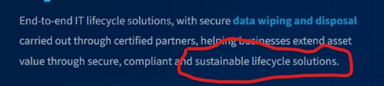
Link to /e-waste page

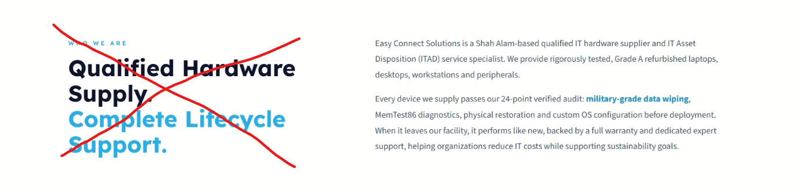
Who We Are should be H2
Add a relevant picture instead of “Qualified hardware supply. Complete lifecycle support.”


“Vision, Mission and Values” should be H2
rest should be normal text underneath like "where premium IT hardware..."

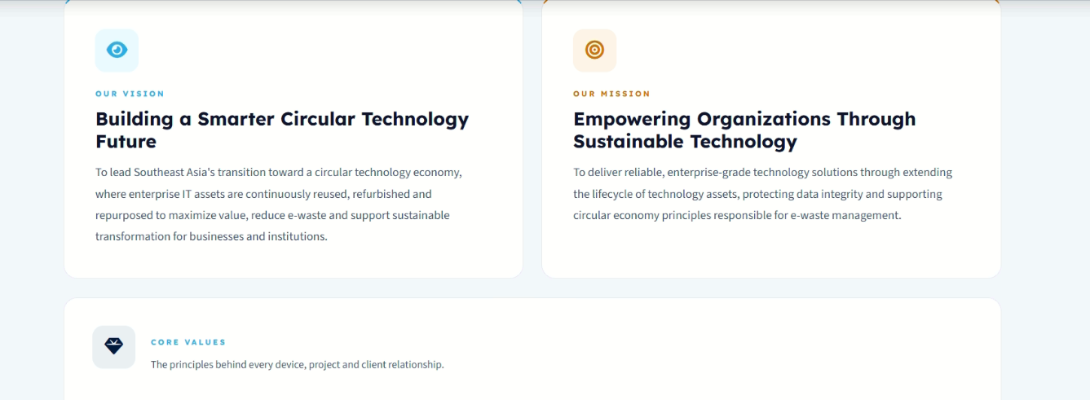
Our Vision, Our Mission, Core Values should be H3
“Building a Smarter Circular Technology Future”, “Empowering Organizations Through Sustainable Technology” should be italic H4

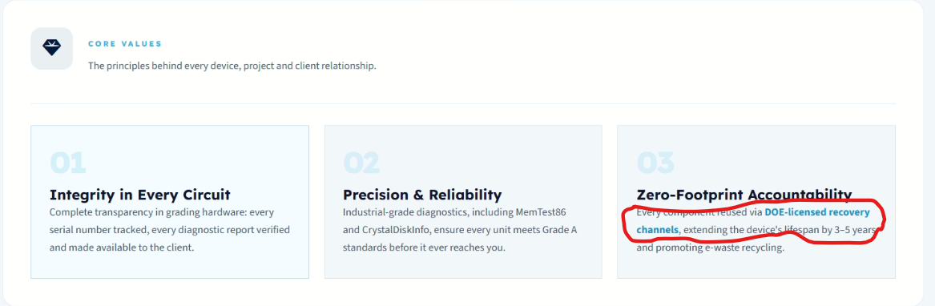
Remove link from “DOE licensed…” plz
“Integrity in Every Circuit”, “Precision & Reliability”, “Zero-Footprint Accountability” should be italic H4

brands we carry mein pehle logos aa rahe thay like above, wo ziada acha lag raha tha ab sirf naam aa raha brand ka.

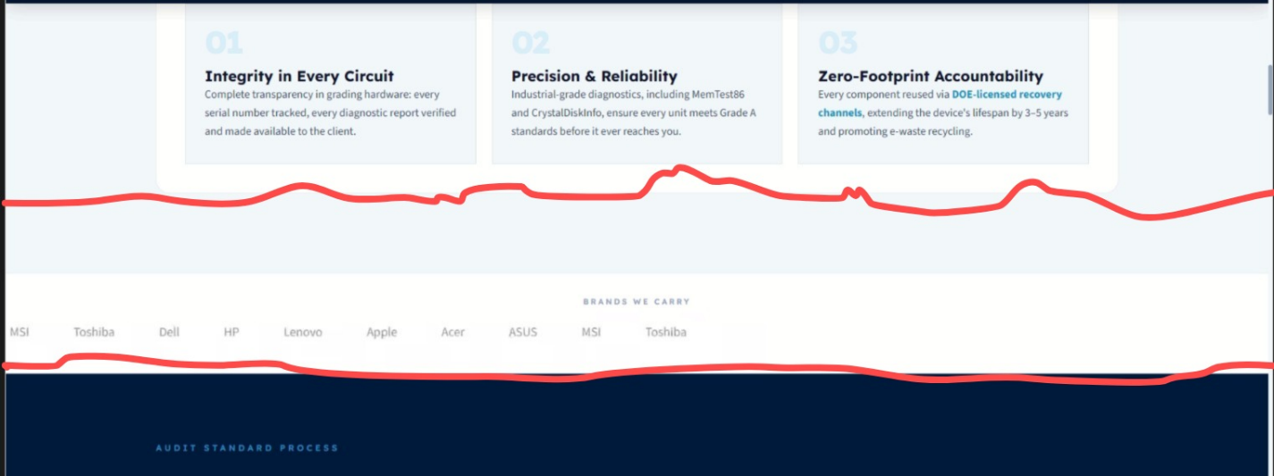
“Brands We Carry” should be between this area takay uske bad bhi kuch space ho, then ye audit standard process ka section aye. Currently it seems joined with audit standard...

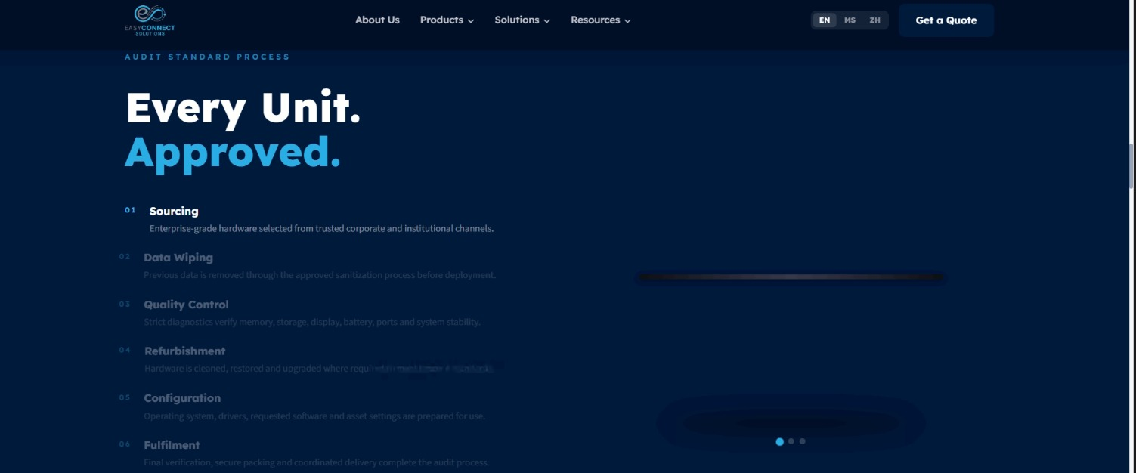
H2: Audit Standard Process
“Every Unit Approved” should be the eyebrow text
Rest of the headings 1-6 should be H3

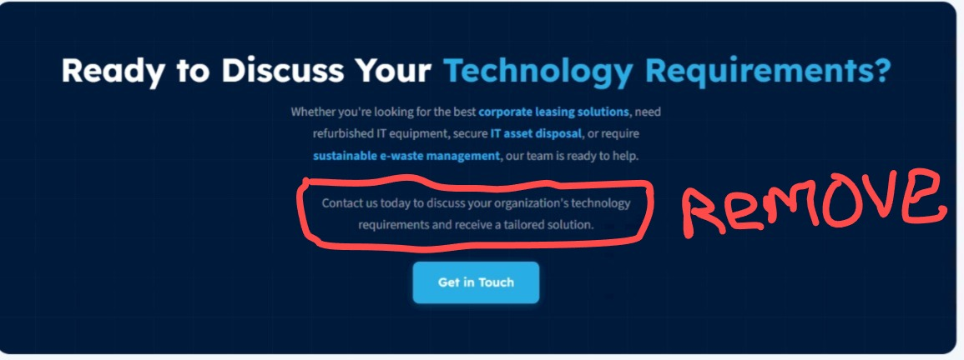
H2: Ready to Equip Your Organization?

/products/ Page
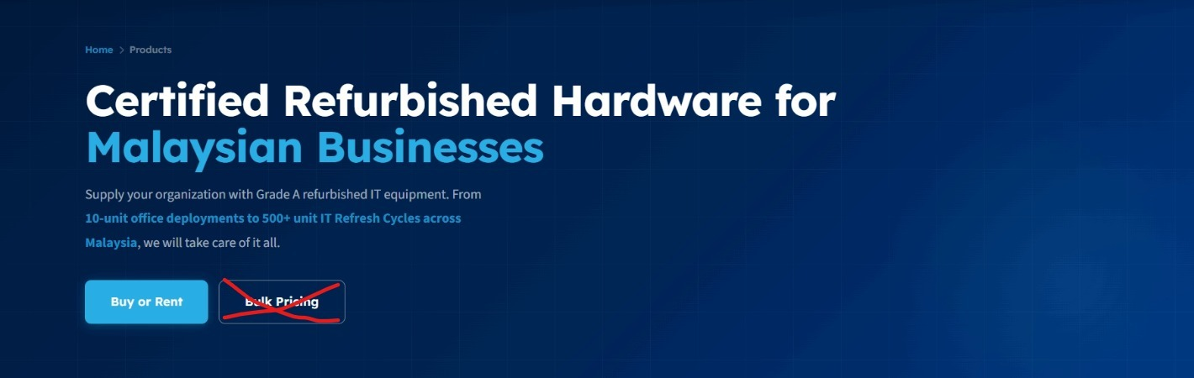
Remove “bulk pricing” button
sirf "IT refresh cycles" ko link krna hai

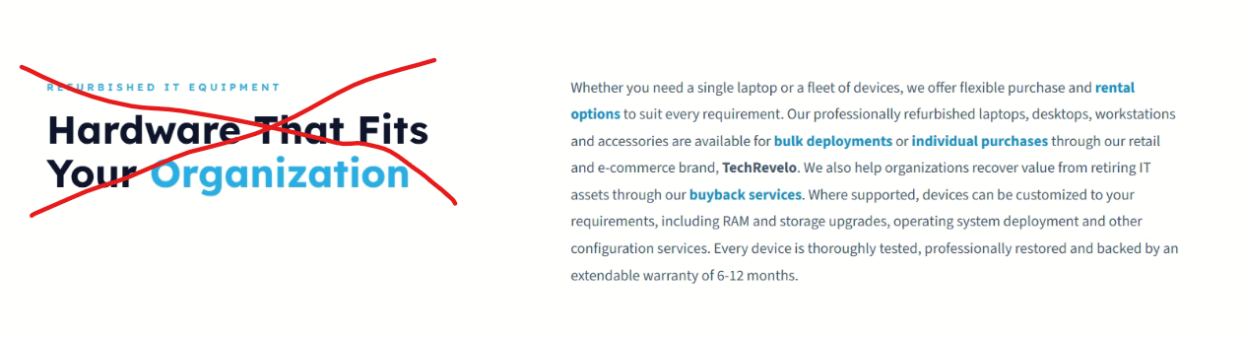
Add a relevant picture instead of “hardware that fits…” Techrevelo ki koi picture laga sakte maybe
Don’t link “individual purchases”
Link “retail” to the contacts page
Link “e-commerce brand, Techrevelo” directly to the shopee page

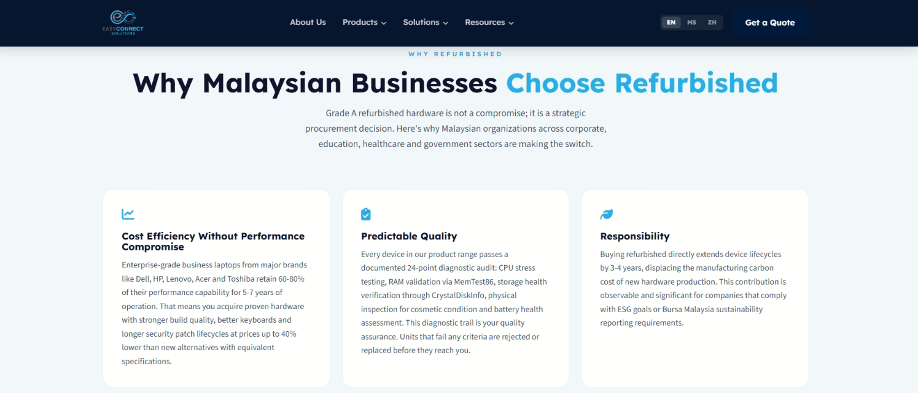

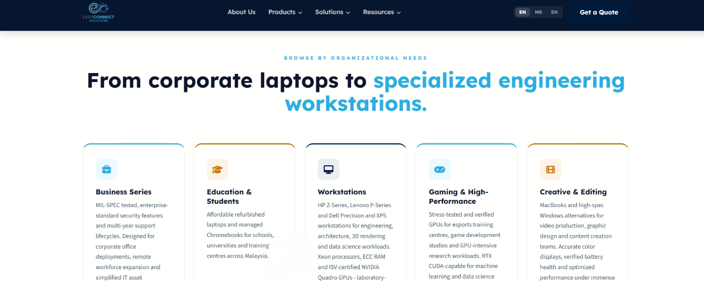
H2: Browse by Organizational Needs
“From corporate laptops to specialized engineering workstations.” Normal text in grey color under H2.
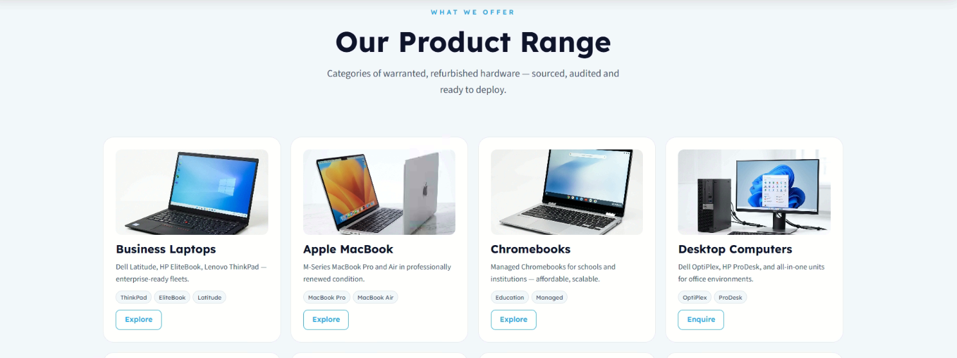

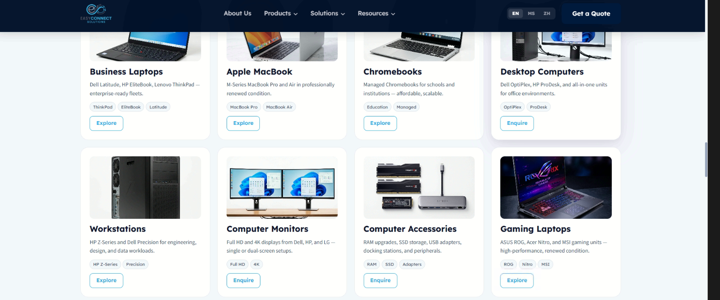
Instead of “Explore” button in every card, we can add just one “Explore” button below all these cards. Cards will occupy less space this way.

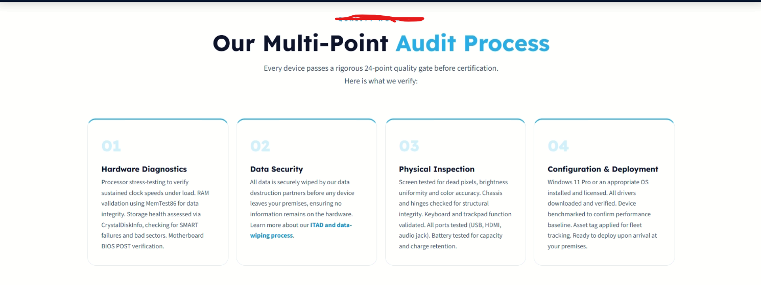

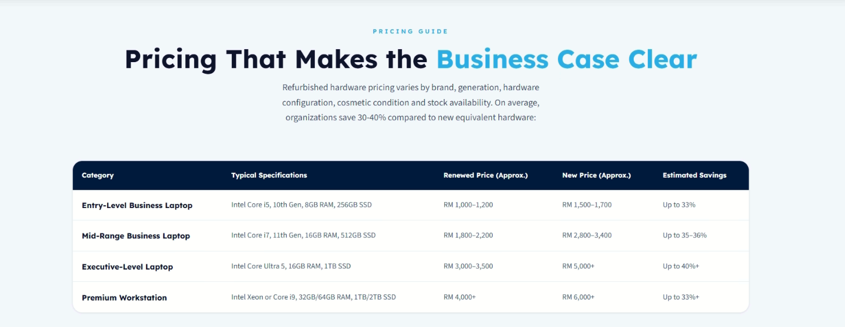
You can expand the circled text. 2 lines mein ajaye ga I guess


Add space before the circled text and link “speak with a Hardware Specialist.”

/products/business-series page
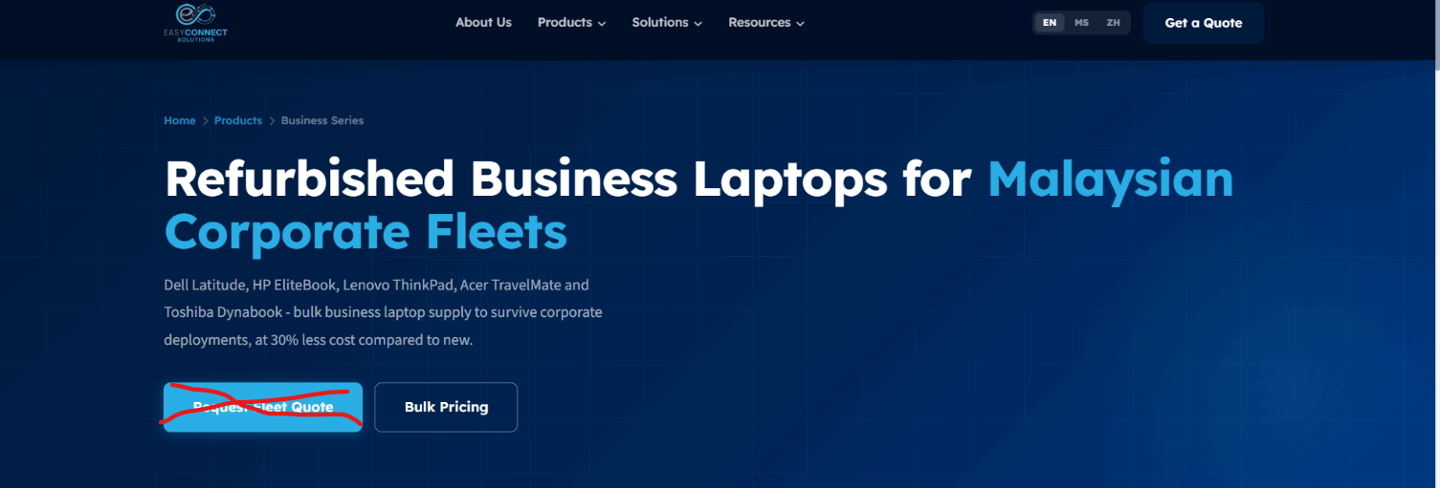

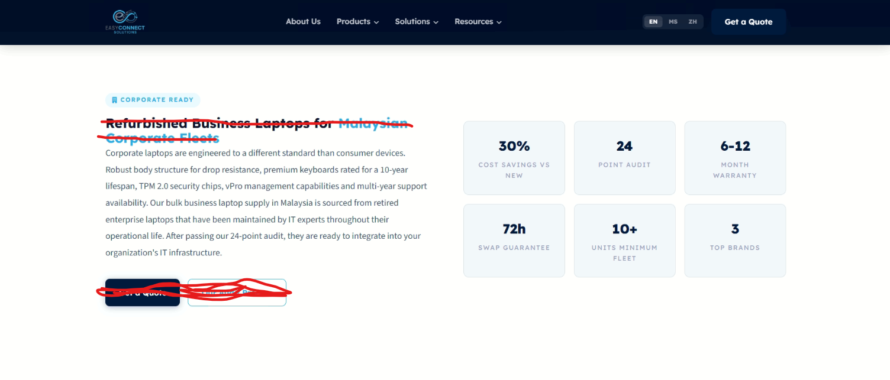
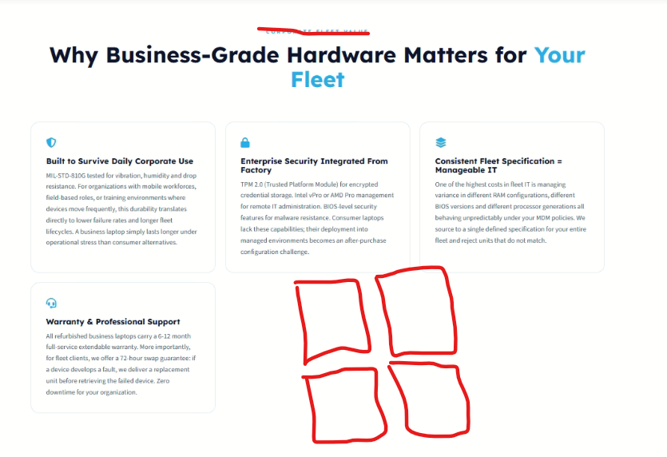
Arrange cards this way

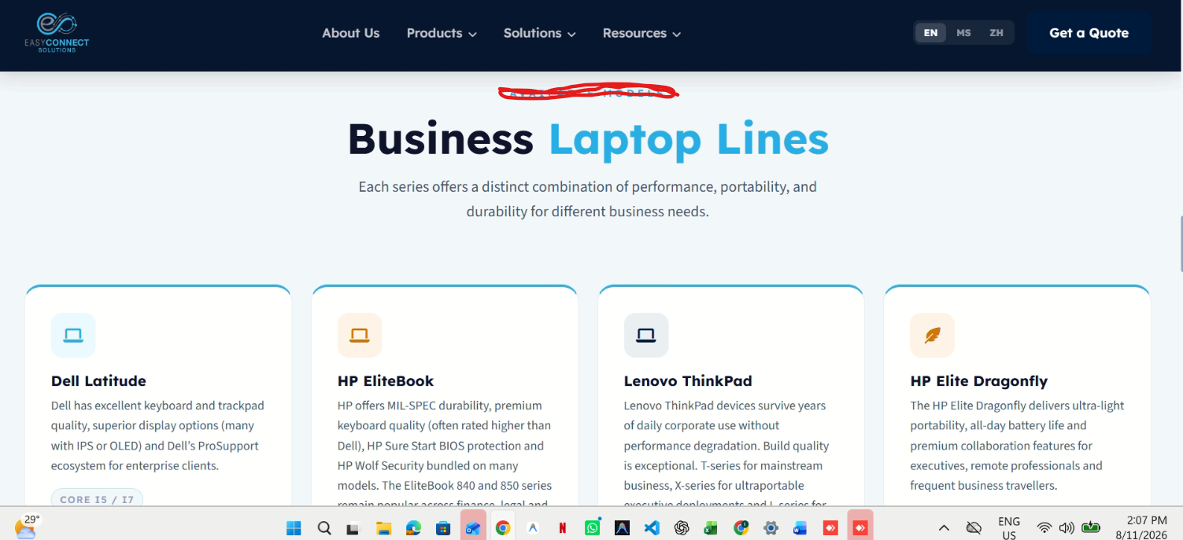
H2: Business Laptop Lines We Supply

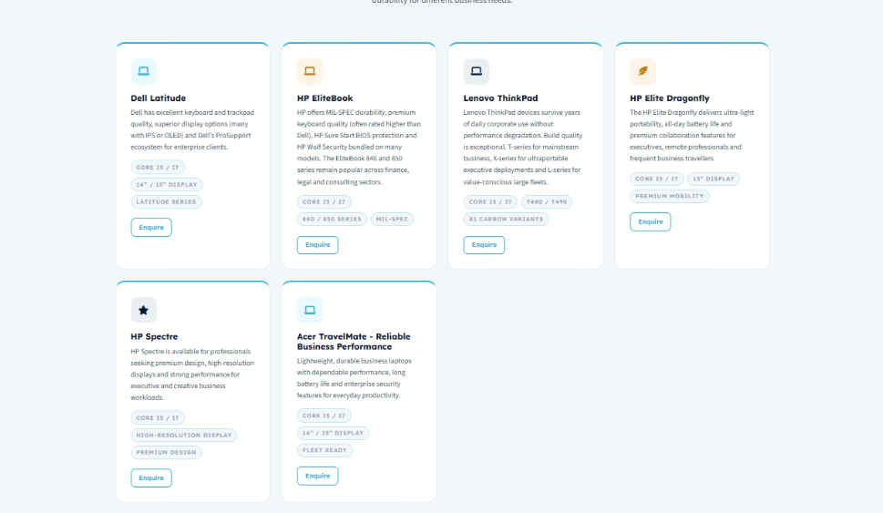
One enquire button beneath all cards
Arrange cards in the described manner.
Jo cut kia hai wo remove krna hai

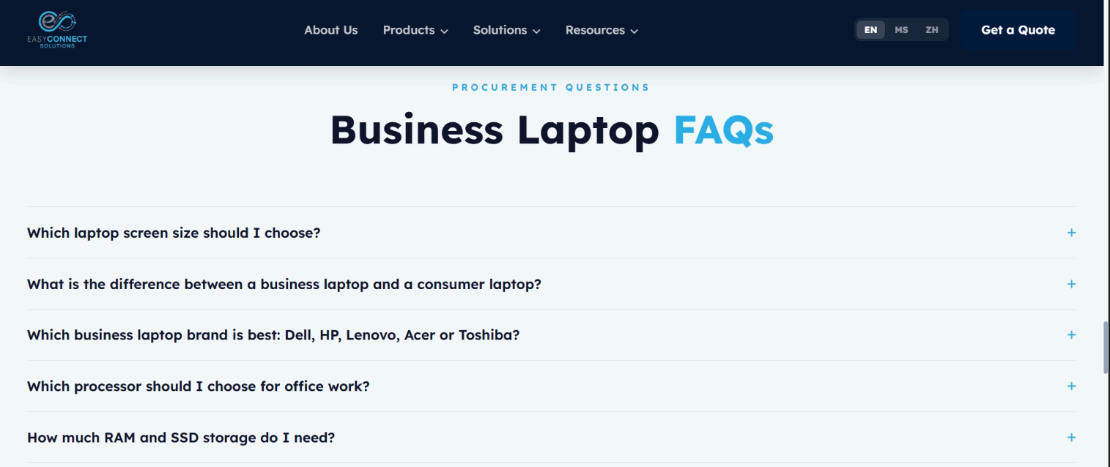
FAQ answers are not as provided. They are incomplete. Plz look into it.



