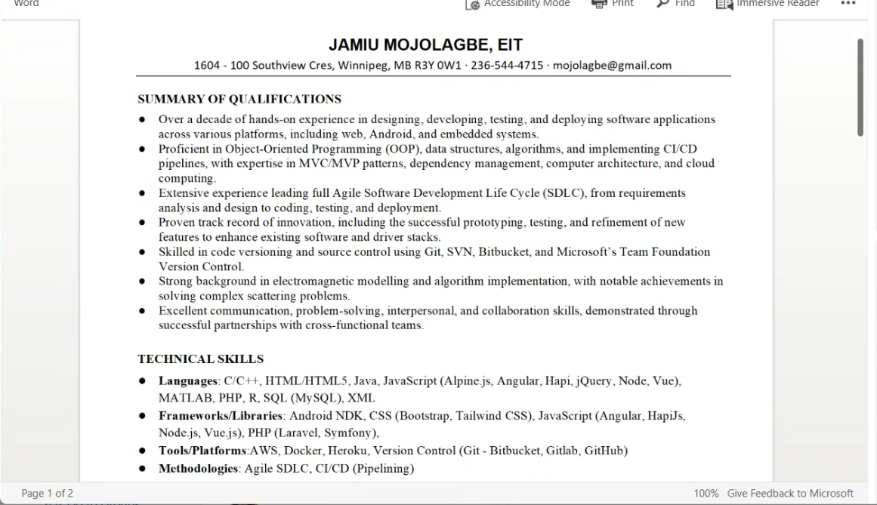

JAMIU MOJOLAGBE, EIT

1604 - 100 Southview Cres, Winnipeg, MB R3Y 0W1 ∙ 236-544-4715 ∙ mojolagbe@gmail.com

SUMMARY OF QUALIFICATIONS

● Over a decade of hands-on experience in designing, developing, testing, and deploying software applications across various platforms, including web, Android, and embedded systems.

● Proficient in Object-Oriented Programming (OOP), data structures, algorithms, and implementing CI/CD pipelines, with expertise in MVC/MVP patterns, dependency management, computer architecture, and cloud computing.

● Extensive experience leading full Agile Software Development Life Cycle (SDLC), from requirements analysis and design to coding, testing, and deployment.

● Proven track record of innovation, including the successful prototyping, testing, and refinement of new features to enhance existing software and driver stacks.

● Skilled in code versioning and source control using Git, SVN, Bitbucket, and Microsoft’s Team Foundation Version Control.

● Strong background in electromagnetic modelling and algorithm implementation, with notable achievements in solving complex scattering problems.

● Excellent communication, problem-solving, interpersonal, and collaboration skills, demonstrated through successful partnerships with cross-functional teams.

TECHNICAL SKILLS

● Languages: C/C++, HTML/HTML5, Java, JavaScript (Alpine.js, Angular, Hapi, jQuery, Node, Vue), MATLAB, PHP, R, SQL (MySQL), XML

● Frameworks/Libraries: Android NDK, CSS (Bootstrap, Tailwind CSS), JavaScript (Angular, HapiJs, Node.js, Vue.js), PHP (Laravel, Symfony),

● Tools/Platforms:AWS, Docker, Heroku, Version Control (Git - Bitbucket, Gitlab, GitHub)

● Methodologies: Agile SDLC, CI/CD (Pipelining)

● Operating Systems: Linux, Mac, Windows

● Parallel Computing: High-Performance Computing (HPC) using C/C++ (MPI and OpenMP)

WORK EXPERIENCE

Web Developer (R & D Department)

Real Estate Webmasters Inc. – Nanaimo, BC. Aug 2018 – Present

● Promoted from Professional Services Dept to R & D Department in Aug 2021 for exemplary performance and expertise in customising software developed by the R&D team.

● Architect design, requirement gathering, and development of web applications (in PHP, MySQL, HTML, CSS, JavaScript, jQuery, and Vue) within the R&D department.

● Utilise Agile methodologies to manage project scope, define user stories, and create use case diagrams to drive software development processes.

● Collaborate with peers (Design, SEO, Sales, and Project Coordination) to translate business requirements into technical solutions.

● Conduct regular code reviews and provide mentorship to junior developers to ensure code quality and adherence to best practices.

● Maintain documentation and track project progress within the project management tracking system.

● Identify problems, understand causes, evaluate, and recommend the best course of action, including proposing and implementing innovative solutions.

● Spearhead research initiatives to explore emerging technologies and industry trends, incorporating findings into product development strategies.

● Pioneered the creation of documentation on common customizations that was instrumental in educating the team on new products.

Research Assistant

University of Manitoba – Winnipeg, MB. May 2016 – Jun 2018

● Spearheaded the implementation of H-Matrices based EM fast solver (for scattering problems) in C/C++.

● Led the development and implementation of 10+ computational physics algorithms.

● Coordinated with other team members to ensure proper code versioning practices are employed.

● Profiled existing code, refactored inefficient steps and over 50% performance improvement was achieved.

Webmaster/Software Developer

KAISTE Ventures Limited - Lagos, Nigeria. Mar 2015 – May 2016

● Led the development of 10+ web applications and built 4 Android apps while strictly following MVP pattern.

● Refactored a major part of the company website thereby improving the site’s speed and/or performance.

● Performed compatibility tests across web browsers, operating systems, and devices.

● Oversaw periodic server maintenance, configuration, and troubleshooting.

Software Developer

HBLP ICT Centre – Warri, Nigeria May 2013 – Mar 2015

● Contributed to the development of 5+ desktop applications and 5 web solutions.

● Participated in the design, and deployment of software applications with well documented Use-Cases and UML diagrams.

● Participated in the maintenance, and enhancement of existing software solutions.

EDUCATION

PhD Electrical & Computer Engineering 2022 – Present

University of Manitoba – Winnipeg, MB, Canada

M. Sc. Electrical & Computer Engineering 2016 - 2018

University of Manitoba – Winnipeg, MB, Canada

B. Tech in Computer Engineering 2007 - 2012

Ladoke Akintola University of Technology – Ogbomoso, Nigeri