**LAB Assignment No. 5**



**Name: Arham Ijaz**

**Roll Number: FA21-BSE-018**

**Section: C**

**Subject: ICT**

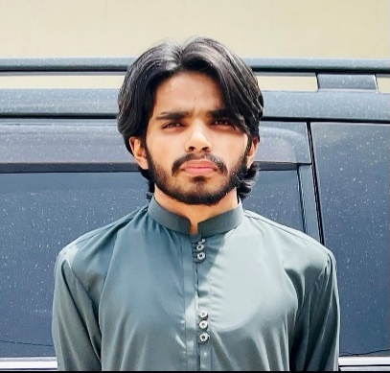

**Educational Background:**

* I did my O levels in 8 mandatory subjects (pre-med) in 2018 from The City School.
* I graduated from A levels in 3 subjects (pre-eng) in 2020 from Beaconhouse College Campus Gulberg

**Name**: Arham Ijaz

**Phone Number:** 03139900022

**Address:** Askari X, Lahore

**Email:** [arhamijaz57@gmail.com](mailto:arhamijaz57@gmail.com)

**Hobbies:**

1. Football
2. Programming
3. Gaming

**Professional Experience:**

* In A levels I did an internship in Plan9 (platform located in ITU, Arfa Karim Tower) where I learned and practiced graphic designing.
* I did freelancing on Upwork platform making static web pages using HTML5 and CSS3 and worked collaboratively with teams to work on front-end projects.

**Objective and Motivation:**

* My objective is to strive in this particular field and learn, explore and discover new exciting things in this profession. My personal interest is in Cyber Security which is one of the most emerging fields in this digitalized world.
* My motivation in this field is the freedom of work. A person is not restricted to certain prerequisites as compared to other jobs .Anyone of any age can work and show his/her skills.

**Skills:**

1. HTML5
2. CSS3
3. JAVASCRIPT
4. BOOTSTRAP 4
5. MS WORD
6. MS EXCEL
7. MS POWERPOINT
8. REACT JS
9. WORDPRESS