TASK 1
1. Existing users / roles and their permissions
SELECT
rolname,
rolsuper,
rolcreatedb,
rolcreaterole,
rolcanlogin,
rolreplication,
rolconnlimit,
rolvaliduntil
FROM pg_roles
ORDER BY rolname;

Output
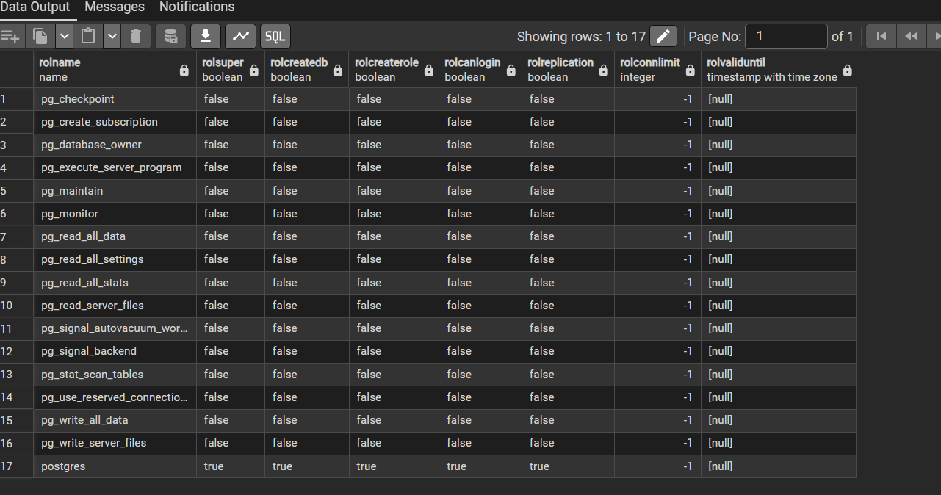

1.2 Role Memberships
SELECT
parent.rolname AS role_name,
member.rolname AS member_name,
am.admin_option
FROM pg_auth_members am
JOIN pg_roles parent ON parent.oid = am.roleid
JOIN pg_roles member ON member.oid = am.member
ORDER BY role_name, member_name;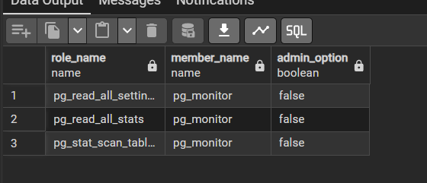

2. Table‑level privileges

SELECT
table_schema,
table_name,
grantee,
privilege_type
FROM information_schema.table_privileges
WHERE table_schema NOT IN ('pg_catalog', 'information_schema')
ORDER BY table_schema, table_name, grantee, privilege_type;

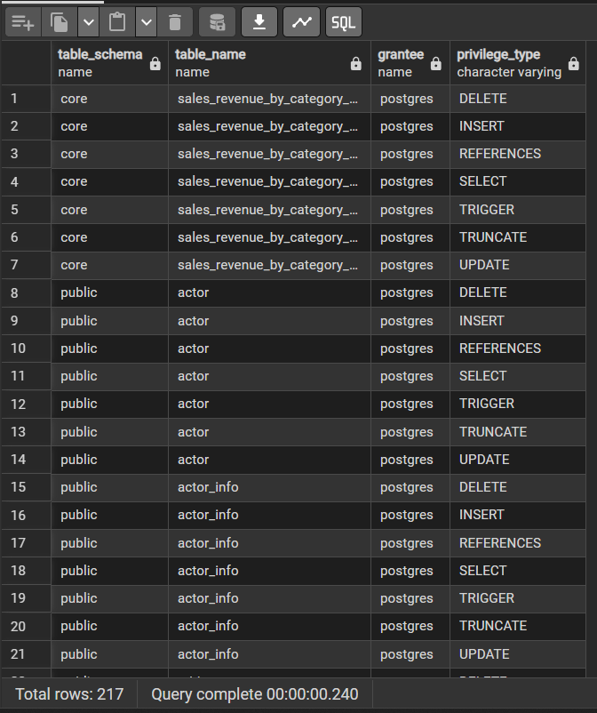

2.2. Privileges for specific tables

Customer table:
SELECT grantee, privilege_type
FROM information_schema.table_privileges
WHERE table_schema = 'public'
AND table_name = 'customer'
ORDER BY grantee, privilege_type;
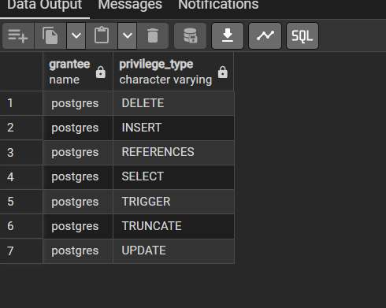

Rental table:

SELECT grantee, privilege_type
FROM information_schema.table_privileges
WHERE table_schema = 'public'
AND table_name = 'rental'
ORDER BY grantee, privilege_type;
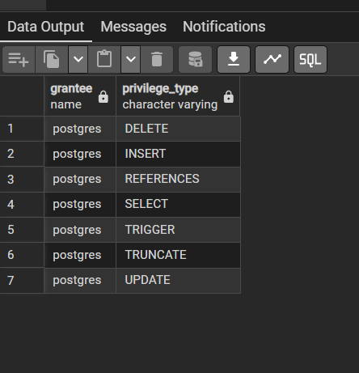

Payment table:

SELECT grantee, privilege_type
FROM information_schema.table_privileges
WHERE table_schema = 'public'
AND table_name = 'payment'
ORDER BY grantee, privilege_type;

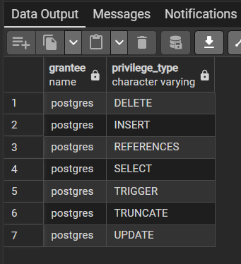

3. Existing row‑level security (RLS) policies

SELECT
schemaname,
tablename,
policyname,
permissive,
roles,
cmd,
qual,
with_check
FROM pg_policies
ORDER BY schemaname, tablename, policyname;
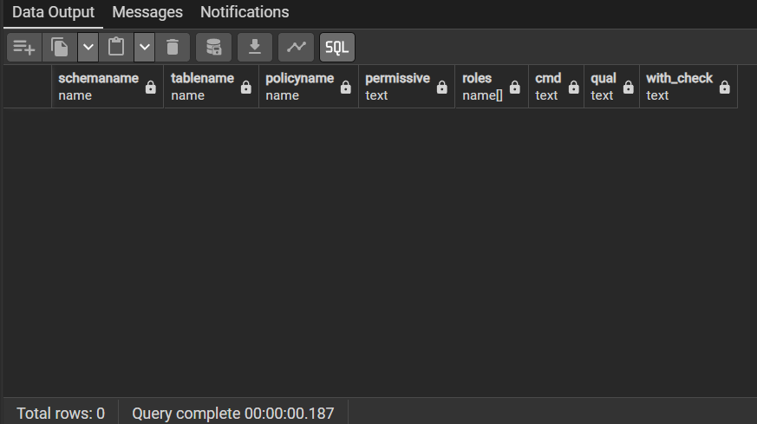
4. Database‑level settings (connection and authentication related)

4.1. Database connection limits for dvd_rental

SELECT
datname,
datdba::regrole AS owner,
datallowconn,
datconnlimit
FROM pg_database
WHERE datname = 'dvdrental';
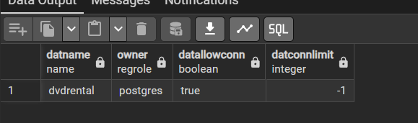

4.2. Global connection limit

SHOW max_connections;
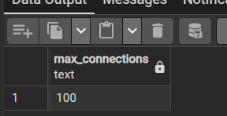

4.3. Password encryption and SSL

SHOW password_encryption;
SHOW ssl;
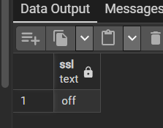

4.4. Client authentication configuration

SHOW hba_file;
