1 Business Description
1.1 Business background
A metropolitan subway system is a complex public transportation network designed for high-capacity, rapid transit in an urban area. Its core business is to provide safe, reliable, and efficient transportation for millions of passengers daily. This involves managing extensive infrastructure (stations, tracks, tunnels), a large fleet of trains, a significant workforce, and complex operational logistics like scheduling, ticketing, and maintenance.

1.2 Problems.
Current Situation
Without a centralized, well-designed database, a subway operator faces significant challenges:
- Data Silos: Information about schedules, maintenance, and staffing is often stored in separate, incompatible systems (like spreadsheets or legacy software), making it difficult to get a complete operational picture.
- Inefficient Scheduling: Creating and modifying schedules is a manual and error-prone process, leading to suboptimal train frequencies, delays, and inefficient use of trains and drivers.
- Reactive Maintenance: Maintenance is often performed only after a failure occurs, causing service disruptions. There's no easy way to track asset history or predict future maintenance needs.
- Poor Customer Information: It's difficult to provide passengers with real-time arrival/departure information or flexible ticketing options and promotions.
- Lack of Insight: Management cannot easily generate reports on key performance indicators like on-time performance, passenger volume, or maintenance costs, hindering strategic decision-making.

1.3 the Benefits of implementing a database.
Project Vision
Implementing this database will create a single source of truth for all subway operations.
Project Vision: To develop a centralized digital backbone that integrates all aspects of subway management, leading to enhanced operational efficiency, improved passenger experience, and data-driven strategic planning.
Benefits:
- Operational Efficiency: Automated scheduling, optimized crew and train assignments, and streamlined communication.
- Predictive Maintenance: A comprehensive log of all repairs and inspections allows for analysis that can predict failures before they happen, reducing downtime.
- Enhanced Passenger Experience: Enables real-time tracking of trains for apps and station displays. Facilitates a flexible and dynamic ticketing system with discounts and promotions.
- Data-Driven Decisions: Provides management with powerful reporting tools to analyze performance, ridership patterns, and operational costs.

2 Model description
The purpose of this database is to create a centralized, single source of truth for all subway operations, replacing the current system's inefficient data silos. It is designed as the digital backbone for managing the entire system, from infrastructure (like stations and trains) and scheduling to maintenance and staffing. The ultimate goal is to enhance operational efficiency, enable data-driven decisions, and improve the passenger experience.
The model is built around key entities such as lines, stations, trains, employees (workforce), and schedules. Several major design decisions were made to ensure data integrity and achieve Third Normal Form (3NF), directly addressing the current problems.
- Schedule Normalization (3NF): To fix inefficient scheduling, the concept of a "schedule" is broken down. The schedules table acts only as a template (e.g., "Weekday Peak"). The trips table represents a specific instance of that template (e.g., the 8:00 AM trip on Monday). Finally, the stop_times table holds the actual timetable (list of stations and times) for that one trip. This structure avoids massive data redundancy.
- Many-to-Many Relationships (M:N):
  - A critical M:N relationship exists between lines and stations (a station can be on multiple lines, and a line has many stations). This is resolved by a line_stations junction table, which also stores the stop_sequence to define the route's order.
  - A similar M:N junction table links ticket_types and promotions to facilitate a flexible ticketing system.
- Self-Referential Relationship: The employees (staffing) table uses a self-referential relationship (a manager_id column) to efficiently model the company's management hierarchy.
- Data Integrity: Constraints like NOT NULL are used on critical fields (e.g., trips.train_id, employees.role_id) to prevent incomplete or corrupt data, which is a key weakness of the current system.

2.1 Definitions & Acronyms
- ERD (Entity-Relationship Diagram): A visual blueprint that illustrates the tables (entities) and the logical connections (relationships) between them.
- 3NF (Third Normal Form): A database normalization standard applied to this model to reduce data redundancy. It means that every column in a table is dependent only on that table's primary key.
- PK (Primary Key): A field that uniquely identifies each record in a table. Its value must be unique and cannot be NULL.
- FK (Foreign Key): A field in one table that refers to the Primary Key in another table, creating a link.
- snake_case: The naming convention used in this model, where all words are lowercase and separated by underscores (e.g., first_name).

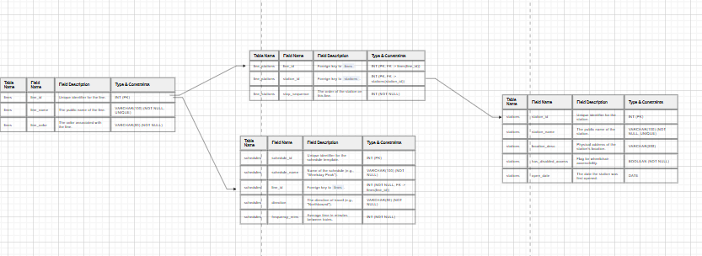
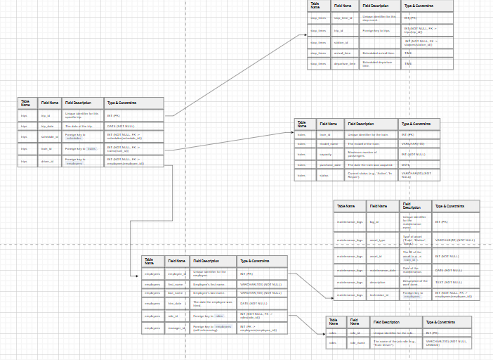
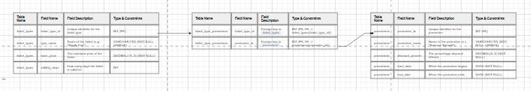
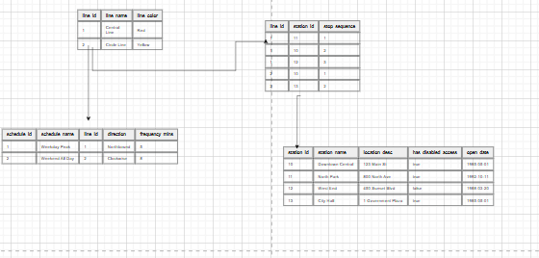
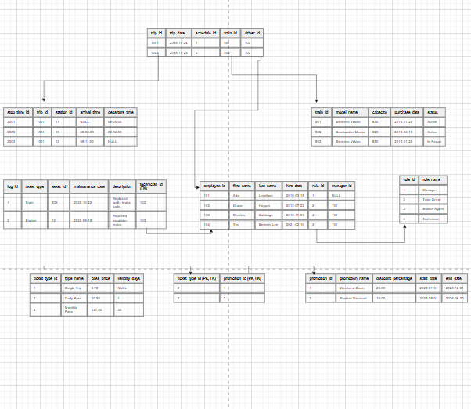

2.3 Objects
Table 1: lines
Stores information about each subway line or route.
Table Name | Field Name | Field Description | Type & Constraints
lines | line_id | Unique identifier for the line. | INT (PK)
lines | line_name | The public name of the line. | VARCHAR(100) (NOT NULL, UNIQUE)
lines | line_color | The color associated with the line. | VARCHAR(50) (NOT NULL)
Table 2: stations
<description> Stores information about each subway station.
Table Name | Field Name | Field Description | Type & Constraints
stations | station_id | Unique identifier for the station. | INT (PK)
stations | station_name | The public name of the station. | VARCHAR(100) (NOT NULL, UNIQUE)
stations | location_desc | Physical address of the station's location. | VARCHAR(255)
stations | has_disabled_access | Flag for wheelchair accessibility. | BOOLEAN (NOT NULL)
stations | open_date | The date the station was first opened. | DATE
Table 3: line_stations (Junction Table)
Links lines and stations to resolve their many-to-many relationship. Defines the order of stations on a line.
Table Name | Field Name | Field Description | Type & Constraints
line_stations | line_id | Foreign key to lines. | INT (PK, FK -> lines(line_id))
line_stations | station_id | Foreign key to stations. | INT (PK, FK -> stations(station_id))
line_stations | stop_sequence | The order of the station on this line. | INT (NOT NULL)
Table 4: trains
Stores information about each individual train in the fleet.
Table Name | Field Name | Field Description | Type & Constraints
trains | train_id | Unique identifier for the train. | INT (PK)
trains | model_name | The model of the train. | VARCHAR(100)
trains | capacity | Maximum number of passengers. | INT (NOT NULL)
trains | purchase_date | The date the train was acquired. | DATE
trains | status | Current status (e.g., 'Active', 'In Repair'). | VARCHAR(50) (NOT NULL)
Table 5: roles
Stores the different job roles for employees.
Table Name | Field Name | Field Description | Type & Constraints
roles | role_id | Unique identifier for the role. | INT (PK)
roles | role_name | The name of the job role (e.g., "Train Driver"). | VARCHAR(100) (NOT NULL, UNIQUE)
Table 6: employees
Stores information about all subway staff8. Features a self-referencing FK to model the management hierarchy.
Table Name | Field Name | Field Description | Type & Constraints
employees | employee_id | Unique identifier for the employee. | INT (PK)
employees | first_name | Employee's first name. | VARCHAR(100) (NOT NULL)
employees | last_name | Employee's last name. | VARCHAR(100) (NOT NULL)
employees | hire_date | The date the employee was hired. | DATE (NOT NULL)
employees | role_id | Foreign key to roles. | INT (NOT NULL, FK -> roles(role_id))
employees | manager_id | Foreign key to employees (self-referencing). | INT (FK -> employees(employee_id))
Table 7: schedules
Defines reusable schedule templates (e.g., weekday vs. weekend service)9.
Table Name | Field Name | Field Description | Type & Constraints
schedules | schedule_id | Unique identifier for the schedule template. | INT (PK)
schedules | schedule_name | Name of the schedule (e.g., "Weekday Peak"). | VARCHAR(100) (NOT NULL)
schedules | line_id | Foreign key to lines. | INT (NOT NULL, FK -> lines(line_id))
schedules | direction | The direction of travel (e.g., "Northbound"). | VARCHAR(50) (NOT NULL)
schedules | frequency_mins | Average time in minutes between trains. | INT (NOT NULL)
Table 8: trips
Represents a single, specific journey of a train following a schedule on a particular day.
Table Name | Field Name | Field Description | Type & Constraints
trips | trip_id | Unique identifier for this specific trip. | INT (PK)
trips | trip_date | The date of the trip. | DATE (NOT NULL)
trips | schedule_id | Foreign key to schedules. | INT (NOT NULL, FK -> schedules(schedule_id))
trips | train_id | Foreign key to trains. | INT (NOT NULL, FK -> trains(train_id))
trips | driver_id | Foreign key to employees. | INT (NOT NULL, FK -> employees(employee_id))
Table 9: stop_times
Stores the specific scheduled arrival and departure times for one trip at each station on its route.
Table Name | Field Name | Field Description | Type & Constraints
stop_times | stop_time_id | Unique identifier for this stop event. | INT (PK)
stop_times | trip_id | Foreign key to trips. | INT (NOT NULL, FK -> trips(trip_id))
stop_times | station_id | Foreign key to stations. | INT (NOT NULL, FK -> stations(station_id))
stop_times | arrival_time | Scheduled arrival time. | TIME
stop_times | departure_time | Scheduled departure time. | TIME
Table 10: maintenance_logs
A record of all maintenance and repair activities10.
Table Name | Field Name | Field Description | Type & Constraints
maintenance_logs | log_id | Unique identifier for the maintenance event. | INT (PK)
maintenance_logs | asset_type | Type of asset ('Train', 'Station', 'Track'). | VARCHAR(50) (NOT NULL)
maintenance_logs | asset_id | The ID of the asset (e.g., a train_id). | INT (NOT NULL)
maintenance_logs | maintenance_date | Date of the maintenance. | DATE (NOT NULL)
maintenance_logs | description | Description of the work done. | TEXT (NOT NULL)
maintenance_logs | technician_id | Foreign key to employees. | INT (NOT NULL, FK -> employees(employee_id))
Table 11: ticket_types
Stores the different kinds of tickets available for purchase111111.
Table Name | Field Name | Field Description | Type & Constraints
ticket_types | ticket_type_id | Unique identifier for the ticket type. | INT (PK)
ticket_types | type_name | Name of the ticket (e.g., "Single Trip"). | VARCHAR(100) (NOT NULL, UNIQUE)
ticket_types | base_price | The standard price of the ticket. | DECIMAL(10, 2) (NOT NULL)
ticket_types | validity_days | How many days the ticket is valid for. | INT
Table 12: promotions
Stores information about discounts and special offers121212.
Table Name | Field Name | Field Description | Type & Constraints
promotions | promotion_id | Unique identifier for the promotion. | INT (PK)
promotions | promotion_name | Name of the promotion (e.t., "Summer Special"). | VARCHAR(100) (NOT NULL, UNIQUE)
promotions | discount_percent | The percentage discount offered. | DECIMAL(5, 2) (NOT NULL)
promotions | start_date | When the promotion begins. | DATE (NOT NULL)
promotions | end_date | When the promotion ends. | DATE (NOT NULL)
Table 13: ticket_type_promotions (Junction Table)
Links ticket_types and promotions to resolve their many-to-many relationship13.
Table Name | Field Name | Field Description | Type & Constraints
ticket_type_promotions | ticket_type_id | Foreign key to ticket_types. | INT (PK, FK -> ticket_types(ticket_type_id))
ticket_type_promotions | promotion_id | Foreign key to promotions. | INT (PK, FK -> promotions(promotion_id))

Comments on table relationships
This model's relationships are designed to be normalized (3NF), ensuring data is stored logically without redundancy.
- Addressing the schedules Table: A common design question is why schedules doesn't contain station or time information. This is intentional and correct normalization. The schedules table is a template (e.g., "Weekday Peak," "Weekend Off-Peak"), not a specific timetable. This design directly addresses the problem of inefficient, manual scheduling. The logical flow is:
  - A line has many schedules.
  - A schedule is used to generate many trips (e.g., the 8:00 AM Weekday Peak trip on Oct 24th).
  - Each trip then has many entries in the stop_times table, which lists the actual stations and times for that specific trip. This hierarchy prevents storing the same timetable thousands of times.
- Many-to-Many Relationships:
  - lines ↔️ stations: Resolved by the line_stations junction table, which also uses stop_sequence to define the route order.
  - ticket_types ↔️ promotions: Resolved by the ticket_type_promotions table, allowing for flexible promotions.
- One-to-Many Relationships:
  - lines → schedules: One line has many schedules.
  - schedules → trips: One schedule template is used for many trips.
  - trips → stop_times: One trip has many station stops.
  - trains → trips: One train can run many trips.
  - employees → trips: One driver can run many trips.
  - roles → employees: One role applies to many employees.
  - employees → maintenance_logs: One technician can perform many maintenance actions.
  - stations → stop_times: One station appears in many stop times.
- Self-Referential Relationship:
  - employees ↔️ employees: The manager_id (FK) in the employees table points to the employee_id (PK) in the same table. This models the manager-employee hierarchy.

EXAMPLE WITH DATA :

roles
role_id | role_name
1 | Manager
2 | Train Driver
3 | Station Agent
4 | Technician

lines
line_id | line_name | line_color
1 | Central Line | Red
2 | Circle Line | Yellow

stations
station_id | station_name | location_desc | has_disabled_access | open_date
10 | Downtown Central | 123 Main St | true | 1985-05-01
11 | North Park | 800 North Ave | true | 1992-10-11
12 | West End | 450 Sunset Blvd | false | 1988-03-20
13 | City Hall | 1 Government Plaza | true | 1985-05-01

trains
train_id | model_name | capacity | purchase_date | status
501 | Siemens Velaro | 850 | 2015-01-20 | Active
502 | Bombardier Movia | 820 | 2018-06-15 | Active
503 | Siemens Velaro | 850 | 2015-01-20 | In Repair

ticket_types
ticket_type_id | type_name | base_price | validity_days
1 | Single Trip | 2.75 | NULL
2 | Daily Pass | 10.50 | 1
3 | Monthly Pass | 127.00 | 30

promotions
promotion_id | promotion_name | discount_percent | start_date | end_date
1 | Weekend Saver | 20.00 | 2025-01-01 | 2025-12-31
2 | Student Discount | 15.00 | 2025-09-01 | 2026-06-30

employees
employee_id | first_name | last_name | hire_date | role_id | manager_id
101 | Ada | Lovelace | 2010-03-15 | 1 | NULL
102 | Grace | Hopper | 2012-07-22 | 2 | 101
103 | Charles | Babbage | 2018-11-01 | 4 | 101
104 | Tim | Berners-Lee | 2021-02-10 | 3 | 101

line_stations
line_id | station_id | stop_sequence
1 | 11 | 1
1 | 10 | 2
1 | 12 | 3
2 | 10 | 1
2 | 13 | 2

schedules
schedule_id | schedule_name | line_id | direction | frequency_mins
1 | Weekday Peak | 1 | Northbound | 5
2 | Weekend All Day | 2 | Clockwise | 8

ticket_type_promotions
ticket_type_id | promotion_id
2 | 1
3 | 2

trips
trip_id | trip_date | schedule_id | train_id | driver_id
1001 | 2025-10-24 | 1 | 501 | 102
1002 | 2025-10-25 | 2 | 502 | 102

maintenance_logs
log_id | asset_type | asset_id | maintenance_date | description | technician_id
1 | Train | 503 | 2025-10-22 | Replaced faulty brake pads. | 103
2 | Station | 12 | 2025-09-15 | Repaired escalator motor. | 103

stop_times
(This data shows the specific timetable for Trip 1001)
stop_time_id | trip_id | station_id | arrival_time | departure_time
2001 | 1001 | 11 | NULL | 08:00:00
2002 | 1001 | 10 | 08:05:00 | 08:06:00
2003 | 1001 | 12 | 08:11:00 | NULL

