Project Report On

Railway Management System



**BY:ARHANJIT SINGH SODHI**

**102003116**

# INDEX

|  |  |
| --- | --- |
| **CONTENTS** | **PAGE NUMBER** |
| Problem Statement | 3 |
| ER Diagram | 4 |
| ER Diagram to Table | 5 |
| Normalized Tables | 6 |
| Creating tables | 7 |
| Insertion of data in the tables | 8 |
| SQL Output Screenshots | 10 |
| PL/SQL Codes and screenshots | 13 |

**Problem Statement**

A database to keep record of train timings and tracking the routes of trains. Moreover, keeping track of the total number of seats, the number of seats available and the price of each type of ticket while also keeping record of all the passengers and their type of ticket.

# Entity-Relationship Diagram

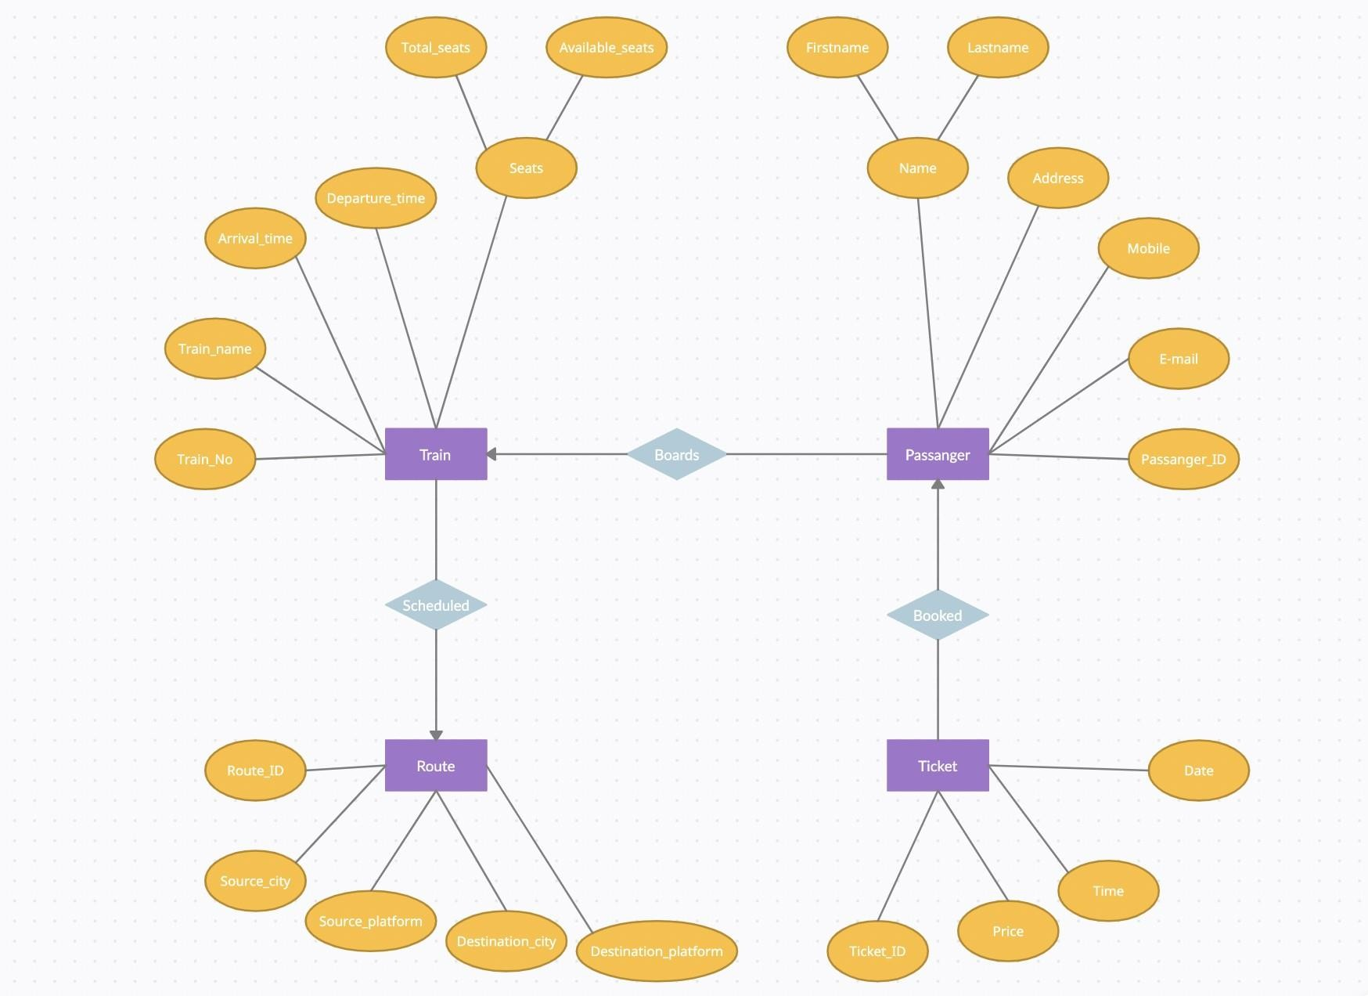

**ER Diagram to Table**

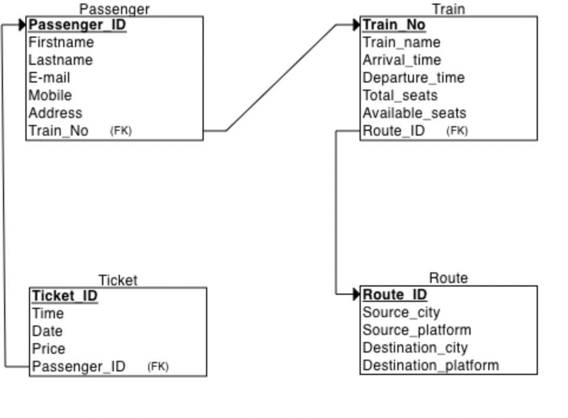

**Normalized Table**

Ticket Table

|  |  |  |  |  |
| --- | --- | --- | --- | --- |
| Ticket_ID | Time | Date | Price | Passenger_ID |

Passenger Table

|  |  |  |  |  |  |  |
| --- | --- | --- | --- | --- | --- | --- |
| Passenger_ ID | First name | Last name | E-mail | Mobile | Address | Train_No |

Train Table

|  |  |  |  |  |  |  |
| --- | --- | --- | --- | --- | --- | --- |
| Train_No | Train_ name | Arrival_ time | Departure_ time | Total_ seats | Available_ seats | Route_ ID |

Route Table

|  |  |  |  |  |
| --- | --- | --- | --- | --- |
| Route_ID | Source_city | Source_ platform | Destination_ city | Destination_ platform |

**Creating Table**

create table Route(Route_ID int primary key, Source_city varchar(20),

Source_platform int, Destination_city varchar(20), Destination_platform int);

create table Train(Train_No int primary key, Train_name varchar(20),

Arrival_time timestamp, Departure_time timestamp, Total_seats int, Available_seats int, Route_ID int,

CONSTRAINT FK_Route_ID FOREIGN KEY (Route_ID)

REFERENCES Route(Route_ID));

create table Passenger(Passenger_ID int primary key, Firstname varchar(20),

Lastname varchar(20), Email varchar(30), Mobile number(10), Address varchar(50), Train_No int,

CONSTRAINT FK_Train_No FOREIGN KEY (Train_No) REFERENCES Train(Train_No));

create table Ticket(Ticket_ID int primary key, Train_time timestamp,

Train_date date, Price number(10), Passenger_ID int,

CONSTRAINT FK_Passenger_ID FOREIGN KEY (Passenger_ID) REFERENCES Passenger(Passenger_ID));

# Inserting data in the Table

INSERT INTO Route VALUES(1, 'Delhi', 2, 'Patiala', 3);

INSERT INTO Route VALUES(2, 'Mumbai', 1, 'Kolkata', 6); INSERT INTO Route VALUES(3, 'Chennai', 4, 'Ahemdabad', 4); INSERT INTO Route VALUES(4, 'Shimla', 7, 'Bhopal', 5); INSERT INTO Route VALUES(5, 'Goa', 3, 'Bengluru', 8);

Select * from Route;

INSERT INTO Train VALUES(123,'PTL Express','10-Jun-2022 07:20:00am','9-Jun-2022 10:30:00pm',1000,843,1);

INSERT INTO Train VALUES(666,'BLR Shatabdi','19-May-2022 08:05:00pm','18-Jan2022 12:35:00am',500,321,5);

INSERT INTO Train VALUES(341,'Bengal EXP','22-May-2022 11:30:00am','21-May-2022 02:30:30pm',500,254,2);

INSERT INTO Train VALUES(101,'MP EXP','26-May-2022 11:30:00pm','26-May-2022 02:30:30pm',1000,754,4);

INSERT INTO Train VALUES(255,'GUJ Express','31-May-2022 09:30:00am','30-May-2022 12:30:30pm',500,254,3);

Select * from Train;

INSERT INTO Passenger VALUES(124, 'Ishan', 'Jain', 'ijain@gmail.com', 9899898812, 'Model Town, Ludhiana', 123);

INSERT INTO Passenger VALUES(73, 'Raj', 'Gupta', 'rgupta@gmail.com', 9873654812, 'Mall road, Shimla', 101);

INSERT INTO Passenger VALUES(492, 'Rohit', 'Thapar', 'rthapar@gmail.com', 8899898833, 'Ashok Vihar, Delhi', 123);

INSERT INTO Passenger VALUES(44, 'Riya', 'Rampal', 'rrampal@gmail.com', 7645898812, 'Beach road, Goa', 666);

INSERT INTO Passenger VALUES(317, 'Ishani', 'Sharma', 'isharma@gmail.com', 6439894313, 'Chennai', 255);

Select * from Passenger;

INSERT INTO Ticket VALUES(2819542664,'26-May-2022 02:30:30pm','26-May-2022',1500, 73);

INSERT INTO Ticket VALUES(1817642634,'9-Jun-2022 10:30:00pm','09-Jun-2022',500, 1); INSERT INTO Ticket VALUES(2961542333,'9-Jun-2022 10:30:00pm','09-Jun-2022',1250, 492);

INSERT INTO Ticket VALUES(1613742677,'30-May-2022 12:30:30pm','30-May-2022',400, 317);

INSERT INTO Ticket VALUES(1939542312,'18-Jan-2022 12:35:00am','18-Jan-2022',15000, 44);

# SQL Output Screenshots

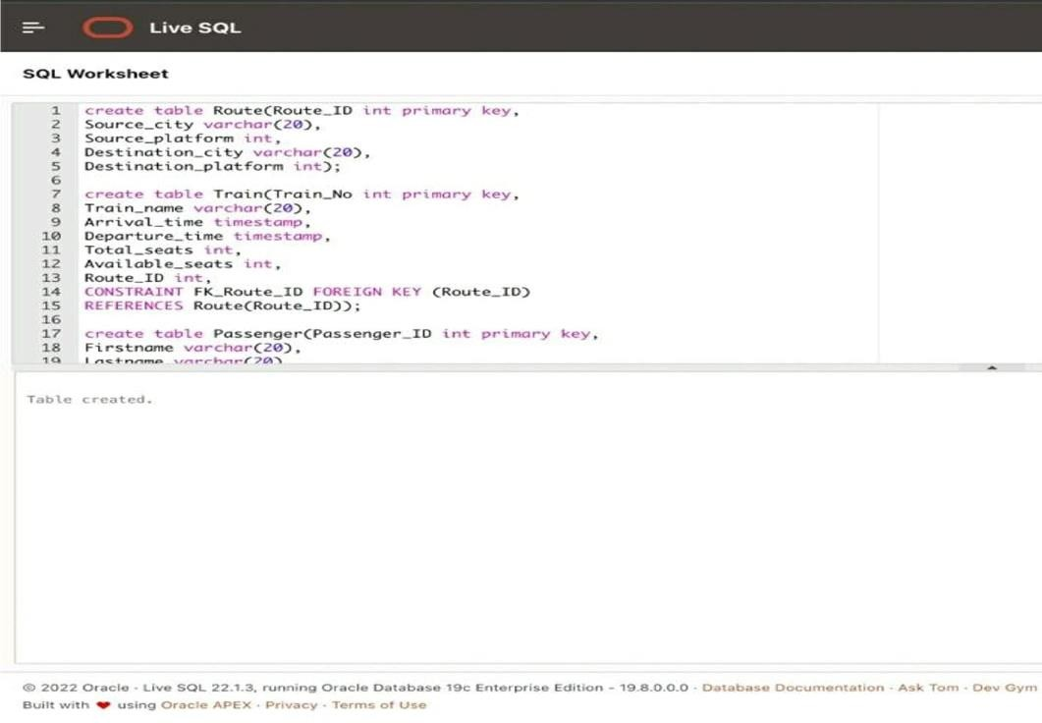

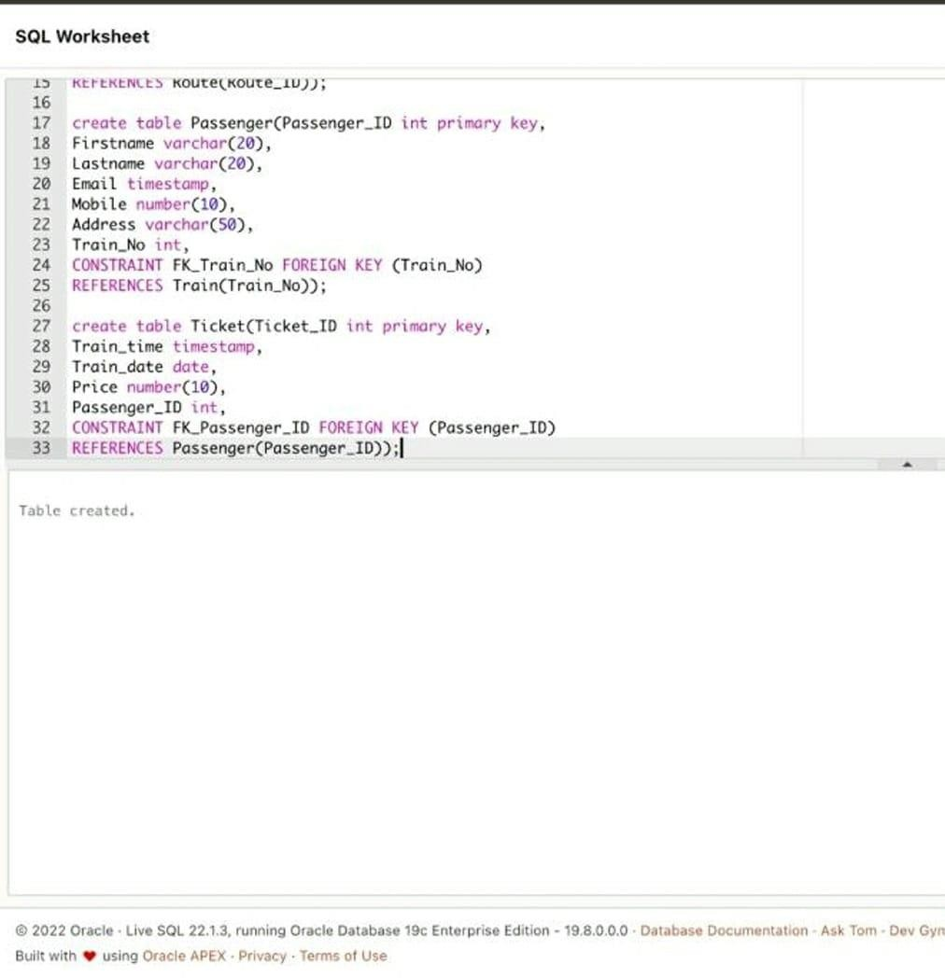

1. INSERT INTO Route VALUES(l,
2. INSERT INTO Route VALUESC2,
3. INSERT INTO Route VALUESC3,
4. INSERT INTO Route VALUES(4,
5. INSERT INTO Route VALUESCS,
6. Select * from Route:I

De1ht ' , 2, Patta1a , 3} ; Mumbat , 1, Ko1kata' , 6J; Chennai , 4, Ahendabad , 4g ; Shtulo , 7, Bhopal , 5} ; 'Goo', 3, 'Bengluru', 8);

|  |  |  |  |  |
| --- | --- | --- | --- | --- |
| R0UTE_ID | S0URCE_CITY | S0URCE_PLATF0RH | DESTINATI0N_€ITY | DESTINATI0N_PLATF0RH |
| 1 | De\.h1 |  | Pat1a\.a | 3 |
| 2 | Numba1 |  | Kolkata | 6 |
| 3 | Chenna 1 | 4 | Ahe¥dabad | 4 |
| 4 | Sh1mta | 7 | Bhopa \. | 5 |
| 5  Download | Goa  CSV | 3 | Beng tu ru |  |

5 rows selected.

4Z INSERT INTO Troin VALUES(123,'PTL Express','10-Juu Z0Z2 07:20:00om','9-1un-202Z 10:30:00pm',1000,843,1);

43 INSERT INTO Troin VALUES(666,'BLR Shotobdi’,'l9-Moy-2022 08:05:00pm',’18-JOn2022 12:35:00om',500,321,S);

44 INSERT INTO Tnoin VALUES(341,'Beugol EXP’,’2Z-Hoy-Z02Z 11:30:00om','21-Moy-Z022 02:30:30pm',S0e,ZS4,2);

45 INSERT INTO Troin VALUES(101,'HP EXP','26 Moy—2022 11:30:00pm',’Z6—Moy-Z0ZZ 02:30:30pm',1000,754,4);

1. INSERT INTO Train VALUES{Z55, ' GUJ Express’ , ' 31-Hay-Z0ZZ 09 : 30: 06om’ , ' 30-boy- ZOZZ 12: 3e : 30pm' , 500, Z54,33 ;
2. Select ” froa Tra** :l

ARItZVAL_TEHE Y0YAL_SEAtS At/AELABLE_SEATS R0UTE_1D

|  |  |  |  |  |  |  |
| --- | --- | --- | --- | --- | --- | --- |
| 123 | PTL Expres s | 18-JIPI-22 87.28.08.808888 AH | 09-JUN-22 16. 30.88.888880 PN | 1088 | B43 | 1 |
| 666 | BLR Shatabd i | 19JAY-22 BB.B5.6B.B608BB FBI | L8-3AN-2Z 1Z.35.BB. 6BBBg0 AN | SBB | 321 |  |
| 341 | Bengal EXP | 22—NAY-22 11.38.66.0e0688 IN | 21—NAY-2Z 82. 36. 36. 86086B PN | 508 | 254 |  |
| I0l | TR EXP |  |  |  | 754 | 4 |
| 255 | GU3 Expres s | 31—NAY-22 B9.3B.08. 960988 IN | 36—NAY-22 12.36.36.B96896 PN | 568 | 254 |  |

Ba\an toad CSV

5 rows sete ct ed .

1. INSERT INTO Possengen VALUES(124, 'Ishon', 'Join’, 'ijoin0gmoil.com', 9899898812, 'Model Town, Ludhiono', 123J;
2. INSERT INTO Possengen VALUESC73, ’Rgj', '(upto', 'n9uptaen„tl.com', 9873654812, 'Moll rood, Shimlo', 101J;
3. INSERT INTO Possengen VALUESC492, 'Rohit', 'Thopor’, 'rthOpon0gmoil.com', 8899898833, 'Ashok Vihon, Delhi', 123J;
4. INSERT INT0 Pos senger VALUES{44, ' Riya' , ’Rompot ’ , ’ rrompat9gmoi I . com’ , 7645898812, ’ Beach road , Gov ' , 6663 ;
5. INSERT INTO Possengen VALUESC317, 'Ishoni', 'ShOrmO', 'ishormo0gmOil.com', 6439894313, 'Chennai', 255J;
6. Select from Passenger;

|  |  |  |  |  |  |  |
| --- | --- | --- | --- | --- | --- | --- |
| PASSEHGER_ID | FIRSTHAHE | LASTNAf1E | EnAIL | FI0BILE ADDRESS | | |
|  | Is han | 3a in | ij a inqgnaiI. com | 9899898812 | Nodet Town, Ludhiana | 123 |
| 73 | Raj | Gupta | rguptaQgmail.com | 9873654812 | Mall road, Shimld | 101 |
| 492 | Rohit | Thapa r | rthapar0gmail.coil | 8B99898833 | As hok Viha r, Delhi | 123 |
| 44 | Riya | Ranpa I | rrampa tqgmai\. coa | 7645898812 | Beach road, Goa | 666 |
| 317 | Is hani | Sharna | ssharna0gmall.*com* | 6439894313 | Chennai | 255 |

Down toad CSV

5 rows selected .

57

58 INSERT INT0 Ttcket VALUES{2819542664, ’ Z6—May— Z02Z 02 : 30 : 30pm’ , ’ 26—May— Z022 ’ , 1500, 73} ;

59 INSERT INTO Ticket VALUES(1817642634,'9-Jun-202Z 10:30:00pm','09-Jun-Z0Z2',500, IQ;

60 INSERT INTO Ticket VALUES(2961542333,'9-Jun-202Z 10:30:00pm','09-Jun-Z0Z2',1250, 49Z);

61 INSERT INTO Ticket VALUES(16I3742677,'30-Moy-Z0ZZ 12:30:30pm','30-Moy-Z022',400, 317);

62 INSERT INTO Ticket VALUES(1939542312,'18-Jon-Z0ZZ 12:35:00om','18-Jon-Z022',15000, 44J;

63 Select * from Ticket;

|  |  |  |  |  |
| --- | --- | --- | --- | --- |
| TICKET_ID | TRAIN_TINE | TRAIN_DATE | PRICE | PASSENGER_ID |
| 2961542333 | 09—3UN—22 10.36. 00. 0000e0 PN | 09—3UN—22 | 1250 | 492 |
| 1613742677 | 30—NAY—22 12.36.30. 0000e0 PN | 30—HAY—22 | 460 | 317 |
| 1939542312 | 18—3AN—22 12.35. 66. 0000e0 AH | 18—3AN—22 | 15060 | 44 |
| 1817642634 | 09—3UN—22 10.36. 66. 0000e0 PN | 09—3UN—22 | 560 | 1 |
| 2819542664 | 26—NAY—22 e2.36.36. 0000e0 PN | 26—NAY—22 | 1506 | 73 |

Down toad

5 rows seI ec t ed.

# PL/SQL Codes and Screenshots

## To display details of all passengers

Declare

P_Firstname Passenger.Firstname%type; P_Lastname Passenger.Lastname%type; Mobile Passenger.Mobile%type; Address Passenger.Address%type;

Cursor c IS select Firstname,Lastname,Mobile,Address from Passenger;

Begin open c; loop

fetch c into P_Firstname,P_Lastname,Mobile,Address; exit when c%NOTFOUND;

dbms_output.put_line(P_Firstname||' '||P_Lastname||' '||Mobile||' '||Address); end loop;

close c; end;

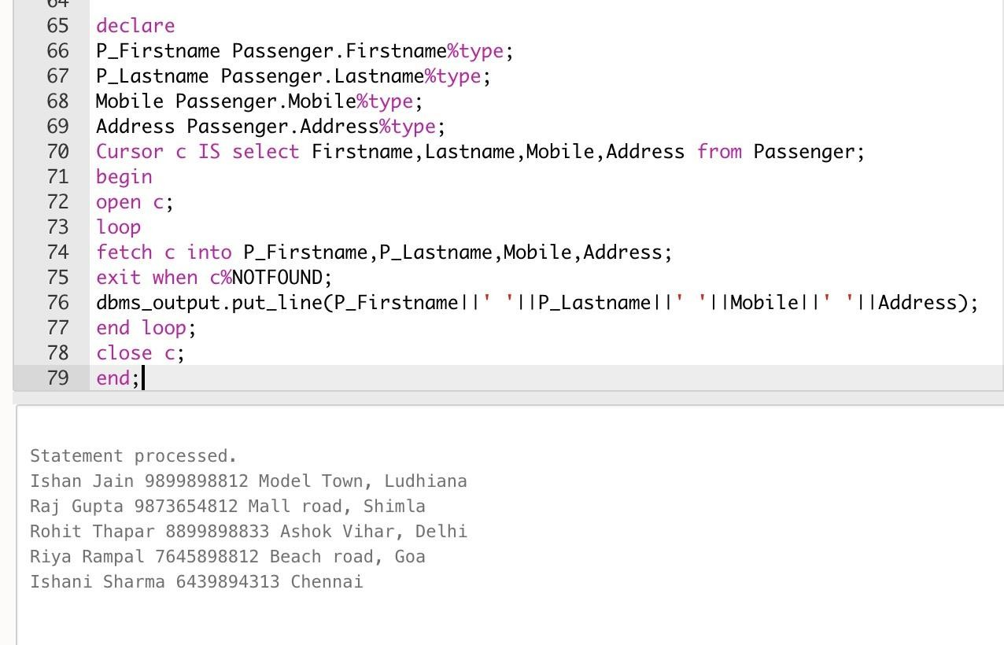

## To display the details of passenger whose has taken highest fair ticket

declare

P_Firstname Passenger.Firstname%type; P_Lastname Passenger.Lastname%type; Mobile Passenger.Mobile%type; Address Passenger.Address%type;

CustomerId Passenger.Passenger_ID%type;

Cursor c IS select P.Firstname,P.Lastname,P.Mobile,P.Address,T.Passenger_ID from Passenger P,Ticket T where

Price=(select max(Price) from Ticket) and T.Passenger_ID=P.Passenger_ID; begin

open c; loop

fetch c into P_Firstname,P_Lastname,Mobile,Address,CustomerId; exit when c%NOTFOUND;

dbms_output.put_line(P_Firstname||' '||P_Lastname||' '||Mobile||' '||Address||' '||CustomerId||' ');

end loop; close c; end;

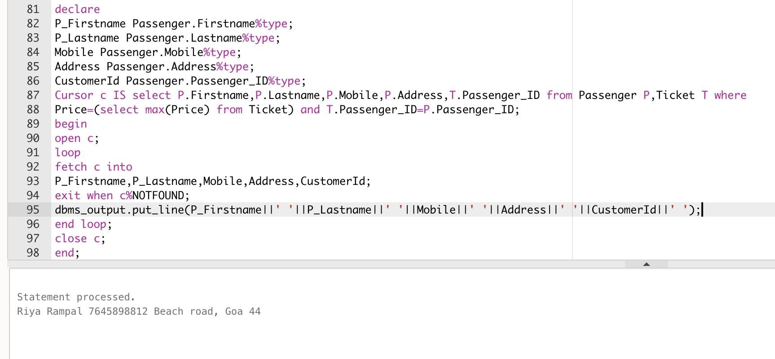

## To display the details of passenger whose train is in evening declare

declare

P_Firstname Passenger.Firstname%type; P_Lastname Passenger.Lastname%type; Mobile Passenger.Mobile%type; Address Passenger.Address%type; Train_No Passenger.Train_No%type;

Cursor c IS select P.Firstname,P.Lastname,P.Mobile,P.Address,T.Train_No from Passenger P,Train T where

to_char(T.Arrival_time,'pm')='pm' and T.Train_No=P.Train_No; begin

open c; loop

fetch c into P_Firstname,P_Lastname,Mobile,Address,Train_No; exit when c%NOTFOUND;

dbms_output.put_line(P_Firstname||' '||P_Lastname||' '||Mobile||' '||Address||' '||Train_No||' ');

end loop; close c; end;

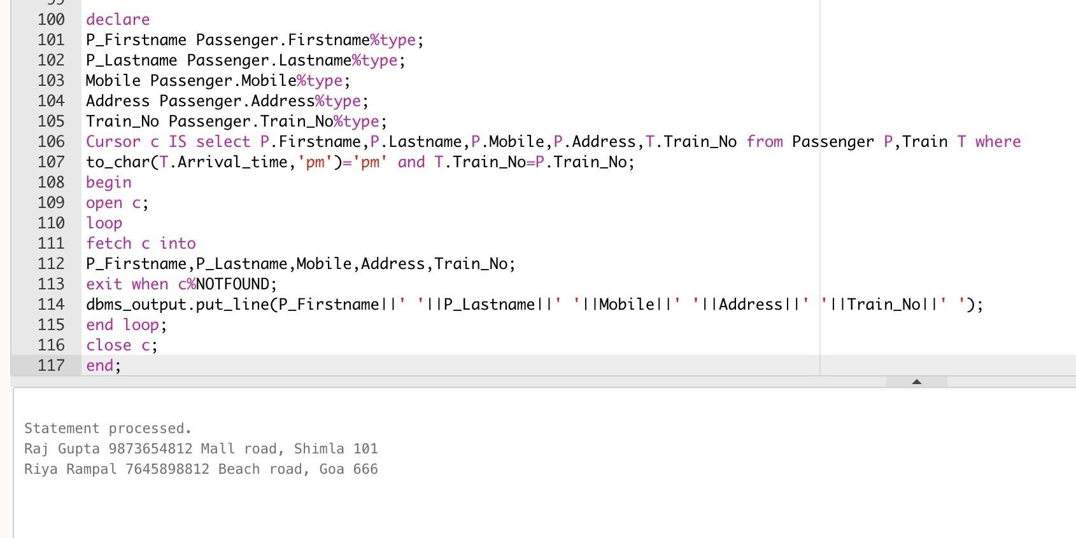

## Exception handling

declare

P_Email Passenger.Email%type; P_Passenger_ID Passenger.Passenger_ID%type; e_invalid_ID EXCEPTION;

begin

update Passenger

set Email = 'random@gmail.com' where P_Passenger_ID = 2;

if SQL%NOTFOUND then raise e_invalid_ID;

End if; commit; EXCEPTION

When no_data_found then dbms_output.put_line('No such record');

When too_many_rown then dbms_output.put_line('More than one record found');

When e_invalid_ID then dbms_output.put_line('No such passenger exists');

When others then dbms_output.put_line('Some error found'); end;

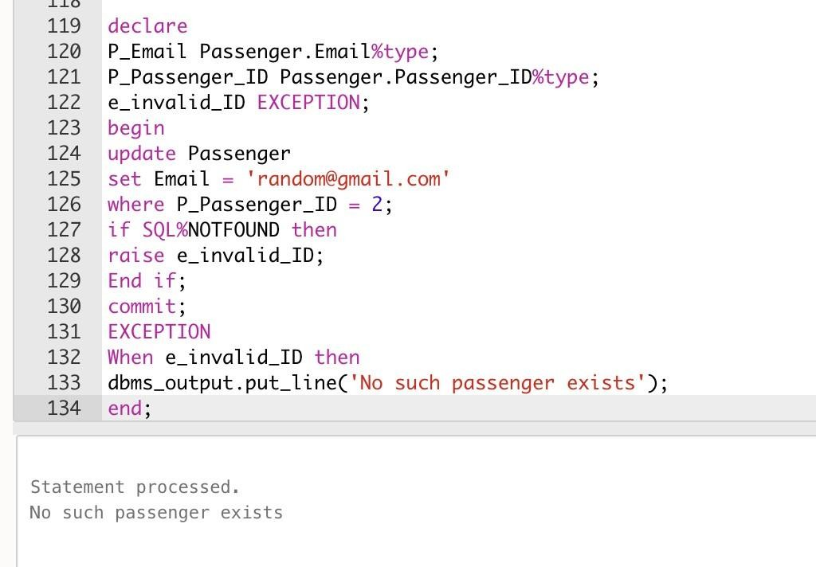

## Procedure to add route

create or replace procedure add_route (R_ID in Route.Route_ID%type, S_city in Route.Source_city%type,

S_platform in Route.Source_platform%type, D_city in Route.Destination_city%type, D_platform in Route.Destination_platform%type) is

begin

insert into Route values (R_ID, S_city, S_platform, D_city, D_platform); dbms_output.put_line('Route added.');

end;

execute add_route(6,'Patiala',4,'Hydrabad',8); select * from route;

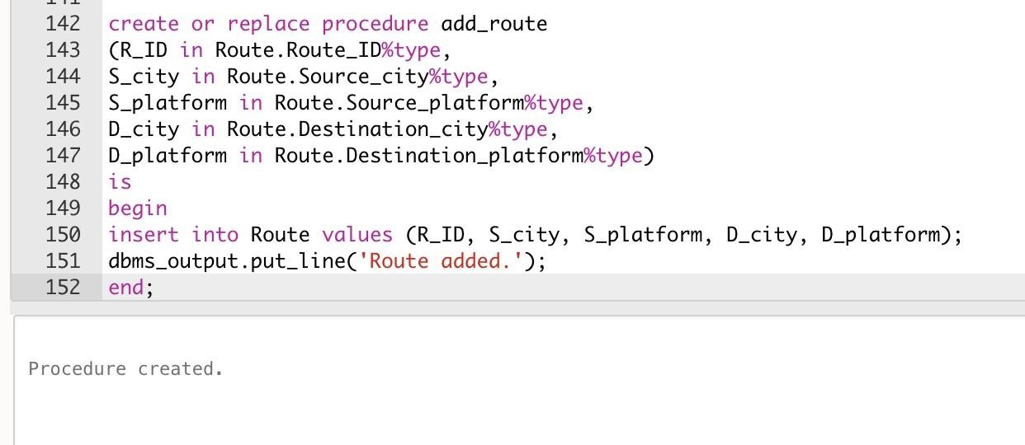

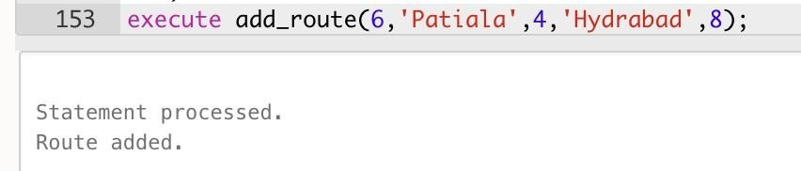

1. creote *or* replace procedure odd_route
2. (R_ID in Route.Route_ID%type,
3. S_city tn Route.Source_ctty%type,
4. S_plotform in Route.Source_plotform%type,
5. D_city tn Route.Desttnotton_ctty%type,
6. D_plotform in Route.Desttnotion_plotform%type)
7. IS
8. begin
9. insert tnto Route vogues (R_ID, S_city, S_plotform, D_city, D_plotform);
10. dbms_output.put_line('Route Odded.');
11. end ;
12. execut.e odd_route{6, ’ PatI aI a ' , 4, ' Hyd rabad ’ , 8} ;
13. set eel. * from route :I

|  |  |  |  |  |
| --- | --- | --- | --- | --- |
| R0UTE_ |  | | | |
| 6 | Patiata | 4 | Hyd rabad |  |
| 1 | Delhi |  | Patiata | 3 |
|  | Mumbai | 1 | No I kat a |  |
| 3 | Chennai | 4 | Ahendaba d | 4 |
| 4 | Shimla  Goa | 3 | Bhopal  Beng I u ru | 5 |

