CREATE TABLE route

(

route_id NUMBER PRIMARY KEY,

source_city VARCHAR2(500),

dest_city VARCHAR2(500),

source_country VARCHAR2(500),

dest_country VARCHAR2(500),

distance NUMBER

);

-------------------------------------------------------------------------------------------------------------------

insert into route (route_id, source_city, dest_city, source_country, dest_country, distance) values (1, 'Grazhdanka', 'Solnechnoye', 'Russia', 'Russia', '5585');

insert into route (route_id, source_city, dest_city, source_country, dest_country, distance) values (2, 'Mont-Laurier', 'Jiangtian', 'Canada', 'China', '879');

insert into route (route_id, source_city, dest_city, source_country, dest_country, distance) values (3, 'Nanganumba', 'Amiens', 'Indonesia', 'France', '1723');

insert into route (route_id, source_city, dest_city, source_country, dest_country, distance) values (4, 'Cruz', 'Zhouling', 'Portugal', 'China', '244');

insert into route (route_id, source_city, dest_city, source_country, dest_country, distance) values (5, 'Višňové', 'Karviná', 'Czech Republic', 'Czech Republic', '25');

insert into route (route_id, source_city, dest_city, source_country, dest_country, distance) values (6, 'Samut Sakhon', 'Joroan', 'Thailand', 'Philippines', '3800');

insert into route (route_id, source_city, dest_city, source_country, dest_country, distance) values (7, 'Santa Rosa de Copán', 'Malandag', 'Honduras', 'Philippines', '2118');

insert into route (route_id, source_city, dest_city, source_country, dest_country, distance) values (8, 'Laocheng', 'Bochov', 'China', 'Czech Republic', '2569');

insert into route (route_id, source_city, dest_city, source_country, dest_country, distance) values (9, 'Herby', 'Vila Velha', 'Poland', 'Brazil', '36');

insert into route (route_id, source_city, dest_city, source_country, dest_country, distance) values (10, 'Anin', 'Solok', 'Indonesia', 'Indonesia', '981');

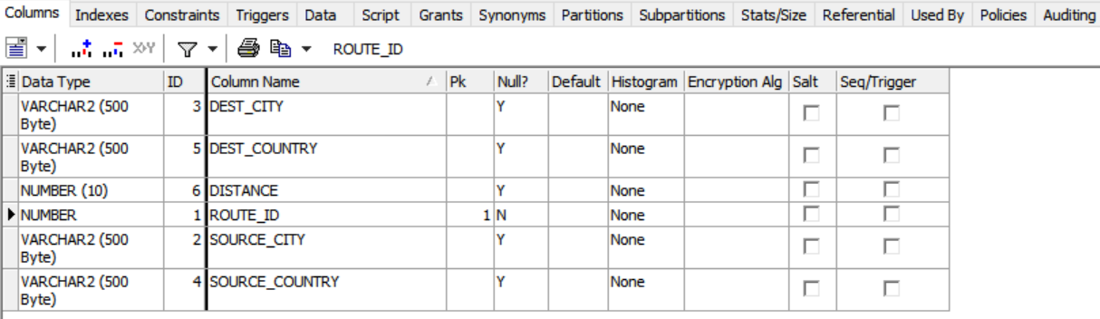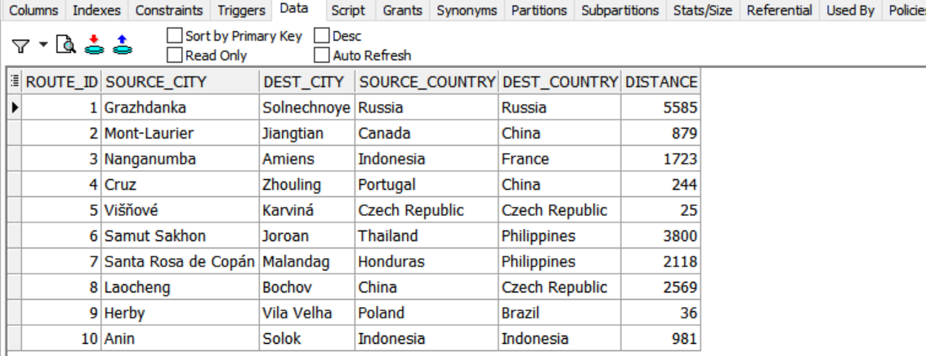

CREATE TABLE aircraft

(

aircraft_id NUMBER PRIMARY KEY,

model VARCHAR2(500),

type VARCHAR2(500),

manufacturer VARCHAR2(500),

capacity NUMBER(10)

);

insert into aircraft (aircraft_id, model, type, manufacturer, capacity) values (1, 'Paseo', 'Piseo-ri (Muan)', 'Toyota', 645);

insert into aircraft (aircraft_id, model, type, manufacturer, capacity) values (2, 'DTS', 'El Banco', 'Cadillac', 530);

insert into aircraft (aircraft_id, model, type, manufacturer, capacity) values (3, 'Trooper', 'Kuria', 'Isuzu', 827);

insert into aircraft (aircraft_id, model, type, manufacturer, capacity) values (4, 'NMA', 'LSK', 'ABC', 1000);

insert into aircraft (aircraft_id, model, type, manufacturer, capacity) values (5, '80', 'Esa''ala', 'Audi', 701);

insert into aircraft (aircraft_id, model, type, manufacturer, capacity) values (6, '600SEL', 'Island Lake', 'Mercedes-Benz', 823);

insert into aircraft (aircraft_id, model, type, manufacturer, capacity) values (7, 'V8 Vantage', 'Morrisville', 'Aston Martin', 512);

insert into aircraft (aircraft_id, model, type, manufacturer, capacity) values (8, 'Expedition', 'Guanaja', 'Ford', 878);

insert into aircraft (aircraft_id, model, type, manufacturer, capacity) values (9, '3 Series', 'Mendi', 'BMW', 610);

insert into aircraft (aircraft_id, model, type, manufacturer, capacity) values (10, 'Seville', 'Lunyuk-Simbawa Island', 'Cadillac', 951);

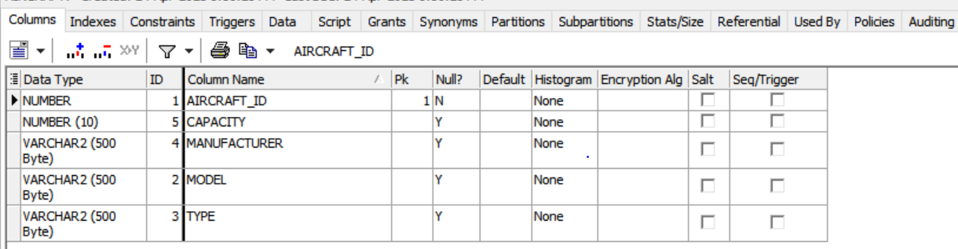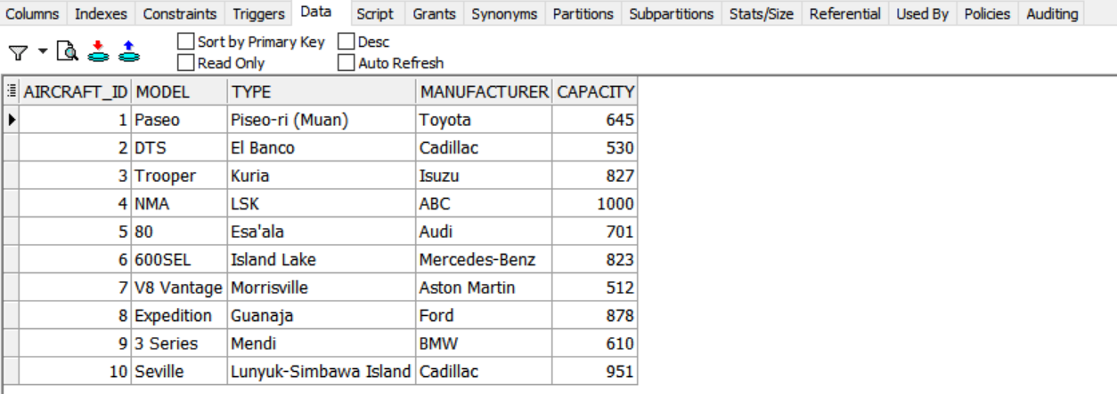

CREATE TABLE airport

(

airport_id NUMBER PRIMARY KEY,

name VARCHAR2(1000),

city VARCHAR2(1000),

country VARCHAR2(1000)

);

insert into airport (airport_id, name, city, country) values (1, 'Drummond Island Airport', 'Arruda dos Vinhos', 'Portugal');

insert into airport (airport_id, name, city, country) values (2, 'Sócrates Rezende Airport', 'Nanae', 'Japan');

insert into airport (airport_id, name, city, country) values (3, 'Cairo_air', 'Egypt', 'Cairo');

insert into airport (airport_id, name, city, country) values (4, 'Blackbushe Airport', 'Ghazni', 'Afghanistan');

insert into airport (airport_id, name, city, country) values (5, 'Montluçon-Guéret Airport', 'Yangzizhou', 'China');

insert into airport (airport_id, name, city, country) values (6, 'Brigadier Mayor D Cesar Raul Ojeda Airport', 'Gangmei', 'China');

insert into airport (airport_id, name, city, country) values (7, 'Tumbler Ridge Airport', 'São Domingos', 'Cape Verde');

insert into airport (airport_id, name, city, country) values (8, 'Tchongorove Airport', 'Khóra', 'Greece');

insert into airport (airport_id, name, city, country) values (9, 'Verona Villafranca Airport', 'Kakamigahara', 'Japan');

insert into airport (airport_id, name, city, country) values (10, 'Moosonee Airport', 'Susuman', 'Russia');

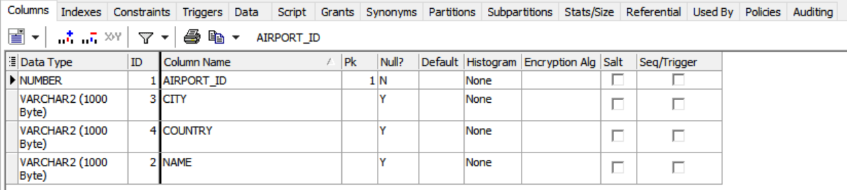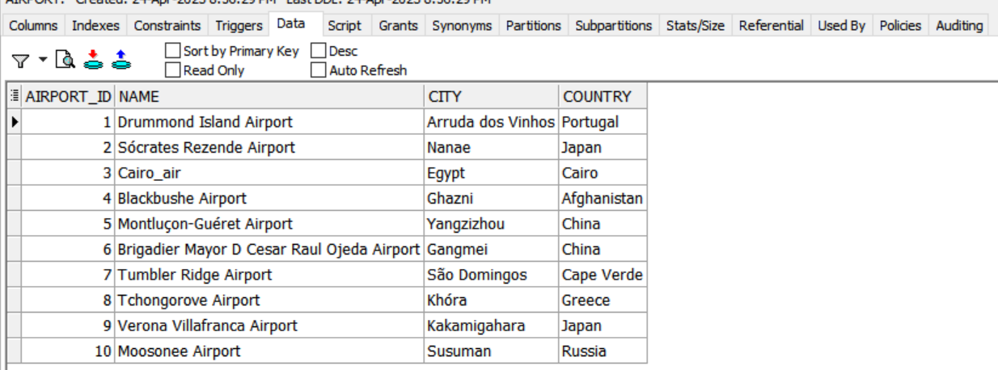

CREATE TABLE crew_member

(

member_id NUMBER PRIMARY KEY,

first_name VARCHAR2(1000),

last_name VARCHAR2(1000),

gender VARCHAR2(1000),

job_type VARCHAR2(1000),

hire_date DATE,

dob DATE,

country VARCHAR2(1000),

email VARCHAR2(1000),

phone VARCHAR2(1000)

);

insert into crew_member (member_id, first_name, last_name, gender, job_type, hire_date, dob, country, email, phone) values (1, 'Jolene', 'Stuart', 'Female', 'Administrative Assistant I', to_date(‘03-04-2010’,’dd-mm-yyyy’),to_date(‘02-01-1999’,’dd-mm-yyyy’), 'Chile', 'jstuart0@mozilla.com', '493-219-0862');

insert into crew_member (member_id, first_name, last_name, gender, job_type, hire_date, dob, country, email, phone) values (2, 'Ralph', 'Froude', 'Male', 'Paralegal', to_date(‘04-08-2019’,’dd-mm-yyyy’),to_date(‘03-03-1980’,’dd-mm-yyyy’), 'Tanzania', 'rfroude1@usgs.gov', '565-720-6902');

insert into crew_member (member_id, first_name, last_name, gender, job_type, hire_date, dob, country, email, phone) values (3, 'Thaxter', 'Cubley', 'Male', 'Research Associate', to_date(‘06-09-2020’,’dd-mm-yyyy’),to_date(‘04-08-2000’,’dd-mm-yyyy’), 'China', 'tcubley2@washington.edu', '778-854-6819');

insert into crew_member (member_id, first_name, last_name, gender, job_type, hire_date, dob, country, email, phone) values (4, 'Dorena', 'Midden', 'Female', 'Biostatistician III',to_date(‘06-09-2021’,’dd-mm-yyyy’),to_date(‘04-09-1980’,’dd-mm-yyyy’), 'Afghanistan', 'dmidden3@ustream.tv', '702-939-7850');

insert into crew_member (member_id, first_name, last_name, gender, job_type, hire_date, dob, country, email, phone) values (5, 'Bethina', 'Roony', 'Female', 'Paralegal', to_date(‘06-09-2009’,’dd-mm-yyyy’),to_date(‘05-08-1970’,’dd-mm-yyyy’), 'Poland', 'broony4@slashdot.org', '442-119-4079');

insert into crew_member (member_id, first_name, last_name, gender, job_type, hire_date, dob, country, email, phone) values (6, 'Shirley', 'McMurtyr', 'Female', 'Accounting Assistant III', to_date(‘06-09-2007’,’dd-mm-yyyy’),to_date(‘12-10-1988’,’dd-mm-yyyy’), 'Indonesia', 'smcmurtyr5@about.com', '920-707-8695');

insert into crew_member (member_id, first_name, last_name, gender, job_type, hire_date, dob, country, email, phone) values (7, 'Shirley', 'McMurtyr', 'Female', 'Accounting Assistant III',to_date(‘06-09-2005’,’dd-mm-yyyy’),to_date(‘13-2-1998’,’dd-mm-yyyy’), 'Sweden', 'hshooter6@nydailynews.com', '561-471-7126');

insert into crew_member (member_id, first_name, last_name, gender, job_type, hire_date, dob, country, email, phone) values (8, 'Xylia', 'Jollye', 'Female', 'Financial Analyst',to_date(‘08-10-2018’,’dd-mm-yyyy’),to_date(‘10-10-1973’,’dd-mm-yyyy’), 'Philippines', 'xjollye7@cbsnews.com', '636-235-9871');

insert into crew_member (member_id, first_name, last_name, gender, job_type, hire_date, dob, country, email, phone) values (9, 'Lindy', 'Rolley', 'Female', 'Compensation Analyst', to_date(‘11-12-2020’,’dd-mm-yyyy’),to_date(‘02-09-1998’,’dd-mm-yyyy’), 'Portugal', 'lrolley8@psu.edu', '881-428-2579');

insert into crew_member (member_id, first_name, last_name, gender, job_type, hire_date, dob, country, email, phone) values (10, 'Berti', 'Slessor', 'Female', 'General Manager', to_date(‘30-05-2001’,’dd-mm-yyyy’),to_date(‘01-01-1999’,’dd-mm-yyyy’), 'Indonesia', 'bslessor9@elegantthemes.com', '923-327-0049');

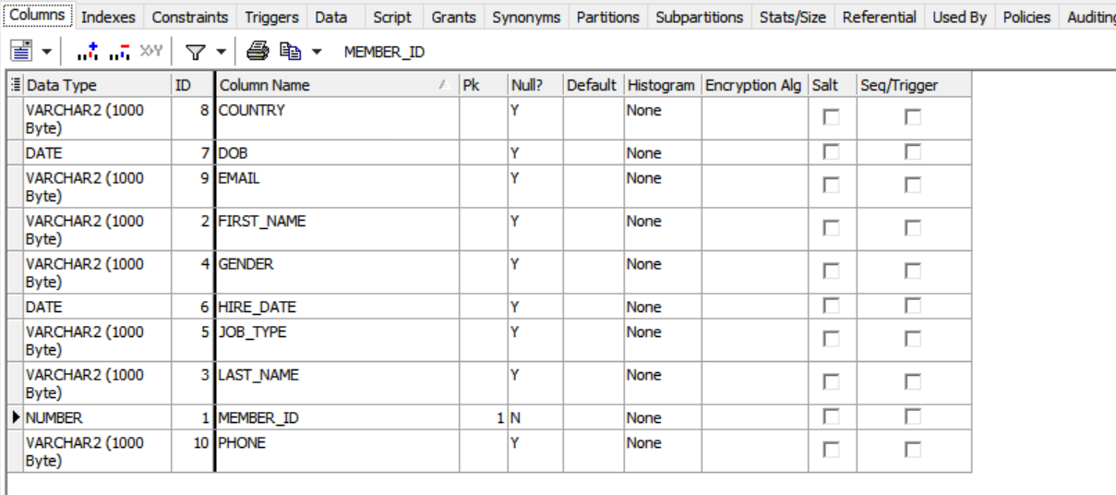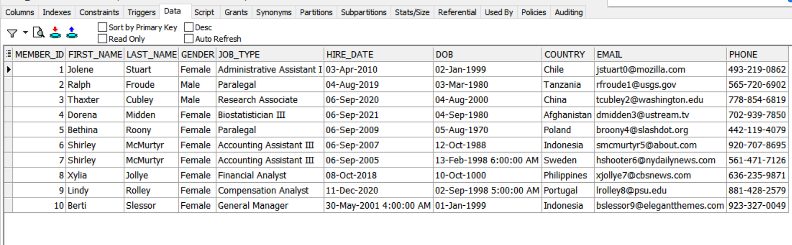CREATE TABLE flight_date

(

date_id NUMBER PRIMARY KEY,

month DATE,

day NUMBER,

year NUMBER,

minute NUMBER,

hour NUMBER,

week NUMBER

);

insert into flight_dateMONTHMONTHMONTHMONTHMONTHMONTHMONTH (date_id, month, day, year, minute, hour, week) values (1,10, 12, 1988, 5, 18, 5);

insert into flight_date (date_id, month, day, year, minute, hour, week) values (2, 11, 25, 1988, 41, 12, 5);

insert into flight_date (date_id, month, day, year, minute, hour, week) values (3, 5, 30, 1988, 41, 12, 5);

insert into flight_date (date_id, month, day, year, minute, hour, week) values (4, 6, 13, 1954, 25, 1, 3);

insert into flight_date (date_id, month, day, year, minute, hour, week) values (5, 9, 8, 2008, 35, 9, 2);

insert into flight_date (date_id, month, day, year, minute, hour, week) values (6, 4, 19, 1984, 60, 12, 5);

insert into flight_date (date_id, month, day, year, minute, hour, week) values (7, 3, 18, 2014, 20, 16, 2);

insert into flight_date (date_id, month, day, year, minute, hour, week) values (8, 6, 10, 1983, 10, 5, 2);

insert into flight_date (date_id, month, day, year, minute, hour, week) values (9, 7, 6, 1935, 41, 1, 3);

insert into flight_date (date_id, month, day, year, minute, hour, week) values (10, 4, 15, 1935, 37, 1, 1);

ALTER TABLE flight_date

MODIFY month number ;

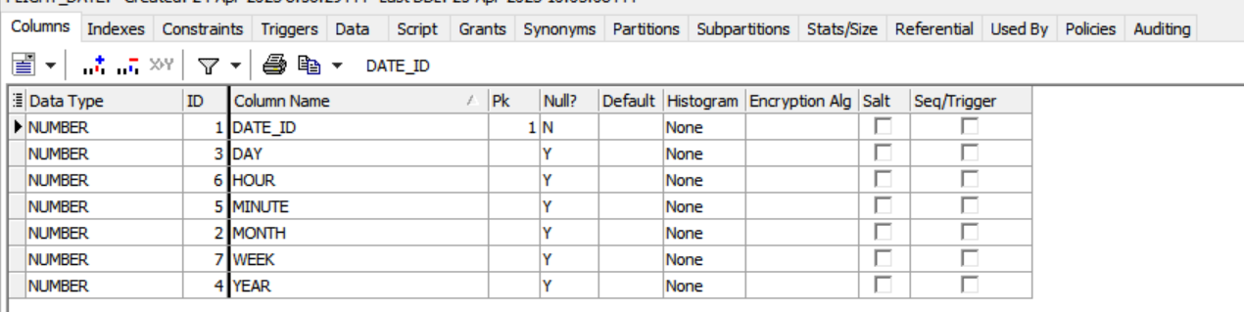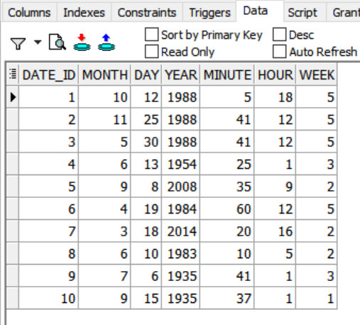

CREATE TABLE customer

(

customer_id NUMBER PRIMARY KEY,

first_name VARCHAR2(1000),

last_name VARCHAR2(1000),

gender VARCHAR2(1000),

city VARCHAR2(1000),

country VARCHAR2(1000),

dob DATE,

email VARCHAR2(1000),

phone VARCHAR2(1000),

status VARCHAR2(1000)

);

insert into customer (customer_id, first_name, last_name, gender, city, country, dob, email, phone, status) values (11, 'Joyce', 'McKernon', 'F', 'Łomża', 'Poland',to_date('03-2-1999','dd-mm-yyyy'), 'jmckernon0@dmoz.org', '863-751-0797', 'good');

insert into customer (customer_id, first_name, last_name, gender, city, country, dob, email, phone, status) values (2, null, null, null, null, null, null, 'akondratenya1@google.pl', '635-544-2609', null);

insert into customer (customer_id, first_name, last_name, gender, city, country, dob, email, phone, status) values (3, 'Carlita', 'Doswell', 'F', 'Nusajaya', 'Indonesia', to_date('03-2-1999','dd-mm-yyyy'), 'cdoswell2@feedburner.com', '867-830-9917', 'null');

insert into customer (customer_id, first_name, last_name, gender, city, country, dob, email, phone, status) values (4, 'Bob', 'Mulrean', 'M', 'La Suiza', 'Costa Rica', to_date('03-2-1999','dd-mm-yyyy'), 'bmulrean3@examiner.com', '253-665-4073', 'good');

insert into customer (customer_id, first_name, last_name, gender, city, country, dob, email, phone, status) values (5, 'Jereme', 'Stadden', 'M', 'Talun', 'Indonesia', to_date('03-2-1999','dd-mm-yyyy'), 'jstadden4@google.ca', '566-833-6876', 'good');

insert into customer (customer_id, first_name, last_name, gender, city, country, dob, email, phone, status) values (6, 'Lacey', 'Colliford', 'F', 'Handa', 'Japan', to_date('03-2-1999','dd-mm-yyyy'), 'lcolliford5@dropbox.com', '148-959-1619', 'good');

insert into customer (customer_id, first_name, last_name, gender, city, country, dob, email, phone, status) values (7, 'Broddie', 'Nussen', 'M', 'Lakateng', 'Indonesia', to_date('03-2-1999','dd-mm-yyyy'), 'bnussen6@zdnet.com', '902-355-7453', 'good');

insert into customer (customer_id, first_name, last_name, gender, city, country, dob, email, phone, status) values (8, 'Olva', 'Creigan', 'F', 'Carriedo', 'Philippines', to_date('03-2-1999','dd-mm-yyyy'), 'ocreigan7@intel.com', '484-499-5525', 'null');

insert into customer (customer_id, first_name, last_name, gender, city, country, dob, email, phone, status) values (9, 'Egon', 'Skidmore', 'M', 'Diveyevo', 'Russia', to_date('03-2-1999','dd-mm-yyyy'), 'eskidmore8@drupal.org', '505-525-1977', 'v_good');

insert into customer (customer_id, first_name, last_name, gender, city, country, dob, email, phone, status) values (10, 'Maureene', 'Derx', 'F', 'Cerro Punta', 'Panama',null, 'mderx9@ucoz.ru', '662-147-4794', 'good');

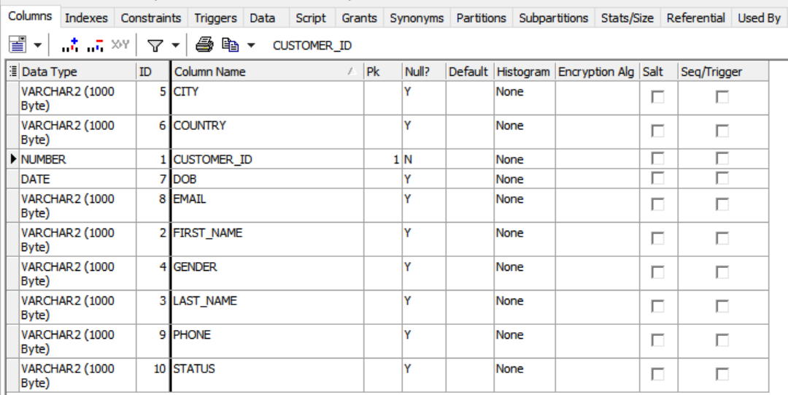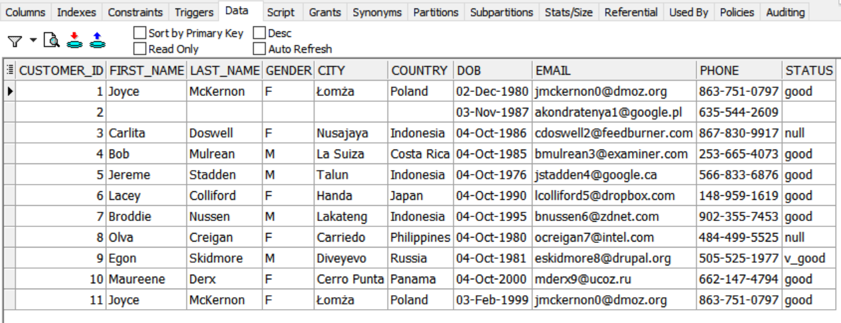

CREATE TABLE channel

(

channel_id NUMBER PRIMARY KEY,

name VARCHAR2(1000),

description VARCHAR2(1000),

status VARCHAR2(1000)

);

insert into channel (channel_id, name, description, status) values (1, 'text', 'f', 'bad');

insert into channel (channel_id, name, description, status) values (2, 'text', 'f', 'good');

insert into channel (channel_id, name, description, status) values (3, 'mobile app', 'l', 'good');

insert into channel (channel_id, name, description, status) values (4, 'mobile app', 'l', 'bad');

insert into channel (channel_id, name, description, status) values (5, 'mobile app', 'f', 'good');

insert into channel (channel_id, name, description, status) values (6, null, 'l', 'bad');

insert into channel (channel_id, name, description, status) values (7, 'mobile app', 'l', 'good');

insert into channel (channel_id, name, description, status) values (8, null, 'm', 'bad');

insert into channel (channel_id, name, description, status) values (9, 'online', 'h', 'good');

insert into channel (channel_id, name, description, status) values (10, 'text', 'l', 'bad');

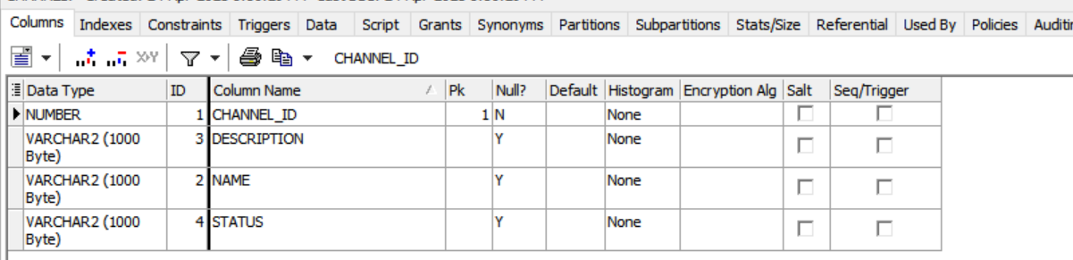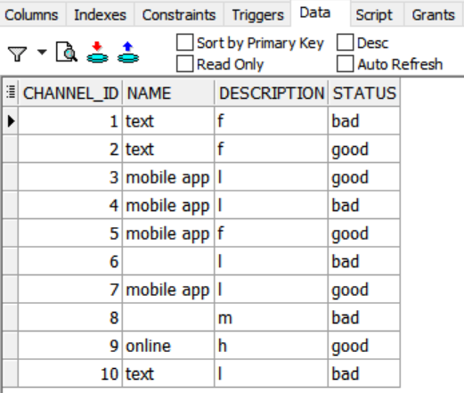

CREATE TABLE fare_class

(

fare_class_id NUMBER PRIMARY KEY,

name VARCHAR2(1000),

description VARCHAR2(1000)

);

insert into fare_class (fare_class_id, name, description) values (1, 'z', null);

insert into fare_class (fare_class_id, name, description) values (2, 'x', null);

insert into fare_class (fare_class_id, name, description) values (3, 'x', null);

insert into fare_class (fare_class_id, name, description) values (4, 'y', null);

insert into fare_class (fare_class_id, name, description) values (5, 'z', null);

insert into fare_class (fare_class_id, name, description) values (6, 'y', null);

insert into fare_class (fare_class_id, name, description) values (7, 'z', null);

insert into fare_class (fare_class_id, name, description) values (8, 'y', null);

insert into fare_class (fare_class_id, name, description) values (9, 'y', null);

insert into fare_class (fare_class_id, name, description) values (10, 'y', null);

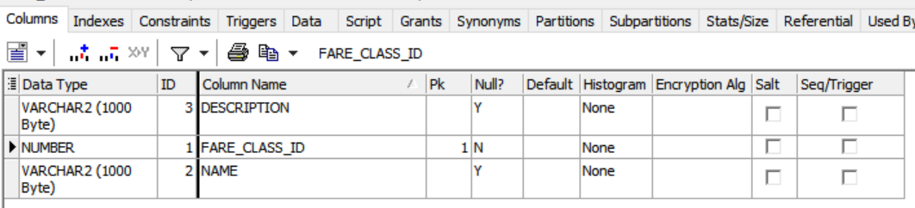

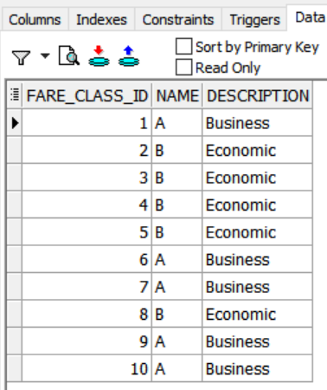

CREATE TABLE action

(

action_id NUMBER PRIMARY KEY,

name VARCHAR2(1000),

type VARCHAR2(1000),

description VARCHAR2(1000)

);

insert into action (action_id, name, type, description) values (1, null, 'n', null);

insert into action (action_id, name, type, description) values (2, 'bad_review', 'n', null);

insert into action (action_id, name, type, description) values (3, 'bad_review', 'o', ‘replace’);

insert into action (action_id, name, type, description) values (4, 'bad_review', 'o', ‘replace’);

insert into action (action_id, name, type, description) values (5, 'bad_review', 'n', ‘replace’);

insert into action (action_id, name, type, description) values (6, 'bad_review', 'p', ‘replace’);

insert into action (action_id, name, type, description) values (7, 'bad_review', 'n', ‘replace’);

insert into action (action_id, name, type, description) values (8, 'suffering', 'n', ‘discount);

insert into action (action_id, name, type, description) values (9, 'suffering', 'n', ‘discount’);

insert into action (action_id, name, type, description) values (10, 'bad_review', 'n', ‘replace);

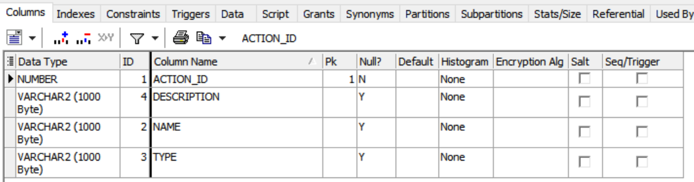

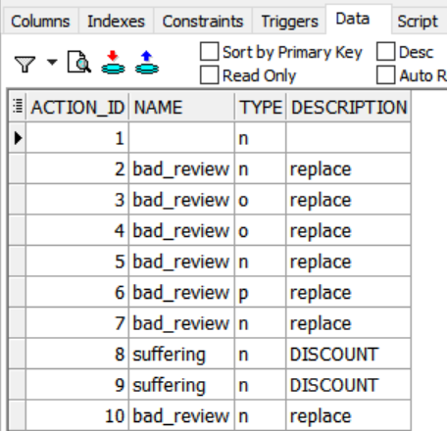

CREATE TABLE upgrade

(

upgrade_id NUMBER PRIMARY KEY,

name VARCHAR2(1000),

start_date DATE,

end_date DATE

);

insert into upgrade (upgrade_id, name, start_date, end_date) values (4, 'Bigtax', to_date('03-2-1999','dd-mm-yyyy'), to_date('03-2-1999','dd-mm-yyyy'));

insert into upgrade (upgrade_id, name, start_date, end_date) values (5, 'Home Ing', to_date('03-2-1999','dd-mm-yyyy'), to_date('03-2-1999','dd-mm-yyyy'));

insert into upgrade (upgrade_id, name, start_date, end_date) values (6, 'Toughjoyfax', to_date('03-2-1999','dd-mm-yyyy'), to_date('03-2-1999','dd-mm-yyyy'));

insert into upgrade (upgrade_id, name, start_date, end_date) values (7, 'Regrant', to_date('03-2-1999','dd-mm-yyyy'), to_date('03-2-1999','dd-mm-yyyy'));

insert into upgrade (upgrade_id, name, start_date, end_date) values (8, null, to_date('03-2-1999','dd-mm-yyyy'), to_date('03-2-1999','dd-mm-yyyy'));

insert into upgrade (upgrade_id, name, start_date, end_date) values (9, 'Span', to_date('03-2-1999','dd-mm-yyyy'), to_date('03-2-1999','dd-mm-yyyy'));

insert into upgrade (upgrade_id, name, start_date, end_date) values (10, 'Subin', to_date('03-2-1999','dd-mm-yyyy'), to_date('03-2-1999','dd-mm-yyyy'));

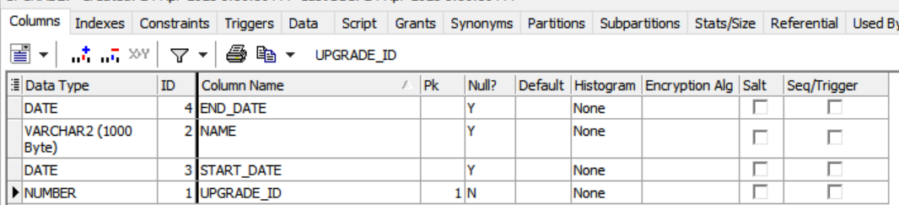

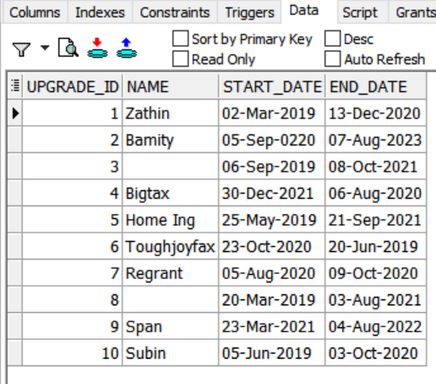

CREATE TABLE flyer_miles

(

flyer_miles_id NUMBER PRIMARY KEY,

miles NUMBER(10)

);

insert into flyer_miles (flyer_miles_id, miles) values (1, '3156', to_date('03-2-1999','dd-mm-yyyy'), to_date('03-2-1999','dd-mm-yyyy'));

insert into flyer_miles (flyer_miles_id, miles) values (2, '3156', to_date('03-2-1999','dd-mm-yyyy'), to_date('03-2-1999','dd-mm-yyyy'));

insert into flyer_miles (flyer_miles_id, miles) values (3, '8', to_date('03-2-1999','dd-mm-yyyy'), to_date('03-2-1999','dd-mm-yyyy'));

insert into flyer_miles (flyer_miles_id, miles) values (4, '3156', to_date('03-2-1999','dd-mm-yyyy'), to_date('03-2-1999','dd-mm-yyyy'));

insert into flyer_miles (flyer_miles_id, miles) values (5, '814', to_date('03-2-1999','dd-mm-yyyy'), to_date('03-2-1999','dd-mm-yyyy'));

insert into flyer_miles (flyer_miles_id, miles) values (6, '3156', to_date('03-2-1999','dd-mm-yyyy'), to_date('03-2-1999','dd-mm-yyyy'));

insert into flyer_miles (flyer_miles_id, miles) values (7, '2475', to_date('03-2-1999','dd-mm-yyyy'), to_date('03-2-1999','dd-mm-yyyy'));

insert into flyer_miles (flyer_miles_id, miles) values (8, '3156', to_date('03-2-1999','dd-mm-yyyy'), to_date('03-2-1999','dd-mm-yyyy'));

insert into flyer_miles (flyer_miles_id, miles) values (9, '60', to_date('03-2-1999','dd-mm-yyyy'), to_date('03-2-1999','dd-mm-yyyy'));

insert into flyer_miles (flyer_miles_id, miles) values (10, '3156', to_date('03-2-1999','dd-mm-yyyy'), to_date('03-2-1999','dd-mm-yyyy'));

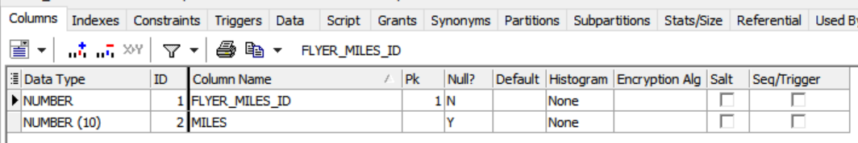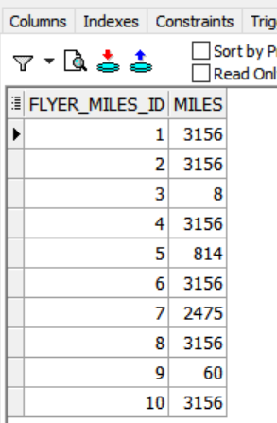

CREATE TABLE promotion

(

promotion_id NUMBER PRIMARY KEY,

name VARCHAR2(1000),

start_date DATE,

end_date DATE

);

insert into promotion (promotion_id, name, start_date, end_date) values (1, 'Mraz-Hilpert', to_date('03-2-2023','dd-mm-yyyy'), to_date('03-2-1999','dd-mm-yyyy'));

insert into promotion (promotion_id, name, start_date, end_date) values (2, 'Mraz-Hilpert', to_date('03-2-2023,'dd-mm-yyyy'), to_date('03-2-1999','dd-mm-yyyy'));

insert into promotion (promotion_id, name, start_date, end_date) values (3, 'Breitenberg-Yost', to_date('03-2-1999','dd-mm-yyyy'), to_date('03-2-1999','dd-mm-yyyy');

insert into promotion (promotion_id, name, start_date, end_date) values (4, 'Conroy LLC', to_date('03-2-2023','dd-mm-yyyy'), to_date('03-2-1999','dd-mm-yyyy'));

insert into promotion (promotion_id, name, start_date, end_date) values (5, 'Fay Inc', to_date('03-2-1999','dd-mm-yyyy'), to_date('03-2-1999','dd-mm-yyyy');

insert into promotion (promotion_id, name, start_date, end_date) values (6, 'Leuschke-Lockman', to_date('03-2-1999','dd-mm-yyyy'), to_date('03-2-1999','dd-mm-yyyy'));

insert into promotion (promotion_id, name, start_date, end_date) values (7, 'Rohan LLC', to_date('03-2-1999','dd-mm-yyyy'), to_date('03-2-1999','dd-mm-yyyy'));

insert into promotion (promotion_id, name, start_date, end_date) values (8, 'Feeney, Krajcik and Will', to_date('03-2-1999','dd-mm-yyyy'), to_date('03-2-1999','dd-mm-yyyy')l);

insert into promotion (promotion_id, name, start_date, end_date) values (9, 'Rempel Inc', to_date('03-2-1999','dd-mm-yyyy'), to_date('03-2-1999','dd-mm-yyyy'));

insert into promotion (promotion_id, name, start_date, end_date) values (10, 'Treutel and Sons', to_date('03-2-1999','dd-mm-yyyy'), to_date('03-2-1999','dd-mm-yyyy'));

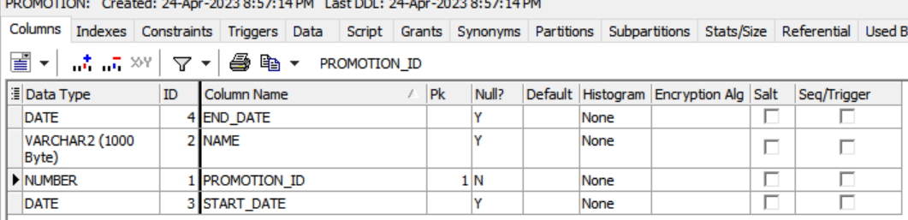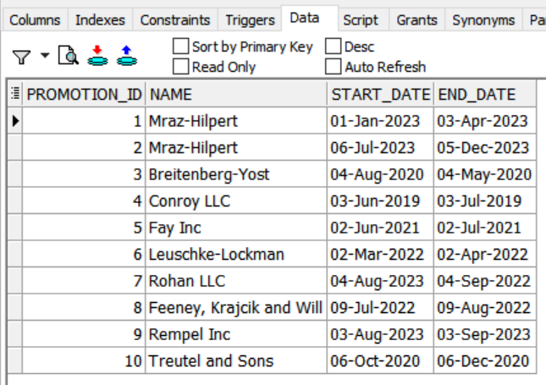

CREATE TABLE flight

(

flight_id NUMBER PRIMARY KEY,

route_id NUMBER REFERENCES route(route_id)

);

add arriv_time number ;

alter table flight

add depat_time number;

insert into flight (flight_id, route_id) values (1, 1,12,15);

insert into flight (flight_id, route_id) values (2, 2,11,20);

insert into flight (flight_id, route_id) values (3, 3,13,24);

insert into flight (flight_id, route_id) values (4, 4,1,12);

insert into flight (flight_id, route_id) values (5, 5,5,11);

insert into flight (flight_id, route_id) values (6, 6,6,4);

insert into flight (flight_id, route_id) values (7, 7,3,6);

insert into flight (flight_id, route_id) values (8, null,24,7);

insert into flight (flight_id, route_id) values (9, 9,15,8);

insert into flight (flight_id, route_id) values (10, 10,17,10);

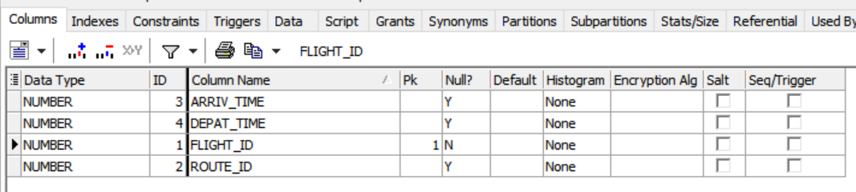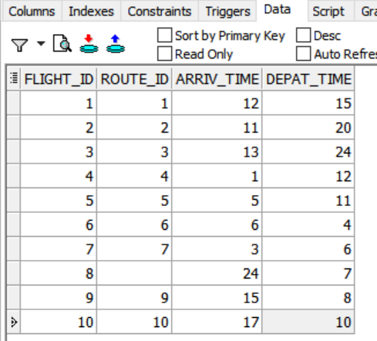

CREATE TABLE marketing_analysis

(

ma_id NUMBER PRIMARY KEY,

date_id NUMBER REFERENCES flight_date(date_id),

customer_id NUMBER REFERENCES customer(customer_id),

upgrade_id NUMBER REFERENCES upgrade(upgrade_id),

promotion_id NUMBER REFERENCES promotion(promotion_id),

flyer_miles_earned_id NUMBER REFERENCES flyer_miles(flyer_miles_id),

flyer_miles_redeemed_id NUMBER REFERENCES flyer_miles(flyer_miles_id),

flight_id NUMBER REFERENCES flight(flight_id)

);

insert into marketing_analysis (ma_id, date_id, customer_id, upgrade_id, promotion_id, flyer_miles_earned_id, flyer_miles_redeemed_id, flight_id) values (1, 2, 3, 4, 5, 6, 7, 8);

insert into marketing_analysis (ma_id, date_id, customer_id, upgrade_id, promotion_id, flyer_miles_earned_id, flyer_miles_redeemed_id, flight_id) values (2, 2, 2, 2, 2, 2, 2, 2);

insert into marketing_analysis (ma_id, date_id, customer_id, upgrade_id, promotion_id, flyer_miles_earned_id, flyer_miles_redeemed_id, flight_id) values (3, 3, 3, 3, 3, 3, 3, 3);

insert into marketing_analysis (ma_id, date_id, customer_id, upgrade_id, promotion_id, flyer_miles_earned_id, flyer_miles_redeemed_id, flight_id) values (4, 4, 4, 4, 4, 4, 4, 4);

insert into marketing_analysis (ma_id, date_id, customer_id, upgrade_id, promotion_id, flyer_miles_earned_id, flyer_miles_redeemed_id, flight_id) values (5, null, null, null, null, null, null, null);

insert into marketing_analysis (ma_id, date_id, customer_id, upgrade_id, promotion_id, flyer_miles_earned_id, flyer_miles_redeemed_id, flight_id) values (6, 6, 6, 6, 6, 6, 6, 6);

insert into marketing_analysis (ma_id, date_id, customer_id, upgrade_id, promotion_id, flyer_miles_earned_id, flyer_miles_redeemed_id, flight_id) values (7, 7, 7, 7, 7, 7, 7, 7);

insert into marketing_analysis (ma_id, date_id, customer_id, upgrade_id, promotion_id, flyer_miles_earned_id, flyer_miles_redeemed_id, flight_id) values (8, 8, 8, 8, 8, 8, 8, 8);

insert into marketing_analysis (ma_id, date_id, customer_id, upgrade_id, promotion_id, flyer_miles_earned_id, flyer_miles_redeemed_id, flight_id) values (9, null, null, null, null, null, null, null);

insert into marketing_analysis (ma_id, date_id, customer_id, upgrade_id, promotion_id, flyer_miles_earned_id, flyer_miles_redeemed_id, flight_id) values (10, 10, 10, 10, 10, 10, 10, 10);

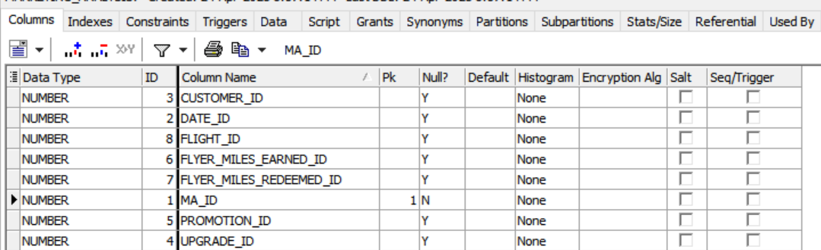

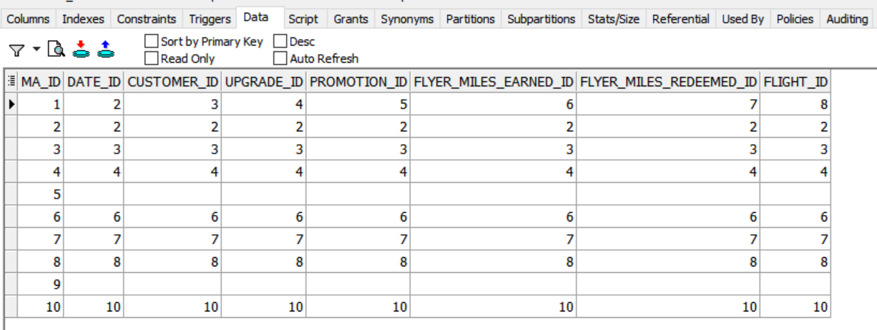

CREATE TABLE payment_method

(

payment_method_id NUMBER PRIMARY KEY,

payment_method_name VARCHAR2(1000)

);

insert into payment_method (payment_method_id, payment_method_name) values (1, 'ggrunson0');

insert into payment_method (payment_method_id, payment_method_name) values (2, 'ajentges1');

insert into payment_method (payment_method_id, payment_method_name) values (3, 'bgudgion2');

insert into payment_method (payment_method_id, payment_method_name) values (4, 'vroubottom3');

insert into payment_method (payment_method_id, payment_method_name) values (5, 'tdouche4');

insert into payment_method (payment_method_id, payment_method_name) values (6, 'fweems5');

insert into payment_method (payment_method_id, payment_method_name) values (7, 'jlewknor6');

insert into payment_method (payment_method_id, payment_method_name) values (8, 'sstute7');

insert into payment_method (payment_method_id, payment_method_name) values (9, 'dwitherbed8');

insert into payment_method (payment_method_id, payment_method_name) values (10, 'bfrantz9');

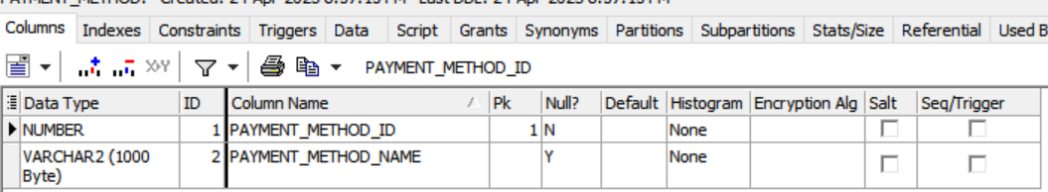

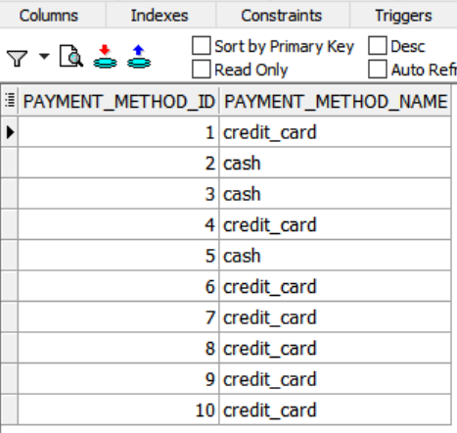

CREATE TABLE flight_activity

(

id NUMBER PRIMARY KEY,

num_passengers NUMBER,

empty_seats NUMBER,

num_crew NUMBER,

flight_id NUMBER REFERENCES flight(flight_id),

aircraft_id NUMBER REFERENCES aircraft(aircraft_id),

src_airport_id NUMBER REFERENCES airport(airport_id),

dest_airport_id NUMBER REFERENCES airport(airport_id),

captain_id NUMBER REFERENCES crew_member(member_id),

flight_attendant_id NUMBER

)

insert into flight_activity (id, num_passengers, empty_seats, num_crew, flight_id, aircraft_id, src_airport_id, dest_airport_id, captain_id, flight_attendant_id) values (1, 368, 96, 15, 1, 1, 2, 2, 6, 3);

insert into flight_activity (id, num_passengers, empty_seats, num_crew, flight_id, aircraft_id, src_airport_id, dest_airport_id, captain_id, flight_attendant_id) values (2, 472, 46, 14, 2, 2, 3, 1, 7, 5);

insert into flight_activity (id, num_passengers, empty_seats, num_crew, flight_id, aircraft_id, src_airport_id, dest_airport_id, captain_id, flight_attendant_id) values (3, 290, 5, 12, 3, 3, 2, 4, 2, 7);

insert into flight_activity (id, num_passengers, empty_seats, num_crew, flight_id, aircraft_id, src_airport_id, dest_airport_id, captain_id, flight_attendant_id) values (4, 414, 46, 10, 4, 4, 5, 8, 3, 6);

insert into flight_activity (id, num_passengers, empty_seats, num_crew, flight_id, aircraft_id, src_airport_id, dest_airport_id, captain_id, flight_attendant_id) values (5, null, null, null, null, null, null, null, null, null);

insert into flight_activity (id, num_passengers, empty_seats, num_crew, flight_id, aircraft_id, src_airport_id, dest_airport_id, captain_id, flight_attendant_id) values (6, 308, 82, 11, 6, 6, 3, 7, 4, 8);

insert into flight_activity (id, num_passengers, empty_seats, num_crew, flight_id, aircraft_id, src_airport_id, dest_airport_id, captain_id, flight_attendant_id) values (7, 259, 28, 14, 7, 7, 1, 8, 1, 6);

insert into flight_activity (id, num_passengers, empty_seats, num_crew, flight_id, aircraft_id, src_airport_id, dest_airport_id, captain_id, flight_attendant_id) values (8, 219, 49, 14, 8, 8, 6, 8, 9, 1);

insert into flight_activity (id, num_passengers, empty_seats, num_crew, flight_id, aircraft_id, src_airport_id, dest_airport_id, captain_id, flight_attendant_id) values (9, 297, 9, 12, 9, 9, 7, 4, 2, 6);

insert into flight_activity (id, num_passengers, empty_seats, num_crew, flight_id, aircraft_id, src_airport_id, dest_airport_id, captain_id, flight_attendant_id) values (10, 210, 71, 11, 10, 10, 9, 10, 8, 4);

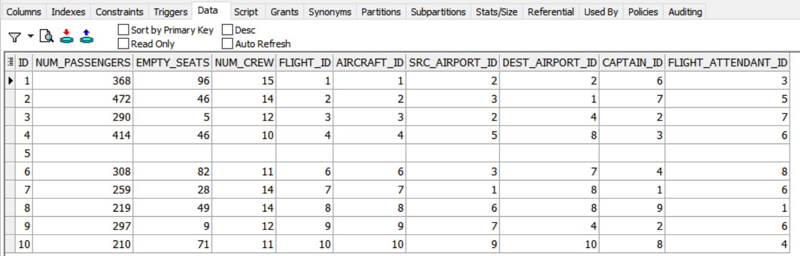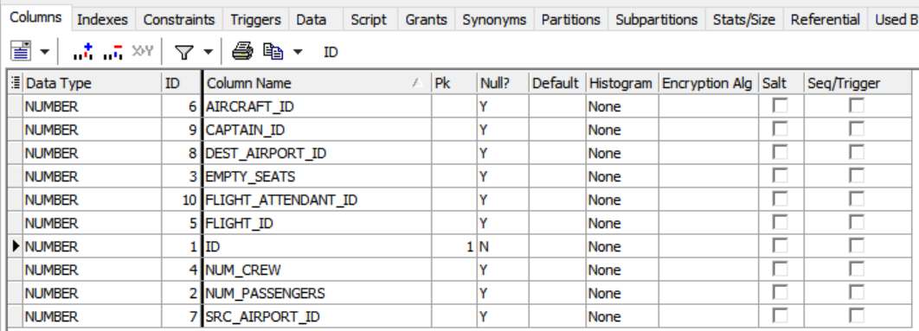

CREATE TABLE Reservation

(

seat_number number,

Base_price number,

Discount number,

Price number,

overnight_stand number,

Resrv_Id number,

Customer_Id number,

PM_ID number,

channel_id number,

flight_id number,

Fare_class_id number,

Date_Id number,

PRIMARY KEY (Resrv_Id),

FOREIGN KEY (Customer_Id) REFERENCES Customer(Customer_Id),

FOREIGN KEY (PM_ID) REFERENCES payment_method(payment_method_id),

FOREIGN KEY (channel_id) REFERENCES Channel(channel_id),

FOREIGN KEY (flight_id) REFERENCES flight(flight_id),

FOREIGN KEY (Fare_class_id) REFERENCES fare_class(fare_class_id),

FOREIGN KEY (Date_Id) REFERENCES flight_date(date_id)

);

insert into Reservation (seat_number, base_price, discount, price, overnight_stand, resrv_id, customer_id, pm_id, channel_id, flight_id, fare_class_id, date_id) values (243, 8860, 2470, 7143, 2, 1, 10, 2, 2, 6, 3, 5);

insert into Reservation (seat_number, base_price, discount, price, overnight_stand, resrv_id, customer_id, pm_id, channel_id, flight_id, fare_class_id, date_id) values (225, 6344, 3876, 5740, 12, 2, 6, 5, 1, 1, 8, 2);

insert into Reservation (seat_number, base_price, discount, price, overnight_stand, resrv_id, customer_id, pm_id, channel_id, flight_id, fare_class_id, date_id) values (384, 7798, 3078, 3824, 10, 3, 8, 10, 6, 3, 3, 2);

insert into Reservation (seat_number, base_price, discount, price, overnight_stand, resrv_id, customer_id, pm_id, channel_id, flight_id, fare_class_id, date_id) values (294, 2969, 3263, 7701, 20, 4, 5, 3, 7, 3, 4, 3);

insert into Reservation (seat_number, base_price, discount, price, overnight_stand, resrv_id, customer_id, pm_id, channel_id, flight_id, fare_class_id, date_id) values (46, 3131, 3166, 5588, 17, 5, 7, 8, 8, 3, 6, 5);

insert into Reservation (seat_number, base_price, discount, price, overnight_stand, resrv_id, customer_id, pm_id, channel_id, flight_id, fare_class_id, date_id) values (232, 7185, 3961, 6733, 18, 6, 9, 5, 2, 3, 9, 1);

insert into Reservation (seat_number, base_price, discount, price, overnight_stand, resrv_id, customer_id, pm_id, channel_id, flight_id, fare_class_id, date_id) values (325, 7547, 2672, 7688, 16, 7, 5, 10, 7, 5, 4, 1);

insert into Reservation (seat_number, base_price, discount, price, overnight_stand, resrv_id, customer_id, pm_id, channel_id, flight_id, fare_class_id, date_id) values (121, 5196, 1534, 4951, 7, 8, 4, 8, 1, 4, 1, 10);

insert into Reservation (seat_number, base_price, discount, price, overnight_stand, resrv_id, customer_id, pm_id, channel_id, flight_id, fare_class_id, date_id) values (346, 5349, 1982, 1070, 1, 9, 5, 8, 8, 5, 1, 2);

insert into Reservation (seat_number, base_price, discount, price, overnight_stand, resrv_id, customer_id, pm_id, channel_id, flight_id, fare_class_id, date_id) values (null, null, null, null, null, 10, 4, null, null, null, null, null);

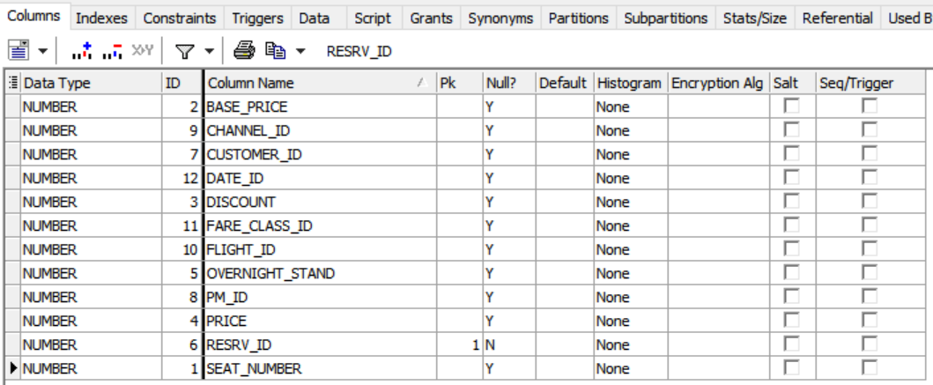

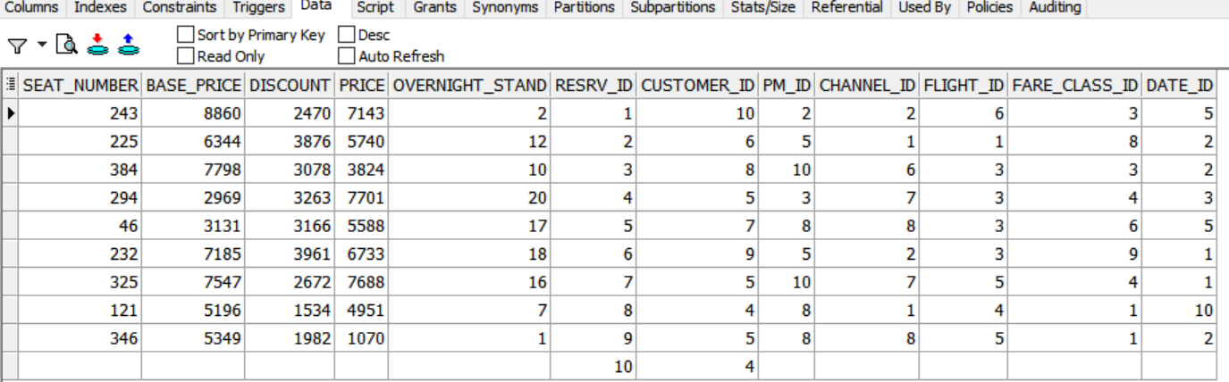

CREATE TABLE Customer_service

(

problem_Severty varchar(500),

CSer_ID number,

Action_id number,

Customer_Id number,

Date_Id number,

flight_id number,

PM_ID number,

channel_id number,

Member_id number,

PRIMARY KEY (CSer_ID),

FOREIGN KEY (Action_id) REFERENCES Action(Action_id),

FOREIGN KEY (Customer_Id) REFERENCES Customer(Customer_Id),

FOREIGN KEY (Date_Id) REFERENCES flight_date(date_Id),

FOREIGN KEY (flight_id) REFERENCES flight(flight_id),

FOREIGN KEY (PM_ID) REFERENCES payment_method (payment_method_id),

FOREIGN KEY (channel_id) REFERENCES Channel(channel_id),

FOREIGN KEY (Member_id) REFERENCES crew_member(Member_id)

);

insert into Customer_service (problem_severty, cser_id, action_id, customer_id, date_id, flight_id, pm_id, channel_id, member_id) values (1, 1, 3, 4, 9, 6, 6, 10, 2);

insert into Customer_service (problem_severty, cser_id, action_id, customer_id, date_id, flight_id, pm_id, channel_id, member_id) values (null, 2, null, null, null, null, null, null, null);

insert into Customer_service (problem_severty, cser_id, action_id, customer_id, date_id, flight_id, pm_id, channel_id, member_id) values (1, 3, 9, 4, 1, 6, 8, 3, 5);

insert into Customer_service (problem_severty, cser_id, action_id, customer_id, date_id, flight_id, pm_id, channel_id, member_id) values (1, 4, 8, 8, 5, 8, 7, 7, 3);

insert into Customer_service (problem_severty, cser_id, action_id, customer_id, date_id, flight_id, pm_id, channel_id, member_id) values (0, 5, 7, 3, 3, 3, 5, 3, 9);

insert into Customer_service (problem_severty, cser_id, action_id, customer_id, date_id, flight_id, pm_id, channel_id, member_id) values (null, 6, null, null, null, null, null, null, null);

insert into Customer_service (problem_severty, cser_id, action_id, customer_id, date_id, flight_id, pm_id, channel_id, member_id) values (null, 7, null, null, null, null, null, null, null);

insert into Customer_service (problem_severty, cser_id, action_id, customer_id, date_id, flight_id, pm_id, channel_id, member_id) values (1, 8, 7, 4, 5, 5, 3, 3, 7);

insert into Customer_service (problem_severty, cser_id, action_id, customer_id, date_id, flight_id, pm_id, channel_id, member_id) values (0, 9, 3, 9, 10, 1, 8, 4, 7);

insert into Customer_service (problem_severty, cser_id, action_id, customer_id, date_id, flight_id, pm_id, channel_id, member_id) values (1, 10, 1, 8, 2, 4, 8, 10, 3);

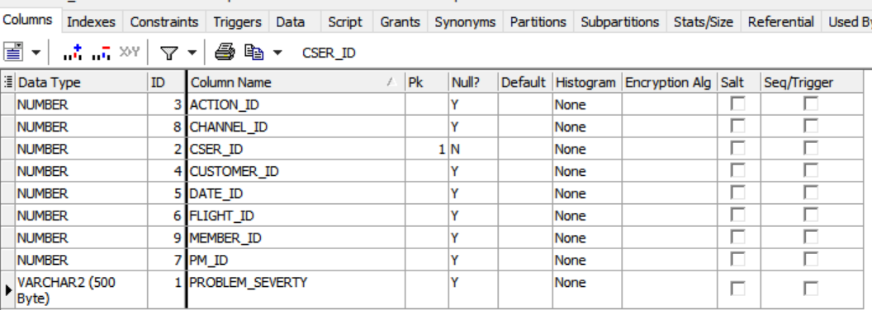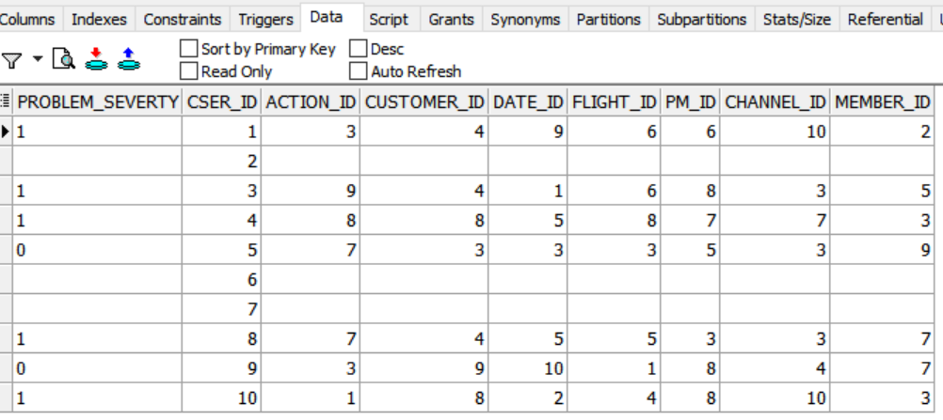

----------------------indexes

---- unique index in email column

CREATE UNIQUE INDEX idx_customer_email ON hr.customer(email);

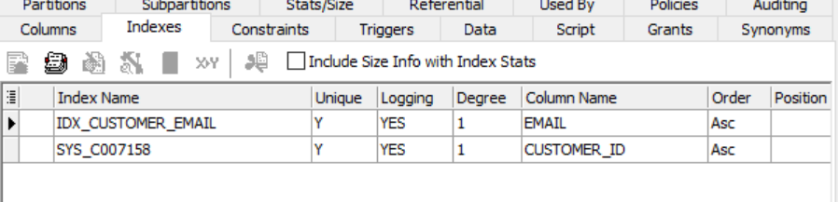

----- B-tree index in fk

CREATE INDEX idx_flight_activity_flight_id ON hr.flight_activity(flight_id);

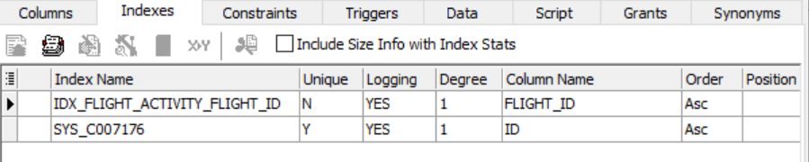

----- clustered index on each pk in each table

