ACCRA TECHNICAL UNIVERSITY
Department of Computer Science
BCS 404: Introduction to Data Science with Python

Exploratory Data Analysis, Statistical Analysis and
Machine Learning on the Titanic Dataset Using Python
Student Name: Arhinful Emmanuel
Index Number: 01259048B
Lecturer: Dr. Joseph Dadzie
Academic Year: 2025/2026 Second Semester
Submission Date: Sunday, 19 July 2026

Table of Contents
1. Introduction
2. Dataset Description
3. Methodology
4. Results
5. Discussion
6. Conclusion
7. References
8. Appendix: Python Code Summary

1. Introduction
The Titanic dataset is one of the most common real-world datasets used to introduce data science and machine learning. It contains information about passengers on the Titanic, including passenger class, age, sex, fare, embarkation point, and whether the passenger survived. The main aim of this project is to demonstrate practical competence in exploratory data analysis, statistical analysis, data visualisation, and introductory machine learning using Python.
This report follows the project requirements by acquiring the dataset, inspecting its structure, cleaning missing values, producing visualisations, performing statistical analysis, and developing a Logistic Regression classifier to predict survival.

2. Dataset Description
The dataset used for this analysis contains 891 observations and 12 variables. Each row represents one passenger and each column records an attribute of that passenger. The target variable for machine learning is Survived, where 0 indicates that the passenger did not survive and 1 indicates that the passenger survived.
The dataset columns are PassengerId, Survived, Pclass, Name, Sex, Age, SibSp, Parch, Ticket, Fare, Cabin, and Embarked.

First Five Observations
PassengerId | Survived | Pclass | Sex | Age | SibSp | Parch | Fare | Embarked
1 | 0 | 3 | male | 22.0 | 1 | 0 | 7.25 | S
2 | 1 | 1 | female | 38.0 | 1 | 0 | 71.2833 | C
3 | 1 | 3 | female | 26.0 | 0 | 0 | 7.925 | S
4 | 1 | 1 | female | 35.0 | 1 | 0 | 53.1 | S
5 | 0 | 3 | male | 35.0 | 0 | 0 | 8.05 | S

3. Methodology
The analysis was carried out using Python libraries including Pandas, NumPy, Matplotlib, Seaborn, and Scikit-Learn. The methodology followed six major steps: data acquisition, data cleaning, data visualisation, statistical analysis, machine learning, and interpretation of findings.
For data cleaning, missing values in Age were filled with the median age because the median is less affected by extreme values. Missing values in Embarked were filled with the mode because Embarked is categorical. The Cabin column was removed because it had many missing values and would not be reliable without more advanced preprocessing. Duplicates were checked and removed where necessary.
Column | Missing Before Cleaning | Missing After Cleaning
PassengerId | 0 | 0
Survived | 0 | 0
Pclass | 0 | 0
Name | 0 | 0
Sex | 0 | 0
Age | 177 | 0
SibSp | 0 | 0
Parch | 0 | 0
Ticket | 0 | 0
Fare | 0 | 0
Cabin | 687 | Dropped
Embarked | 2 | 0

4. Results

4.1 Data Visualisation
The figures below show the required visualisations for understanding the dataset. The updated version uses clearer contrasting colours so that categories such as passenger class and survival status are easier to distinguish.

Figure 1: Histogram of Passenger Ages
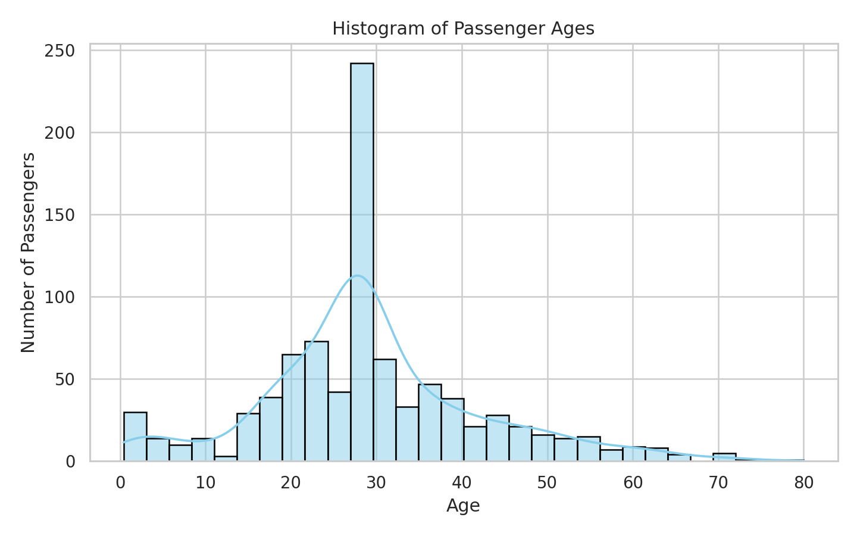
Most passengers were young adults, especially around their twenties and thirties. The light-blue bars with black edges make the age distribution easier to read.

Figure 2: Passenger Class Distribution
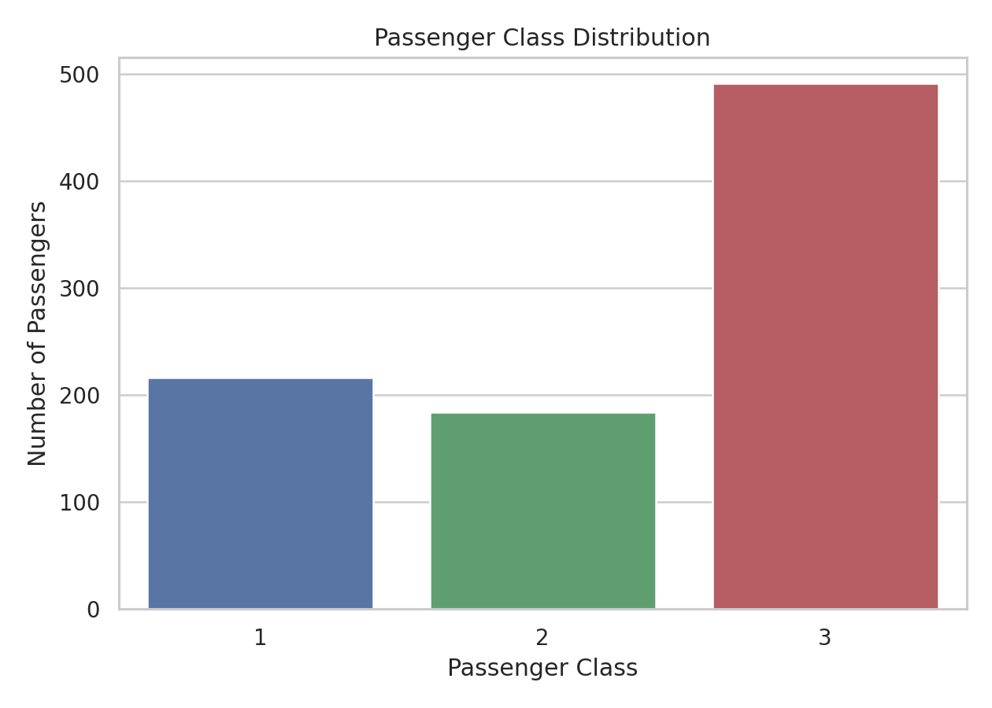
Third class had the largest number of passengers. The three separate colours make it easier to compare passenger classes.

Figure 3: Boxplot of Age by Passenger Class
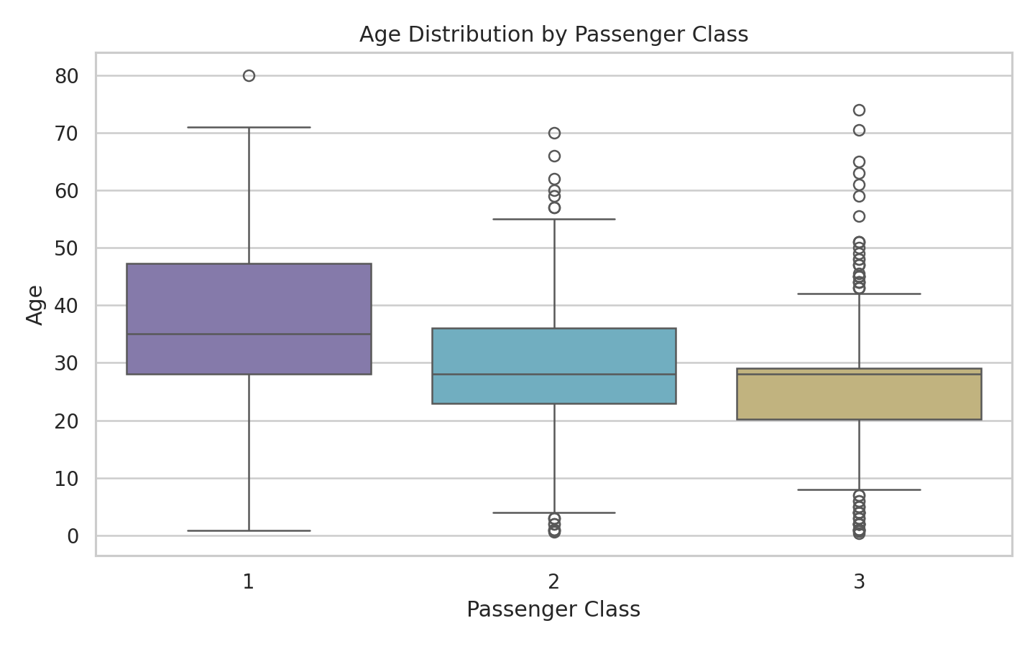
First class passengers generally appear older than second and third class passengers. Different box colours make the class comparison clearer.

Figure 4: Scatter Plot of Age versus Fare
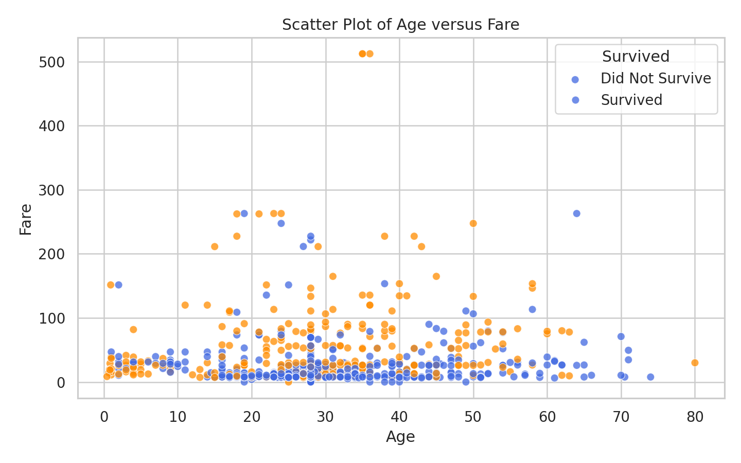
Most passengers paid low fares, while a few paid very high fares. Colour coding separates passengers who survived from those who did not.

Figure 5: Correlation Heatmap
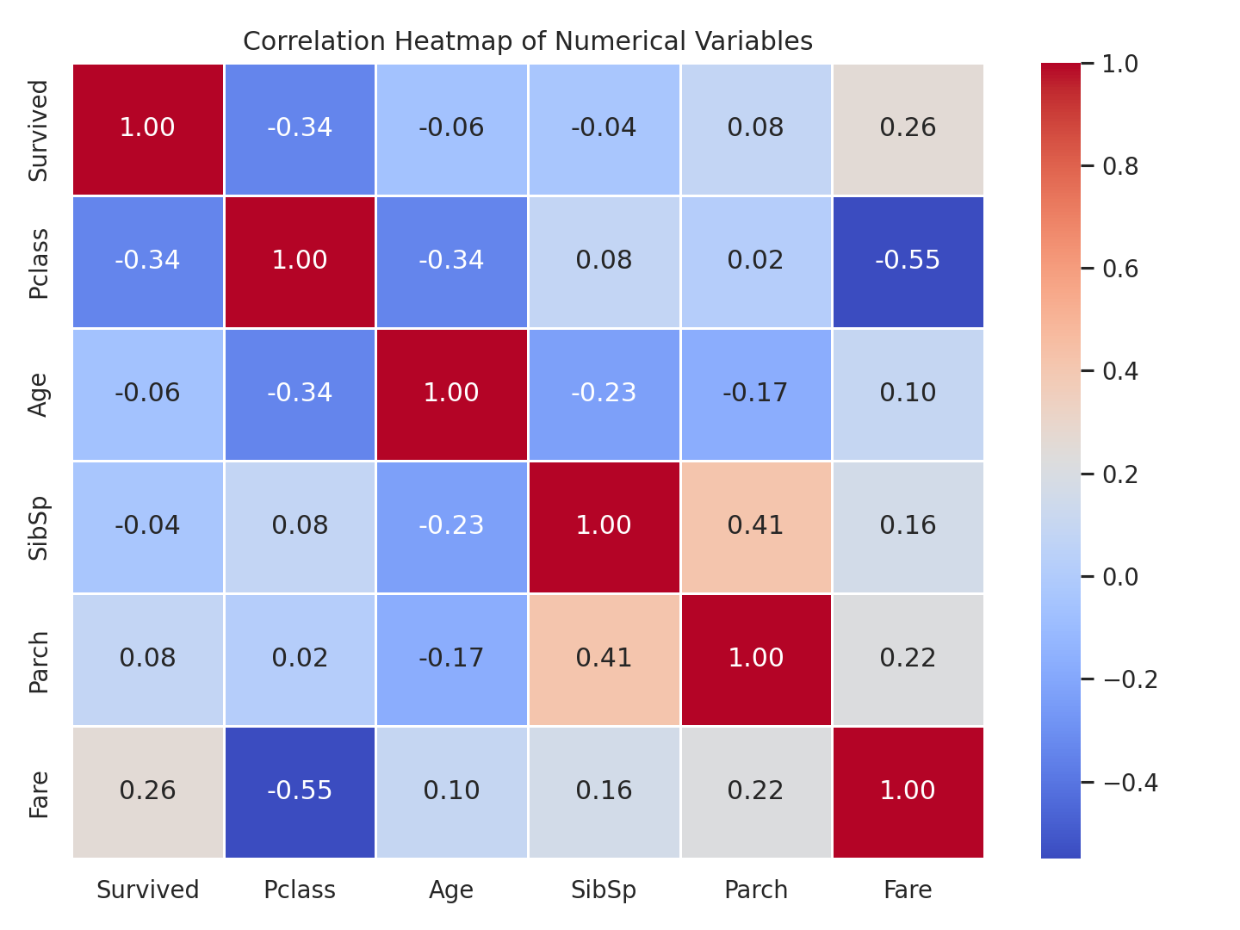
Passenger class and fare show a strong negative relationship, while fare shows a positive relationship with survival. The heatmap uses contrasting warm and cool colours.

Figure 6: Pairplot of Selected Numerical Variables
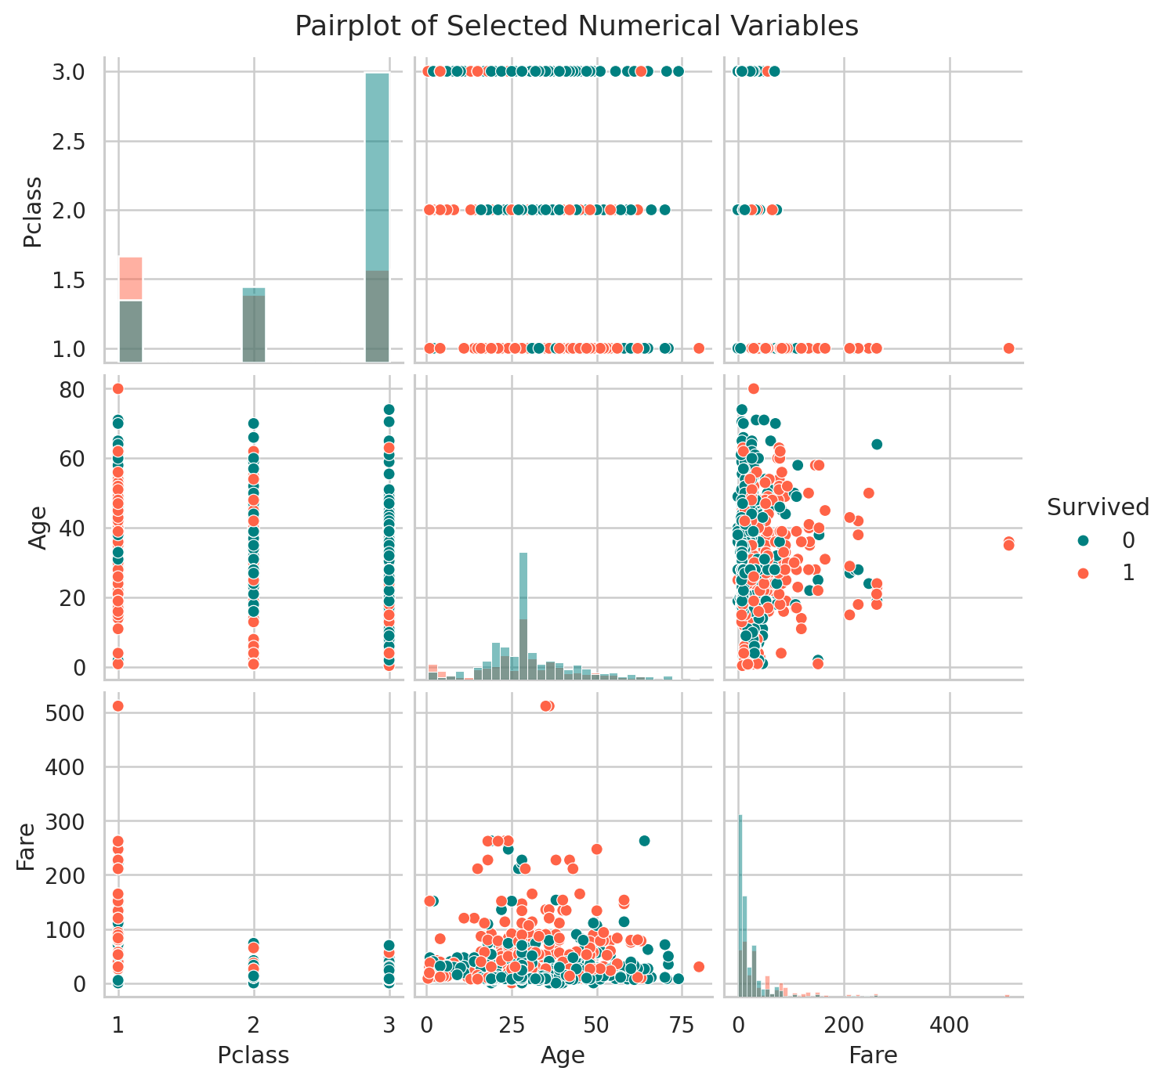
The pairplot gives a combined view of selected variables and uses different colours for survival groups.

4.2 Statistical Analysis
Descriptive statistics were used to summarise the numerical variables. Frequency distributions were used to examine categorical and grouped variables such as survival, passenger class, sex, and embarkation point.

Descriptive Statistics
Statistic | PassengerId | Survived | Pclass | Age | SibSp | Parch | Fare
count | 891.0 | 891.0 | 891.0 | 891.0 | 891.0 | 891.0 | 891.0
mean | 446.0 | 0.38 | 2.31 | 29.36 | 0.52 | 0.38 | 32.2
std | 257.35 | 0.49 | 0.84 | 13.02 | 1.1 | 0.81 | 49.69
min | 1.0 | 0.0 | 1.0 | 0.42 | 0.0 | 0.0 | 0.0
25% | 223.5 | 0.0 | 2.0 | 22.0 | 0.0 | 0.0 | 7.91
50% | 446.0 | 0.0 | 3.0 | 28.0 | 0.0 | 0.0 | 14.45
75% | 668.5 | 1.0 | 3.0 | 35.0 | 1.0 | 0.0 | 31.0
max | 891.0 | 1.0 | 3.0 | 80.0 | 8.0 | 6.0 | 512.33

Frequency Distributions
Variable | Category | Frequency
Survived | 0 | 549
Survived | 1 | 342
Pclass | 3 | 491
Pclass | 1 | 216
Pclass | 2 | 184
Sex | male | 577
Sex | female | 314
Embarked | S | 646
Embarked | C | 168
Embarked | Q | 77

The strongest positive correlation was between SibSp and Parch with a value of 0.415. The strongest negative correlation was between Pclass and Fare with a value of -0.549.
Important statistical findings include: first, more passengers died than survived; second, third class passengers formed the largest passenger group; third, fare and passenger class were strongly related, and fare had some positive relationship with survival.

4.3 Machine Learning Results
A Logistic Regression classifier was used to predict survival. The selected predictor variables were Pclass, Sex, Age, SibSp, Parch, Fare, and Embarked. Categorical variables were encoded using dummy variables before training. The dataset was divided into training and testing sets using an 80:20 split.
Metric | Value
Accuracy | 80.45%
Training records | 712
Testing records | 179

Confusion Matrix
 | Predicted 0 | Predicted 1
Actual 0 | 98 | 12
Actual 1 | 23 | 46

Classification Report
Class | Precision | Recall | F1-score | Support
0 | 0.81 | 0.89 | 0.85 | 110
1 | 0.79 | 0.67 | 0.72 | 69

The model achieved an accuracy of approximately 80.45%. This result is acceptable for a simple introductory model. The model performed reasonably well because important predictors such as sex, passenger class, age, and fare were included.

5. Discussion
The analysis shows that survival on the Titanic was not random. Passenger class, fare, age, and sex influenced survival patterns. The class distribution showed that third class passengers were the largest group, while the visualisations suggested that fare and passenger class were related to survival. The correlation analysis also supported the idea that fare and class were important variables.
From a statistical point of view, the strongest negative correlation was observed between passenger class and fare. This means that as passenger class number increases from first class to third class, fare tends to decrease. The strongest positive correlation among the selected numerical variables was between SibSp and Parch, suggesting that passengers travelling with siblings or spouses were also more likely to have parents or children on board.
The Logistic Regression model provided a simple method for predicting survival. Logistic Regression is suitable because survival is a binary target variable. The model accuracy shows that the selected variables contain useful information for prediction. However, the model is limited because it uses simple preprocessing and does not include advanced feature engineering. Variables such as Name and Ticket were not used, although they may contain useful information such as titles or ticket groups.
The limitations of the study include missing values, especially in Cabin; the use of median and mode imputation; and the use of only one machine learning algorithm. Future work could compare Logistic Regression with Decision Trees, Random Forest, or Support Vector Machines. The analysis could also improve by engineering new features such as family size, title from passenger name, and age group.

6. Conclusion
This project successfully applied data science methods to the Titanic dataset. The dataset was loaded, inspected, cleaned, visualised, and analysed statistically. A Logistic Regression classifier was trained to predict passenger survival. The results showed that passenger class, fare, sex, and age were useful factors for understanding survival outcomes. Although the model performed reasonably well, further improvements could be made through feature engineering and model comparison.

7. References
Kaggle. (n.d.). Titanic - Machine Learning from Disaster. Kaggle.
McKinney, W. (2022). Python for Data Analysis: Data Wrangling with pandas, NumPy, and Jupyter. O'Reilly Media.
Pedregosa, F., Varoquaux, G., Gramfort, A., Michel, V., Thirion, B., Grisel, O., et al. (2011). Scikit-learn: Machine Learning in Python. Journal of Machine Learning Research, 12, 2825-2830.
Waskom, M. L. (2021). Seaborn: Statistical data visualization. Journal of Open Source Software, 6(60), 3021.

8. Appendix: Python Code Summary
The full source code is provided in the Jupyter Notebook and in src/titanic_analysis.py. The code imports libraries, loads the dataset, handles missing values, creates visualisations with improved contrasting colours, computes statistics, trains Logistic Regression, and evaluates the model using accuracy, confusion matrix, and classification report.

