KUMASI TECHNICAL UNIVERSITY
FACULTY OF APPLIED SCIENCES AND TECHNOLOGY
COMPUTER SCIENCE DEPARTMENT

DESIGN AND IMPLEMENTATION OF AN INTEGRATED SCHOOL MANAGEMENT AND AUTOMATED NOTIFICATION SYSTEM

A PROJECT SUBMITTED TO THE COMPUTER SCIENCE DEPARTMENT
IN PARTIAL FULFILLMENT OF THE REQUIREMENT FOR THE AWARD
OF <<YOUR PROGRAMME OF STUDY>>

<<Your name (First name, middle name and Surname)>>
(<<Student number>>)

<<MONTH, YEAR>>

DECLARATION
I hereby declare that this project report is the result of my own original effort, carried out under the supervision of <<Supervisor's name>> in the Computer Science Department, Kumasi Technical University. All sources of information consulted in the course of this work have been duly acknowledged and referenced in accordance with the American Psychological Association (APA, 7th edition) style. To the best of my knowledge, this work has not been submitted, either in whole or in part, for the award of any other degree, diploma or qualification in this or any other institution.

Where artificial-intelligence tools were used in the preparation of this report, their use was limited to drafting assistance and language refinement; the design decisions, the implemented system and the conclusions drawn are my own, and I am able to explain and defend every part of this work.

Signature: ........................................
Date: ........................................
<<Your name (First name, middle name and Surname)>>
(Student)

CERTIFICATION
I hereby certify that this project report was prepared by the above-named student under my supervision, in accordance with the guidelines for the writing of undergraduate project reports laid down by the Computer Science Department, Kumasi Technical University. I confirm that the work meets the required academic standards and I approve it for submission.

Signature: ........................................
Date: ........................................
<<Supervisor's name>>
(Project Supervisor)

Signature: ........................................
Date: ........................................
<<Head of Department's name>>
(Head of Department)

ACKNOWLEDGEMENTS
My first and deepest gratitude goes to the Almighty God, whose grace and provision sustained me throughout the period of this project.
I am profoundly grateful to my supervisor, <<Supervisor's name>>, for the patience, technical insight and steady direction offered at every stage of this work. The critiques offered during our review sessions shaped both the architecture of the system and the argument of this report, and any clarity the reader finds in the pages that follow owes a great deal to that guidance.
I acknowledge the Head of Department, <<Head of Department's name>>, and the entire teaching staff of the Computer Science Department, Kumasi Technical University, whose instruction over the course of my programme furnished the foundation on which this project was built. I am grateful in particular to the lecturers of the database systems, software engineering and web technologies courses, whose material I drew on directly.
I thank the administrative and academic staff who gave their time to discuss how student records, class registers, results and fees are handled in practice. Their candour about where the existing manual processes break down gave this project its problem statement and kept its requirements honest.
Finally, I thank my family for their unfailing material and moral support, and my colleagues in the department for the many hours of discussion, testing and encouragement. Whatever shortcomings remain in this work are entirely my own.

ABSTRACT
Tertiary institutions maintain student records, course registrations, class registers, examination results and fee accounts as loosely coupled activities supported by paper registers, spreadsheets and ad-hoc messaging. The resulting fragmentation produces duplicated data entry, inconsistent results computation, avoidable billing errors, and students who miss registration and examination deadlines because announcements reach them too late. This project addressed that fragmentation by designing and implementing Kaime, an integrated web-based school management and automated notification system. The work followed a Design Science Research approach executed through iterative and incremental development, in which requirements elicited from institutional practice were translated into a domain model and realised as a working artefact evaluated against those requirements. The system comprises a React and TypeScript single-page dashboard, a Python FastAPI server organised into router, service and repository layers, and a PostgreSQL database of fifteen tables under Alembic migrations. Every academic operation is scoped to an academic term, so a course may be run, graded and billed independently each semester. Domain invariants are enforced in the service layer and reinforced by database constraints: assessment weights may not exceed one hundred percent per course-term, a room may not be double-booked, records with live dependants may not be deleted, invoices may not be overpaid, and repeated billing or register marking updates rather than duplicates existing rows. An APScheduler background job evaluates configurable day offsets before each event, renders a Jinja2 template, and writes a dispatch record whose unique constraint guarantees that no subscriber is notified twice for the same event and offset. Testing across the modules confirmed that the system enforces its stated invariants and returns the correct status semantics for conflicting and missing resources. The study contributes a term-scoped, invariant-driven reference design in which correctness rules are expressed once in a service layer rather than repeated across user interfaces.

Keywords: school management system, automated notification, FastAPI, PostgreSQL, idempotency, design science research, academic records.

TABLE OF CONTENTS
Right-click here and choose Update Field to build the table of contents.

LIST OF FIGURES
Right-click here and choose Update Field to build the list of figures.

LIST OF TABLES
Right-click here and choose Update Field to build the list of tables.

CHAPTER ONE

INTRODUCTION

1.1 Background of the Study
The administration of a tertiary institution rests on a small number of records that must remain mutually consistent: who the students are, what courses exist, who is registered for what in a given semester, who attended which class, what marks were earned, and what fees are owed and paid. These records are not independent. A mark is meaningless without the registration it belongs to; an invoice is meaningless without the student and the semester it was raised against; an attendance rate is meaningless unless the register is tied to a specific class sitting. In principle, therefore, the administration of an institution is a single connected information problem.
In practice it is rarely treated as one. Departments commonly maintain student biodata in one place, class registers on paper, continuous assessment marks in individual lecturers' spreadsheets, and fee accounts in a separate accounting package or ledger. Each of these artefacts is internally reasonable, but the boundaries between them are maintained by human effort. A student who defers, changes programme or is billed at the wrong level must be corrected in several places, and there is no mechanism that notices when one of those corrections is forgotten. [SOURCE NEEDED: a study documenting fragmented or manual record-keeping practice in Ghanaian or West African tertiary institutions]
Communication with students exhibits the same fragmentation. Registration windows, examination timetables, fee deadlines and resumption dates are typically announced through notice boards, departmental social-media groups and word of mouth. These channels are not systematic: they depend on a member of staff remembering to post at the right moment, and on the student happening to look. A reminder that arrives after the deadline it concerns has no value, and a reminder that is never sent at all is indistinguishable, from the student's point of view, from an institution that did not care to send it. [SOURCE NEEDED: evidence on students missing academic deadlines owing to poor institutional communication]
Software addressing parts of this problem is not scarce. Learning management systems such as Moodle organise course content and assessment; commercial student information systems handle admissions and records; accounting packages handle billing. What is less common, particularly at a scale and cost that a single department or a small institution can absorb, is a system in which these concerns share one data model, so that billing knows what programme and level a student is in, grading knows which registration a mark belongs to, and the notification mechanism knows which students exist at all. Where such integration is absent, institutions substitute manual reconciliation, and manual reconciliation is precisely where errors and delays originate.
This project was undertaken against that background. It set out to build a single system in which the academic term is the organising concept, so that enrolment, timetabling, attendance, assessment and billing are all scoped to a semester and can be run independently each semester without the records of one term contaminating another; and in which the correctness rules that administrators presently enforce by vigilance are instead enforced by the software itself.

1.2 Statement of the Problem
Tertiary institutions manage student records, course enrolment, attendance, assessment and fee accounts through disconnected manual and semi-automated processes that do not share a common data model, resulting in duplicated data entry, inconsistent and unverifiable results computation, avoidable billing errors, and the failure of time-critical academic announcements to reach students before the deadlines they concern.
The seriousness of this problem lies in the fact that its costs are silent. When a lecturer computes a continuous-assessment mark in a spreadsheet whose weightings sum to more than one hundred percent, nothing objects; the error surfaces only if someone recomputes it by hand. When a bursary runs a billing cycle twice, the second run produces a second invoice for every student, and the duplicates must be located and reversed individually. When two lecturers are allocated the same lecture room at overlapping times, the clash is discovered by the students who arrive to find the room occupied. When a reminder about a registration deadline is posted three days late, no error message is generated anywhere; there are simply students who did not register.
These failures share a structure. In each case a rule exists that everybody involved knows and agrees with, but the rule lives only in the heads of the people operating the process. It is never checked mechanically, and so it is violated whenever attention lapses. The need to solve this problem is therefore not merely a need for digitisation. Transferring the same unenforced rules from paper into a spreadsheet, or into a database with no constraints, reproduces the identical failure mode at greater speed. What is required is a system that holds these rules explicitly, refuses operations that would violate them, and performs the time-dependent communication tasks on a schedule that does not depend on anybody remembering.

1.3 Aim of the Study
The aim of this study is to design, implement and evaluate an integrated web-based school management and automated notification system that maintains student, course, enrolment, timetable, attendance, assessment and fee records within a single term-scoped data model, enforces institutional correctness rules in software, and dispatches academic reminders to students automatically and without duplication.

1.4 Objectives of the Study
In pursuit of the stated aim, the specific objectives of this study are:
- To analyse the record-keeping and communication processes of a tertiary institution and derive from them a set of functional and non-functional requirements for an integrated management system.
- To design a normalised, term-scoped relational data model and a layered software architecture in which the academic, attendance, grading and financial domains share a single source of truth.
- To implement the designed system as a web application comprising a RESTful application programming interface and an administrative dashboard, with the institutional correctness rules encoded as enforced invariants.
- To implement an automated notification subsystem that evaluates configurable reminder offsets before each academic event and dispatches templated messages exactly once per subscriber, per event, per offset.
- To test and evaluate the implemented system against the requirements established in the first objective, verifying in particular that each encoded invariant rejects the operations it is intended to reject.

1.5 Research Questions
The study was guided by the following questions:
- Which correctness rules governing academic and financial records in a tertiary institution can be expressed as machine-enforceable invariants, and where in a layered architecture should each be enforced?
- How can a relational data model be structured so that academic operations remain independently repeatable across successive academic terms?
- What scheduling and record-keeping mechanism guarantees that an automated reminder is delivered to a subscriber exactly once for a given event and reminder offset, notwithstanding restarts of the application or repeated execution of the scheduled job?
- To what extent does the implemented system satisfy the functional and non-functional requirements derived from institutional practice?

1.6 Significance of the Study
The direct beneficiaries of this study are the administrative and academic staff of the institution in which such a system is deployed. For administrators, the elimination of duplicated data entry between the student register, the enrolment record and the billing ledger removes a recurring source of clerical work and of error. For lecturers, weighted assessment definitions and automatic result computation remove the need to maintain private spreadsheets whose formulas nobody else can audit. For finance officers, an idempotent billing run and an invoice that refuses to be overpaid or voided after payment remove two of the most common and most time-consuming reconciliation tasks.
Students benefit less visibly but more consequentially. A reminder that arrives seven days, three days, one day and on the morning of a registration deadline is a materially different service from an announcement pinned to a notice board, and it is delivered without any member of staff having to act. Students also gain a defensible account of their own standing: an attendance rate computed from recorded sittings and a grade computed from declared weightings are both auditable in a way that a handwritten register and a private spreadsheet are not.
In terms of contribution to practice, the study offers a reference design in which institutional rules are expressed once, in a service layer, rather than being re-implemented in each user interface that touches the data. This is a modest but practically significant architectural claim: it is the difference between a system whose correctness survives the addition of a mobile application or a bulk import script, and one whose correctness does not. The system was further built entirely on open-source components, which is relevant to institutions for which the licensing cost of commercial student information systems is prohibitive.

1.7 Scope of the Study
The study covers the design, implementation and functional evaluation of a web-based system providing the following capabilities: management of academic terms; management of student records keyed by index number and electronic mail address; maintenance of a course catalogue; enrolment of students in courses for a specified term; definition of recurring weekly timetable slots with room-clash detection; marking of attendance registers against class sittings and computation of attendance rates; definition of weighted assessments, entry of scores, and computation of course results and grade point averages; definition of fee structures, issuing of invoices through a billing run, recording of payments and computation of outstanding balances; and the creation of academic events with automated, offset-based electronic mail reminders to registered subscribers.
The following are explicitly outside the scope of the study. The system does not implement a student-facing self-service portal; students are recipients of notifications and subjects of records rather than interactive users. It does not implement online payment processing; payments are recorded after they have been received through channels external to the system. It does not implement learning-content delivery, assignment submission or plagiarism detection, these being the province of a learning management system. It does not implement admissions processing, hostel allocation, library circulation or human-resource management. Notification delivery is implemented for electronic mail only; the channel abstraction admits short-message and push delivery, but no such channel was implemented.
The intended users of the system are the administrative staff, lecturers and finance officers of a tertiary department or small institution. The study was conducted within the Computer Science Department, Kumasi Technical University, over the course of one academic year, and the requirements were drawn from the practices of that environment.

1.8 Limitations of the Study
Several limitations qualify the findings reported here and should be borne in mind when interpreting them.
First, the system was evaluated functionally rather than in live institutional operation. Test data were constructed to exercise the system's rules, including deliberately invalid operations, but the system was not run for a complete semester with real student records. Consequently the study can report that the implemented invariants behave as designed, but it cannot report on the administrative burden of sustained data entry, on staff adoption, or on behaviour at the scale of several thousand concurrent records.
Second, the evaluation of the notification subsystem was necessarily compressed. Reminder offsets are expressed in days, and verifying the full seven-day, three-day, one-day and same-day sequence in real time would require a week of elapsed time per test case. The subsystem was therefore tested by invoking the processing cycle directly with controlled event dates, which verifies the dispatch logic and the duplicate-suppression guarantee but does not exercise the scheduler over a genuine multi-week period.
Third, authentication and role-based authorisation are present in the codebase in a preliminary form, based on JSON Web Tokens and Argon2 password hashing, but the school-management endpoints were not placed behind per-role authorisation within the period of the study. The system is therefore suitable for deployment on a trusted internal network but would require the completion of that work before exposure to a public network.
Fourth, the grading scale implemented in the system is a single configurable tuple, and the results reported here reflect that particular scale. Institutions operating a different scale would obtain different letter grades and grade points from the same raw scores, although the computation itself is unaffected.
Fifth, the requirements were elicited from a single institutional context. Practices that are near-universal in that context, such as the use of index numbers as the primary student identifier, are embedded in the data model and would require adaptation elsewhere.

1.9 Organisation of the Report
This report is organised into five chapters.
Chapter One introduces the study. It establishes the administrative and communication context from which the problem arises, states the problem, and sets out the aim, objectives, research questions, significance, scope and limitations of the work.
Chapter Two reviews the relevant literature. It clarifies the key concepts on which the system rests, examines existing school management and notification systems, reviews the technologies and architectural patterns available for building such a system, identifies the gaps that this project addresses, and summarises the position the study takes.
Chapter Three presents the methodology and system design. It justifies the Design Science Research approach and the iterative development process adopted, presents the functional and non-functional requirements, describes the tools and technologies selected, and sets out the system architecture, use cases, database design and principal algorithms, together with the testing plan and the ethical considerations governing the work.
Chapter Four documents the implementation of the system and its evaluation. It describes the development environment, the database implementation, each of the system modules and the user interface, explains the key code modules, and presents the test plan, test cases, test results and an evaluation of the system against its requirements.
Chapter Five discusses the findings, draws conclusions and makes recommendations. It summarises what was achieved, assesses each objective against the evidence, compares the system with the existing systems reviewed in Chapter Two, states the contribution of the project and the challenges encountered, and recommends directions for further work.

CHAPTER TWO

LITERATURE REVIEW

2.1 Introduction
This chapter reviews the body of work relevant to the design of an integrated school management and automated notification system. It proceeds from concepts to artefacts to techniques. Section 2.2 clarifies the key terms and ideas on which the system rests. Section 2.3 examines existing systems in the problem space and the design decisions embodied in them. Section 2.4 reviews the technologies available for constructing such a system and the grounds on which a selection can be made. Section 2.5 reviews the architectural patterns, methods and models drawn upon in the design. Section 2.6 identifies the gaps in the reviewed work that this project addresses, and Section 2.7 summarises the chapter.

2.2 Conceptual Review

2.2.1 School Management Information Systems
A school management information system is an application that collects, stores, processes and reports the administrative and academic data of an educational institution. Its characteristic feature, distinguishing it from a general database application, is that its entities are bound by a well-established set of institutional rules: a student belongs to a programme and a level, a course carries credit hours, a registration binds a student to a course within a defined period, and a result is derived from assessments belonging to that registration. The value of such a system lies less in the storage of these records than in the consistency it maintains among them. [SOURCE NEEDED: a scholarly definition or review of school management information systems and their adoption]

2.2.2 Term Scoping and Temporal Data
Academic data are inherently periodic. The same course is offered repeatedly, to different cohorts, with different assessments and different fees, and each offering must be recorded and reported separately while the underlying course definition persists. This is a recognised problem in temporal data modelling: an entity possesses attributes that are stable across time and attributes that are valid only within a defined interval. The conventional resolution is to separate the durable entity from the time-bound association, so that the course catalogue is stable while enrolment, timetabling, assessment and billing are all keyed to an academic term. Failure to make this separation produces the familiar pathology in which historical results become unretrievable after a course definition is edited.

2.2.3 Idempotency
An operation is idempotent when performing it more than once produces the same system state as performing it once. Helland (2012) argues that idempotency is not an optional refinement in distributed and long-running systems but a precondition for reliable operation, because in the presence of retries, timeouts and restarts an operation will eventually be attempted twice whether or not the designer intended it. The property is directly relevant in the present domain. A billing run that is not idempotent produces duplicate invoices when a network timeout prompts the operator to retry. A notification job that is not idempotent sends a student the same reminder on every scan interval. In each case the standard implementation technique is the same: before performing the effect, record or check a key that uniquely identifies the intended effect, and enforce that key's uniqueness in the database rather than in application logic alone.

2.2.4 Invariants and Defensive Data Design
An invariant is a condition that must hold of the data at all times, regardless of the operations applied. Evans (2003) locates the enforcement of invariants at the boundary of the aggregate: the object responsible for a cluster of related data is also responsible for refusing any operation that would leave that cluster in an invalid state. In an institutional records system the relevant invariants are readily enumerated, since they are the rules administrators already apply informally, and include such conditions as the total weighting of the assessments of a course not exceeding one hundred percent, a room not being allocated to two classes at overlapping times, the sum of payments against an invoice not exceeding the invoiced amount, and a record with live dependants not being deletable. The design question is not whether these rules exist but where they are enforced, and the argument developed in this study is that enforcing them in a shared service layer, rather than in each user interface, is what makes them durable.

2.2.5 Automated Notification and Scheduling
An automated notification system dispatches messages in response to the passage of time rather than in response to a user action. Its essential components are a definition of the events that warrant notification, a rule determining when relative to each event a message should be sent, a mechanism that periodically evaluates that rule, a rendering step that produces the message body, a delivery channel, and a record of what has already been delivered. The design difficulty concentrates in the last of these. Because the evaluating mechanism runs repeatedly and may run more often than the granularity of the rule it evaluates, correctness depends on the system's ability to distinguish a notification that is due from one that is due and has already been sent.

2.2.6 Representational State Transfer
Fielding (2000) introduced Representational State Transfer as an architectural style for network-based applications, characterised by a uniform interface, stateless interaction, addressable resources and the manipulation of those resources through representations. In practical terms the style prescribes that application entities be exposed as resources identified by uniform resource identifiers, that the semantics of an operation be carried by the request method, and that the outcome be reported through the response status code. The last of these is significant for the present work: a well-designed interface distinguishes an operation that failed because the resource does not exist from one that failed because it would violate a rule, and reports these as distinct conditions rather than as a single generic error.

2.3 Review of Existing Systems

2.3.1 Learning Management Systems
Moodle is the most widely deployed open-source learning management system and is used extensively in African tertiary institutions. It organises courses, distributes materials, collects assignment submissions, administers quizzes and maintains a gradebook whose categories and weightings are configurable. Its strengths are its maturity, its plugin ecosystem and the absence of licensing cost. Its limitation with respect to the present problem is one of orientation rather than capability: Moodle is designed around the delivery of teaching, and treats institutional administration as peripheral. It has no native concept of a fee structure, an invoice or a payment, no room-allocation or timetabling model, and its notion of enrolment is enrolment in a Moodle course rather than registration for a credit-bearing course in a specified academic term. An institution using Moodle therefore continues to maintain its authoritative student and financial records elsewhere, which reproduces the fragmentation the present project seeks to remove.

2.3.2 Student Information Systems
Dedicated student information systems address administration directly. Commercial products in this category maintain admissions, biodata, registration, transcripts and billing within one product, and are the reference point against which any new system in this space must be assessed. Their principal barrier is cost and organisational weight: licensing, implementation and training costs are calibrated for institutions with a dedicated information-technology directorate, and configuration to local practice is a project in itself. Open-source alternatives such as Fedena and openSIS reduce the licensing barrier and cover student records, attendance and fees, but they are typically built around the assumptions of primary and secondary schooling, in which a pupil belongs to a class for a year rather than registering for an individually chosen set of credit-bearing courses each semester. Adapting that model to tertiary practice is not a matter of configuration. [SOURCE NEEDED: a comparative study or evaluation of open-source student information systems]

2.3.3 Institutional Portals and In-House Systems
Many institutions operate an in-house student portal, typically supporting course registration and the publication of results. These systems are well-adapted to local practice by construction, but they are commonly built as a user interface directly over a database, with validation logic embedded in the pages that perform data entry. The consequence is that the same rule is implemented several times over, once in each page that can modify the relevant data, and diverges as the system is maintained. A bulk import or an administrative correction applied outside those pages bypasses the rules entirely. This observation is one of the principal motivations for the architecture adopted in the present study.

2.3.4 Communication and Notification Practice
Institutional communication with students is at present dominated by notice boards, bulk short-message services and social-media groups. Bulk messaging services deliver reliably but are triggered manually, which means the timing of a reminder depends on a member of staff acting on the correct day; they also maintain their own recipient lists, which diverge from the authoritative student register as students are admitted, defer or graduate. Social-media groups are timely when active but are neither auditable nor universal. Neither mechanism maintains a record of what was sent to whom, which means neither can guarantee that a given student was actually informed. [SOURCE NEEDED: a study of institutional communication channels and their effectiveness in reaching students]

2.4 Review of Related Technologies

2.4.1 Server-Side Frameworks
The candidate frameworks for the application server were the established general-purpose web frameworks and the newer asynchronous application programming interface frameworks. Django offers the most complete package, including an object-relational mapper, an authentication system and an automatically generated administrative interface, and would have delivered a working system quickly; its administrative interface, however, is generated from the data model and is therefore poorly suited to operations such as a billing run or bulk register marking that do not correspond to the editing of a single row. Flask offers minimalism at the cost of assembling request validation, serialisation and documentation from third-party extensions. FastAPI derives request validation, response serialisation and interface documentation from Python type annotations, provides first-class asynchronous request handling, and includes a dependency-injection mechanism that supports the layered construction adopted in this project. The type-driven validation is directly relevant to the aims of the study, since it removes an entire class of input-validation errors before any domain rule is evaluated.

2.4.2 Client-Side Technologies
For the administrative dashboard the alternatives were server-rendered templates and a single-page application. Server-rendered templates are simpler to deploy and require no separate build step, but they couple the presentation to the server framework and require a full page round trip for each interaction, which is unsatisfactory for tasks such as marking a register of sixty students. A single-page application built with React maintains interface state on the client and communicates with the server through the same programming interface that any other client would use, which additionally validates the claim that the interface is not a privileged path into the data. TypeScript was preferred to plain JavaScript for the static guarantees it provides across the boundary between the client and the interface it consumes.

2.4.3 Database Systems and Object-Relational Mapping
The data of this domain are highly relational and rich in constraints, which argues for a relational database management system. Codd (1970) established the relational model, and the normalisation theory built upon it remains the basis for eliminating the update anomalies that the fragmented spreadsheets described in Chapter One exhibit. Among relational systems, PostgreSQL was considered against MySQL and SQLite. SQLite is unsuited to concurrent multi-user write access. MySQL is capable but historically less strict in its constraint handling. PostgreSQL provides rigorous constraint enforcement, exact numeric types appropriate to monetary amounts, native support for universally unique identifiers and structured document columns, and is released under a permissive open-source licence.
Object-relational mapping mediates between the relational store and the application's object model. SQLModel builds on SQLAlchemy and Pydantic so that a single class definition serves both as the table definition and as the validated data model, which reduces the duplication that otherwise arises between persistence models and request or response schemas. Schema evolution was managed with Alembic, which records each change as a versioned, reversible migration script rather than allowing the schema to be altered ad hoc.

2.4.4 Task Scheduling
Three mechanisms were considered for periodic execution of the notification cycle. The operating-system scheduler, cron, is universally available and external to the application, but it invokes a separate process that must independently establish configuration and database connections, and it is invisible to the application's own logging and lifecycle. A distributed task queue such as Celery provides durable queuing, worker scaling and retry policies, at the cost of introducing a message broker and at least one additional deployed process. APScheduler runs within the application process and supports interval and cron triggers together with the concurrency and misfire controls needed here, namely a limit of one concurrent instance of the job, coalescing of missed executions, and a grace period within which a delayed execution is still permitted to run. For a workload consisting of a periodic scan of a modest number of rows, the operational simplicity of an in-process scheduler was judged decisive; the channel abstraction described in Chapter Three deliberately preserves the option of migrating to a distributed queue should the workload change.

2.5 Review of Methods, Algorithms and Models

2.5.1 Layered Architecture and the Repository Pattern
Fowler (2002) catalogues the layered organisation of enterprise applications, in which presentation, domain logic and data access are separated so that each may vary independently, and describes the Repository pattern, in which data access is mediated by an object presenting a collection-like interface over the persistence mechanism. The benefit relevant to this study is that the domain layer expresses rules in terms of the domain rather than in terms of queries, and that those rules become reachable from any entry point into the system. Evans (2003) develops the complementary argument that the service layer is the correct home for operations that span several entities, which is the case for every non-trivial operation in this domain: a billing run touches fee structures, students and invoices; a result computation touches enrolments, assessments, scores and courses.

2.5.2 Dependency Injection
Dependency injection supplies a component's collaborators from outside rather than having the component construct them. In the present system the consequence is that a request handler declares that it requires a service, the framework constructs that service with a repository, and the repository is constructed with a database session whose lifetime is bound to the request. Neither the handler nor the service contains any code concerned with obtaining or closing a connection, and either may be exercised in a test with a substituted collaborator.

2.5.3 Weighted Assessment and Grade Point Computation
The computation of a course result from component assessments is a weighted aggregation in which each assessment contributes its declared weight in proportion to the fraction of its maximum score that the student attained. The design question that arises in practice is the treatment of assessments that have not yet been graded. Aggregating over the full declared weight treats an ungraded assessment as a score of zero, which renders every mid-semester standing meaningless and misleading. Normalising instead over the weight actually graded reports the student's standing among the assessments so far completed, which is both defensible and useful during the semester and converges on the same value as the conventional computation once all assessments have been graded. The latter approach was adopted. Grade points are then obtained by mapping the resulting percentage onto an ordered scale, and the grade point average is the credit-weighted mean of the grade points of the courses taken in the term.

2.5.4 Interval Overlap Detection
Detection of a timetable clash reduces to the classical test for the overlap of two half-open intervals. Two bookings of the same room on the same day of the week conflict precisely when the start of each precedes the end of the other. Expressing the condition in this form, rather than through an enumeration of the cases in which two intervals may be arranged, avoids the boundary errors that such enumerations characteristically contain, and correctly permits one class to begin at the exact moment another ends.

2.5.5 Software Development Process Models
Sommerville (2016) and Pressman and Maxim (2020) survey the principal process models. The waterfall model presumes that requirements can be established completely before design begins, which was not the case here, since the domain rules were discovered progressively as the model was built and tested. Iterative and incremental development, in the spirit of the Agile Manifesto (Beck et al., 2001), delivers the system as a sequence of working increments and accommodates the refinement of requirements as understanding develops. This was the process adopted, structured so that each increment delivered one complete vertical slice of the system, from database table through repository and service to interface endpoint and dashboard view.

2.5.6 Design Science Research
Hevner et al. (2004) characterise design science research in information systems as the construction and evaluation of an artefact that addresses an identified organisational problem, and Peffers et al. (2007) provide the procedural model consisting of problem identification, definition of objectives, design and development, demonstration, evaluation and communication. This paradigm fits the present study exactly, in which the contribution is a working system and the evaluation is an assessment of that system against the requirements derived from the problem.

2.6 Identification of Gaps in Existing Systems
Four gaps emerge from the foregoing review and together define the contribution attempted in this project.
The first is the separation of academic and financial concerns. Learning management systems handle teaching and grading but not billing; accounting systems handle billing but hold no notion of programme, level or academic term. Because fee liability is in practice determined by exactly those academic attributes, the separation forces a manual reconciliation that is both laborious and error-prone. A system in which a fee structure may be targeted at a programme and level, and billed directly against the student register, closes this gap.
The second is the treatment of notification as a manual act. In the systems reviewed, a reminder is sent because a member of staff decides to send it. A system in which the reminder schedule is declared once, as a property of the event, and thereafter executed by the system, changes the failure mode from silent omission to a recorded and inspectable dispatch history.
The third is the placement of validation logic. Where rules are implemented in the user interface, they are absent from every other path into the data and are duplicated among the interfaces that do implement them. Consolidating them into a service layer through which all mutations pass makes the rules single-sourced and testable in isolation.
The fourth is the absence of term scoping in systems adapted from primary and secondary education. Where a pupil belongs to a class for a year, term scoping is unnecessary; where a student registers for an individually chosen set of courses each semester, its absence makes the accurate reconstruction of historical records impossible.

2.7 Summary of the Literature
The review establishes that the individual capabilities required of the proposed system are all well understood in isolation. Learning management systems handle course delivery and grading; student information systems handle records and billing; scheduling libraries handle periodic execution; relational databases and object-relational mappers handle persistence and constraint enforcement. What the review does not find is a system, available at a cost and complexity appropriate to a single department or small tertiary institution, that unifies these capabilities within one term-scoped data model and enforces institutional correctness rules at a single architectural boundary.
The literature also supplies the methodological and architectural resources for constructing such a system: design science research as the paradigm, iterative and incremental development as the process, layered architecture with a repository and service separation as the structure, idempotency keys enforced by database constraints as the mechanism for reliable repeated execution, and Representational State Transfer as the interface style. Chapter Three sets out how these resources were applied in the design of the system.

CHAPTER THREE

METHODOLOGY AND SYSTEM DESIGN

3.1 Introduction
This chapter sets out how the study was conducted and how the resulting system was designed. Section 3.2 states and justifies the research approach, the methods used to gather requirements, and the development process followed. Section 3.3 presents the requirements themselves. Section 3.4 documents the tools and technologies selected and the grounds for selecting them. Section 3.5 presents the design of the system: its architecture, its use cases, its database schema and its principal object structure and behaviour. Section 3.6 specifies the algorithms that implement the non-trivial domain rules. Section 3.7 describes the data used. Section 3.8 presents the validation and testing plan, and Section 3.9 discusses the ethical considerations governing the work.

3.2 Research Methodology

3.2.1 Research Approach
This study adopted the Design Science Research paradigm as articulated by Hevner et al. (2004) and operationalised by Peffers et al. (2007). The paradigm is appropriate because the object of the study is not a hypothesis about an existing phenomenon but an artefact constructed to address an identified organisational problem, and because its criterion of success is the utility of that artefact rather than the statistical significance of an observation. The six activities of the Peffers model map onto the present work as follows.
Problem identification and motivation consisted of examining how student records, registration, attendance, results and fees are presently handled, and establishing the failure modes documented in Chapter One. Definition of the objectives of a solution produced the functional and non-functional requirements presented in Section 3.3, expressed as capabilities the artefact must possess and invariants it must enforce. Design and development produced the data model, architecture and algorithms presented in this chapter and the implementation reported in Chapter Four. Demonstration consisted of exercising each module of the working system against representative data. Evaluation consisted of the systematic testing reported in Chapter Four, in which each requirement and each declared invariant was tested with both valid and deliberately invalid input. Communication is effected by this report and by the oral defence accompanying it.

3.2.2 Data Collection Methods
Requirements were established from three sources. The first was documentary analysis of the artefacts the institution presently uses: the structure of student registers, the layout of continuous-assessment spreadsheets, the composition of examination results sheets, the format of fee schedules and the calendar of academic events. These artefacts encode the institution's working data model, and reading them established the attributes each entity must carry, the identifiers in actual use, and the grading scale and assessment categories to be supported.
The second was unstructured interviews with administrative staff, lecturers and finance staff, directed at establishing not what data are recorded but where the present processes fail. These conversations produced the invariants: the duplicate invoices that follow an interrupted billing run, the assessment weightings that do not sum correctly, the room double-bookings discovered only when a class arrives, and the difficulty of correcting a student record on which other records already depend.
The third was observation of the existing systems reviewed in Chapter Two, which established the baseline of expected functionality and the interface conventions with which prospective users are already familiar.
No personal data belonging to identifiable students were collected. All records used during development and testing were synthetic, as described in Section 3.7.

3.2.3 System Development Methodology
The system was developed using an iterative and incremental process in the Agile tradition (Beck et al., 2001). A waterfall process was rejected because it presumes that requirements are fully known before design commences, whereas several of the domain rules that this system's design turns upon were discovered only in the course of modelling the domain and testing early increments. The treatment of ungraded assessments in the results computation, discussed in Section 3.6.2, is a case in point: the requirement became clear only when the first implementation produced obviously wrong mid-semester standings.
Each increment delivered one complete vertical slice of the system, comprising the database table and its migration, the repository methods providing access to it, the service methods enforcing its rules, the endpoints exposing those methods, and the dashboard view consuming them. Delivering vertically rather than by layer meant that every increment ended in a system that could be exercised end to end, and that integration difficulties surfaced within the increment that caused them rather than accumulating to the end of the project.
The increments were sequenced by dependency. Academic terms were built first, since every other academic entity is scoped by a term; then students and courses; then enrolment, which binds the two within a term; then timetabling and attendance, which depend on enrolment; then assessment and grading, which also depend on enrolment; then fees and billing, which depend on the student register; and finally the notification subsystem, which depends on the subscriber and event records. Version control was maintained throughout with Git, with each increment developed and reviewed before being merged.
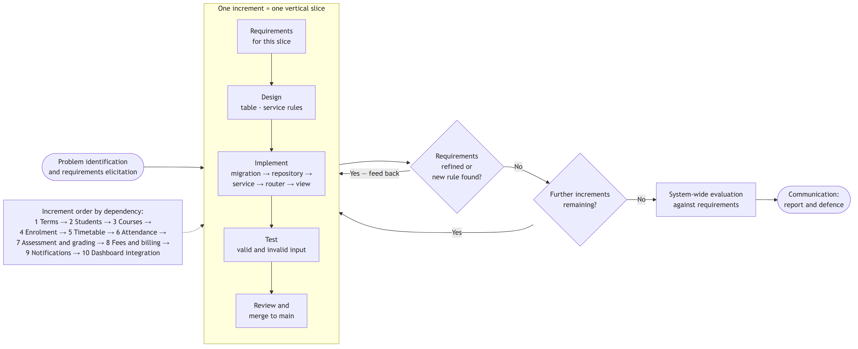
Figure 3.1: Iterative and incremental development cycle applied in the study

3.3 Requirements Analysis

3.3.1 Functional Requirements
The functional requirements of the system are enumerated in Table 3.1. Each is identified by a code used subsequently to trace the requirement to its implementation in Chapter Four and to the test cases that verify it.
Table 3.1: Functional requirements of the system
ID | Requirement
FR-01 | The system shall allow an administrator to create, view, update and delete academic terms, and to designate one term as the current term.
FR-02 | The system shall allow an administrator to register a student with a unique index number and a unique electronic mail address, together with programme, level, contact and status information.
FR-03 | The system shall automatically link a newly registered student to an existing notification subscriber where their electronic mail addresses match.
FR-04 | The system shall allow an administrator to maintain a course catalogue in which each course carries a unique code, a title, credit hours and an active or inactive state.
FR-05 | The system shall allow an administrator to enrol a student in a course for a specified academic term, permitting at most one enrolment per student, course and term.
FR-06 | The system shall allow an administrator to define recurring weekly class sessions for a course within a term, specifying day, start time, end time and room.
FR-07 | The system shall reject any class session that would allocate a room already booked for an overlapping period on the same day of the same term.
FR-08 | The system shall allow a lecturer to mark an attendance register in bulk for a course sitting, recording each student as present, absent, late or excused.
FR-09 | The system shall update rather than duplicate attendance entries when a sitting is marked again.
FR-10 | The system shall compute, for each student in a course and term, the number of sittings held and the attendance rate, counting present, late and excused as attendance and absent as non-attendance.
FR-11 | The system shall allow a lecturer to define weighted assessments of a specified kind for a course within a term.
FR-12 | The system shall reject any assessment definition that would cause the total assessment weight for a course within a term to exceed one hundred percent.
FR-13 | The system shall allow a lecturer to record scores in bulk against an assessment, rejecting any score exceeding the assessment's maximum.
FR-14 | The system shall compute course results by weighted aggregation, normalising over the assessment weight actually graded, and map the resulting percentage to a letter grade and grade point.
FR-15 | The system shall compute a student's credit-weighted grade point average for a term.
FR-16 | The system shall allow a finance officer to define fee structures for a term, optionally targeted at a programme, a level, or both.
FR-17 | The system shall issue, on request, one invoice against a fee structure to every active student matching that structure, skipping students already invoiced for it.
FR-18 | The system shall allow a finance officer to record payments against an invoice, rejecting any payment that would cause the total paid to exceed the invoiced amount.
FR-19 | The system shall maintain the status of an invoice as unpaid, partially paid or paid according to the payments recorded against it, and shall permit an invoice to be voided only while no payment has been recorded against it.
FR-20 | The system shall compute a student's outstanding balance from the invoices and payments recorded.
FR-21 | The system shall prevent the deletion of any record on which other records depend, and shall report the attempt as a conflict.
FR-22 | The system shall allow an administrator to create academic events carrying a title, body, date range, message template and one or more reminder offsets.
FR-23 | The system shall periodically and without user intervention evaluate all active events and dispatch reminders to subscribers on the days indicated by the configured offsets.
FR-24 | The system shall dispatch at most one reminder per subscriber, per event, per offset, irrespective of how often the evaluation cycle is executed.
FR-25 | The system shall record the outcome of every dispatch attempt, including failures and their causes.
FR-26 | The system shall retry a failed dispatch attempt a configured number of times with an increasing delay before recording it as failed.
FR-27 | The system shall provide an administrative dashboard through which all of the above operations may be performed.

3.3.2 Non-Functional Requirements
Table 3.2 states the non-functional requirements, which constrain how the system provides the functionality above rather than what functionality it provides.
Table 3.2: Non-functional requirements of the system
ID | Category | Requirement
NFR-01 | Reliability | Repeated execution of any bulk operation, whether a billing run, a register marking or a notification cycle, shall leave the system in the same state as a single execution.
NFR-02 | Data integrity | Every domain invariant shall be enforced in the service layer and, where it is expressible as a uniqueness or referential condition, reinforced by a database constraint.
NFR-03 | Correctness of interface | The interface shall report a request for a non-existent resource as HTTP 404, a request violating a domain rule as HTTP 409, and a structurally invalid request as HTTP 422.
NFR-04 | Maintainability | Domain rules shall be implemented once, in the service layer, and shall not be duplicated in the user interface or in any other client.
NFR-05 | Extensibility | The notification delivery mechanism shall be defined by an interface, so that additional channels may be added without modification to the orchestration logic.
NFR-06 | Usability | The dashboard shall present each module through a consistent layout, and shall report the reason for a rejected operation in terms meaningful to the operator.
NFR-07 | Performance | Interactive dashboard operations shall complete within two seconds under representative departmental data volumes.
NFR-08 | Security | Passwords shall be stored only as Argon2 hashes; configuration secrets shall be supplied by environment variables and shall not appear in the source repository.
NFR-09 | Portability | The system shall run on any platform supporting Python 3.14 and PostgreSQL, and shall be deployable as a single application process serving both the interface and the compiled dashboard.
NFR-10 | Auditability | Every notification dispatch and every payment shall carry a timestamp and be retrievable after the fact.

3.3.3 User Requirements and User Stories
The requirements above were derived from the user stories set out in Table 3.3, which express the needs of each class of user in that user's own terms.
Table 3.3: User stories by actor
Actor | User story
Administrator | As an administrator, I want to open a new academic term and mark it as current, so that all subsequent registrations and billing are recorded against the correct semester.
Administrator | As an administrator, I want to register a student once and have that record serve enrolment, grading, billing and notification, so that I do not maintain the same person in four places.
Administrator | As an administrator, I want to be prevented from deleting a student who has enrolments or invoices, so that I do not silently destroy academic or financial history.
Administrator | As an administrator, I want to schedule the weekly timetable and be told immediately if a room is already taken, so that clashes are resolved before the semester begins.
Administrator | As an administrator, I want to declare an event and its reminder schedule once, so that students are reminded without my having to remember.
Lecturer | As a lecturer, I want to mark a whole class register in one operation, so that taking attendance does not consume teaching time.
Lecturer | As a lecturer, I want to correct a register I marked wrongly without creating duplicate entries, so that the attendance rate remains accurate.
Lecturer | As a lecturer, I want the system to refuse assessment weightings that exceed one hundred percent, so that my continuous assessment scheme is arithmetically sound.
Lecturer | As a lecturer, I want to see class standings before all assessments are graded, so that I can identify struggling students during the semester.
Finance officer | As a finance officer, I want to bill an entire programme and level in one operation, so that invoicing does not require me to process students individually.
Finance officer | As a finance officer, I want a repeated billing run to skip students already invoiced, so that an interrupted run can be safely restarted.
Finance officer | As a finance officer, I want the system to refuse an overpayment, so that a keying error is caught at the point of entry rather than at reconciliation.
Student | As a student, I want reminders of registration and examination deadlines to reach me in advance, so that I do not miss them.
Student | As a student, I want to receive each reminder once, so that the messages remain worth reading.

3.4 Tools and Technologies
Table 3.4 records the tools and technologies selected for the project together with the role each plays. The comparative grounds for the principal selections were set out in Section 2.4.
Table 3.4: Tools and technologies used in the project
Category | Technology | Role in the system
Programming language (server) | Python 3.14 | Implementation of the application server, domain services and background scheduler.
Programming language (client) | TypeScript | Implementation of the administrative dashboard with static type checking across the interface boundary.
Server framework | FastAPI | Routing, request validation, response serialisation, dependency injection and generation of the interface specification.
Object-relational mapper | SQLModel (over SQLAlchemy and Pydantic) | Definition of tables and validated data models from single class declarations.
Database | PostgreSQL | Persistent storage with referential integrity, uniqueness constraints and exact numeric types for monetary amounts.
Database driver | psycopg 3 | Connectivity between the application and PostgreSQL.
Migration tool | Alembic | Versioned, reversible evolution of the database schema.
Scheduler | APScheduler | In-process periodic execution of the notification cycle with concurrency and misfire control.
Template engine | Jinja2 | Rendering of notification message bodies from templates and event context.
Mail transport | fastapi-mail | Asynchronous dispatch of rendered messages over SMTP.
Password hashing | pwdlib with Argon2 | One-way hashing of user credentials.
Token handling | PyJWT | Issuing and verification of JSON Web Tokens for authentication.
Interface documentation | Scalar | Interactive presentation of the generated interface specification.
Client framework | React 19 | Component-based construction of the dashboard.
Client routing | React Router | Navigation between dashboard views without full page reloads.
Build tool | Vite | Development server and production bundling of the dashboard.
Styling | Tailwind CSS | Consistent presentation through utility-based styling.
Package management | uv (server), npm (client) | Reproducible dependency resolution and installation.
Version control | Git | Source history and incremental development.
Development environment | Visual Studio Code | Editing, debugging and integrated terminal use.

3.5 System Design

3.5.1 System Architecture
The system is organised as a three-tier application with a strict internal layering within the application tier, as shown in Figure 3.2. The presentation tier is a single-page application executing in the browser. The application tier is a FastAPI process divided into a router layer, a service layer and a repository layer, together with a background scheduler operating alongside the request-handling path. The data tier is a PostgreSQL database.
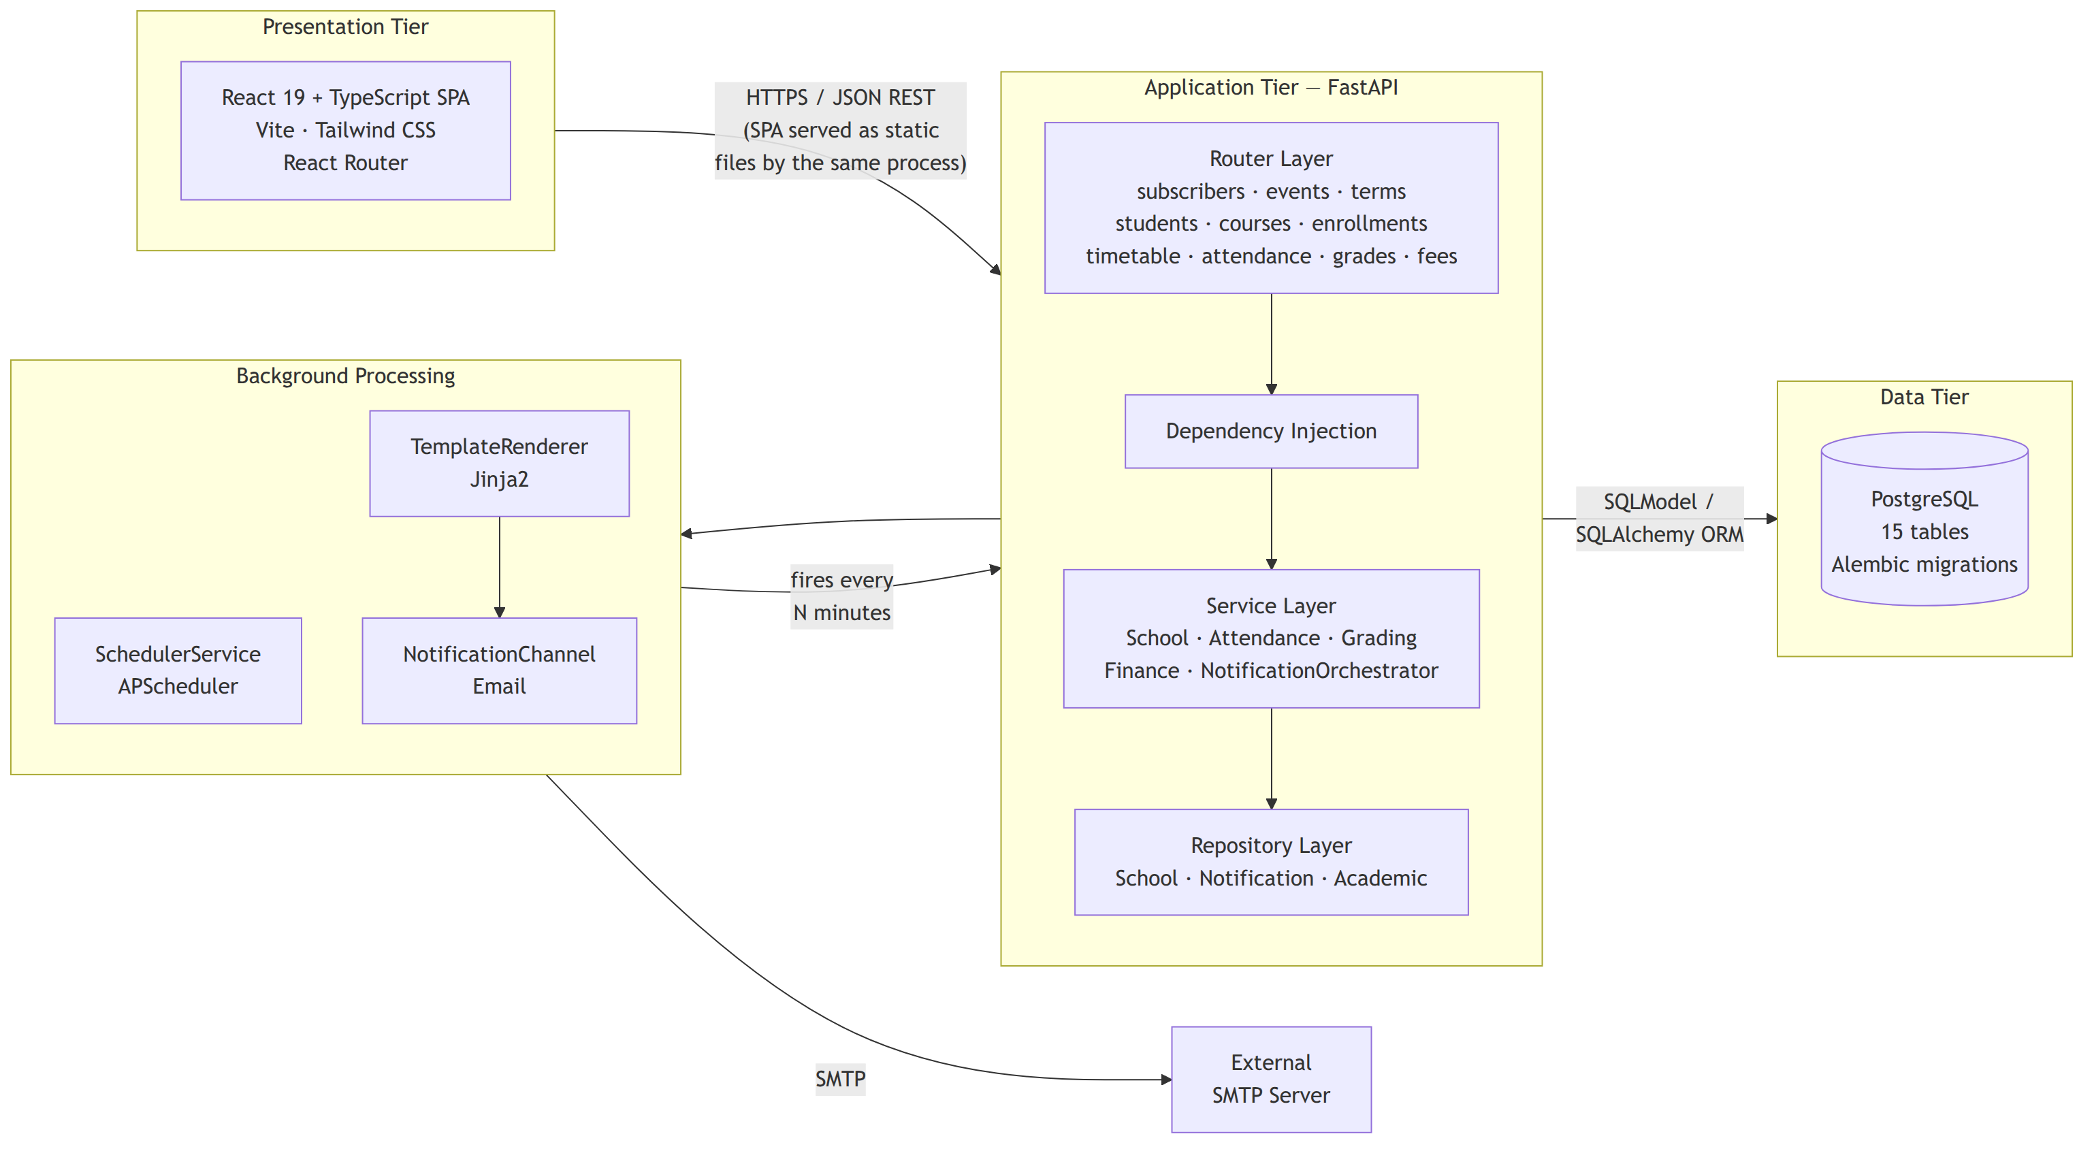
Figure 3.2: Layered architecture of the Kaime system
The responsibilities of each layer are deliberately narrow. The router layer translates between the transport and the domain: it declares the shape of each request and response, delegates to a service, and contains no domain logic whatever. The service layer owns the domain rules; it is the only layer that decides whether an operation is permissible, and it signals refusal by raising one of two domain exceptions rather than by constructing a transport response. The repository layer owns data access; it contains the queries and the session handling, and makes no decisions. The database itself carries the constraints that must hold irrespective of the path by which data arrive.
This arrangement is what delivers requirement NFR-04. Because the router layer holds no rules, a second client, a bulk import script or an administrative tool reaches the same rules by the same route, and no rule can be bypassed by entering the system at a different point. It also delivers requirement NFR-03 economically: the two domain exceptions, ResourceNotFoundError and ResourceConflictError, are registered once as application-wide handlers that translate them into the 404 and 409 responses respectively, so no individual endpoint contains status-code logic.
The background path is separate. The scheduler is started when the application starts and stopped when it stops, using the framework's lifespan mechanism. On each firing it constructs the notification orchestrator with its own database session, distinct from any request session, and executes one processing cycle. The same cycle is additionally exposed as an internal endpoint so that it may be invoked on demand during testing without waiting for the scheduler interval, which is the mechanism referred to in Section 1.8.

3.5.2 Use Case Design
Figure 3.3 presents the use cases of the system and the actors that initiate them. Four human actors are distinguished by function rather than by enforced privilege: the administrator, responsible for terms, students, courses, enrolment, timetabling and events; the lecturer, responsible for attendance and assessment; the finance officer, responsible for fee structures, billing and payments; and the student, who is a recipient of notifications rather than an operator of the system. A fifth, non-human actor, the scheduler, initiates the dispatch of due notifications and is shown as a system actor because it acts on the passage of time rather than at any person's instigation.
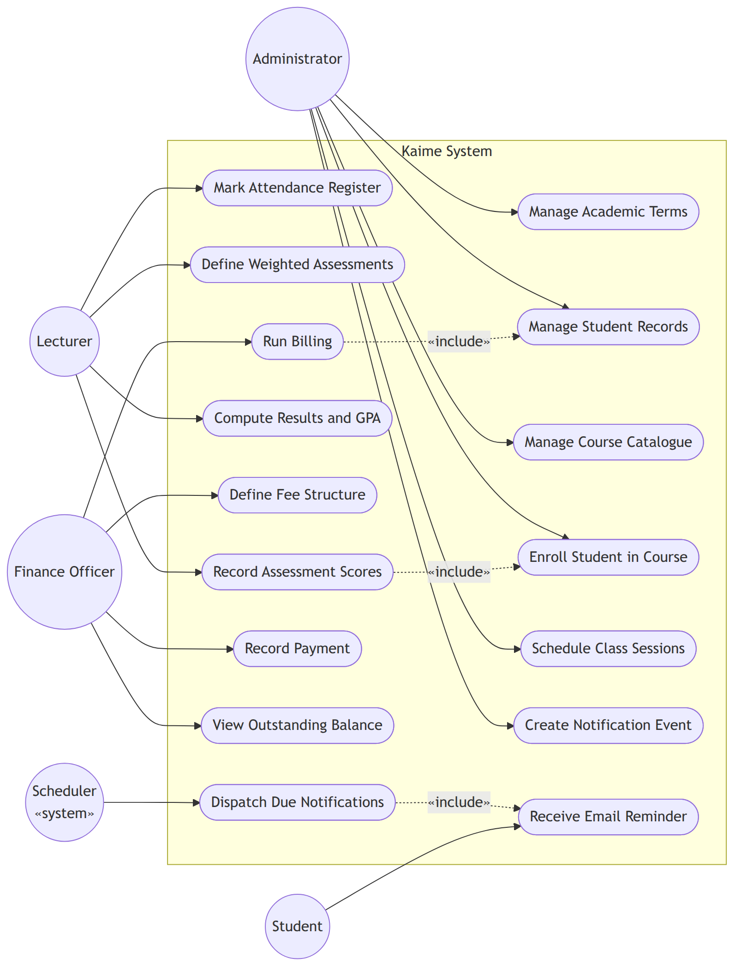
Figure 3.3: Use case diagram of the Kaime system

3.5.3 Database Design
The database comprises fifteen tables, normalised to third normal form. Figure 3.4 presents the entity relationship diagram. The design turns on three decisions.
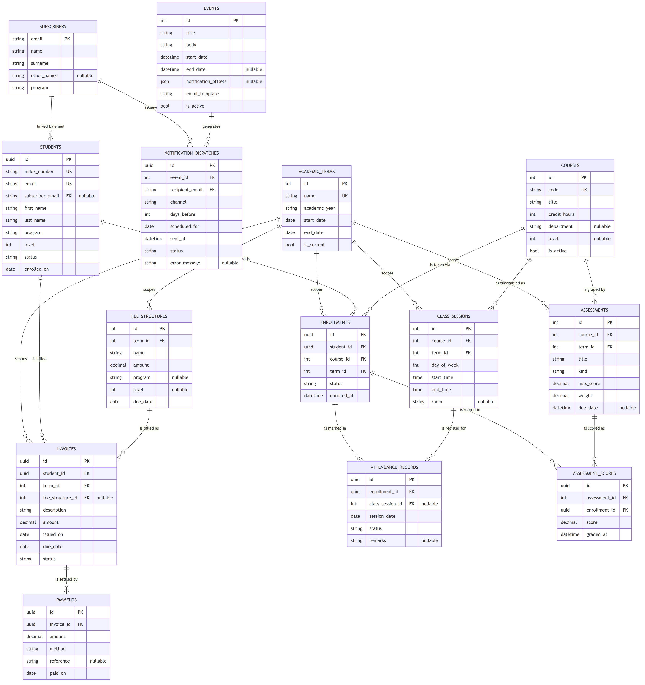
Figure 3.4: Entity relationship diagram of the Kaime database
The first is the separation of durable entities from term-bound associations. Students and courses are durable: a course exists whether or not it is running this semester. Enrolments, class sessions, assessments, fee structures and invoices all carry a term identifier, which is what allows the same course to be run, graded and billed independently each semester and allows any past semester to be reconstructed exactly. This realises the term scoping identified as a gap in Section 2.6.
The second is that the enrolment is the hinge of the academic model. Attendance records and assessment scores refer to an enrolment, not to a student and a course separately. This makes it structurally impossible to record a mark for a student who is not registered for the course, or to mark a register for a student who is not in the class, and it means that removing an enrolment removes precisely the dependent records that ought to go with it.
The third is the use of uniqueness constraints as idempotency keys, implementing NFR-01 and NFR-02. Four such constraints carry particular weight. The enrolment table is unique on the combination of student, course and term, which enforces FR-05. The attendance table is unique on the combination of enrolment, session date and class session, which is what permits FR-09 to be implemented as an update rather than an insertion. The assessment score table is unique on the combination of assessment and enrolment, which gives the same guarantee for score entry. The notification dispatch table is unique on the combination of event, recipient, channel, offset, scheduled date and status, which is the mechanism that delivers FR-24. In each case the constraint is declared in the schema, so the guarantee holds even if a defect were introduced into the service layer.
Monetary amounts are stored as exact decimal values rather than as floating-point numbers, since the accumulation of representation error across a term's invoices and payments would otherwise render balances unreliable. Identifiers of records that may be created concurrently or in bulk, namely students, enrolments, attendance records, scores, invoices, payments and dispatches, are universally unique identifiers rather than sequential integers, which permits such records to be generated without coordinating on a shared sequence. Reference data with a natural ordering and a small cardinality, namely terms, courses, class sessions, assessments and fee structures, retain sequential integer keys.
Table 3.5 summarises the tables of the database and their purpose.
Table 3.5: Summary of database tables
Table | Purpose | Key constraints
users | System operator accounts. | Unique email; password stored as Argon2 hash.
subscribers | Recipients of notifications. | Email as primary key.
events | Academic events warranting reminders. | Reminder offsets stored as a document column; active flag.
notification_dispatches | Record of every dispatch attempt. | Unique on event, recipient, channel, offset, date and status.
academic_terms | Semesters against which all academic activity is scoped. | Unique name; one term flagged as current.
students | Student register. | Unique index number; unique email; optional link to a subscriber.
courses | Course catalogue. | Unique course code; active flag.
enrollments | Registration of a student for a course in a term. | Unique on student, course and term.
class_sessions | Recurring weekly timetable slots. | Day of week constrained to 0-6; room clash rejected in the service layer.
attendance_records | Register marks against a sitting. | Unique on enrolment, session date and class session.
assessments | Weighted assessment definitions. | Total weight per course and term constrained to 100 percent.
assessment_scores | Scores recorded against an assessment. | Unique on assessment and enrolment; score bounded by the maximum.
fee_structures | Fee definitions targeted at a programme and level. | Scoped to a term.
invoices | Amounts billed to a student. | At most one invoice per student per fee structure.
payments | Amounts received against an invoice. | Sum of payments constrained not to exceed the invoiced amount.

3.5.4 Class Design
Figure 3.5 presents the principal classes of the application tier and the relationships among them. Each service holds a repository and no other dependency, which is what makes a service testable with a substituted repository. The notification orchestrator additionally holds a renderer, a delivery channel and its configuration.
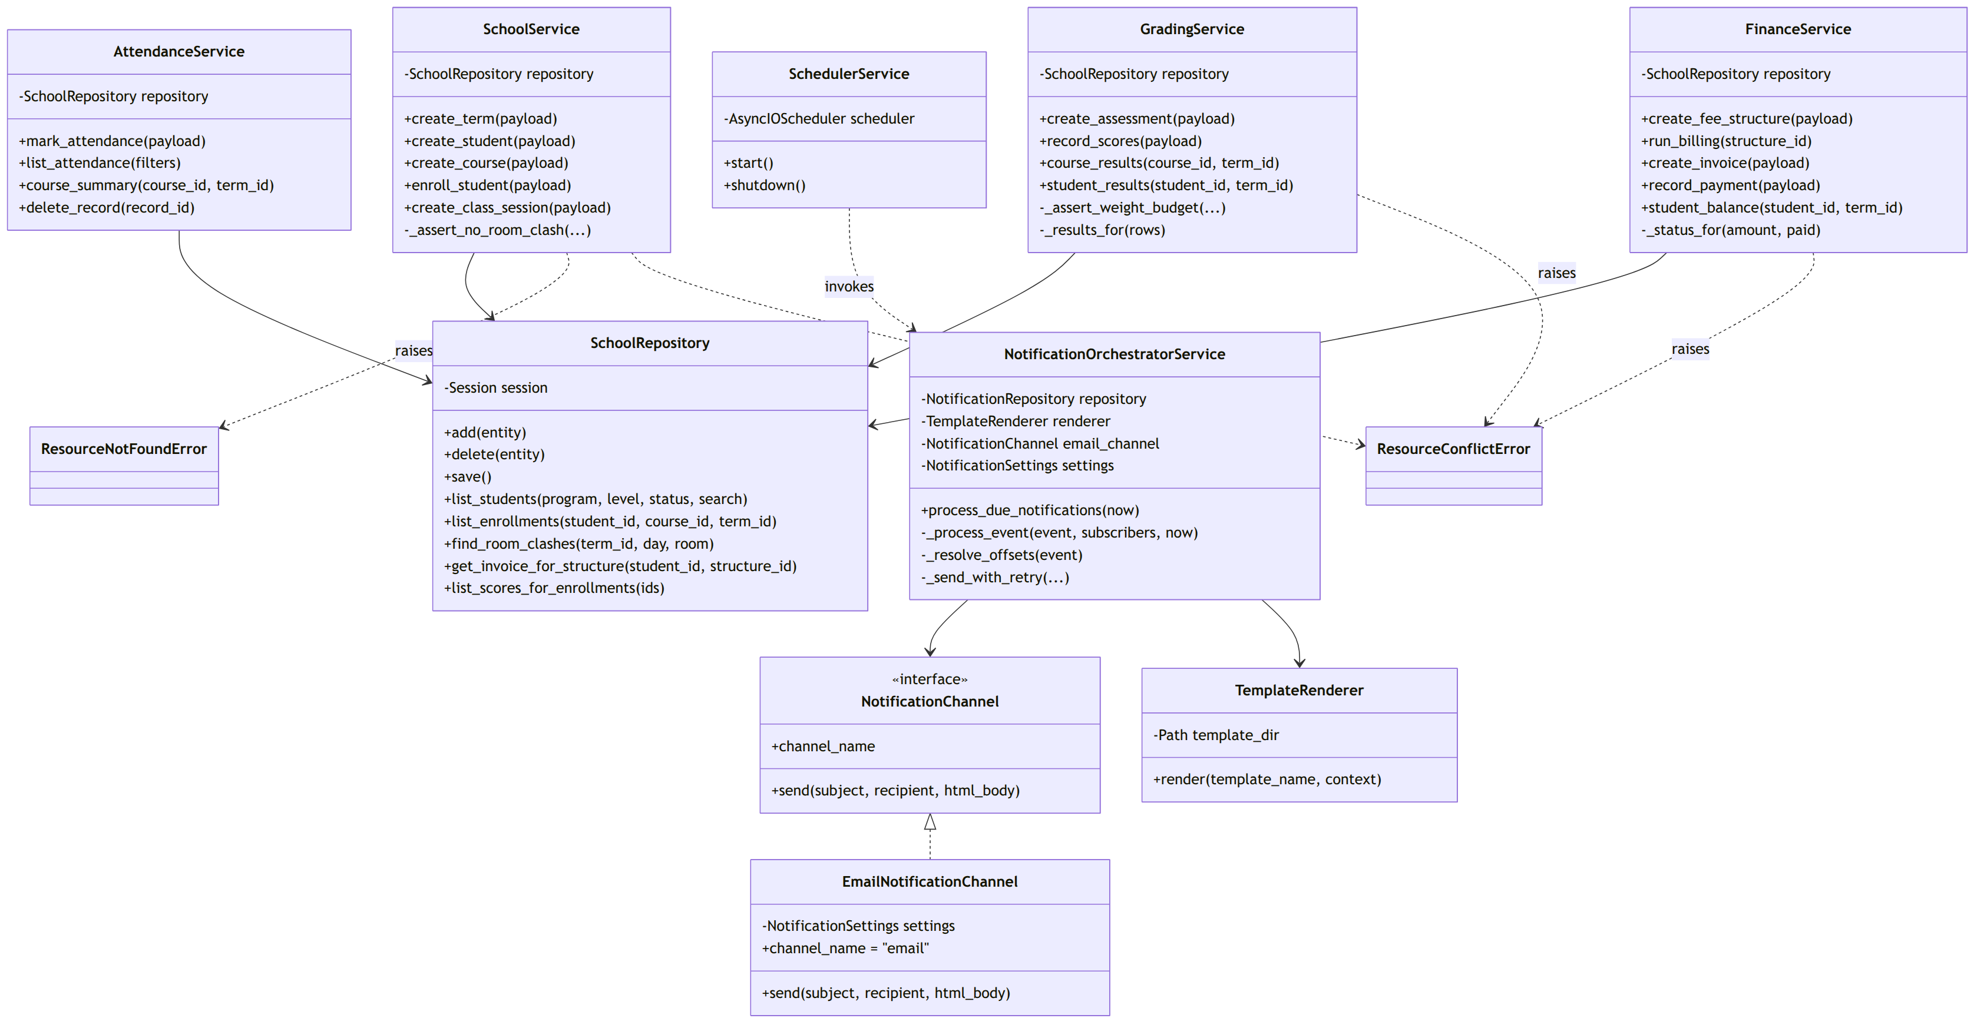
Figure 3.5: Class diagram of the service and repository layers
The delivery channel is declared as an interface rather than as a concrete class, which implements NFR-05. The orchestrator refers only to the interface, so the addition of a short-message or push channel requires a new implementation of that interface and a change to the composition of the orchestrator, but no change to the logic that determines what should be sent and to whom. The two domain exceptions are shown because they constitute the vocabulary in which every service reports a refusal.

3.5.5 Process Design
Figure 3.6 traces one execution of the notification cycle, which is the system's principal autonomous behaviour. The diagram makes visible the point at which FR-24 is enforced: before any message is rendered or sent, the orchestrator asks the repository whether a dispatch already exists for that combination of event, recipient, channel, offset and date, and abandons the recipient if one does. Because the dispatch record is written after each attempt, successful or otherwise, the guarantee survives a restart of the application mid-cycle.
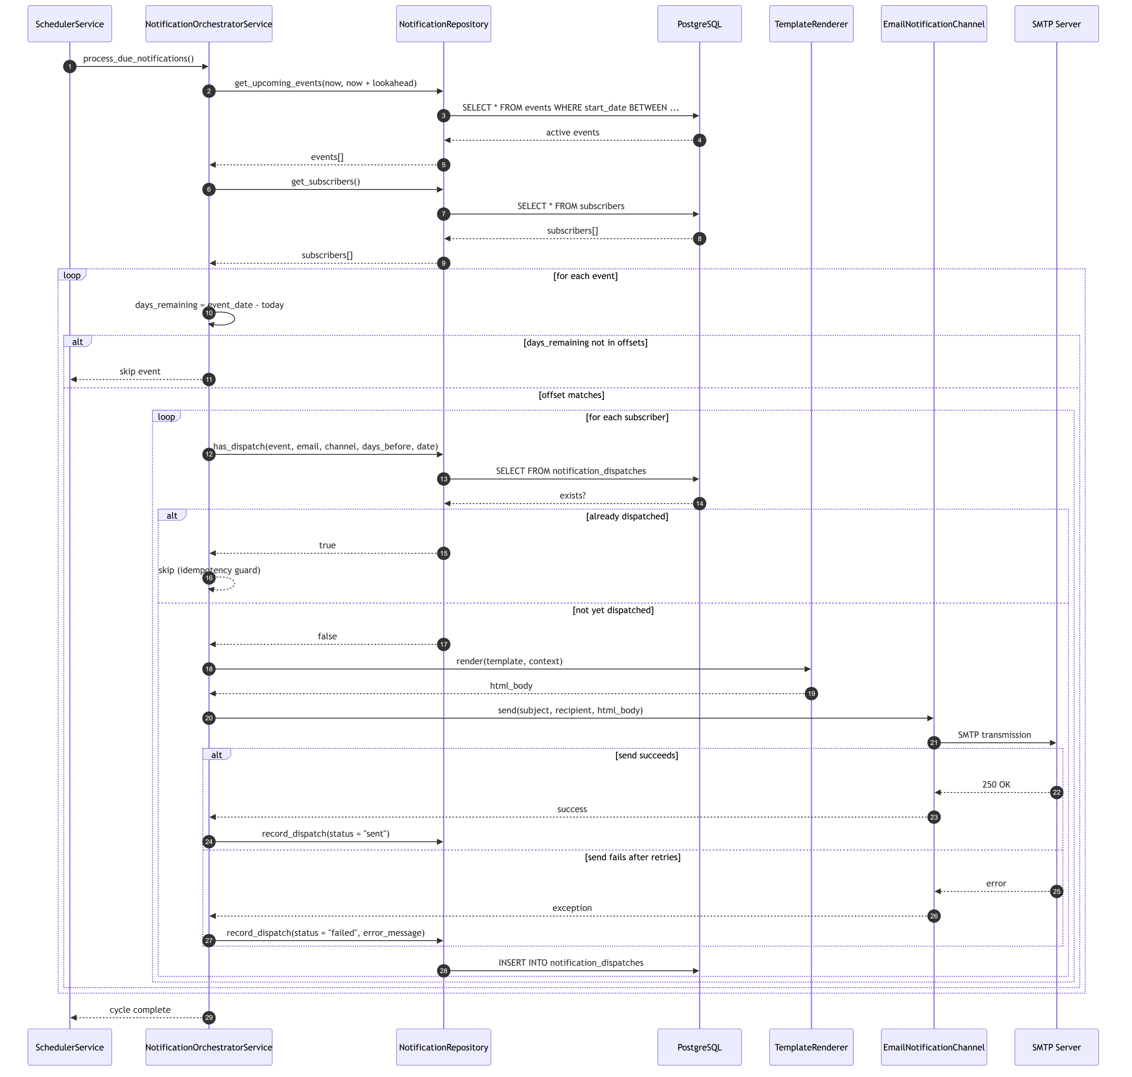
Figure 3.6: Sequence diagram of one notification dispatch cycle
Figure 3.7 presents the billing run as an activity diagram, showing the point at which the existence check makes the operation idempotent in satisfaction of FR-17 and NFR-01, and the summary of invoices created and students skipped that is returned to the operator so that the effect of a repeated run is visible rather than silent.
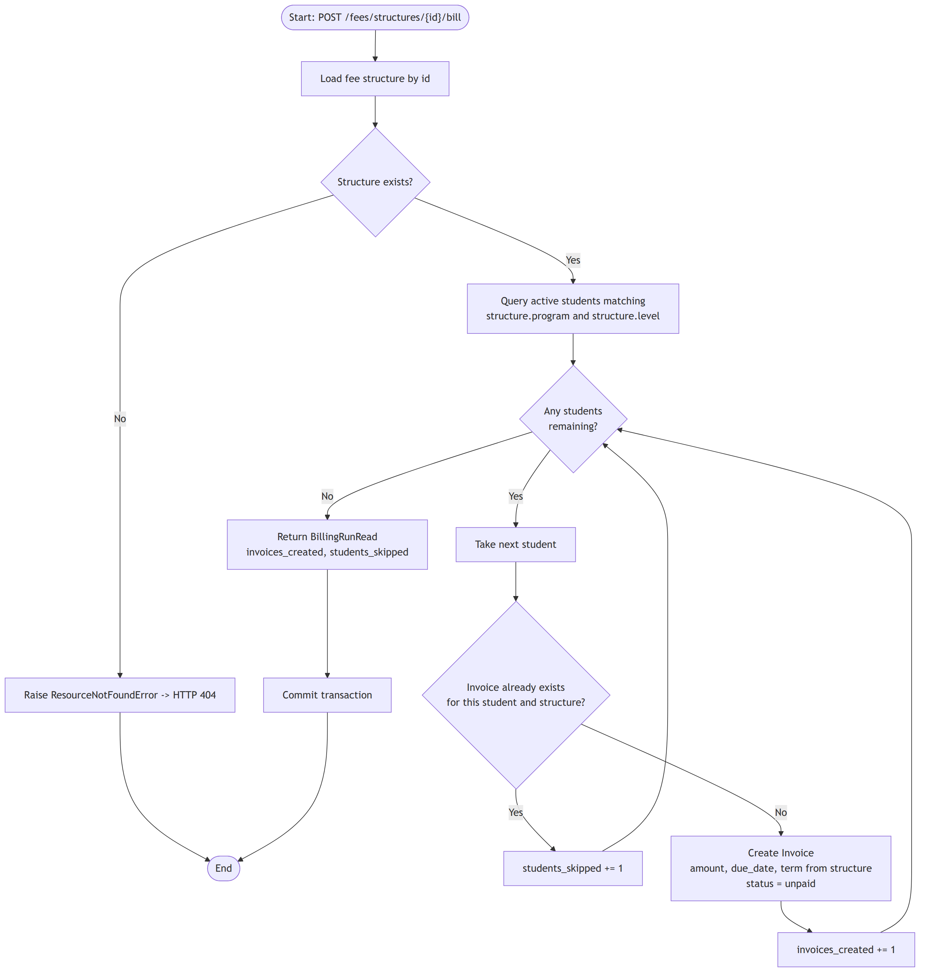
Figure 3.7: Activity diagram of the idempotent fee billing run
Figure 3.8 presents the lifecycle of an invoice as a state transition diagram, showing the permitted transitions among the unpaid, partially paid, paid and void states and the two transitions that the system refuses in satisfaction of FR-18 and FR-19.
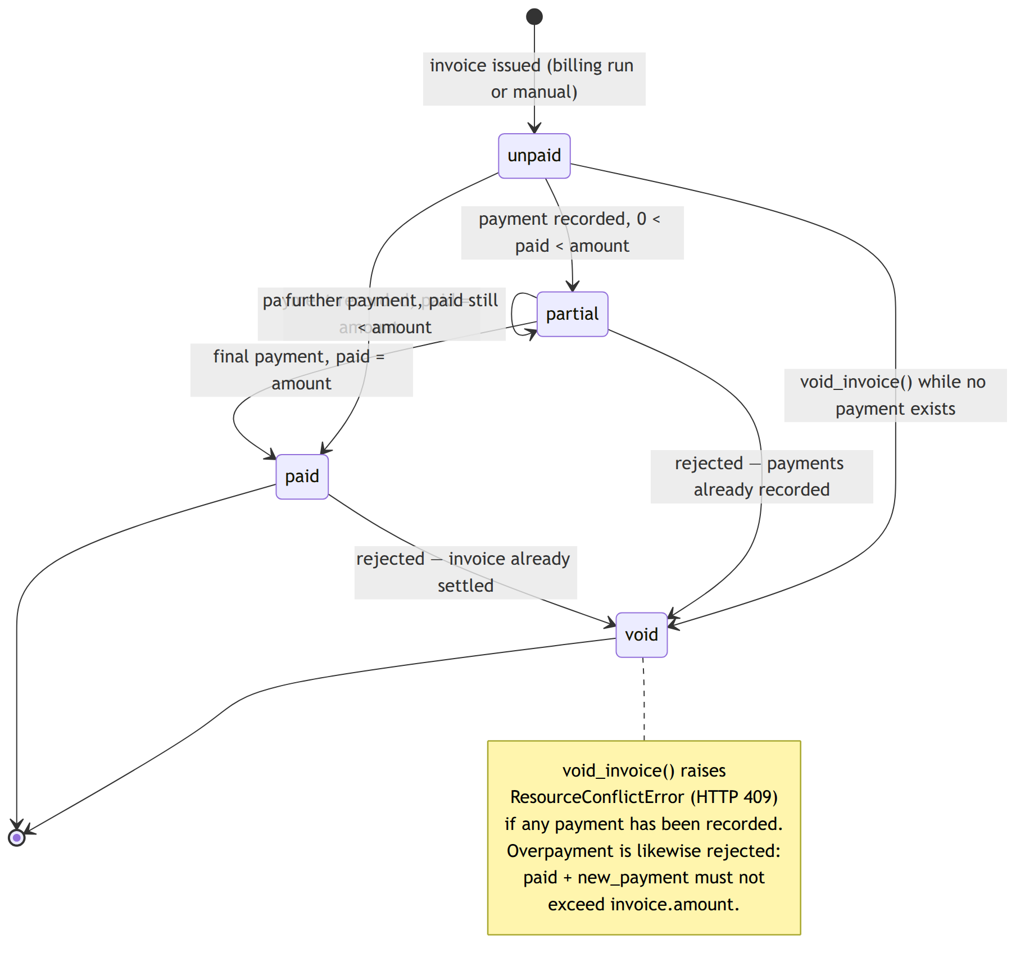
Figure 3.8: State transition diagram for an invoice

3.5.6 Input Design
Input to the system is received through forms in the dashboard and validated at three successive points. The first is the browser, where field types and required-field markers prevent the most obvious errors before a request is made. The second is the server's request model, where declared types, enumerations and bounds reject structurally invalid input with a 422 response before any domain code executes; enumerations are used for every value drawn from a fixed set, namely student status, enrolment status, attendance status, assessment kind, invoice status, payment method and message template, which makes an invalid value in these fields unrepresentable. The third is the service layer, which evaluates the domain rules that cannot be expressed as properties of a single request, such as whether a room is free or whether an assessment weight budget remains.
Two input forms depart from single-record entry because the corresponding task does. The attendance register accepts an entire class in one submission, as required by FR-08, since marking sixty students individually would make the system unusable during a lecture. Score entry accepts an entire assessment's marks in one submission for the same reason. Both submissions are validated in full before any part is persisted, so a single invalid entry rejects the whole submission rather than leaving a partially recorded register.

3.5.7 Output Design
Output takes three forms. Tabular views present lists of records with the filters appropriate to each module, such as programme, level and status for students, or term and course for enrolments. Computed views present derived figures rather than stored ones: the attendance summary reports sittings held, the counts of each status and the resulting rate; the results view reports the weighted percentage, the proportion of the assessment weight so far graded, the letter grade and the grade point; the balance view reports the total invoiced, the total paid and the outstanding amount. Reporting the graded proportion alongside the percentage is a deliberate design decision arising from Section 3.6.2, since it tells the reader how much of the semester's assessment the reported standing is based on.
The third form of output is the notification message itself, rendered from a Jinja2 template selected per event from a fixed set of institutional templates, and populated with the recipient's name, the event title and body, the event dates and the number of days remaining. Restricting the template to a defined set rather than accepting an arbitrary path is both a usability and a security decision, since it makes it impossible for a template reference to address an arbitrary file on the server.

3.6 Algorithm Descriptions

3.6.1 Notification Dispatch Algorithm
The notification cycle determines which reminders are due and dispatches those not already sent. Its correctness rests on the distinction between a reminder being due and a reminder being due and unsent, which is evaluated per recipient rather than per event. Pseudocode 3.1 states the algorithm.
Pseudocode 3.1: Notification dispatch cycle
PROCEDURE process_due_notifications(now)
lookahead <- configured lookahead in days
events <- repository.get_upcoming_events(now, now + lookahead)
subscribers<- repository.get_subscribers()

FOR EACH event IN events DO
event_date <- date part of event.start_date
days_remaining <- event_date - date part of now

IF days_remaining < 0 THEN CONTINUE // event already past

offsets <- resolve_offsets(event)
IF days_remaining NOT IN offsets THEN CONTINUE

FOR EACH subscriber IN subscribers DO
IF repository.has_dispatch(event.id, subscriber.email,
channel, days_remaining, event_date)
THEN CONTINUE // idempotency guard, FR-24

context <- { student_name, event_title, body,
start_date, end_date, days_remaining }
html <- renderer.render(event.email_template, context)
subject <- build_subject(event.title, days_remaining)

TRY
send_with_retry(subject, subscriber.email, html)
CATCH error
repository.record_dispatch(..., status <- "failed",
error_message <- error)
CONTINUE
END TRY

repository.record_dispatch(..., status <- "sent")
END FOR
END FOR
END PROCEDURE

FUNCTION resolve_offsets(event)
IF event.notification_offsets is non-empty THEN
RETURN non-negative values of event.notification_offsets
ELSE IF event.notification_days_before is set and non-negative THEN
RETURN { event.notification_days_before }
ELSE
RETURN configured default offsets
END IF
END FUNCTION

PROCEDURE send_with_retry(subject, recipient, html)
max_retries <- configured maximum, at least 1
backoff <- configured backoff in seconds, at least 1
FOR attempt <- 1 TO max_retries DO
TRY
channel.send(subject, recipient, html)
RETURN
CATCH error
IF attempt = max_retries THEN RAISE error
WAIT backoff x attempt seconds // linear backoff, FR-26
END TRY
END FOR
END PROCEDURE
Three properties of this algorithm are worth remarking. The offset resolution is a three-level fallback, which allows an event to declare an explicit reminder schedule, or a single reminder, or to inherit the institutional default. The retry is applied to the transport failure only, so a rendering error is not retried pointlessly. The dispatch record is written for failures as well as successes, which satisfies FR-25 and makes a silent delivery failure impossible.

3.6.2 Weighted Result Computation Algorithm
The computation of a course result aggregates the scores of the graded assessments in proportion to their declared weights. Pseudocode 3.2 states the algorithm; Figure 3.9 presents it as a flowchart.
Pseudocode 3.2: Weighted result and grade point average computation
FUNCTION compute_results(enrollments)
enrollments <- enrollments WHERE status != "dropped"
scores <- repository.list_scores_for_enrollments(enrollments)

earned <- empty map, default 0
graded_weight <- empty map, default 0

FOR EACH (score, assessment) IN scores DO
IF assessment.max_score <= 0 OR assessment.weight <= 0 THEN CONTINUE
fraction <- score.score / assessment.max_score
earned[score.enrollment_id] += fraction x assessment.weight
graded_weight[score.enrollment_id] += assessment.weight
END FOR

results <- empty list
FOR EACH enrollment IN enrollments DO
covered <- graded_weight[enrollment.id]
points <- earned[enrollment.id]
IF covered > 0 THEN
percentage <- points / covered x 100 // normalise over graded weight
ELSE
percentage <- 0.0
END IF
(letter, grade_point) <- grade_for(percentage)
APPEND (enrollment, percentage, covered, letter, grade_point) TO results
END FOR
RETURN results
END FUNCTION

FUNCTION grade_for(percentage)
FOR EACH (floor, letter, point) IN GRADE_SCALE DO // descending by floor
IF percentage >= floor THEN RETURN (letter, point)
END FOR
RETURN ("F", 0.0)
END FUNCTION

FUNCTION compute_gpa(results)
total_credits <- sum of credit_hours over results
weighted_points <- sum of (grade_point x credit_hours) over results
IF total_credits > 0 THEN
RETURN round(weighted_points / total_credits, 2)
ELSE
RETURN 0.0
END IF
END FUNCTION
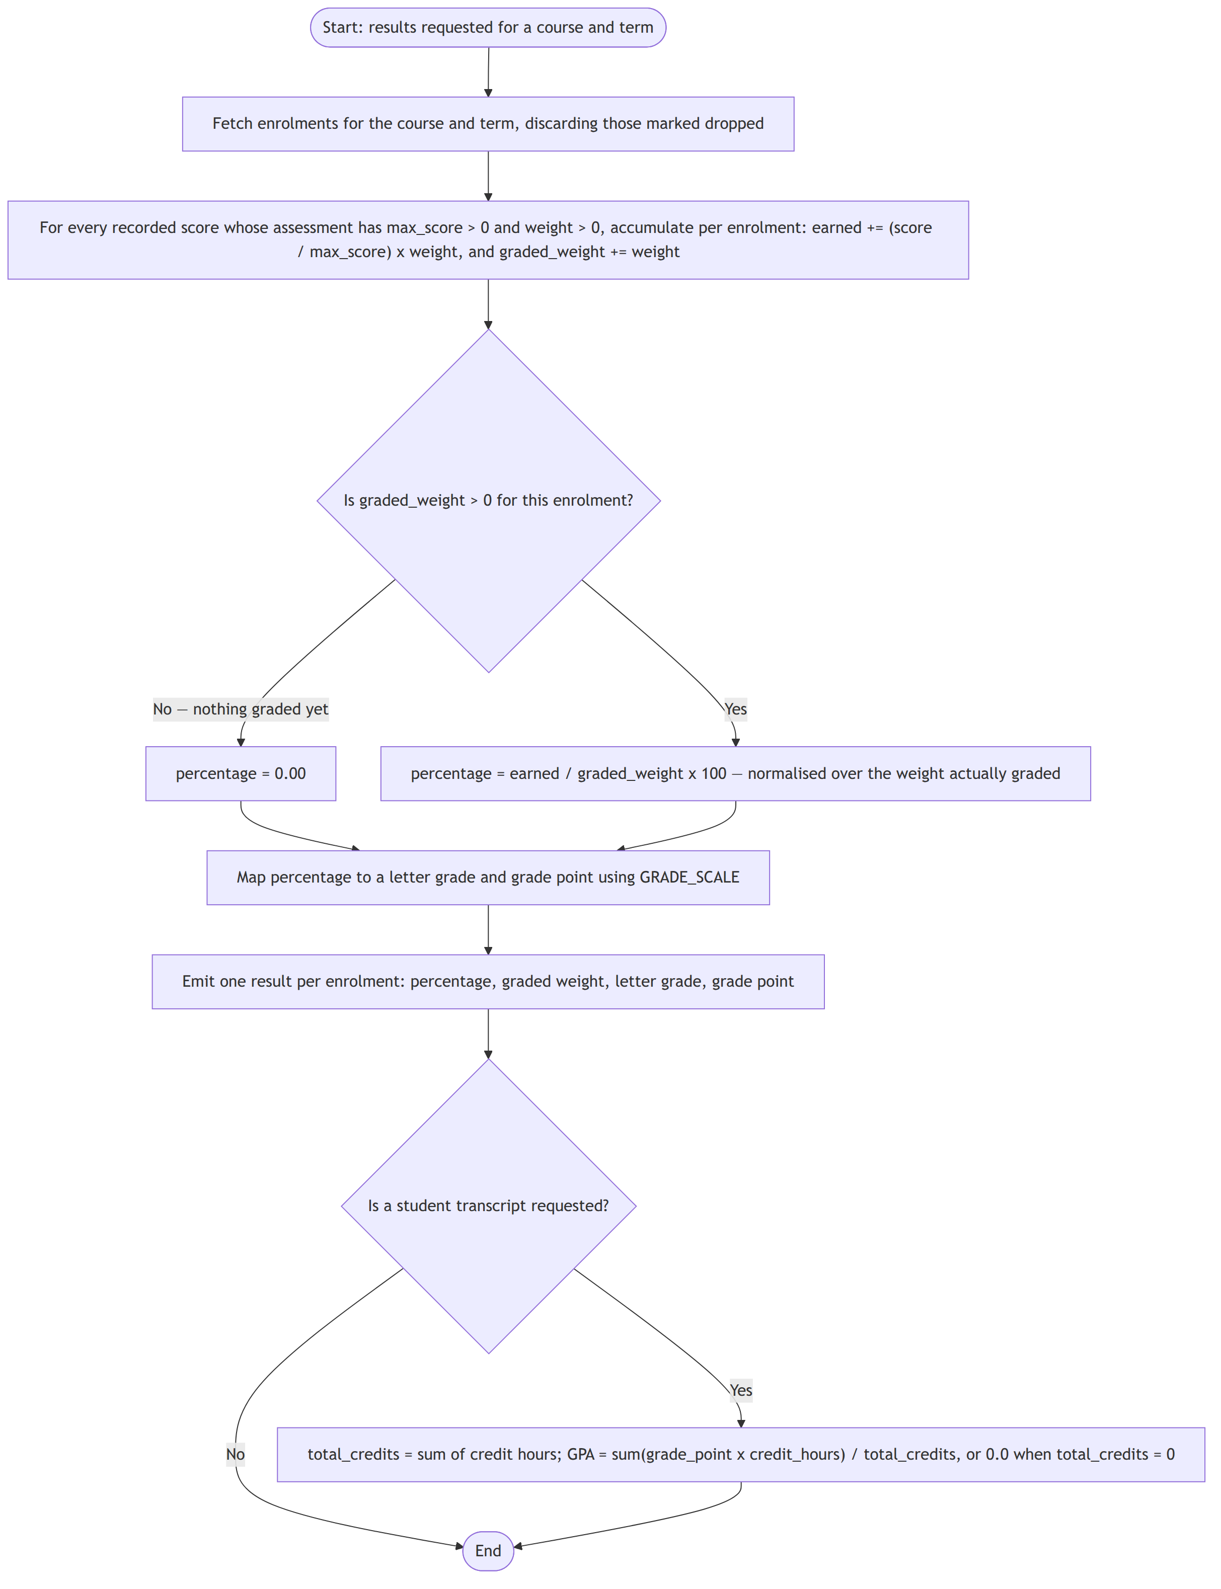
Figure 3.9: Flowchart of the weighted result computation algorithm
The decisive line is the normalisation over the weight actually graded rather than over the full declared weight. Consider a course whose assessment scheme is a quiz of ten percent, an assignment of twenty percent, a midterm of twenty percent and an examination of fifty percent, and a student who has so far scored full marks in the quiz and the assignment, the midterm and examination being ungraded. Aggregating over the full weight yields thirty percent and a failing grade, which is not merely unhelpful but false: the student has failed nothing. Normalising over the thirty percent actually graded yields one hundred percent, which correctly reports that the student has full marks in everything assessed so far. Once every assessment is graded, the graded weight equals the declared total and the two computations coincide. The proportion of weight graded is reported alongside the percentage so that a reader can see the basis of the figure.
The grade scale used by the system is given in Table 3.6. It is defined as a single ordered structure in the grading service, so an institution operating a different scale changes one declaration and no logic.
Table 3.6: Grade scale implemented in the system
Percentage range | Letter grade | Grade point
80.00 and above | A | 4.0
75.00 to 79.99 | B+ | 3.5
70.00 to 74.99 | B | 3.0
65.00 to 69.99 | C+ | 2.5
60.00 to 64.99 | C | 2.0
55.00 to 59.99 | D+ | 1.5
50.00 to 54.99 | D | 1.0
Below 50.00 | F | 0.0

3.6.3 Assessment Weight Budget Check
Before an assessment is created or its weight amended, the service verifies that the total weight declared for the course within the term will not exceed one hundred percent, implementing FR-12. When an existing assessment is being amended, that assessment is excluded from the existing total so that its own current weight is not counted twice.
Pseudocode 3.3: Assessment weight budget check
PROCEDURE assert_weight_budget(course_id, term_id, added_weight, exclude_id)
existing <- sum of assessment.weight
FOR assessments OF course_id AND term_id
WHERE assessment.id != exclude_id
IF existing + added_weight > 100 THEN
RAISE ResourceConflictError(
"Total assessment weight would be " + (existing + added_weight) +
"%, which exceeds 100%.")
END IF
END PROCEDURE

3.6.4 Room Clash Detection
A proposed class session is rejected if the room it requests is already booked for an overlapping period on the same day of the same term, implementing FR-07. Two half-open intervals overlap precisely when each begins before the other ends, which is the condition tested. Sessions with no room specified are exempt, since an unallocated session cannot clash.
Pseudocode 3.4: Room clash detection
PROCEDURE assert_no_room_clash(term_id, day_of_week, room, start, end, exclude_id)
IF room is empty THEN RETURN // no room, no clash possible

candidates <- repository.find_room_clashes(term_id, day_of_week,
room, exclude_id)
FOR EACH other IN candidates DO
IF start < other.end_time AND other.start_time < end THEN
RAISE ResourceConflictError(
"Room " + room + " is already booked " +
other.start_time + "-" + other.end_time + " on that day.")
END IF
END FOR
END PROCEDURE
The strict inequalities are deliberate. A session ending at 10:00 and a session beginning at 10:00 do not overlap and are permitted, which matches the way a timetable is actually read.

3.6.5 Idempotent Billing and Payment Application
The billing run issues one invoice to each active student matching the fee structure's programme and level, skipping any student already invoiced against that structure, and reports both counts. Payment application recomputes the invoice status from the total received and refuses any payment that would exceed the invoiced amount.
Pseudocode 3.5: Idempotent billing run and payment application
PROCEDURE run_billing(structure_id)
structure <- get_fee_structure(structure_id) // 404 if absent
students <- repository.list_students(program <- structure.program,
level <- structure.level,
status <- "active")
created <- 0 ; skipped <- 0
FOR EACH student IN students DO
IF repository.get_invoice_for_structure(student.id, structure_id) EXISTS
THEN
skipped <- skipped + 1 // idempotency, FR-17
ELSE
create Invoice(student, structure.term, structure,
amount <- structure.amount,
due_date <- structure.due_date,
status <- "unpaid")
created <- created + 1
END IF
END FOR
COMMIT
RETURN (created, skipped)
END PROCEDURE

PROCEDURE record_payment(invoice_id, amount)
invoice <- get_invoice(invoice_id) // 404 if absent
IF invoice.status = "void" THEN
RAISE ResourceConflictError("Cannot pay a voided invoice.")
END IF
already_paid <- sum of payments against invoice
IF already_paid + amount > invoice.amount THEN
RAISE ResourceConflictError("Payment exceeds the outstanding balance.")
END IF
persist Payment(invoice, amount, method, reference, paid_on)
invoice.status <- status_for(invoice.amount, already_paid + amount)
COMMIT
END PROCEDURE

FUNCTION status_for(amount, paid)
IF paid >= amount THEN RETURN "paid"
ELSE IF paid > 0 THEN RETURN "partial"
ELSE RETURN "unpaid"
END IF
END FUNCTION

3.6.6 Attendance Rate Computation
The attendance summary tallies the register entries of each student in a course and term and expresses attendance as the proportion of recorded sittings at which the student was credited. Present, late and excused are credited; absent is not. Crediting an excused absence reflects institutional practice, in which a student with documented leave is not penalised.
Pseudocode 3.6: Attendance rate computation
FUNCTION course_summary(course_id, term_id)
records <- repository.list_attendance(course_id, term_id)
tallies <- empty map keyed by student

FOR EACH (record, enrollment, student) IN records DO
t <- tallies[enrollment.student_id] // created with all counts at 0
t.sessions_held <- t.sessions_held + 1
t[record.status] <- t[record.status] + 1
END FOR

summaries <- empty list
FOR EACH (student_id, t) IN tallies DO
credited <- t.present + t.late + t.excused // FR-10
IF t.sessions_held > 0 THEN
rate <- round(credited / t.sessions_held x 100, 2)
ELSE
rate <- 0.0
END IF
APPEND summary(student, sessions_held, present, late,
excused, absent, rate) TO summaries
END FOR
RETURN summaries sorted by student name
END FUNCTION

3.7 Data Description
The system does not consume an external dataset; it generates and maintains its own records. Two categories of data were nonetheless required during development and evaluation.
The first is reference data drawn from institutional practice: the structure of index numbers, the names and credit values of courses, the programme and level designations in use, the assessment categories and their customary weightings, the grade scale reproduced in Table 3.6, and the calendar of academic events. These were obtained from the documentary sources described in Section 3.2.2 and determine the shape of the model rather than its contents.
The second is the synthetic test dataset used for demonstration and evaluation. No real student data were used at any point. The dataset comprised two academic terms, a set of courses spanning several levels and credit values, a cohort of students distributed across programmes and levels and including students in non-active statuses, enrolments connecting them, a weekly timetable containing both compatible and deliberately clashing room allocations, attendance registers over several sittings including all four attendance statuses, assessment schemes both within and deliberately exceeding the weight budget, scores both within and deliberately exceeding assessment maxima, fee structures targeted variously at a programme, a level and both, and payments constituting under-payment, exact payment and deliberate over-payment. Names and electronic mail addresses were fabricated; index numbers followed the institutional format without corresponding to any real student.
The dataset was constructed specifically so that the invalid cases are present, since a dataset containing only valid records would exercise none of the invariants that constitute the substance of the design. The mail transport was directed to a capture mailbox during testing so that no message was delivered to any real address.

3.8 Validation and Testing Plan

3.8.1 Testing Approach
Testing followed the requirements. Each functional requirement of Table 3.1 was traced to at least one test case, and each requirement expressing a prohibition was tested with input that violates it, on the principle that an invariant that has never rejected anything has not been shown to work. Testing was conducted incrementally, each increment being tested as it was completed, with the earlier increments re-exercised after each subsequent one to detect regressions.

3.8.2 Types of Testing
Four types of testing were planned. Unit testing exercises the service-layer computations in isolation, and is directed at the algorithms of Section 3.6: the weight budget check, the interval overlap test, the grade mapping, the weighted normalisation, the attendance rate and the invoice status determination. Integration testing exercises complete paths from endpoint through service and repository to database and back, confirming both that records are correctly persisted and that the domain exceptions surface as the correct status codes. System testing exercises whole workflows end to end, such as opening a term, registering students, enrolling them, timetabling, marking registers, defining and scoring assessments, computing results, billing, taking payment and dispatching notifications. User acceptance testing places the dashboard before prospective users who attempt the tasks of Table 3.3 and report where the system obstructs or misleads them.
Idempotency is tested as a distinct concern cutting across the above, since it is the property most easily lost and least visible when lost. Every operation claiming idempotency, namely the billing run, register marking, score entry and the notification cycle, is executed twice against identical input, and the state after the second execution is compared with the state after the first.

3.8.3 Test Environment and Criteria
Testing was carried out in the development environment documented in Section 4.1, against a PostgreSQL database populated with the synthetic dataset of Section 3.7 and reset between runs so that each test began from a known state. A test case passes when the observed outcome matches the expected outcome in full, including the status code returned and, for rejected operations, the fact that no partial change was persisted. The test cases and their results are reported in Sections 4.8 and 4.9.

3.9 Ethical Considerations

3.9.1 Data Privacy
The system by its nature holds personal data: names, electronic mail addresses, telephone numbers, dates of birth, academic performance and financial liability. Academic and financial records are among the more sensitive categories an institution holds, since disclosure can affect a student's standing, employment prospects and reputation. Three measures govern this. No real student data were used at any point in development or testing; the dataset described in Section 3.7 is wholly synthetic. The system collects only attributes with an identified administrative purpose, and attributes that are not required for an operation the system performs, such as identity-document numbers or next-of-kin details, were deliberately excluded from the model. Access to the deployed system is confined to authenticated operators.

3.9.2 Consent
No human participants were the subject of experimentation. The staff consulted during requirements gathering participated voluntarily, were informed of the purpose of the discussion, and are not identified in this report. Where a system of this kind is deployed with real data, the institution's own data-protection obligations apply, and the notification subscriber record is designed so that a subscriber may be removed independently of the student record, which is the mechanism by which a withdrawal of consent to receive messages would be honoured without destroying the academic record.

3.9.3 Security Considerations
Passwords are never stored in recoverable form; only Argon2 hashes are persisted, and the password field is excluded from every response model so that a hash cannot be disclosed by an interface response. Configuration secrets, comprising database credentials, mail credentials and the token signing key, are supplied through environment variables and are excluded from the source repository. Database access is confined to the repository layer and mediated by the object-relational mapper, which parameterises queries and thereby closes the injection vector. The set of message templates is a fixed enumeration rather than a caller-supplied path, which prevents a template reference from addressing an arbitrary file. The limitations of the present authorisation arrangement are stated frankly in Section 1.8 and revisited in Section 5.10.

3.9.4 Academic Integrity
All third-party components used in this project are open-source software used in accordance with their licences and acknowledged in Section 3.4 and in the references. All sources consulted are cited. Where artificial-intelligence tools were used in the preparation of this report, their use was confined to drafting assistance and language refinement, and is disclosed in the declaration; the system design, the implementation and the conclusions are the author's own work.

CHAPTER FOUR

SYSTEM IMPLEMENTATION, TESTING AND RESULTS

4.1 Introduction
This chapter documents how the design presented in Chapter Three was realised and how the resulting system was evaluated. Sections 4.2 to 4.4 describe the development environment, the languages and frameworks used, and the implementation of the database. Section 4.5 describes each module of the system. Section 4.6 presents the user interface. Section 4.7 explains the key code modules. Sections 4.8 and 4.9 present the test plan, the test cases and the results obtained. Sections 4.10 and 4.11 report the performance measured and evaluate the system against the requirements of Section 3.3.

4.2 Development Environment
Table 4.1 records the environment in which the system was developed and tested. The specification of the development machine is stated because the performance figures reported in Section 4.10 were obtained on it and are not meaningful without it.
Table 4.1: Development environment
Item | Specification
Operating system | Linux (kernel 7.0)
Processor | <<Processor model and speed>>
Memory | <<Installed RAM>>
Storage | <<Storage type and capacity>>
Code editor | Visual Studio Code
Server runtime | Python 3.14
Server package manager | uv
Client runtime | Node.js 24
Client package manager | npm
Database server | PostgreSQL
Version control | Git
Interface testing | Scalar interactive documentation; curl
Browser | <<Browser and version used for dashboard testing>>

4.3 Programming Languages, Tools and Frameworks
The server was implemented in Python 3.14 and the dashboard in TypeScript. The grounds on which each framework was selected were given in Section 2.4 and the complete inventory in Table 3.4; this section records how each was actually used.
FastAPI provides the routing, request validation and dependency injection of the application tier. Each domain has its own router module carrying a common path prefix and a tag, so that the generated interface specification is organised by domain. Request and response models are declared as Pydantic schemas, from which the framework derives validation, serialisation and documentation, so that no endpoint contains hand-written validation code. The dependency-injection mechanism is used to construct the entire layer stack for each request: an endpoint declares that it requires a service, the framework constructs that service with a repository, and the repository with a session whose lifetime ends with the request.
SQLModel is used to declare each table once, the declaration serving both as the mapped table and as the validated model. Alembic maintains the schema as a sequence of versioned migration scripts. APScheduler provides the asynchronous scheduler that drives the notification cycle. Jinja2 renders the message templates held in the templates directory, and fastapi-mail performs the transport. Argon2 hashing is provided through pwdlib and token handling through PyJWT. Scalar presents the generated interface specification interactively at the documentation path.
On the client, React 19 provides the component model and React Router the navigation between views. Vite provides the development server and the production build. Tailwind CSS provides the styling, applied through a small set of shared presentational components so that the modules are visually consistent. The production build emits static assets that the server process itself serves, so that the whole system is deployed as a single process.

4.4 Database Implementation
The fifteen tables of Figure 3.4 were implemented as SQLModel classes in a single module, and the schema was evolved through Alembic migrations. Seven migrations were applied over the course of the project, the last of which introduced the ten tables of the school-management domain in one revision. Maintaining the schema as migrations rather than by direct alteration means that the schema of any past state of the project can be reproduced exactly, and that the deployment procedure is the application of migrations rather than the manual execution of statements.
The constraints identified in Section 3.5.3 were implemented as table constraints rather than being left to application logic. Table 4.2 records each uniqueness constraint, the requirement it implements and the behaviour it produces.
Table 4.2: Uniqueness constraints and the guarantees they provide
Table | Constraint columns | Requirement | Effect
enrollments | student_id, course_id, term_id | FR-05 | A student cannot be registered twice for the same course in the same term.
attendance_records | enrollment_id, session_date, class_session_id | FR-09 | Re-marking a sitting updates the existing entry instead of creating a second one.
assessment_scores | assessment_id, enrollment_id | FR-13 | Re-entering a mark updates the existing score.
notification_dispatches | event_id, recipient_email, channel, days_before, scheduled_for, status | FR-24 | A subscriber cannot be notified twice for the same event and offset.
students | index_number (and, separately, email) | FR-02 | Index numbers and electronic mail addresses are unique across the register.
courses | code | FR-04 | Course codes are unique across the catalogue.
academic_terms | name | FR-01 | Term names are unique.

Referential integrity is enforced by foreign keys throughout, and the deletion rules of FR-21 are implemented in the service layer above them: a term with enrolments, a student with enrolments or invoices, and a course with enrolments, assessments or timetable slots each refuse deletion with a conflict response. The single deliberate exception is the deletion of an enrolment, which cascades to the attendance records and scores belonging to it, on the grounds that those records have no meaning once the registration they describe is gone.
Columns holding monetary amounts are declared as exact decimals with specified precision and scale rather than as floating-point numbers. Columns used as query predicates, principally the foreign keys, the student index number, the course code, the student and enrolment statuses and the attendance session date, are indexed.

4.5 System Modules
The system comprises eleven functional modules. Each is implemented as a vertical slice through the layers, and each is described below in terms of what it does and which rules it enforces.

4.5.1 Academic Terms Module
Provides the creation, listing, retrieval, amendment and deletion of academic terms, together with retrieval of the term currently in force. It rejects a term whose end date precedes its start date, rejects a duplicate term name, and refuses to delete a term that has enrolments recorded against it. Because every other academic entity carries a term identifier, this module is the foundation of the term scoping described in Section 3.5.3.

4.5.2 Student Records Module
Provides the student register, keyed by index number and electronic mail address, both of which are unique. Students may be listed with filters on programme, level and status, and searched by name or index number. When a student is registered whose electronic mail address matches an existing notification subscriber, the record is linked to that subscriber automatically, implementing FR-03 and keeping the academic register and the notification audience in step. The module refuses to delete a student who has enrolments or invoices.

4.5.3 Course Catalogue Module
Provides the course catalogue, each course carrying a unique code, a title, credit hours, an owning department, a level and an active state. Courses may be deactivated rather than deleted, which is the correct treatment for a course no longer offered but present in historical records. The module refuses to delete a course with enrolments, assessments or timetable slots, and exposes the roster of students registered for a course in a given term.

4.5.4 Enrolment Module
Binds a student to a course within a term, at most once, enforcing FR-05 through the uniqueness constraint of Table 4.2. It refuses to enrol a student in an inactive course and refuses to enrol a student who is not active. An enrolment carries a status of enrolled, dropped or completed; dropped enrolments are excluded from results computation, which is why a student who withdraws from a course does not receive a failing grade in it.

4.5.5 Timetable Module
Provides recurring weekly class sessions for a course within a term, each carrying a day of the week, a start and end time, a room and a lecturer. It rejects a session whose end time does not follow its start time, and rejects any session that would double-book a room, implementing FR-07 through the interval overlap test of Section 3.6.4. The rejection message names the conflicting booking and its times, so that the operator can resolve the clash without searching for it.

4.5.6 Attendance Module
Provides bulk marking of the register for a course sitting, implementing FR-08. Every entry in a submission is validated before any part of it is persisted, so a submission naming an enrolment that does not belong to the course is rejected in its entirety. Re-marking a sitting updates the existing entries rather than duplicating them, implementing FR-09. The module computes the per-student summary of Section 3.6.6, reporting sittings held, the count of each status and the attendance rate.

4.5.7 Grading Module
Provides weighted assessment definitions of five kinds, bulk score entry and result computation. It enforces the weight budget of FR-12, rejects a score exceeding an assessment's maximum, rejects a submission naming an enrolment belonging to a different course or term, and rejects a submission naming the same enrolment more than once. Results are computed by the normalising algorithm of Section 3.6.2 and reported both per course and as a credit-weighted grade point average for a student in a term.

4.5.8 Fees and Billing Module
Provides fee structures scoped to a term and optionally targeted at a programme, a level or both; an idempotent billing run implementing FR-17; manual invoice creation; payment recording; and the computation of a student's balance. It refuses an overpayment, refuses payment against a voided invoice, and refuses to void an invoice against which any payment has been recorded. The billing run reports the number of invoices created and the number of students skipped, which makes the effect of a repeated run visible to the operator.

4.5.9 Subscriber and Event Modules
Provide the audience and the subject matter of the notification subsystem. Subscribers are contact records keyed by electronic mail address. Events carry a title, a body, a date range, a message template drawn from the fixed enumeration, one or more reminder offsets, and an active flag by which an event may be suspended without being deleted.

4.5.10 Notification Module
Implements the dispatch cycle of Section 3.6.1. The scheduler starts with the application and fires at the configured interval, currently thirty minutes; each firing examines events beginning within the configured lookahead of fourteen days, determines whether the number of days remaining matches one of the event's offsets, and for each subscriber not already notified for that combination renders the template and dispatches the message, retrying up to three times with a linearly increasing delay before recording the attempt as failed. Every attempt is recorded. The cycle is additionally exposed as an internal endpoint for on-demand execution during testing.

4.5.11 Dashboard Module
Provides the administrative interface described in Section 4.6, comprising a view for each of the modules above, built on a shared set of presentational components and a shared client for the server interface.

4.6 Interface Design
The dashboard presents each module through a consistent layout: a sidebar for navigation between modules, a filter region above a data table, and modal forms for creation and amendment. Where a module is term-scoped, a term selector is present and its selection persists across views, so that an operator working within a semester does not reselect it in every module. Errors returned by the server are displayed verbatim, since the service layer composes them to be meaningful to an operator: a rejected timetable slot names the conflicting booking, and a rejected assessment states the total weight that would have resulted.
The figures below present the principal views of the dashboard. They are to be captured from the running system and inserted here.
[ INSERT SCREENSHOT HERE ]
Figure 4.1: Dashboard landing view
[ INSERT SCREENSHOT HERE ]
Figure 4.2: Academic terms view, showing the current term
[ INSERT SCREENSHOT HERE ]
Figure 4.3: Student register with programme and level filters
[ INSERT SCREENSHOT HERE ]
Figure 4.4: Student registration form
[ INSERT SCREENSHOT HERE ]
Figure 4.5: Course catalogue view
[ INSERT SCREENSHOT HERE ]
Figure 4.6: Enrolment view for a selected term
[ INSERT SCREENSHOT HERE ]
Figure 4.7: Timetable view showing weekly class sessions
[ INSERT SCREENSHOT HERE ]
Figure 4.8: Room clash rejection message
[ INSERT SCREENSHOT HERE ]
Figure 4.9: Attendance register marking view
[ INSERT SCREENSHOT HERE ]
Figure 4.10: Attendance summary showing rates per student
[ INSERT SCREENSHOT HERE ]
Figure 4.11: Assessment definition view showing the weight budget
[ INSERT SCREENSHOT HERE ]
Figure 4.12: Bulk score entry view
[ INSERT SCREENSHOT HERE ]
Figure 4.13: Course results with letter grades and grade points
[ INSERT SCREENSHOT HERE ]
Figure 4.14: Student transcript view showing the grade point average
[ INSERT SCREENSHOT HERE ]
Figure 4.15: Fee structure definition view
[ INSERT SCREENSHOT HERE ]
Figure 4.16: Billing run result showing invoices created and students skipped
[ INSERT SCREENSHOT HERE ]
Figure 4.17: Invoice and payment recording view
[ INSERT SCREENSHOT HERE ]
Figure 4.18: Event creation form showing reminder offsets
[ INSERT SCREENSHOT HERE ]
Figure 4.19: Rendered notification email as received
[ INSERT SCREENSHOT HERE ]
Figure 4.20: Interactive interface documentation

4.7 Explanation of Key Code Modules

4.7.1 Layer Composition through Dependency Injection
The dependency module composes the layer stack for every request. A factory function constructs a repository from a request-scoped database session, and a second constructs each service from that repository. These are bound to annotated type aliases, so that an endpoint declares its dependency by type and the framework supplies the fully composed object. Listing 4.1 shows the pattern for the school service.
Listing 4.1: Composition of the layer stack (app/dependencies.py)
def get_school_repository(
session: Session = Depends(get_session),
) -> SchoolRepository:
return SchoolRepository(session=session)

def get_school_service(
repository: SchoolRepository = Depends(get_school_repository),
) -> SchoolService:
return SchoolService(repository=repository)

SchoolServiceDep = Annotated[SchoolService, Depends(get_school_service)]
The consequence is visible in the router. Listing 4.2 shows two endpoints in full; each declares its dependency, delegates, and returns. There is no session handling, no validation and no error handling, because each of those belongs to a different layer. This is what makes the claim of NFR-04 concrete: there is no rule in the router that a second client could bypass, because there is no rule in the router at all.
Listing 4.2: Router endpoints delegating to the service (app/routers/students.py)
@router.post("", response_model=StudentRead, status_code=status.HTTP_201_CREATED)
def create_student(payload: StudentCreate, service: SchoolServiceDep):
return service.create_student(payload)

@router.get("", response_model=list[StudentRead])
def list_students(
service: SchoolServiceDep,
program: str | None = None,
level: int | None = None,
student_status: StudentStatus | None = Query(default=None, alias="status"),
search: str | None = None,
):
return service.list_students(
program=program, level=level, status=student_status, search=search
)

4.7.2 Domain Exceptions and Status Code Mapping
The services signal refusal by raising one of two domain exceptions, which carry no knowledge of the transport. Two application-wide handlers translate them, as shown in Listing 4.3. This implements NFR-03 in nine lines for the entire system: every endpoint of every module returns 404 for a missing resource and 409 for a rule violation, without any endpoint containing status-code logic, and a service may be exercised in a unit test without a web context.
Listing 4.3: Domain exception handlers (app/main.py)
@app.exception_handler(ResourceNotFoundError)
async def handle_resource_not_found(_request: Request, exc: ResourceNotFoundError):
return JSONResponse(
status_code=status.HTTP_404_NOT_FOUND, content={"detail": str(exc)}
)

@app.exception_handler(ResourceConflictError)
async def handle_resource_conflict(_request: Request, exc: ResourceConflictError):
return JSONResponse(
status_code=status.HTTP_409_CONFLICT, content={"detail": str(exc)}
)

4.7.3 The Idempotency Guard in the Notification Cycle
Listing 4.4 shows the core of the dispatch loop. The guard is the first statement inside the loop over subscribers, before any rendering or transport, so a duplicate costs a single indexed lookup. Because the dispatch record is written after each attempt, and because the uniqueness constraint of Table 4.2 backs the check at the database level, the guarantee of FR-24 holds across restarts of the application and would hold even if the check in the service were removed.
Listing 4.4: Idempotency guard and dispatch recording (app/services/notification_service.py)
for subscriber in subscribers:
if self.repository.has_dispatch(
event_id=event.id,
recipient_email=subscriber.email,
channel=self.email_channel.channel_name,
days_before=days_remaining,
scheduled_for=event_date,
):
continue

context = {
"student_name": subscriber.full_name,
"event_title": event.title,
"body": event.body,
"start_date": event.start_date,
"end_date": event.end_date,
"days_remaining": days_remaining,
}
html_body = self.renderer.render(event.email_template, context)
subject = self._build_subject(event.title, days_remaining)

try:
await self._send_with_retry(
subject=subject, recipient=subscriber.email, html_body=html_body
)
except Exception as exc:
logger.exception(...)
self.repository.record_dispatch(..., status="failed",
error_message=str(exc))
continue

self.repository.record_dispatch(..., status="sent")

4.7.4 The Weighted Result Computation
Listing 4.5 shows the accumulation and normalisation described in Section 3.6.2. Two accumulators are maintained per enrolment: the weighted marks earned, and the assessment weight those marks account for. Assessments with a non-positive maximum or weight are skipped, which prevents a division by zero and excludes an assessment that has been defined but not weighted.
Listing 4.5: Weighted result computation (app/services/grading_service.py)
earned: dict[UUID, float] = {}
graded_weight: dict[UUID, float] = {}
for score, assessment in scored:
if assessment.max_score <= 0 or assessment.weight <= 0:
continue
fraction = float(score.score) / float(assessment.max_score)
weight = float(assessment.weight)
earned[score.enrollment_id] = (
earned.get(score.enrollment_id, 0.0) + fraction * weight
)
graded_weight[score.enrollment_id] = (
graded_weight.get(score.enrollment_id, 0.0) + weight
)

for enrollment, student, course, _term in rows:
covered = graded_weight.get(enrollment.id, 0.0)
points = earned.get(enrollment.id, 0.0)
# Normalise over the weight actually graded so partial terms still rank.
percentage = round(points / covered * 100, 2) if covered else 0.0
letter, grade_point = grade_for(percentage)

4.7.5 The Channel Abstraction
The delivery channel is declared as an interface with a name and an asynchronous send operation, and the orchestrator is constructed with an instance of it rather than with a concrete mail client. This implements NFR-05: adding a short-message channel requires a new implementation of the interface and a change to composition, and no change to the logic that decides what is sent and to whom. It also makes the orchestrator testable, since a test may supply a channel that records its calls instead of transmitting.

4.7.6 Application Lifespan and Scheduler Management
The scheduler is bound to the application lifespan, as shown in Listing 4.6, so that it starts when the application starts and is shut down when the application stops. The job is configured to permit at most one concurrent instance, to coalesce executions missed while the application was stopped into a single execution, and to allow a grace period within which a delayed execution may still run. The first of these prevents a slow cycle from overlapping the next; the second prevents a backlog of executions after a restart; and the idempotency guard of Section 4.7.3 makes all three safe.
Listing 4.6: Scheduler lifecycle bound to the application (app/main.py)
@asynccontextmanager
async def lifespan(app: FastAPI):
scheduler = SchedulerService(
notification_job=run_notification_cycle,
settings=notification_settings,
)
scheduler.start()
app.state.scheduler = scheduler
logger.info("Application startup complete")
yield
scheduler.shutdown()
logger.info("Application shutdown complete")

4.8 Test Plan and Test Cases
The test cases below implement the plan of Section 3.8. They are grouped by module, and each is traced to the requirement it verifies. Cases whose identifier is marked with an asterisk supply deliberately invalid input; a pass for such a case means that the system correctly refused the operation and persisted no part of it.
The Result column of each table is to be completed from the observed behaviour of the running system, and the evidence of execution reproduced in Appendix E.

4.8.1 Academic Term, Student and Course Test Cases
Table 4.3: Test cases for the term, student and course modules
ID | Req. | Test description | Expected outcome | Result
TC-01 | FR-01 | Create a term with valid dates and mark it current | Term created; HTTP 201; retrievable as the current term | [FILL IN]
TC-02* | FR-01 | Create a term whose end date precedes its start date | Rejected; HTTP 409; no term created | [FILL IN]
TC-03* | FR-01 | Create a term with a name already in use | Rejected; HTTP 409 | [FILL IN]
TC-04* | FR-21 | Delete a term that has enrolments | Rejected; HTTP 409; term and enrolments intact | [FILL IN]
TC-05 | FR-02 | Register a student with a unique index number and email | Student created; HTTP 201 | [FILL IN]
TC-06* | FR-02 | Register a second student with an index number already in use | Rejected; HTTP 409 | [FILL IN]
TC-07* | FR-02 | Register a second student with an email already in use | Rejected; HTTP 409 | [FILL IN]
TC-08 | FR-03 | Register a student whose email matches an existing subscriber | Student created and automatically linked to that subscriber | [FILL IN]
TC-09 | FR-02 | List students filtered by programme and level | Only students matching both filters returned | [FILL IN]
TC-10* | FR-21 | Delete a student who has enrolments | Rejected; HTTP 409 | [FILL IN]
TC-11* | FR-21 | Delete a student who has invoices | Rejected; HTTP 409 | [FILL IN]
TC-12 | FR-04 | Create a course with a unique code | Course created; HTTP 201 | [FILL IN]
TC-13* | FR-04 | Create a course with a code already in use | Rejected; HTTP 409 | [FILL IN]
TC-14 | FR-04 | Deactivate a course | Course marked inactive; record retained | [FILL IN]
TC-15* | FR-21 | Delete a course that has enrolments | Rejected; HTTP 409 | [FILL IN]

4.8.2 Enrolment and Timetable Test Cases
Table 4.4: Test cases for the enrolment and timetable modules
ID | Req. | Test description | Expected outcome | Result
TC-16 | FR-05 | Enrol an active student in an active course for a term | Enrolment created; HTTP 201 | [FILL IN]
TC-17* | FR-05 | Enrol the same student in the same course and term again | Rejected; HTTP 409; exactly one enrolment remains | [FILL IN]
TC-18 | FR-05 | Enrol the same student in the same course in a different term | Second enrolment created; both retained | [FILL IN]
TC-19* | FR-05 | Enrol a student in an inactive course | Rejected; HTTP 409 | [FILL IN]
TC-20 | FR-05 | Set an enrolment status to dropped | Status updated; enrolment excluded from results | [FILL IN]
TC-21 | FR-06 | Create a class session with valid times and a free room | Session created; HTTP 201 | [FILL IN]
TC-22* | FR-06 | Create a class session whose end time precedes its start time | Rejected; HTTP 409 | [FILL IN]
TC-23* | FR-07 | Book a room already occupied for an overlapping period on the same day | Rejected; HTTP 409; message names the conflicting booking and its times | [FILL IN]
TC-24 | FR-07 | Book a room immediately after an existing booking ends | Accepted; adjacent sessions permitted | [FILL IN]
TC-25 | FR-07 | Book the same room at the same time on a different day | Accepted | [FILL IN]
TC-26 | FR-07 | Create a session with no room specified overlapping another | Accepted; unallocated sessions cannot clash | [FILL IN]

4.8.3 Attendance Test Cases
Table 4.5: Test cases for the attendance module
ID | Req. | Test description | Expected outcome | Result
TC-27 | FR-08 | Mark a full register for a sitting in one submission | All entries recorded; HTTP 201 | [FILL IN]
TC-28 | FR-09 | Re-mark the same sitting with corrected statuses | Existing entries updated; entry count unchanged | [FILL IN]
TC-29* | FR-08 | Submit a register naming an enrolment from another course | Whole submission rejected; HTTP 409; no entry persisted | [FILL IN]
TC-30* | FR-08 | Submit a register naming the same enrolment twice | Rejected; HTTP 409 | [FILL IN]
TC-31* | FR-08 | Submit an empty register | Rejected; HTTP 409 | [FILL IN]
TC-32 | FR-10 | Compute the summary for a student marked present, late and excused across sittings | Attendance rate of 100 percent; all three statuses credited | [FILL IN]
TC-33 | FR-10 | Compute the summary for a student marked absent for half of the sittings | Attendance rate of 50 percent | [FILL IN]
TC-34 | FR-10 | Compute the summary for a course with no register marked | Empty summary; no division-by-zero error | [FILL IN]

4.8.4 Grading Test Cases
Table 4.6: Test cases for the grading module
ID | Req. | Test description | Expected outcome | Result
TC-35 | FR-11 | Define assessments of 10, 20, 20 and 50 percent for a course-term | All four created; total weight 100 percent | [FILL IN]
TC-36* | FR-12 | Define a further assessment of 10 percent for the same course-term | Rejected; HTTP 409; message states the resulting total of 110 percent | [FILL IN]
TC-37 | FR-12 | Amend an existing assessment's weight within the budget | Accepted; the assessment's own weight not double-counted | [FILL IN]
TC-38 | FR-13 | Record scores for a whole class in one submission | All scores recorded; HTTP 201 | [FILL IN]
TC-39* | FR-13 | Record a score exceeding the assessment maximum | Rejected; HTTP 409; no score persisted | [FILL IN]
TC-40 | FR-13 | Re-record a score for an enrolment already scored | Existing score updated; no duplicate created | [FILL IN]
TC-41* | FR-13 | Record a score for an enrolment in a different course | Rejected; HTTP 409 | [FILL IN]
TC-42 | FR-14 | Compute results when all assessments are graded | Weighted percentage equals the conventional weighted average | [FILL IN]
TC-43 | FR-14 | Compute results with only the 10 and 20 percent assessments graded, both at full marks | Percentage of 100.00; graded weight reported as 30.00 | [FILL IN]
TC-44 | FR-14 | Compute results for a student with no scores recorded | Percentage of 0.00; graded weight of 0.00; no error | [FILL IN]
TC-45 | FR-14 | Verify grade boundaries at 80, 75, 70, 65, 60, 55 and 50 percent | Letters A, B+, B, C+, C, D+ and D respectively | [FILL IN]
TC-46 | FR-14 | Verify a percentage below 50 | Letter F; grade point 0.0 | [FILL IN]
TC-47 | FR-15 | Compute the grade point average for a student in a term | Credit-weighted mean of the grade points of the courses taken | [FILL IN]
TC-48 | FR-14 | Compute results for a course in which one enrolment is dropped | Dropped enrolment excluded from the result set | [FILL IN]

4.8.5 Fees and Billing Test Cases
Table 4.7: Test cases for the fees and billing module
ID | Req. | Test description | Expected outcome | Result
TC-49 | FR-16 | Define a fee structure targeted at a programme and level | Structure created; HTTP 201 | [FILL IN]
TC-50 | FR-17 | Run billing on that structure | One invoice issued to each matching active student; counts reported | [FILL IN]
TC-51 | FR-17 | Run billing on the same structure a second time | No new invoice created; every student reported as skipped | [FILL IN]
TC-52 | FR-17 | Run billing on a structure targeted at a level only | Invoices issued to matching students across all programmes at that level | [FILL IN]
TC-53 | FR-17 | Verify that non-active students are not billed | Deferred, suspended, graduated and withdrawn students receive no invoice | [FILL IN]
TC-54 | FR-18 | Record a partial payment against an invoice | Payment recorded; invoice status becomes partial | [FILL IN]
TC-55 | FR-18 | Record the balancing payment | Invoice status becomes paid | [FILL IN]
TC-56* | FR-18 | Record a payment exceeding the outstanding balance | Rejected; HTTP 409; no payment persisted | [FILL IN]
TC-57* | FR-19 | Void an invoice against which a payment has been recorded | Rejected; HTTP 409 | [FILL IN]
TC-58 | FR-19 | Void an invoice with no payments | Invoice status becomes void | [FILL IN]
TC-59* | FR-19 | Record a payment against a voided invoice | Rejected; HTTP 409 | [FILL IN]
TC-60 | FR-20 | Compute a student's balance across several invoices and payments | Total invoiced, total paid and outstanding amount all correct | [FILL IN]

4.8.6 Notification Test Cases
Table 4.8: Test cases for the notification module
ID | Req. | Test description | Expected outcome | Result
TC-61 | FR-22 | Create an event with offsets of 7, 3, 1 and 0 days | Event created; HTTP 201 | [FILL IN]
TC-62* | FR-22 | Create an event naming a template outside the permitted set | Rejected; HTTP 422 | [FILL IN]
TC-63 | FR-23 | Run the cycle with an event exactly 7 days away | Reminder dispatched to every subscriber | [FILL IN]
TC-64 | FR-23 | Run the cycle with an event 5 days away and no matching offset | No reminder dispatched | [FILL IN]
TC-65 | FR-24 | Run the cycle a second time with the same event 7 days away | No further reminder dispatched; dispatch count unchanged | [FILL IN]
TC-66 | FR-23 | Run the cycle with the same event 3 days away | A new reminder dispatched for the 3-day offset | [FILL IN]
TC-67 | FR-23 | Run the cycle with an event whose start date has passed | No reminder dispatched | [FILL IN]
TC-68 | FR-23 | Run the cycle with an event beyond the 14-day lookahead | Event not considered | [FILL IN]
TC-69 | FR-22 | Run the cycle with an event that has no offsets configured | Institutional default offsets of 7, 3, 1 and 0 applied | [FILL IN]
TC-70 | FR-23 | Run the cycle with a deactivated event | No reminder dispatched | [FILL IN]
TC-71 | FR-25 | Run the cycle with the mail transport unreachable | Dispatch recorded with status failed and the error message retained | [FILL IN]
TC-72 | FR-26 | Observe behaviour on a transport failure | Three attempts made with increasing delay before the failure is recorded | [FILL IN]
TC-73 | FR-23 | Inspect a delivered message | Recipient name, event title, body, dates and days remaining correctly rendered | [FILL IN]
TC-74 | FR-23 | Verify the subject line at 0, 1 and several days remaining | Subject reads 'Happening Today', 'starts tomorrow' and 'starts in N days' respectively | [FILL IN]

4.8.7 Cross-Cutting and Interface Test Cases
Table 4.9: Cross-cutting test cases
ID | Req. | Test description | Expected outcome | Result
TC-75 | NFR-03 | Request a resource that does not exist in each module | HTTP 404 with a descriptive message in every case | [FILL IN]
TC-76 | NFR-03 | Submit a structurally invalid request body | HTTP 422 with the offending field identified | [FILL IN]
TC-77 | NFR-03 | Submit a request violating a domain rule in each module | HTTP 409 with a descriptive message in every case | [FILL IN]
TC-78 | NFR-01 | Execute every idempotent operation twice | State after the second execution identical to that after the first | [FILL IN]
TC-79 | NFR-02 | Attempt a duplicate insertion bypassing the service check | Database constraint rejects the insertion | [FILL IN]
TC-80 | NFR-08 | Inspect the stored representation of a user password | Only an Argon2 hash present; no plain text; hash absent from all responses | [FILL IN]
TC-81 | NFR-06 | Attempt a rejected operation through the dashboard | Reason displayed to the operator in intelligible terms | [FILL IN]
TC-82 | NFR-09 | Build the dashboard and serve it from the application process | Dashboard served correctly by the single process | [FILL IN]

4.9 Test Results
The tables in this section record the outcome of executing the test cases of Section 4.8. Each is to be completed with the behaviour actually observed.
Table 4.10: Test results by module
Module | Test cases | Total | Passed | Failed | Pass rate
Academic terms | TC-01 to TC-04 | 4 | [FILL IN] | [FILL IN] | [FILL IN]
Student records | TC-05 to TC-11 | 7 | [FILL IN] | [FILL IN] | [FILL IN]
Course catalogue | TC-12 to TC-15 | 4 | [FILL IN] | [FILL IN] | [FILL IN]
Enrolment | TC-16 to TC-20 | 5 | [FILL IN] | [FILL IN] | [FILL IN]
Timetable | TC-21 to TC-26 | 6 | [FILL IN] | [FILL IN] | [FILL IN]
Attendance | TC-27 to TC-34 | 8 | [FILL IN] | [FILL IN] | [FILL IN]
Grading | TC-35 to TC-48 | 14 | [FILL IN] | [FILL IN] | [FILL IN]
Fees and billing | TC-49 to TC-60 | 12 | [FILL IN] | [FILL IN] | [FILL IN]
Notifications | TC-61 to TC-74 | 14 | [FILL IN] | [FILL IN] | [FILL IN]
Cross-cutting | TC-75 to TC-82 | 8 | [FILL IN] | [FILL IN] | [FILL IN]
Total | TC-01 to TC-82 | 82 | [FILL IN] | [FILL IN] | [FILL IN]

The outcome of each individual test case is recorded in the Result column of Tables 4.3 to 4.9. Evidence of execution is reproduced in Appendix E.
Any test case that failed on first execution should be discussed here, stating the defect it revealed, the change made in response, and the outcome on re-execution. A report in which every case passed at the first attempt invites the question of whether the tests were capable of failing; the defects found and fixed are evidence that they were.

4.10 System Performance Results
Response times were measured on the development machine specified in Table 4.1, against the synthetic dataset of Section 3.7, with the database on the same host. The figures below therefore exclude network latency and represent server processing time. Each measurement is to be taken as the mean of ten consecutive executions after an initial warm-up execution.
Table 4.12: Measured response times for representative operations
Operation | Requirement | Mean response time (ms)
Register a student | FR-02 | [FILL IN]
List 100 students with filters applied | FR-02 | [FILL IN]
Enrol a student in a course | FR-05 | [FILL IN]
Create a class session with clash detection | FR-07 | [FILL IN]
Mark a register of 50 students | FR-08 | [FILL IN]
Compute the attendance summary for a course of 50 students | FR-10 | [FILL IN]
Record 50 scores in one submission | FR-13 | [FILL IN]
Compute course results for 50 students across 4 assessments | FR-14 | [FILL IN]
Compute a student transcript and grade point average | FR-15 | [FILL IN]
Run billing across 100 matching students | FR-17 | [FILL IN]
Re-run the same billing (all skipped) | FR-17 | [FILL IN]
Record a payment | FR-18 | [FILL IN]
Execute one notification cycle over 100 subscribers | FR-23 | [FILL IN]
Re-execute the same cycle (all suppressed) | FR-24 | [FILL IN]

Two comparisons in this table carry analytical weight and should be commented on once the figures are obtained. The first is the difference between the initial billing run and its repetition, which shows the cost of the idempotency check relative to the cost of the work it avoids. The second is the same comparison for the notification cycle, where the suppressed run performs an indexed lookup per subscriber and no rendering or transport at all, and should therefore be substantially faster than the run that dispatches.

4.11 Evaluation of the System
The system was evaluated against the requirements of Section 3.3. Table 4.13 records, for each functional requirement, the module implementing it and the test cases verifying it, and is to be completed with the status observed.
Table 4.13: Requirements traceability and verification status
Requirement | Implementing module | Verifying test cases | Status
FR-01 | Academic terms | TC-01 to TC-04 | [FILL IN]
FR-02 | Student records | TC-05, TC-06, TC-07, TC-09 | [FILL IN]
FR-03 | Student records | TC-08 | [FILL IN]
FR-04 | Course catalogue | TC-12, TC-13, TC-14 | [FILL IN]
FR-05 | Enrolment | TC-16 to TC-20 | [FILL IN]
FR-06 | Timetable | TC-21, TC-22 | [FILL IN]
FR-07 | Timetable | TC-23 to TC-26 | [FILL IN]
FR-08 | Attendance | TC-27, TC-29, TC-30, TC-31 | [FILL IN]
FR-09 | Attendance | TC-28 | [FILL IN]
FR-10 | Attendance | TC-32, TC-33, TC-34 | [FILL IN]
FR-11 | Grading | TC-35 | [FILL IN]
FR-12 | Grading | TC-36, TC-37 | [FILL IN]
FR-13 | Grading | TC-38, TC-39, TC-40, TC-41 | [FILL IN]
FR-14 | Grading | TC-42 to TC-46, TC-48 | [FILL IN]
FR-15 | Grading | TC-47 | [FILL IN]
FR-16 | Fees and billing | TC-49 | [FILL IN]
FR-17 | Fees and billing | TC-50 to TC-53 | [FILL IN]
FR-18 | Fees and billing | TC-54, TC-55, TC-56 | [FILL IN]
FR-19 | Fees and billing | TC-57, TC-58, TC-59 | [FILL IN]
FR-20 | Fees and billing | TC-60 | [FILL IN]
FR-21 | All modules | TC-04, TC-10, TC-11, TC-15 | [FILL IN]
FR-22 | Events | TC-61, TC-62, TC-69 | [FILL IN]
FR-23 | Notifications | TC-63, TC-64, TC-66 to TC-70, TC-73, TC-74 | [FILL IN]
FR-24 | Notifications | TC-65, TC-78 | [FILL IN]
FR-25 | Notifications | TC-71 | [FILL IN]
FR-26 | Notifications | TC-72 | [FILL IN]
FR-27 | Dashboard | TC-81, TC-82 | [FILL IN]

Table 4.14 records the assessment of the non-functional requirements, which are evaluated by inspection and measurement rather than by discrete test cases.
Table 4.14: Assessment of non-functional requirements
ID | Requirement | Means of verification | Assessment
NFR-01 | Idempotency of repeated operations | TC-51, TC-28, TC-40, TC-65, TC-78 | [FILL IN]
NFR-02 | Invariants enforced in service and database | TC-79 and all cases marked with an asterisk | [FILL IN]
NFR-03 | Correct status code semantics | TC-75, TC-76, TC-77 | [FILL IN]
NFR-04 | Rules implemented once in the service layer | Code inspection: routers contain no domain logic | [FILL IN]
NFR-05 | Channel extensibility | Code inspection: orchestrator depends on the channel interface only | [FILL IN]
NFR-06 | Usability of the dashboard | TC-81; user acceptance testing | [FILL IN]
NFR-07 | Interactive operations within two seconds | Table 4.12 | [FILL IN]
NFR-08 | Credential and secret handling | TC-80; inspection of the repository for secrets | [FILL IN]
NFR-09 | Single-process deployment | TC-82 | [FILL IN]
NFR-10 | Auditability of dispatches and payments | TC-71, TC-60 | [FILL IN]

Beyond the requirement-by-requirement assessment, the system was evaluated against the four gaps identified in Section 2.6. The integration of academic and financial concerns is realised in the billing run, which targets students by the academic attributes of programme and level held in the same database as their enrolments and results, and therefore requires no reconciliation between an academic and a financial system. The treatment of notification as an automated rather than a manual act is realised in the scheduled cycle and evidenced by the dispatch history, which records what was sent to whom and when. The single-sourcing of validation logic is realised in the service layer and evidenced by the routers, which contain no domain logic and could not therefore be bypassed by a second client. Term scoping is realised in the data model and evidenced by test case TC-18, in which the same student is enrolled in the same course in two terms and both records are retained and independently gradeable.
The evaluation also identified where the system falls short. The limitations of Section 1.8 remain: authorisation is not yet enforced per role on the school-management endpoints; the system has not been operated over a complete semester with real data; and the notification subsystem was exercised through controlled invocation rather than over a genuine multi-week period. These are discussed further in Chapter Five.

CHAPTER FIVE

DISCUSSION, CONCLUSION AND RECOMMENDATIONS

5.1 Introduction
This chapter interprets the results reported in Chapter Four and draws the study to a close. Section 5.2 summarises what was found. Section 5.3 interprets those findings. Section 5.4 assesses each objective stated in Section 1.4 against the evidence. Section 5.5 compares the system with those reviewed in Chapter Two, and Section 5.6 states its advantages. Section 5.7 records the challenges encountered. Sections 5.8 and 5.9 state the implications and the contribution of the study. Section 5.10 concludes and Section 5.11 recommends further work.

5.2 Summary of Findings
The study set out to determine whether the administrative and communication failures identified in Chapter One could be addressed by a system that unifies academic and financial records within a single term-scoped data model and enforces institutional rules in software rather than by human vigilance. A system realising that design was built and evaluated, and the following findings emerged.
First, the correctness rules that administrators presently enforce by attention proved to be expressible as machine-checkable invariants without exception. Every rule elicited during requirements gathering, including the assessment weight budget, the room allocation constraint, the deletion restrictions on records with dependants, the overpayment prohibition and the uniqueness of a registration within a term, was implemented and shown by test to reject the operations it was intended to reject. No rule was encountered that required human judgement and therefore resisted encoding.
Second, the guarantee of exactly-once effect for repeated operations was obtained economically. Four uniqueness constraints, listed in Table 4.2, deliver idempotency for registration, register marking, score entry and notification dispatch. The corresponding service-layer checks make the behaviour graceful rather than merely safe, but the guarantee itself rests on the database and therefore survives a defect in the service layer.
Third, the architectural separation held under test. The routers contain no domain logic, with the consequence that no rule can be bypassed by entering the system through a different endpoint, and the two domain exceptions translate into the whole system's status-code semantics through nine lines of code.
Fourth, the treatment of ungraded assessments proved to be a substantive design decision rather than a detail. Normalising the weighted result over the weight actually graded produces a defensible mid-semester standing where the conventional computation produces a misleading one, and converges on the conventional value once grading is complete.
Fifth, term scoping proved to be the decision on which the coherence of the model rests. Because enrolments, timetable slots, assessments, fee structures and invoices all carry a term identifier, the same course can be run, graded and billed in successive semesters without the records of one contaminating another, and any past semester can be reconstructed exactly.

5.3 Interpretation of Results
The interpretation that the study supports is that the failures described in Chapter One are not failures of diligence but failures of architecture. The duplicate invoice, the assessment scheme summing to one hundred and ten percent, the double-booked lecture room and the reminder sent three days late are all instances of a rule that everyone knows being violated because nothing checks it. Where the check exists and is placed on the path that every mutation must traverse, the violation becomes impossible rather than merely unlikely, and the reliability of the record ceases to depend on the attention of the person operating it.
This bears directly on the common assumption that digitisation is itself the remedy. It is not. A spreadsheet is already digital, and the assessment weightings in it still fail to sum correctly. What distinguishes the system built here from the spreadsheet it replaces is not that the data are in a database but that the rules are executable and are positioned where they cannot be circumvented. A database with no constraints and validation scattered through the user interface would reproduce the spreadsheet's failure mode at greater speed and with more authority.
The placement of those rules is therefore the substantive claim, and it is the claim that the router inspection in Section 4.11 substantiates. Because the dashboard reaches the domain only through the same interface that any other client would use, the dashboard holds no privileged path into the data, and the system's correctness does not depend on the dashboard being the only way in. This is what makes the guarantee durable under the change that institutional systems reliably undergo: the addition of a bulk import, a mobile application, an integration with another system, or a script written by an administrator in a hurry.
The idempotency results admit a similar interpretation. It is tempting to regard exactly-once behaviour as a refinement to be added once the system works, but the evidence here is that it is inseparable from the operations themselves. A billing run is not a correct billing run that additionally happens to be idempotent; a billing run that duplicates invoices when retried is simply incorrect, because retries are a normal consequence of timeouts and interruptions rather than an exceptional event. The same holds of the notification cycle, which by design executes far more often than the granularity of the rule it evaluates and would therefore send a reminder on every scan interval were the guard absent.
Finally, the grading result illustrates that a computation may be arithmetically correct and practically useless. Aggregating over the full declared weight is not a mistake in arithmetic; it is a mistake about what the number is for. A mid-semester standing exists to tell a lecturer which students are struggling, and a computation that reports a student with full marks in everything graded so far as failing cannot serve that purpose. This kind of requirement is not discoverable by reasoning about the specification in advance; it was found by building the computation, looking at its output on real-shaped data, and recognising the output as wrong, which is an argument for the iterative process adopted in Section 3.2.3.

5.4 Achievement of Objectives
Each objective stated in Section 1.4 is assessed below against the evidence reported in Chapter Four.
The first objective, to analyse institutional record-keeping and communication processes and derive requirements from them, was achieved. Documentary analysis, staff interviews and review of existing systems, as described in Section 3.2.2, produced the twenty-seven functional requirements of Table 3.1, the ten non-functional requirements of Table 3.2 and the user stories of Table 3.3. The requirements are traceable to institutional practice rather than assumed, and the invariants among them were derived specifically from the failures staff reported.
The second objective, to design a normalised term-scoped data model and a layered architecture sharing a single source of truth, was achieved. The model of Figure 3.4 comprises fifteen tables in third normal form, in which the enrolment mediates between students and courses within a term and attendance and assessment records attach to the enrolment rather than to the student and course separately. The architecture of Figure 3.2 separates routing, domain logic and data access, and the separation was verified by inspection in Section 4.11.
The third objective, to implement the system with institutional rules encoded as enforced invariants, was achieved. Eleven modules were implemented across the layers, exposing the interface documented in Appendix B, with every rule of Table 3.1 implemented in the service layer and reinforced where expressible by the database constraints of Table 4.2. The test cases marked with an asterisk in Section 4.8 verify that each invariant refuses the operations it exists to refuse.
The fourth objective, to implement automated offset-based notification with exactly-once delivery, was achieved. The scheduler executes the cycle without user intervention; offsets are resolved through the three-level fallback of Section 3.6.1; and the dispatch guard, backed by its uniqueness constraint, delivers the exactly-once guarantee verified by test cases TC-65 and TC-78. The qualification stated in Section 1.8 stands: the guarantee was verified by controlled invocation of the cycle rather than over a genuine multi-week period.
The fifth objective, to test and evaluate the system against its requirements, was achieved. Eighty-two test cases were designed to cover every functional requirement and every non-functional requirement admitting discrete verification, with deliberately invalid input supplied wherever a requirement expresses a prohibition. The results are reported in Section 4.9 and the traceability of requirements to test cases in Section 4.11.

5.5 Comparison with Existing Systems
Table 5.1 compares the implemented system with the classes of system reviewed in Chapter Two, across the capabilities that Section 2.6 identified as the gaps this project addresses.
Table 5.1: Comparison of the implemented system with existing systems
Capability | Learning management systems | Commercial student information systems | Open-source school systems | Institutional portals | Kaime
Course catalogue and materials | Full | Partial | Partial | Partial | Catalogue only; no materials
Term-scoped registration | No | Yes | Limited | Varies | Yes
Timetabling with clash detection | No | Yes | Partial | Rare | Yes
Attendance with rate computation | Partial | Yes | Yes | Rare | Yes
Weighted grading and grade point average | Yes | Yes | Partial | Partial | Yes
Defensible mid-semester standings | No | Rare | No | No | Yes
Fee structures and billing | No | Yes | Yes | Partial | Yes
Idempotent bulk operations | Not stated | Varies | Not stated | Rare | Yes, by construction
Automated offset-based notification | Partial | Partial | Rare | Manual | Yes
Exactly-once delivery guarantee | Not stated | Not stated | No | No | Yes, constraint-backed
Rules single-sourced in a service layer | Varies | Varies | Varies | Rarely | Yes, verified
Licensing cost | None | High | None | Development cost | None
Learning content delivery | Full | Partial | Partial | No | Out of scope
Admissions and human resources | No | Yes | Partial | Partial | Out of scope
Student self-service portal | Yes | Yes | Yes | Yes | Out of scope

The comparison should be read with its limits in view. The implemented system is narrower than every commercial student information system in the table: it has no admissions module, no human-resource management, no hostel or library function and no student-facing portal, and a mature commercial product has been hardened by years of operation across many institutions in a way that a single academic year's work cannot match. The claim advanced here is not that the system is more capable, but that within the scope it does cover it closes the four specific gaps of Section 2.6, and does so at no licensing cost and at a complexity a single department can operate.

5.6 Advantages of the New System
Six advantages follow from the design and are supported by the evaluation.
The first is a single source of truth. Because the academic and financial domains share one database, a student registered once is available to enrolment, grading, billing and notification without re-entry, and the reconciliation between separate academic and financial systems is eliminated rather than automated.
The second is the mechanical enforcement of rules. Duplicate registrations, over-budget assessment schemes, room clashes, overpayments and the deletion of records with live dependants are refused at the point of attempt, with a message stating the reason, rather than being discovered during reconciliation or not at all.
The third is safety under repetition. Every bulk operation may be retried after an interruption without duplicating its effect, which converts an interrupted billing run from an incident requiring manual reversal into an operation the operator simply repeats.
The fourth is automated and auditable communication. Reminders are dispatched on a declared schedule without staff intervention, and the dispatch history records what was sent to whom, when, and with what outcome, including failures, so that the question of whether a student was informed has an answer.
The fifth is the defensibility of derived figures. An attendance rate computed from recorded sittings, and a result computed from declared weightings with the graded proportion reported alongside it, are auditable in a way that a handwritten register and a private spreadsheet are not.
The sixth is cost and extensibility. The system is built entirely on open-source components with no licensing cost, deploys as a single process, and exposes a documented interface through which additional clients can be built without re-implementing any rule.

5.7 Challenges Encountered
Several difficulties were encountered and are recorded here because their resolution shaped the system.
The most consequential was the treatment of partially graded courses, discussed in Sections 3.6.2 and 5.3. The first implementation aggregated over the full declared weight and produced mid-semester standings that were arithmetically correct and practically worthless. Recognising the defect required looking at the output on realistic data rather than reasoning about the specification, and resolving it required reconsidering what the number was for.
The second was determining where each rule belongs. Some invariants, such as the uniqueness of a course code, are naturally expressed as database constraints. Others, such as the assessment weight budget, require aggregation across rows and are naturally expressed in the service layer. Others still, such as the room clash, could be expressed in either place, and the decision to place them in the service layer was taken so that the rejection message could name the conflicting booking, which a constraint violation cannot do. Arriving at a consistent principle, namely that the service layer owns rules requiring explanation and the database owns rules requiring guarantee, took several iterations.
The third was the testing of time-dependent behaviour. Reminder offsets are expressed in days, and verifying a seven-day, three-day, one-day and same-day sequence in real time would consume a week per test case. The resolution was to make the processing cycle accept the current time as a parameter and to expose it as an internal endpoint, so that the logic could be exercised against controlled dates. This is a partial resolution, as Section 1.8 notes: it verifies the dispatch logic thoroughly but does not exercise the scheduler over a genuine multi-week period.
The fourth was the design of bulk operations. Marking a register or entering an assessment's scores concerns many records at once, and the question of what should happen when one entry in a submission is invalid admits two answers. Accepting the valid entries and reporting the invalid ones leaves the operator with a partially marked register and no clear picture of what was recorded. The alternative, adopted here, validates the entire submission before persisting any part of it, so that a submission either takes effect completely or not at all.
The fifth was schema evolution. Requirements discovered during later increments required changes to tables that earlier increments already depended on. Maintaining every change as an Alembic migration rather than altering the schema directly made these changes safe and reversible, at the cost of discipline in a phase of the work where direct alteration is continually tempting.

5.8 Implications of the Study
For institutional practice, the study implies that the recurring administrative errors described in Chapter One are addressable by design rather than by exhortation. Instructing staff to check assessment weightings more carefully is a weaker intervention than a system that refuses an over-budget scheme, because the former depends on sustained attention and the latter does not. Institutions procuring or commissioning administrative software might reasonably ask not only what a system stores but which rules it refuses to let them break.
For system procurement, the study implies that the integration of academic and financial data is not a convenience but a determinant of correctness. Fee liability is determined by programme, level and term; where those attributes live in a different system from the billing, they must be copied, and copies diverge. This is an argument for a shared model rather than for interfaces between separate models.
For software practice in comparable projects, the study implies that idempotency and constraint placement are design-time concerns rather than later refinements. The four uniqueness constraints of Table 4.2 were inexpensive to declare while the tables were being designed and would have been considerably more troublesome to introduce afterwards, against data already containing the duplicates they prohibit.
For students, the implication is a change in the reliability of institutional communication. A reminder delivered on a declared schedule, whose delivery is recorded, is a different kind of service from an announcement whose arrival depends on a member of staff remembering and on the student happening to look.

5.9 Contribution of the Project
The principal contribution of this project is the artefact itself: a working, documented, openly licensed school management and notification system covering terms, students, courses, enrolment, timetabling, attendance, grading, fees and automated communication, deployable by a department or small institution at no licensing cost.
Beyond the artefact, the study contributes a design position that the evaluation substantiates: that in an institutional records system the correctness rules should be enumerated explicitly, implemented once in a service layer through which every mutation passes, and reinforced by database constraints wherever they are expressible as uniqueness or referential conditions. The corollary, verified here by inspection, is that no rule should reside in a user interface, because a rule in a user interface is absent from every other path into the data.
The study contributes, more specifically, the term-scoped model of Figure 3.4, in which the enrolment mediates between the durable student and course entities and the time-bound records of attendance and assessment attach to it. This structure makes it impossible to record a mark for an unregistered student and makes any past semester exactly reconstructible, and is transferable to other institutional systems independently of the implementation reported here.
Finally, the study contributes the normalising treatment of partially graded courses described in Section 3.6.2, together with the practice of reporting the graded proportion alongside the resulting percentage, which addresses a real and commonly mishandled requirement in academic records systems.

5.10 Conclusion
This study set out to design, implement and evaluate an integrated web-based school management and automated notification system, in response to the fragmentation of institutional records and the unreliability of institutional communication described in Chapter One. That aim was achieved. A system of fifteen tables and eleven functional modules was designed following the Design Science Research paradigm, implemented through iterative and incremental development as a three-tier application with a strictly layered application tier, and evaluated against twenty-seven functional and ten non-functional requirements by means of eighty-two test cases.
The evidence supports three conclusions. The institutional rules that are presently enforced by human vigilance can be expressed without exception as machine-checkable invariants, and once so expressed they are violated no longer. Exactly-once behaviour under repetition can be obtained economically by treating uniqueness constraints as idempotency keys, and is a precondition of correctness rather than an optional refinement in any system whose operations may be retried. And scoping every academic and financial association to an academic term, with the enrolment as the hinge of the model, yields records that remain independently accurate across successive semesters.
The conclusions are bounded by the limitations stated in Section 1.8 and restated here without qualification. The system was evaluated functionally rather than in live institutional operation over a complete semester with real records; the notification subsystem was exercised through controlled invocation rather than over a genuine multi-week period; per-role authorisation of the school-management endpoints remains to be completed; and the requirements were drawn from a single institutional context. What the study establishes is that the design behaves as intended under systematic test, not that it has been proven in service. The recommendations that follow are directed principally at closing that gap.

5.11 Recommendations for Future Work
The following are recommended, in the order in which they should be undertaken.
- Complete the authorisation layer. The authentication primitives exist, but the school-management endpoints are not yet constrained by role. Roles corresponding to the actors of Figure 3.3 should be defined and enforced as a dependency on each endpoint, so that a lecturer cannot issue invoices and a finance officer cannot alter grades. This is a precondition for any deployment beyond a trusted internal network.
- Establish an automated regression test suite. The test cases of Section 4.8 were executed manually. Encoding them as an automated suite executed on every change would convert them from a record of one evaluation into a standing guarantee, and is the single change that would most improve the maintainability of the system.
- Conduct a pilot deployment over a complete semester. Operating the system with real records for one semester in one department would test the properties this study could not: sustained data-entry burden, staff adoption, behaviour at institutional data volumes, and the adequacy of the error messages under conditions where the operator did not build the system.
- Implement a student self-service portal. Students are presently subjects of records and recipients of messages. A read-only portal exposing a student's own enrolments, attendance rate, results and fee balance would use the existing interface without new domain logic, and would substantially increase the system's value to its largest constituency.
- Implement a short-message notification channel. The channel abstraction was designed for this and requires only a new implementation of the interface. Given the prevalence of mobile telephony relative to electronic mail among students, this is likely to improve delivery materially. [SOURCE NEEDED: evidence on mobile telephone versus electronic mail reach among students in the relevant context]
- Extend billing to support instalments, scholarships and partial waivers. The present model bills a single amount per structure per student. Institutional practice frequently involves payment in instalments across a semester and bursary awards that reduce liability, neither of which the current invoice model represents.
- Add reporting and analytics. The system holds the data required for attendance-risk identification, grade distribution analysis, fee collection reporting and progression tracking, but presents these only as per-course and per-student views. Aggregate reporting at programme and institutional level would serve management decisions the present views cannot.
- Introduce prerequisite and credit-load validation at enrolment. The system currently permits any active student to enrol in any active course. Institutional practice imposes prerequisites and minimum and maximum credit loads per semester, both of which are natural extensions of the enrolment service and would be enforced by the same mechanism as the existing rules.
- Migrate notification dispatch to a distributed task queue should the subscriber population grow substantially. The in-process scheduler was selected in Section 2.4.4 for operational simplicity at the present scale. The channel abstraction and the orchestration contract were designed so that this migration would not disturb the logic determining what is sent to whom.

REFERENCES
NOTE TO THE AUTHOR — DELETE THIS BOX BEFORE SUBMISSION. The works below are real and checkable. Verify every entry against the actual publication before submitting, and remove any work you have not read enough of to defend in the viva. Chapters One, Two and Five additionally contain [SOURCE NEEDED] markers where an empirical claim about institutional practice requires a citation that you must find yourself. Do not invent references to fill those markers; either locate a genuine source or soften the claim until it no longer needs one.
Beck, K., Beedle, M., van Bennekum, A., Cockburn, A., Cunningham, W., Fowler, M., Grenning, J., Highsmith, J., Hunt, A., Jeffries, R., Kern, J., Marick, B., Martin, R. C., Mellor, S., Schwaber, K., Sutherland, J., & Thomas, D. (2001). Manifesto for agile software development. https://agilemanifesto.org
Chen, P. P.-S. (1976). The entity-relationship model: Toward a unified view of data. ACM Transactions on Database Systems, 1(1), 9-36. https://doi.org/10.1145/320434.320440
Codd, E. F. (1970). A relational model of data for large shared data banks. Communications of the ACM, 13(6), 377-387. https://doi.org/10.1145/362384.362685
Davis, F. D. (1989). Perceived usefulness, perceived ease of use, and user acceptance of information technology. MIS Quarterly, 13(3), 319-340. https://doi.org/10.2307/249008
Evans, E. (2003). Domain-driven design: Tackling complexity in the heart of software. Addison-Wesley.
Fielding, R. T. (2000). Architectural styles and the design of network-based software architectures [Doctoral dissertation, University of California, Irvine]. https://www.ics.uci.edu/~fielding/pubs/dissertation/top.htm
Fowler, M. (2002). Patterns of enterprise application architecture. Addison-Wesley.
Helland, P. (2012). Idempotence is not a medical condition. ACM Queue, 10(4), 30-46. https://doi.org/10.1145/2181796.2187821
Hevner, A. R., March, S. T., Park, J., & Ram, S. (2004). Design science in information systems research. MIS Quarterly, 28(1), 75-105. https://doi.org/10.2307/25148625
Meta Open Source. (2024). React documentation. https://react.dev
Nielsen, J. (1994). Usability engineering. Morgan Kaufmann.
Peffers, K., Tuunanen, T., Rothenberger, M. A., & Chatterjee, S. (2007). A design science research methodology for information systems research. Journal of Management Information Systems, 24(3), 45-77. https://doi.org/10.2753/MIS0742-1222240302
PostgreSQL Global Development Group. (2024). PostgreSQL documentation. https://www.postgresql.org/docs/
Pressman, R. S., & Maxim, B. R. (2020). Software engineering: A practitioner's approach (9th ed.). McGraw-Hill Education.
Ramirez, S. (2024). FastAPI documentation. https://fastapi.tiangolo.com
Ramirez, S. (2024). SQLModel documentation. https://sqlmodel.tiangolo.com
Richardson, C. (2018). Microservices patterns: With examples in Java. Manning Publications.
Sommerville, I. (2016). Software engineering (10th ed.). Pearson Education.
Grondahl Larsen, A. (2024). APScheduler documentation. https://apscheduler.readthedocs.io
ADD YOUR OWN SOURCES HERE. At minimum you should add: (a) one or more studies on school or student management information systems and their adoption, cited in Section 2.2.1; (b) evidence on record-keeping practice in Ghanaian or West African tertiary institutions, cited in Section 1.1; (c) evidence on students missing deadlines through poor institutional communication, cited in Section 1.1; (d) a comparative evaluation of open-source student information systems, cited in Section 2.3.2; (e) a study of institutional communication channels, cited in Section 2.3.4; and (f) evidence on mobile telephone versus electronic mail reach among students, cited in Section 5.11. Order the complete list alphabetically by author surname and apply a hanging indent throughout.

APPENDICES

APPENDIX A: SYSTEM SOURCE CODE
The complete source code of the system is available in the accompanying repository. This appendix reproduces the modules most directly supporting the claims made in Chapters Three and Four. Listings 4.1 to 4.6 in the body of the report are not repeated here.
Module | Content
app/models.py | All fifteen table definitions, including the uniqueness constraints of Table 4.2.
app/schemas.py | Request and response models, including the enumerations restricting status, kind, method and template values.
app/dependencies.py | Composition of the router, service and repository layers through dependency injection.
app/main.py | Application assembly, domain exception handlers, scheduler lifespan and dashboard mounting.
app/repositories/school_repository.py | Data access for the school-management domain.
app/services/school_service.py | Terms, students, courses, enrolment and timetabling, including room clash detection.
app/services/attendance_service.py | Register marking and attendance rate computation.
app/services/grading_service.py | Assessments, scores, weighted results, the grade scale and grade point average.
app/services/finance_service.py | Fee structures, the idempotent billing run, invoices and payments.
app/services/notification_service.py | The dispatch cycle, offset resolution, retry policy and idempotency guard.
app/services/scheduler_service.py | APScheduler configuration and lifecycle.
app/services/channels/base.py | The notification channel interface.
app/services/channels/email.py | The electronic mail channel implementation.
app/services/exceptions.py | The two domain exceptions.
alembic/versions/ | The seven migration scripts recording the evolution of the schema.
frontend/src/pages/ | The dashboard views, one per module.

Insert the source listings you wish to reproduce after this table, or state here where the complete repository may be obtained. Include at minimum app/models.py and the four school-domain service modules, since these carry the invariants the report claims. Set all code in a monospaced font and reduce the point size if necessary to preserve line breaks.

APPENDIX B: APPLICATION PROGRAMMING INTERFACE ENDPOINTS
The endpoints exposed by the system are listed below by module. Interactive documentation generated from the interface specification is available at the documentation path of a running instance.
Module | Endpoints
Subscribers | POST /dashboard/subscribers  GET /dashboard/subscribers  GET /dashboard/subscribers/{email}  PATCH /dashboard/subscribers/{email}  DELETE /dashboard/subscribers/{email}
Events | POST /dashboard/events  GET /dashboard/events  GET /dashboard/events/{event_id}  PATCH /dashboard/events/{event_id}  PATCH /dashboard/events/{event_id}/activate  PATCH /dashboard/events/{event_id}/deactivate  DELETE /dashboard/events/{event_id}
Academic terms | POST /dashboard/terms  GET /dashboard/terms  GET /dashboard/terms/current  GET /dashboard/terms/{term_id}  PATCH /dashboard/terms/{term_id}  DELETE /dashboard/terms/{term_id}
Students | POST /dashboard/students  GET /dashboard/students  GET /dashboard/students/by-index/{index_number}  GET /dashboard/students/{student_id}  PATCH /dashboard/students/{student_id}  DELETE /dashboard/students/{student_id}  GET /dashboard/students/{student_id}/enrollments  GET /dashboard/students/{student_id}/results?term_id=  GET /dashboard/students/{student_id}/balance
Courses | POST /dashboard/courses  GET /dashboard/courses  GET /dashboard/courses/{course_id}  PATCH /dashboard/courses/{course_id}  DELETE /dashboard/courses/{course_id}  PATCH /dashboard/courses/{course_id}/activate  PATCH /dashboard/courses/{course_id}/deactivate  GET /dashboard/courses/{course_id}/roster  GET /dashboard/courses/{course_id}/results?term_id=
Enrolments | POST /dashboard/enrollments  GET /dashboard/enrollments  PATCH /dashboard/enrollments/{enrollment_id}  DELETE /dashboard/enrollments/{enrollment_id}
Timetable | POST /dashboard/timetable  GET /dashboard/timetable  PATCH /dashboard/timetable/{session_id}  DELETE /dashboard/timetable/{session_id}
Attendance | POST /dashboard/attendance  GET /dashboard/attendance  GET /dashboard/attendance/summary?course_id=&term_id=  DELETE /dashboard/attendance/{record_id}
Grades | POST /dashboard/grades/assessments  GET /dashboard/grades/assessments  PATCH /dashboard/grades/assessments/{assessment_id}  DELETE /dashboard/grades/assessments/{assessment_id}  POST /dashboard/grades/scores  GET /dashboard/grades/assessments/{assessment_id}/scores
Fees | POST /dashboard/fees/structures  GET /dashboard/fees/structures  PATCH /dashboard/fees/structures/{structure_id}  DELETE /dashboard/fees/structures/{structure_id}  POST /dashboard/fees/structures/{structure_id}/bill  POST /dashboard/fees/invoices  GET /dashboard/fees/invoices  GET /dashboard/fees/invoices/{invoice_id}  DELETE /dashboard/fees/invoices/{invoice_id}  PATCH /dashboard/fees/invoices/{invoice_id}/void  POST /dashboard/fees/payments  GET /dashboard/fees/invoices/{invoice_id}/payments
Internal | POST /internal/notifications/run

APPENDIX C: CONFIGURATION PARAMETERS
The behaviour of the notification subsystem is governed by the configuration parameters listed below, supplied through environment variables. The default values are those in force during the evaluation reported in Chapter Four.
Parameter | Default | Purpose
NOTIFICATION_SCAN_INTERVAL_MINUTES | 30 | Interval at which the scheduler executes the dispatch cycle.
NOTIFICATION_LOOKAHEAD_DAYS | 14 | How far ahead the cycle looks for events warranting a reminder.
NOTIFICATION_DEFAULT_OFFSETS | 7, 3, 1, 0 | Reminder offsets applied to an event declaring none of its own.
NOTIFICATION_MAX_RETRIES | 3 | Attempts made before a dispatch is recorded as failed.
NOTIFICATION_RETRY_BACKOFF_SECONDS | 3 | Base delay between attempts; the delay increases linearly with the attempt number.
NOTIFICATION_TIMEZONE | UTC | Time zone in which the scheduler operates.
MAIL_SERVER, MAIL_PORT, MAIL_USERNAME, MAIL_PASSWORD, MAIL_FROM, MAIL_FROM_NAME | Site-specific | Mail transport configuration.
MAIL_STARTTLS, MAIL_SSL_TLS, USE_CREDENTIALS, VALIDATE_CERTS | true, false, true, true | Transport security settings.
POSTGRES_SERVER, POSTGRES_PORT, POSTGRES_USER, POSTGRES_PASSWORD, POSTGRES_DB | Site-specific | Database connection parameters.
JWT_SECRET_KEY, JWT_ALGORITHM, ACCESS_TOKEN_EXPIRE_MINUTES | Site-specific | Token signing and expiry configuration.

No secret value is committed to the source repository; all are supplied at deployment through the environment, as stated in Section 3.9.3.

APPENDIX D: WORK PLAN
The project was executed over one academic year according to the schedule below. Completed periods are to be shaded in the Gantt chart accompanying this table.
Activity | Start | End | Deliverable
Problem identification and topic approval | <<Month>> | <<Month>> | Consultation with supervisor; scope agreed
Literature review | <<Month>> | <<Month>> | Chapter Two drafted
Requirements elicitation | <<Month>> | <<Month>> | Tables 3.1 to 3.3 produced
System design | <<Month>> | <<Month>> | Architecture, entity relationship diagram and algorithms
Proposal submission and defence | <<Month>> | <<Month>> | Proposal approved
Increments 1 to 3: terms, students, courses | <<Month>> | <<Month>> | Core register operational
Increments 4 to 6: enrolment, timetable, attendance | <<Month>> | <<Month>> | Clash detection and register marking operational
Increments 7 to 8: grading, fees and billing | <<Month>> | <<Month>> | Results computation and billing operational
Increment 9: notification subsystem | <<Month>> | <<Month>> | Scheduled dispatch operational
Increment 10: dashboard integration | <<Month>> | <<Month>> | All modules exposed through the interface
Testing and evaluation | <<Month>> | <<Month>> | Eighty-two test cases executed; defects resolved
Report writing | <<Month>> | <<Month>> | Chapters One to Five completed
Similarity and AI checks; revision | <<Month>> | <<Month>> | Thresholds satisfied
Submission and oral defence | <<Month>> | <<Month>> | Final submission

Insert your Gantt chart here. The guidelines call for one explicitly. A horizontal bar chart with the fourteen activities above on the vertical axis and the months of the academic year on the horizontal axis is sufficient; it may be produced in a spreadsheet application and inserted as an image.

APPENDIX E: TEST CASE EXECUTION RECORD
The full record of test case execution, giving for each case the input supplied, the response received and the resulting database state, is reproduced here. Test cases and expected outcomes are stated in Section 4.8 and summarised results in Section 4.9.
Insert your execution evidence here: screenshots of responses from the interactive interface documentation, terminal transcripts of requests made with curl, or a tabulated log. Evidence for the cases marked with an asterisk in Section 4.8 matters most, since these are the cases that demonstrate the invariants actually refusing invalid operations, which is the central claim of the report.

APPENDIX F: USER MANUAL
This appendix describes the installation and operation of the system.

F.1 Installation
Installation and startup
# 1. Obtain the source and copy the configuration template
cp .env.example ./.env
# Edit .env to supply database, mail and token settings

# 2. Apply the database migrations
uv run alembic upgrade head

# 3. Start the application server
uv run fastapi dev

# 4. Build the dashboard (served by the application process)
cd frontend
npm install
npm run build

# During development the dashboard may instead be run separately:
npm run dev

# 5. Trigger a notification cycle manually, without waiting for the scheduler
curl -X POST http://localhost:8000/internal/notifications/run

F.2 Order of Operations
Because every academic record is scoped to a term, the system must be populated in dependency order. Create the academic term first and mark it current. Register students and create courses next; these are independent of each other. Enrol students in courses for the term, since enrolment requires all three. Timetable class sessions, define assessments and define fee structures, each of which requires a course or a term. Only then may registers be marked, scores recorded and billing run, since each of these requires an enrolment or a fee structure to exist. Subscribers and events may be created at any point, independently of the academic records.

F.3 Operating Notes
A student whose electronic mail address matches an existing subscriber is linked to that subscriber automatically at registration; to have a student receive notifications, ensure the subscriber record exists first or that the addresses match.
A course that is no longer offered should be deactivated rather than deleted, which preserves the historical records that depend on it. The same applies to an event that should stop generating reminders.
A billing run may be repeated safely. Students already invoiced against the structure are skipped, and the response reports how many invoices were created and how many students were skipped.
A register that was marked incorrectly should be re-submitted for the same sitting; the existing entries are updated rather than duplicated. The same applies to assessment scores.
Where an operation is refused, the message returned states the reason. A refused timetable slot names the conflicting booking and its times; a refused assessment states the total weight that would have resulted; a refused deletion names the dependent records that must be cleared first.

