To Do List

Repository: https://git.wayne.edu/ft8815/to-do-list.git

Functional Requirements

|  |  |  |
| --- | --- | --- |
| **ID. FR1. Add Tasks** | | |
| Goal: FR1 provides the user the ability to add tasks | | |
| A form with a submit button saying “Add task” will be made available. When the user enters some input and clicks “Add task” button, the task will be added to the database. | | |
| Origin: Initial product requirement. | | |
| Version: 1.0 | Date: 01/14/2019 | Priority: 1 |

|  |  |  |
| --- | --- | --- |
| **ID. FR2. View Tasks** | | |
| Goal: FR2 provides the user the ability to view tasks | | |
| The website will generate an unordered list of all the tasks saved in the database. Directly underneath each task will be a delete button for that task. | | |
| Origin: Initial product requirement. | | |
| Version: 1.0 | Date: 01/14/2019 | Priority: 3 |

|  |  |  |
| --- | --- | --- |
| **ID. FR3. Delete Tasks** | | |
| Goal: FR3 provides the user the ability to delete tasks | | |
| For every task that is shown, a delete button will be directly underneath it. The user is able to click on the delete button for any task and delete that task from the database. | | |
| Origin: Initial product requirement. | | |
| Version: 1.0 | Date: 01/14/2019 | Priority: 2 |

Nonfunctional Requirements

|  |  |  |
| --- | --- | --- |
| **ID. NFR1. Input Authentication** | | |
| Goal: NFR1 authenticates input for adding task is valid | | |
| The web application must verify input from the “add task” field in order to prevent SQL injections. | | |
| Origin: Security. | | |
| Version: 1.0 | Date: 01/14/2019 | Priority: 2 |

|  |  |  |
| --- | --- | --- |
| **ID. NFR2. Task Amount** | | |
| Goal: NFR2 Allows user to add at least 500 tasks | | |
| The web application must be able to accept and display at least 500 tasks from the user without crashing. | | |
| Origin: Usability feature. | | |
| Version: 1.0 | Date: 01/14/2019 | Priority: 4 |

|  |  |  |
| --- | --- | --- |
| **ID. NFR3. Persistent Data** | | |
| Goal: NFR3 Mandates data will persist after web page refreshes | | |
| The web application must be able to retain data even after web page is refreshed. Added tasks must remain and deleted tasks must not return when web page is refreshed. | | |
| Origin: Original Project Requirement. | | |
| Version: 1.0 | Date: 01/14/2019 | Priority: 3 |

System Architecture Diagram:

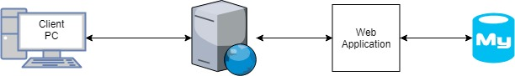

Data Flow Diagram:

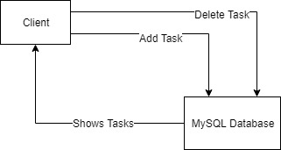

Use Case Diagram:

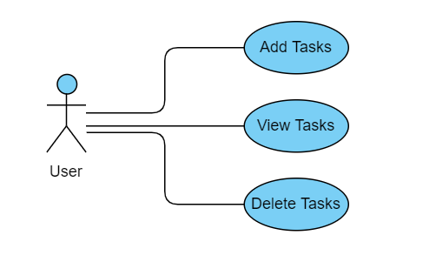

Sequence Diagram:

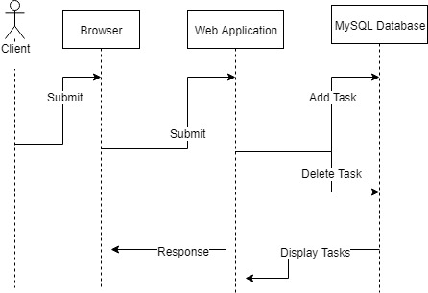

Database Design Diagram:

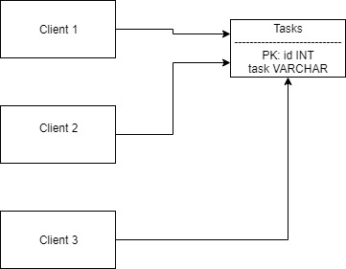

Class Diagram:

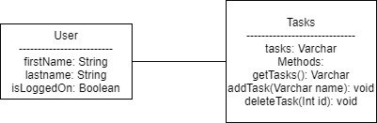

# 

# 

# 

# Test Cases:

# Add Task to To Do List

|  |  |
| --- | --- |
| **Purpose:**  Add a task to the To Do List. | |
| **Test Run Information:**  **Tester Name:** Arhum Ahmed  **Date(s) of Test:** 1.15.2019 | **Prerequisites for this test:** None |
| **Software Versions:**  Browser Google Chrome  Database: MySQL  Operating System: Windows 10 |
| **NOTES and RESULTS:**  Task added successfully. | |

|  |  |  |  |
| --- | --- | --- | --- |
| **TEST SCRIPT STEPS/RESULTS** | | | |
| **STEP** | **TEST STEP/INPUT** | **EXPECTED RESULTS** | **ACTUAL RESULTS** |
| **1.** | Enter string “test” in add task field and click “Add task” button | “test” should appear in the list of tasks and database. | “test” appears in the list of tasks and database. |

# View Tasks in To Do List

|  |  |
| --- | --- |
| **Purpose:**  View tasks in the To Do List. | |
| **Test Run Information:**  **Tester Name:** Arhum Ahmed  **Date(s) of Test:** 1.15.2019 | **Prerequisites for this test:** At Least 1 task must be added to the To Do List. |
| **Software Versions:**  Browser Google Chrome  Database: MySQL  Operating System: Windows 10 |
| **NOTES and RESULTS:**  Tasks displaying successfully. | |

|  |  |  |  |
| --- | --- | --- | --- |
| **TEST SCRIPT STEPS/RESULTS** | | | |
| **STEP** | **TEST STEP/INPUT** | **EXPECTED RESULTS** | **ACTUAL RESULTS** |
| **1.** | Verify that tasks saved inside database “test” and “test2” both display on web application | “test” and “test2” should appear in the list of tasks on the web application. | “test” and “test2” both appear in the list of tasks on the web application. |

# 

# Delete Task from To Do List

|  |  |
| --- | --- |
| **Purpose:**  Delete a task from the To Do List. | |
| **Test Run Information:**  **Tester Name:** Arhum Ahmed  **Date(s) of Test:** 1.15.2019 | **Prerequisites for this test:** At least 1 task already in list. |
| **Software Versions:**  Browser Google Chrome  Database: MySQL  Operating System: Windows 10 |
| **NOTES and RESULTS:**  Task deleted successfully. | |

|  |  |  |  |
| --- | --- | --- | --- |
| **TEST SCRIPT STEPS/RESULTS** | | | |
| **STEP** | **TEST STEP/INPUT** | **EXPECTED RESULTS** | **ACTUAL RESULTS** |
| **1.** | Click delete button underneath task “test” | “test” should disappear from the list of tasks and database. | “test” disappears from the list of tasks and the database. |