a

October 21, 2020

arayana.a.janson@wmich.edu

MONETIZING SUSTAINABLE AGRICULTURE AND FORESTRY

BY REDUCING BARRIERS TO ENTRY TO PRIVATE CARBON MARKETS

the gROWING CLIMATE SOLUTIONS ACT (GCSA) & carbon farming

Arayana Janson

**Growing Climate Solutions Act (GCSA)**

From an economics perspective, one of the problems with carbon pollution is that the incentive to manage it is negligible; because there is no monetary value assigned to the reduction of CO2 emissions, the collective incentives for individuals or companies within markets that impact CO2 emissions do not lead to anything close to the socially optimal level of pollution. As far as carbon dioxide and other greenhouse gas pollution by US industries is concerned, agriculture falls into the smallest category tracked by many organizations, including Climate Central.[1] However, globally, agriculture is responsible for 24% of greenhouse gas emissions when compared to other industry sectors and CO2 is the most significant emission in terms of volume.[2] As a side note, most of these agricultural emissions are not in the form of carbon dioxide.[3]

Agriculture in terms of the percentage that it contributes to national GDP is not very significant in the United States. However, the United States does hold a position of influence when it comes to environmental policy within Mexico through the USMCA agreement, and (perhaps indirectly) in the rest of Central America as well as South America, where the agricultural percentages of GDP are higher than they are in Mexico and the United States.[4]

Regardless of how much agriculture contributes to greenhouse gas emissions or to GDP, the use of private lands for sequestering carbon through agriculture is a seen as a “critical climate solution”.[5],[6],[7] Sequestering carbon from the atmosphere through sustainable agricultural and forestry practices potentially ameliorates not only the amount of carbon dioxide that is produced by agriculture, but also additional amounts of carbon (produced in other industry sectors like transport). The fact that the harm NOT caused directly by farmers can be addressed by farmers assists in explaining why farmers’ usual incentives to sequester carbon through engaging (new and) sustainable practices on their lands may not only be neutral, but negative. In other words, farmers may, without an externally provided incentive, ask themselves why they should be the ones to pay higher costs to produce their agricultural products sustainably to mitigate greenhouse gases for whose emissions they are not themselves responsible.

Without an externally-provided incentive—such as say, the ability to trade their hard work in sequestering carbon on their farm or ranch lands for payments from industrial parties that would rather trade for the farmer’s carbon sequestration over implementing expensive carbon sequestering technology at their own facilities—the farmer’s impetus to sequester carbon for the carbon market is virtually non-existent. The average total cost curve and the variable cost curve for sequestering carbon being very high, while the market price (which’d reflect the fact that the entire cost burden for carbon sequestration would be on the farmer) being very low would together mean that the farmer would rather ignore the carbon trading market completely rather than participate in it.

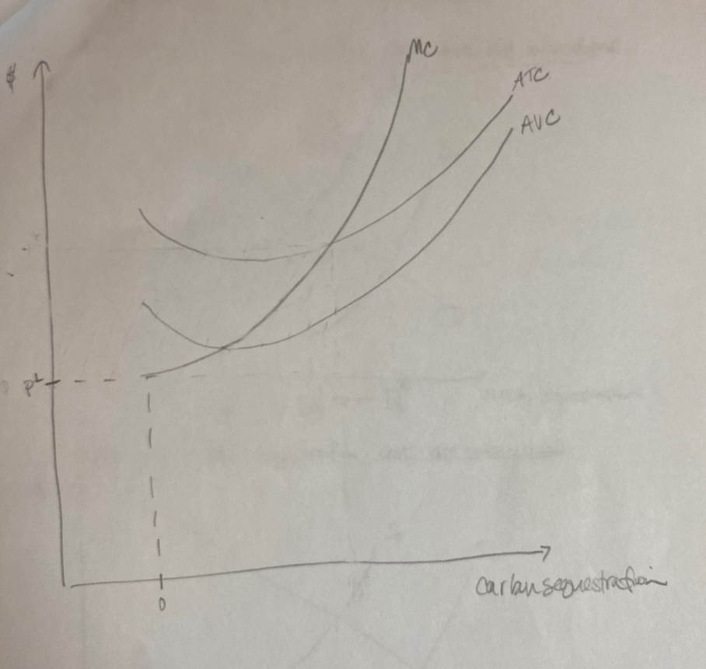

**THE EFFECTS OF THE BURDEN OF CARBON SEQUESTRATION COSTS ON INDIVIDUAL FARMERS WITHOUT ASSISTANCE. The market price (pL) that the individual farmer receives for a carbon credit within a market that puts the entire cost burden on the farmer himself would be low enough that he wouldn’t logically choose to enter the market, or, he would choose to produce zero carbon credits. This is because the farmer would not be able to cover his variable costs and/or he would not be able to produce enough to prevent profit loss. This farmer would continuously lose in order to participate in the carbon trading market, and so, he would simply choose not to participate.**

Throughout the world, farmers and landowners *are* getting paid for sustainable agricultural practices that measurably increase carbon sequestration,[8] such as strengthening soil structure through amendments, cover crops and the reduction of erosion-lending practices like over-tillage. California, for example, has participated in the “carbon farming” market for some time,[9] and other actively interested U.S. states are Hawaii and various states in New England.[10]

Under the *Growing Climate Solutions Act* (GCSA), the Secretary of Agriculture is empowered to “reduce barriers to entry for farmers, ranchers and private forest landowners in certain private markets”.[11] The costs that the GCSA is designed to reduce for farmers and foresters are associated with understanding the (upcoming) carbon markets, participating in those markets via USDA-certified third-party carbon credit sellers, and, carbon credit market updates and maintenance. In more simplified terms, the GCSA is subsidizing the farmers’ and foresters’ costs of uncertainty.

From the farmers’ (and private landowners’) perspectives, getting into the carbon credit market without any kind of governmental assistance represents significant costs (of uncertainty) because a new system must be learned and new participants must get their feet in the door (of the carbon market), all while adopting new technologies and protocols that are in accordance with new guidelines and regulations, not to mention trying to understand when they are getting the best (carbon credit) deal.

From an environmental economics perspective, if we assume that farmers and foresters are profit-maximizing, and, given the idea that GCSA subsidizes farmer and forester efforts by eliminating the (uncertainty) costs of initializing market participation, then we can also assume that the farmers and foresters would logically be interested in converting their agriculture and forestry methods to carbon market-qualified practices.

GCSA aims to reduce the uncertainty behind these factors—as well as the costs of that uncertainty (and other conversion costs)—by making the information about the carbon credit market easier to obtain, and access to the carbon credit market easier to achieve through tools like a third-party certification program, an online hub for farmers and foresters, an advisory council, and, regular reporting.[12] The GCSA wants to help clarify definitions of sustainable land management or soil use practice (or, what qualifies as a “carbon sequestering” practice) for farmers, foresters and carbon credit brokers, in order that a carbon credit purchaser can essentially fund that sustainable practice.[13] Given the subsidy, carbon sequestration levels will increase because the uncertainty regarding conversion costs will be lowered.

The GCSA offering of assistance in education on the processes or applications involved in the carbon market and the coordination of and access to necessary resources would lead to a greater entry of participants in the market. Another economic factor that would drive down carbon credit producer costs and drive market price up is the network effect, or, the additional value that a greater number of carbon market participants would bring to the carbon market. The network effect would exist in this case, since each additional user of a carbon credit market would only add value; the number of users will (at least at first) increase due to more knowledge of the costs involved. Once one farmer or forester sees others trading carbon successfully, in other words, he will be more likely to participate.[14]

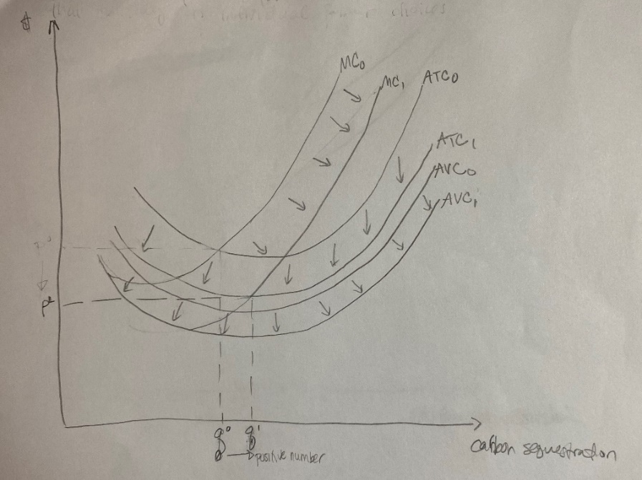

**THE EFFECTS OF A GCSA SUBSIDY ON INDIVIDUAL FARMER CHOICES. Assuming the GCSA subsidizes the costs that would otherwise exist for farmers to implement certified and sustainable carbon sequestration practices, the individual farmer’s marginal cost curve, variable cost curve and average total cost curve would recede, or, shift to the right, increasing the quantities of carbon sequestered.**

Imagine that we combined the supply and demand values from many individual farmers or foresters into one original supply curve, S0. With S0, the original or neutral quantity at market equilibrium is Eq0.

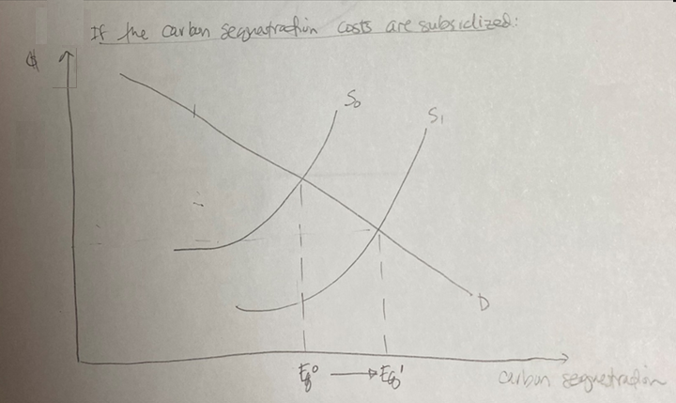

For a market that involves a subsidy, as in the graph above, the supply curve representing all individual farmers’ production levels of carbon sequestration within the carbon market shifts to the right (becoming S1)—as does the market equilibrium (becoming Eq1)—meaning that more carbon will be sequestered (than before).

A bill like GCSA might have much to offer not only to the carbon market but also the other potential emissions trading market scenarios yet to come. Many have looked to agriculture for some time as a proving ground for the free market’s measurable and positive effect on climate change mitigation. (Part of this is because soil carbon measurements are better established, easier to track and trace and can be more directly controlled.[15]) If it can be proven in the skeptical eye of the public that being able to trade carbon credits is much more efficient, and even helps us get closer to the social optimal as far as emissions levels and ozone health are concerned (rather than continuing to favor a gravitation towards the market equilibrium) then we can demonstrate how a greater equity for more people is Pareto-improving.

If we were to think of the GCSA’s (subsidization) effect on the carbon trading market for carbon farming like a positive externality, the (influence that) the education on relevant topics and methods and the resources to achieve those methods has on the carbon sequestration market would make an impact on the achievement of the socially optimal level of carbon sequestration. Added to the marginal private benefit of carbon sequestration, this positive externality helps to produce the marginal social benefit curve. Assuming that this market is working effectively, and that Pareto-improving opportunities continue to be taken until the Pareto optimum has been reached, then the net social benefits have also continuously improved with the growth of the market. Market equilibrium is no longer the default “gravitational point”.

The current scenario will not lead to a recovery of governmental carbon market subsidization costs. Perhaps in my next paper, I’ll get a chance to explore the permit system and its potential initial structure, which could allow for a return of those initial subsidy costs to the government via auction revenue.

**APPENDIX I: Framework and Direction (from Professor)**

Carbon markets are being expanded to pay farmers and foresters for their choices that increase carbon sequestration.  The Growing Climate Solutions Act is a bi-partisan bill that seeks to alter the incentives that individual farmers and foresters face, thereby altering their decisions to participate in carbon sequestration markets**.** Consider uncertainty, and challenges with adopting new technologies, as “costs” for farmers.  Demonstrate how the individual farmers may choose to supply 0 carbon sequestration, when high individual costs and low individual returns are present.  Next, simplify the problem by assuming the bill subsidizes farmer choices (i.e. lowers costs), and demonstrate how this may influence the sequestration choice of farmers.  Show the relationship from the individual farmer to the market supply of carbon sequestration.  What does this program need, from an environmental economics standpoint, to be successful?  Who benefits from this program?

**APPENDIX II: Reference Article (Motivation for Essay)**

Bill would help farmers, foresters participate in carbon markets By Erin Voegele | June 04, 2020

Sens. Mike Braun, R-Ind.; Debbie Stabenow, D-Mich.; Lindsey Graham, R.S.C.; and Sheldon Whitehouse, D-R.I., on June 4 introduced the Growing Climate Solutions Act, which aims to break down barriers for farmers and foresters interested in participating in carbon markets so they can be rewarded for climate-smart practices.

The bill could create a certification program at USDA to help solve technical entry barriers that prevent farmer and forest landowner participation in carbon credit markets. The senators indicated these issues—including access to reliable information about markets and access to qualified technical assistance providers and credit protocol verifiers—have limited both landowner participation and the adoption of practices that help reduce the costs of developing carbon credits.

To address those issues, the bill stablishes a Greenhouse Gas Technical Assistance Provider and Third-Party Verifier Certification Program through which USDA will be able to provide transparency, legitimacy, and informal endorsement of third-party verifiers and technical service providers that help private landowners generate carbon credits through a variety of agriculture- and forestry-related practices. The USDA certification program will aim to ensure that these assistance providers have agriculture and forestry expertise, which is lacking in the current marketplace. As part of the program, USDA would administer a new website that would serve as a “one stop shop” of information and resources for producers and foresters who are interested in participating in carbon markets.

Through the program, USDA would help connect landowners to private sector actors who can assist the landowners in implementing the protocols and monetizing the climate value of their sustainable practices. Third party entities, certified under the program, will be able to claim the status of a “USDA Certified” technical assistance provider or verifier. The USDA certification lowers barriers to entry in the credit markets by reducing confusion and improving information for farmers looking to implement practices that capture carbon, reduce emissions, improve soil health, and make operations more sustainable.

According to the senators, many third-party groups are currently developing protocols and testing methods to calculate emissions reduction and sequestration in agriculture and forestry. The bill recognizes that the landscape is evolving rapidly and provides the USDA with a robust advisory council composed of agriculture experts, scientists, producers and others. The advisory council would advise the secretary of agriculture and ensure that the certification program remains relevant, credible, and responsive to the needs of farmers, forest landowners, and carbon market participants.

The bill also directs USDA to advise Congress about further development of this policy areas, including barriers to market entry, challenges raised by farmers and forest landowners, market performance, and suggestions on where USDA can make a positive contribution to the further adoption of voluntary carbon sequestration practices in agriculture and forestry.

Dozens of agriculture groups, environmental organizations and companies have signed on to support the bill, including the American Farm Bureau Federation, National Farmers Union, National Corn Growers Association, American Soybean Association, Corn Refiners Association, Novozymes, Green Plains, and Archer Daniels Midland Co.

“America’s farmers and ranchers have made tremendous strides in reducing our carbon footprint, with overall greenhouse gas emissions under 10 percent for our industry,” said American Farm Bureau President Zippy Duvall. “As we endeavor to do more with less, we are always focused on doing better and working together to protect the natural resources we all enjoy. We are grateful to Senators Braun and Stabenow for consulting us on their efforts to bring clarity and validity to a voluntary, market-based carbon-credit system and provide a USDA-led review to inspire confidence as we enter the new carbon marketplace.”

“Corn farmers have been leaders in adopting farming practices to improve the quality of soil, water, and air around our farms and are pleased to endorse the Growing Climate Solutions Act,” said Kevin Ross, president, National Corn Growers Association. “This bipartisan effort recognizes agriculture’s role in mitigating the impact of climate change and promotes voluntary, agriculture-friendly ideas into the climate discussion. NCGA thanks the Senators for their leadership and looks forward to working together to implement policy that benefits both the environment and farmers’ bottom line.”

<http://www.biomassmagazine.com/articles/17118/bill-would-help-farmers-foresters-participate-in-carbon-markets>

**ENDNOTES**

1. https://www.climatecentral.org/gallery/graphics/emissions-sources-2020
2. https://www.epa.gov/ghgemissions/global-greenhouse-gas-emissions-data
3. https://www.wri.org/blog/2014/05/everything-you-need-know-about-agricultural-emissions
4. http://mecometer.com/topic/gdp-decomposition-by-sector/
5. https://www.agdaily.com/news/senate-growing-climate-solutions-act/
6. https://www.greenbiz.com/article/carbon-sequestration-farms-actually-working-fight-climate-change
7. https://www.technologyreview.com/2019/06/21/65661/carbon-farming-is-the-hot-and-overhyped-tool-to-fight-climate-change/
8. https://regenerationinternational.org/farmers-are-capitalizing-on-carbon-sequestration
9. https://www.hcn.org/issues/51.9/climate-change-the-case-for-carbon-farming-in-california
10. https://www.ecowatch.com/carbon-farming-2457937143.html
11. https://www.congress.gov/bill/116th-congress/house-bill/7393/all-info#:~:text=Official%20Title%20as%20Introduced,markets%2C%20and%20for%20other%20purposes
12. https://www.agdaily.com/news/senate-growing-climate-solutions-act/
13. https://regenerationinternational.org/farmers-are-capitalizing-on-carbon-sequestration
14. https://www.jstor.org/stable/41307212?seq=1
15. https://www.nature.com/scitable/knowledge/library/soil-carbon-storage-84223790/

    