An Efficient Algorithm for Increasing Modularity in IoT Based Automation Systems
Sumit Kumar, Abhay Pal Singh, Aritra Ghose, Souhardya Haldar
Electronics and Telecommunication Engineering, Symbiosis Institute of Technology, Symbiosis International (Deemed University), Pune
Abstract: With the increase in complexity of devices and processes in industry and commerce, automation presents itself as a technological panacea in the form of IoT (Internet of Devices) based applications. This paper presents an adaptive, efficient and affordable system architecture through which modularity in IoT based automation can be realized. The proposed method involves an IoT based platform to coordinate, control and calibrate microcontrollers connected to various sensors and devices. Using a web page or application as an interface, the system can be configured to operate diversified workloads via distributive control and remote monitoring. The flexible nature of the system allows for a modular approach to parameter design and system integration while allowing dynamic task allocation. Data available through feedback can be used to further streamline and orient tasks in real time. This allows a single platform to multi task using an adaptive algorithm.

Keywords: Automation; Internet of things; Raspberry Pi; IoT platform; Algorithm; Microcontroller; Relay driver
Reference to this paper should be made as follows: Author(s) (2006) ‘paper title ’, Int. J. Ad Hoc and Ubiquitous Computing, Vol. X, No. Y4, pp.000–000.
Biographical notes: (ABS)

1 Introduction

IoT based platforms allow for an integrated approach to digital systems. By interconnecting multiple systems into a single picture, synergy in operation and output can be realized. Such a system is self-sufficient, sustainable and cost effective. The system owing to its modular nature is adaptive to industrial and domestic applications.

On an industrial or even domestic unit, security flaws in prevalent automation systems may be resolved by the usage of logic based algorithms. [1] An IoT based platform to provide a template for automation in industrial application leads to condition and controlled monitoring to increase productivity. This method is advantageous for continuous monitoring of the equipment, receiving alerts and data availability for predictive maintenance. [2]

An automated IoT based system can allow for home automation and energy efficiency at the unit level using innovative modular design processes. [3] This delivers an understanding as to the importance of IoT in providing clean distributed energy for sustainable global economic growth. [4] Advanced IoT based platforms combine remote health monitoring, home automation and alarm systems sensors to acquire data to store and access through an interface access for remote monitoring. [5]

The addition of a wireless module allows for functionality to realize a Web of Things node. This allows for a heterogeneous network in order to interoperate and implement a network stack allows various IoT systems to be integrated. [6] In analog systems, switching between interconnections is performed using relay and/or rotary switches and thus the aforementioned fails to accommodate for the same.

IoT based biometric security measures, leveraging using cloud based security measures are also possible. [7] For the maintenance of security regarding biometric traits via RPi client to the cloud, cryptographic algorithms such as RSA and enhanced AES-256 may be applied. A smart camera network may be used in video surveillance of public spaces, natural habitats, wildfire protection, etc constructed with off-the-shelf components for modular and low cost fabrication. [8]

An IoT derived method could allow for a safe and remote monitoring system for machine tools and distribute industry practices between service centres in the manufacturing environment. [9] The utility of IoT is also realized in the agro sector with accurate forecast models and low cost sensor nodes. [10]

In the case of an IoT capable device like the Raspberry Pi, a number of sensors can be integrated to monitor various parameters of the system. [11] The implementation of a sensor node as part of an IoT system using Raspberry Pi can be realized to allow for a scalable, do it yourself and interdisciplinary approach to IoT platforms. [12]. A software and hardware system can provide feedback via a predesigned interface and provide data on fields. [13]

This paper, factoring the above methodologies into consideration, proposes a method to integrate multiple sensors and microcontrollers to a single control unit at a fraction of the cost. By utilising off the shelf components and observations made in analog switching systems, IoT platforms may be multitasked using a basic unit like the Pi on an industrial scale.

The motivations to undertake such an enterprise lie in an increasing requirement to simply operational costs and techniques while creating interchangeable units of IoT clusters that require minimal manning to produce optimum outputs.

2 Proposed Working Model
In the case of an IoT capable device like the Raspberry Pi, a limited number of sensors can be integrated using a standard relay driver. Thus a concern arises in this regard as to the number of sensors that may be efficiently networked by such a system. [14] Furthermore, programmable input that may be latched using a minimal number of pins is limited to single digits for an off shelf solution. In order to mitigate apparent bottlenecks, deconstruction of IoT – relay interfacing is required.

The proposed method involved the study of available electromechanical systems that require limited input for maximum output based solutions. In analog systems, switching between interconnections was conducted using relay and/or rotary switches [15]. A rotary switch, depending on user requirements may have multiple layers that are interconnected using a common. Connections are effectively ‘sandwiched’ into a singular platform that allows for a modular, robust and affordable device in high voltage applications [16].

For the system to be utilized in an IoT setup, the rotary switch must be deconstructed to a format that may be applicable in a digital system. At its root, the rotary switch is a demux unit that allows for switching between settings in a layered format [17]. Thus while operating the setup, a single setting may be availed, the layered approach reciprocates this to multiple connections at any given time.

To mitigate the problems involving pin usage and programmable input of the IoT platform, a latching mechanism is required. An easily available and tested method of using a Peripheral Programmable Interface can be applied to facilitate flexibility and modularity in system design. The device has three ports of eight pins each requiring an input of eight pins for all three ports. A latched input minimizes the pins and circuit complexity.

High voltage applications in industrial zones pose a challenge in IoT platform integration. Safeguards are thus needed to mitigate potential risks to the central unit. A form of galvanic isolation is needed to ensure sustained operation under such conditions can produce consistent output. The approach must be made affordable in line with cost effectiveness.

The components must then be mated with the IoT platform itself to create a modular, efficient but affordable base for sensor networking and automation, scalable as per requirements. The configuration and usage is set by the microcontroller with which user interaction takes place by a web page and/or web application to receive instantaneous feedback.

3 Methodology
The core focus of the paper revolves around IoT or Internet of things. There are two components to it, the IoT platform itself and the algorithm used to preselect and orient the system operation. The algorithm known as DeHeBBBi is the driving force behind the automation effort. By using an integrated interface to act in tandem with Pi, the flow diagram (Fig. 1) may be accentuated.

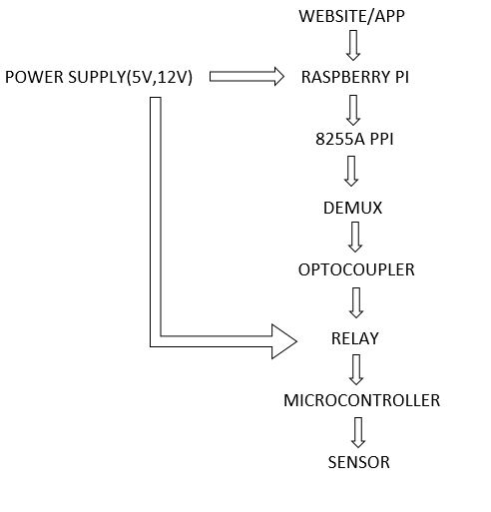

Fig. 1. Raspberry Pi – Microcontroller – Sensor

3.1 Relay – Interface Module
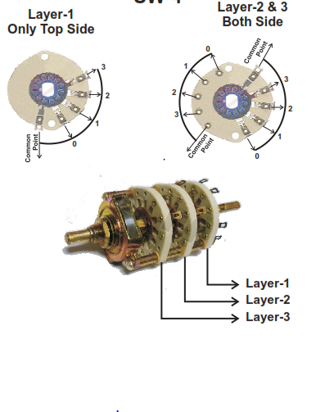

Fig. 2. Rotary Switch

For the system to be utilized in an IoT setup, the rotary switch must be deconstructed to a format that may be applicable in a digital system. At its root, the rotary switch is a demux unit that allows for switching between settings in a layered format [17]. Thus while operating the setup, a single setting may be availed, the layered approach reciprocates this to multiple connections at any given time.

Fig. 2 is a rotary switch, used as a template for the future IoT – relay driver. Due to its analog nature, it must be deconstructed into a format that can be parsed by the microcontroller (Pi) used. Assuming each position of the switch to be a decimal number, an array of numbers equal to the no. of positions that the switch can be slotted into may be constructed as required.

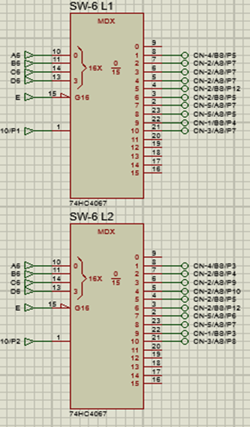

Fig. 3. Demultiplexer Array (Switch)

Assume each layer of the wafer switch to be a demux. For e.g. in this case there will be (1+ (2 x (1+1)) or 5 demux(s) used. To determine the demux to be used simply observe the no. of through(s) used in each layer. (1:16) or (1:8) demux may be used. Accordingly, select lines will be 4 or 3 bits respectively. Demux input can be configured as common in layer(s).

To ensure output from the GPIO pins is stored, an 8255-A, a Peripheral Programmable Interface is used. By manipulating the address bits A0 and A1 of the PPI, PORT A, B and C can be selected to assign upto 24 bits. The 24 bits are divided as groups of 4 to be used as select lines to the demultiplexer(s) which drive the Darlington transistors. This allows for a basic latched input.

The Darlington transistors are adapted to the use of galvanic isolation through the use of optocouplers. The optocouplers prevent back emf from arising due to high voltage applications that may reset or damage the Pi. This allows for additional safety to be integrated into the design. The output drives the relays connected to it. The relays in turn power the connectors that link it to other microcontrollers or Wi-Fi/Bluetooth modules.

In the PPI, the 24 available pins consisting of PORT A, B and C can power 6 demux(s) for 4 bits each. Each 1:16 demux has 16 possible outputs of which one can be controlled at a time as per the select line(s). (Fig. 4) Thus for 6 demux(s), 6 outputs may be monitored simultaneously via pulses at regular intervals of a possible 6 * 16 or 96 outputs to connected devices. Using only 8 output GPIOs of the Pi, 96 or practically 90 outputs (keeping one output in each demux as GND) may be used.

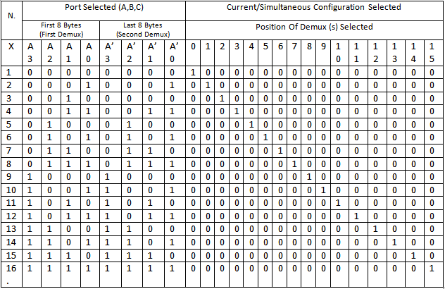

Fig. 4. Truth Table for Pin Configuration
Applying the concept of ‘layers’ used by the rotary switch wherein each ‘switch’ can have outputs with the same configuration, select lines for each demux can be given to multiple demux(s) to form a ‘switch’ (Fig. 3.) . Thus switch 7 has 2 demux(s) assigned to it for a total of 2 * 16 = 32 outputs from one set of 4 bits. Extrapolating this, 6 switches allow 192 (180 practical – 1 GND per demux(s) with 12 simultaneous ones) outputs from 24 bits via just 8 GPIO pins and scaled as required.

3.2 Algorithm
To adapt an analog method of input to a digital system, a deconstructed logic in the form of the algorithm is to be used. The algorithm is called as DeHeBBBi (Decimal – Hexadecimal – Binary Byte – Bit conversion) or ‘Debbie’. This will provide for feed lines assigned to the Raspberry Pi GPIO pins.

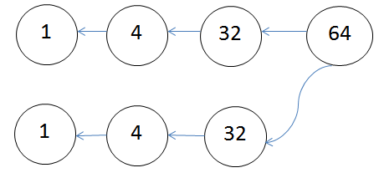

Fig. 5. Reduction of Byte to Bit (Pins)

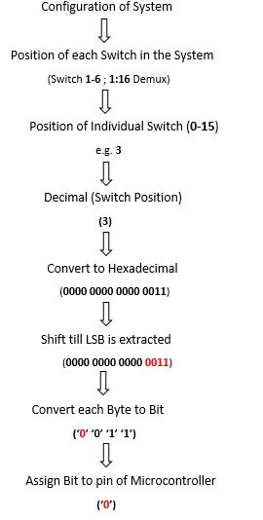

Fig. 6. DeHeBBBi Algorithm
The algorithm called as DeHeBBBi (Fig. 6.) or ‘Debbie’ is used to orient the driver circuit using the Raspberry Pi. Using a menu interface via the website/web application, user down selects the configuration of the system. The configuration endows each individual ‘switch’ (demux) with a decimal position which is converted into a hexadecimal number.

The hexadecimal number is then shifted till the last four bytes i.e. the LSB is obtained. The LSB is then divided into four individual bytes which are then converted into bits (Fig. 5). The bits are then assigned to the GPIO pins of the Raspberry Pi as input feed for the PPI. At a time, the configuration of two demultiplexer(s) can be sent. Configurations for the switches can be preset in code or user defined.

4 Results and Discussion
The device logic was tested on the GPIO pins of a Raspberry Pi used in a home automation system (Fig. 7). The algorithm was adapted to the newer system and was deemed successful on a limited scale operation. Given the low costs in enabling and adapting such a modular method, future work on the model is promising especially when an appropriate back end process is applied.

Load selection was allowed using the GUI interface menu that classified clusters as devices. A 5V relay was operated using this method to power LED(s) and domestic applications.

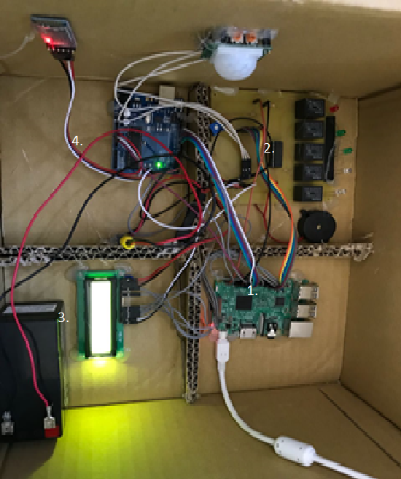

Fig. 7. Experimental Setup

- Quadrant 1 houses the Pi and the script running the setup.
- Quadrant 2 houses the relay driver module.
- Quadrant 3 houses a 12V supply regulated by an IC7805 transistor.
- Quadrant 4 houses the HC-05 Bluetooth Module to interface with a secondary input source.

Quadrant 1 was used as the central node to verify the IoT interfacing with 2. The 8255A PPI was used to operate the relays in this case. 3 and 4 were used as secondary feedback and input respectively. A GUI interface (Fig. 9), scripted in python was used to interact with the Pi. By using a Raspbian OS derived platform like the VNC Viewer, a mobile phone/laptop may be used.

5 Conclusion and Future Works
The setup was concentrated on domestic applications that may be setup using a single control node. The modular nature of the device allows for scaling as required by using very few GPIO pins. Thus ergonomics and efficiency work hand in hand to create IoT systems that are adaptable as per user defined specifications.

Usage of data logging to extract sensor readings and allow for feedback to the interface via user/neural networks may also allow for increased productivity. The open-ended Python script allows for further modifications or expansions as required. Thus as IoT systems become more complex, this algorithm may be used to simply task and purpose. By presenting a unique and cost effective method to implement IoT on a large scale, derived applications in domestic and industrial avenues are expansive. Thus a modular approach can be integrated to automation systems using the ‘Debbie’ algorithm.

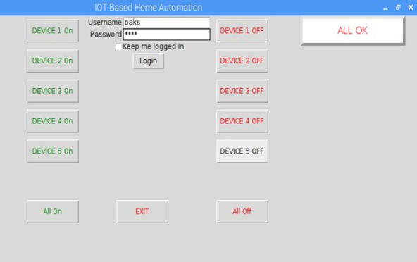

Fig. 8. GUI Interface for Pi

References

[1] Arun Cyril Jose, Reza Malekian, (17 May 2017) ‘Improving Smart Home Security; Integrating Logical Sensing into Smart Home’, IEEE Sensors Journal, Vol. 17, No. 13, pp. 4269 - 4286
[2] A.Ajitha, J.Laxmi Prasanna, D.Swathi, D.Shyamala, (19-20 October 2017) ‘IoT platform for Condition Monitoring of Industrial Motors’ in Proc. 2nd International Conference on Communication and Electronics Systems, pp. 260 – 265
[3] Guneet Bedi, Ganesh Kumar Venayagamoorthy, Rajendra Singh, Richard Brooks, Kuang-Ching Wang, (April 2018) ‘Review of Internet of Things (IoT) in Electric Power and Energy Systems’, IEEE Internet of Things Journal, Vol. 5, No. 2, pp. 847 - 870
[4] Anita Chaudhari, Brinzel Rodriguez, Shraddha More (14-17 Dec. 2016), ‘Automated IoT based system for Home Automation and Prediction of Comparative Usage and Comparative Analysis of various Electricity Provider: SmartPlug’ in Proc. 2nd International Conference on Contemporary Computing and Informatics (IC3I), pp. 390 - 392
[5] *Jayeeta Saha, Arnab Kumar Saha, Jayeeta Saha, Aiswarya Chatterjee, Suyash Agrawal, Ankita Saha, Avirup Kar, Himadri Nath Saha, (8-10 Jan. 2018), ‘Advanced IOT Based Combined Remote Health Monitoring, Home Automation and Alarm System’ in Proc. IEEE 8th Annual Computing and Communication Workshop and Conference (CCWC) IEEE, pp. 602 - 606
[6] V. Georgitzikis, O. Akribopoulos and I. Chatzigiannakis, (22 June 2012), ‘Controlling Physical Objects via the Internet using the Arduino Platform over 802.15.4 Networks’, IEEE Latin America Transactions, Vol. 10, No. 3, pp. 1686 - 1689
[7] Dhvani Shah, Vinayak Haradi, (2016) ‘IoT Based Biometrics Implementation on Raspberry Pi’, Procedia Computer Science, Vol. 79, pp. 328-336
[8] Kevin Abas, Katia Obraczka, Leland Miller, (March 2018) ‘Solar-powered, wireless smart camera network: An IoT solution for outdoor video monitoring’, Computer Communications, Vol. 118, pp. 217-233
[9] Stefano Tedeschi, Jörn Mehnen, Nikolaos Tapoglou, Rajkumar Roy, (2017) ‘Secure IoT Devices for the Maintenance of Machine Tools’, Procedia CIRP, Vol. 59, pp. 150-155
[10] Ahmed Imteaj, Tanveer Rahman, Muhammad Kamrul Hossain, Saika Zaman, (18-20 Dec. 2016), ‘IoT based autonomous percipient irrigation system using raspberry Pi’ in Proc. 19th International Conference on Computer and Information Technology (ICCIT), pp. 563 - 568
[11] Venkat Subramanian Arumuga Perumal, Krishnamoorthy Baskarana, Suleman Khalid Rai, (December 2017) ‘Implementation Of Effective And Low-Cost Building Monitoring System (Bms) Using Raspberry Pi’, Energy Procedia, Vol. 143, pp. 179-185
[12] Vladimir Vujović, Mirjana Maksimović, (May 2015) ‘Raspberry Pi as a Sensor Web node for home automation’, Computers & Electrical Engineering, Vol. 44, pp. 153-171
[13] Tuan Nguyen Gia, Victor Kathan Sarker, Igor Tcarenko, Amir M. Rahmani, Tomi Westerlund, Pasi Liljeberg, Hannu Tenhunen, (1-2 Nov. 2016), ’IoT-based fall detection system with energy efficient sensor nodes’ in Proc. Nordic Circuits and Systems Conference (NORCAS), pp. 1- 6
[14] Emre Yigitoglu, Ling Liu, Margaret Looper, Calton Pu, (25-30 June 2017), ‘Distributed Orchestration in Large-scale IoT Systems’, IEEE International Congress on Internet of Things, pp. 58 - 65
[15] Suneat Pranonsatit, Andrew S. Holmes, Ian D. Robertson and Stepan Lucyszyn, (Dec. 2006) ‘Single-Pole Eight-Throw RF MEMS Rotary Switch’, Journal of Microelectromechanical Systems, Vol. 15, No. 6, pp. 1735 - 1744
[16] S.Vinodh, (July 2010), ‘Improvement of agility and sustainability: A case study in an Indian rotary switches manufacturing organisation.’, Journal of Cleaner Production, Vol. 18, No. 10–11, pp. 1015-1020
[17] Tadahiro Hasegawa, Kenichiro Nakashimaa, Fumiyuki Omatsua, Koji Ikutab, (16 May 2008), ‘Multi-directional micro-switching valve chip with rotary mechanism’, Sensors and Actuators A: Physical, Vol. 143, no. 2, pp. 390-398

