EEG - MOTOR STATE - MACHINE LEARNING

Reading Motor State
from Brain Activity
Single-trial classification of three motor states - quiet stance, straight stepping, and diagonal stepping - from 64-channel scalp EEG, with a per-participant model and nested cross-validation. A companion to the straight-vs-diagonal step-type project.

Prepared by: [your name]
For: [supervisor name]
Affiliation: Sunnybrook Research Institute
Date: June 2026 - full 32-participant cohort

What's in this report
Open in Word and choose Update Field to build the contents.

1 The short version
This is the three-way sibling of the step-type project. Instead of asking straight or diagonal?, it poses a broader decoding question: from a single two-second epoch of 64-channel EEG, can we recover the participant's motor state - quiet stance, straight stepping, or diagonal stepping? Each participant is modelled separately and scored only on their own held-out epochs.
- 0.88 - average score (macro-AUC), where 0.50 = chance
- 73% - three-way accuracy (chance = 33%)
- 32 - participants (full cohort), each with their own model
Headline
Across all thirty-two participants, the model separates the three motor states with an average macro-AUC of 0.878 (chance = 0.50) and 73% accuracy (chance = 33%), and it does so honestly - the gap between its optimistic internal score and its real held-out score is tiny (0.05). Standing is almost always identified correctly; telling a straight step from a diagonal one is the hard part. A controlled comparison (Section 7) shows a planned foot-stimulation feature adds essentially nothing on top of the basic scalp features, while the brain-source feature adds a small but real boost to the hard straight-vs-diagonal distinction.

2 What the project is trying to do
The step-type project showed that the pre-movement contingent negative variation (CNV) - the slow anticipatory potential of the warning-imperative foreperiod - carries a faint trace of which way a participant is about to step. This project widens the scope from two step-types to three motor states: quiet stance, straight stepping, and diagonal stepping, decoded from the ongoing sensorimotor EEG rather than only the preparatory window. It is a step toward decoding a richer state repertoire from a single montage.
With three classes, a naive model would reach only one third (33%) accuracy; anything reliably above that indicates the EEG genuinely separates the states. We retain the project's core design: one model per participant, each evaluated only on epochs it never saw during training or tuning.

3 The three states and where the data come from
Each participant contributes two continuous 64-channel recordings (BioSemi, 1024 or 2048 Hz) that between them supply the three states. Throughout, a single 2 s epoch of the 64-channel montage is one exemplar for the classifier.
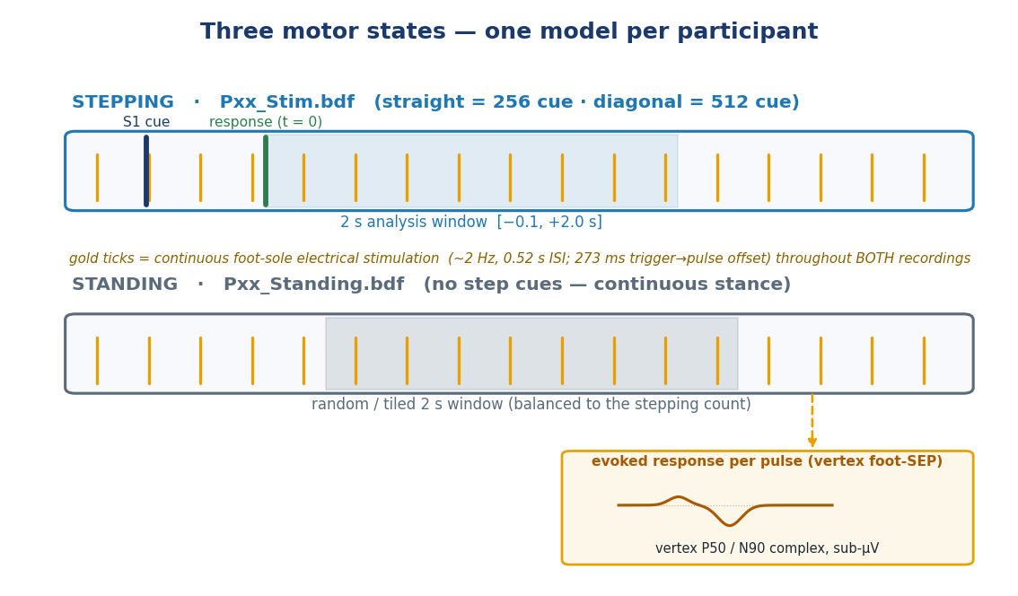
Figure 1. The three-state paradigm and epoching. Stepping (top, Stim recording): a warning-imperative structure in which an S1 direction cue (event code 256 = straight, 512 = diagonal) precedes the response / gait onset (code 96); the analysis epoch is response-locked over [-0.1, +2.0] s. Standing (bottom, Standing recording): no cue structure, so non-overlapping 2 s windows are tiled from the continuous record and count-balanced to the stepping trials. A continuous foot-sole electrical-stimulation train (gold ticks; ~2 Hz, 0.52 s ISI) runs through both recordings; each pulse evokes a low-amplitude vertex somatosensory evoked potential (inset; P50/N90), with the stimulator trigger offset from the true cutaneous pulse by a calibrated 273 ms.
- Straight / diagonal stepping - from the Stim recording. The S1 cue signals the direction; the participant steps ~2 s later. Epochs are locked to the paired response (code 96) over [-0.1, +2.0] s, exactly as in the step-type project (~40 trials per direction).
- Quiet stance - from the Standing recording. With no cue structure, non-overlapping 2 s windows are tiled from the continuous record and down-sampled to the stepping count, giving a balanced ~40/40/40 three-class problem per participant.
A methodological feature of this dataset is that a foot-sole electrical stimulator runs continuously - at ~2 Hz (0.52 s ISI) - across both the stepping and standing recordings. Because the stimulation train is present and matched in every state, it is not a between-state cue in itself; rather, each pulse evokes a small cortical somatosensory evoked potential (SEP) at the vertex, which we exploited as an additional per-epoch feature family (Section 5). The stimulator trigger is offset from the true cutaneous pulse by a fixed 273 ms (calibrated cohort-wide; 95% CI [271.6, 276.1] ms), applied per recording as round(0.273 x sfreq) samples to accommodate the mixed 1024/2048 Hz sampling.

4 The prediction engine: a 3-way XGBoost model
As in the step-type project, the workhorse is XGBoost - a model built from many small decision trees (yes/no flowcharts over the measured numbers) added together, each new tree correcting the previous ones' mistakes. The only change for this project is the output: instead of one probability (“diagonal?”), the model now produces three probabilities that add to 100% - one per state - and predicts whichever is largest.
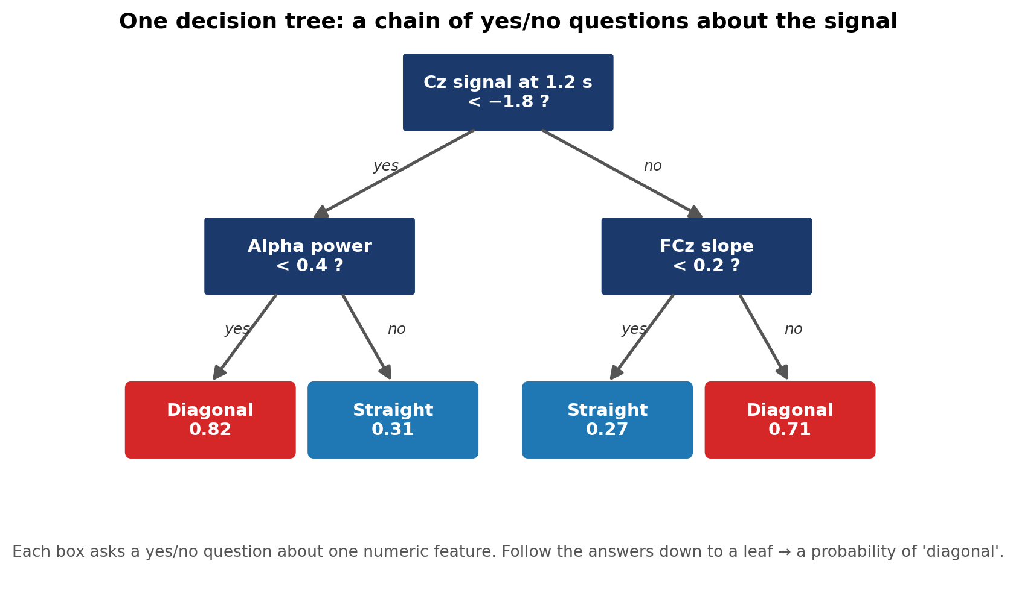
Figure 2. A single decision tree - the building block. Each box asks a yes/no question about one measurement; following the answers leads to a verdict. The model invents its own thresholds from the continuous data.
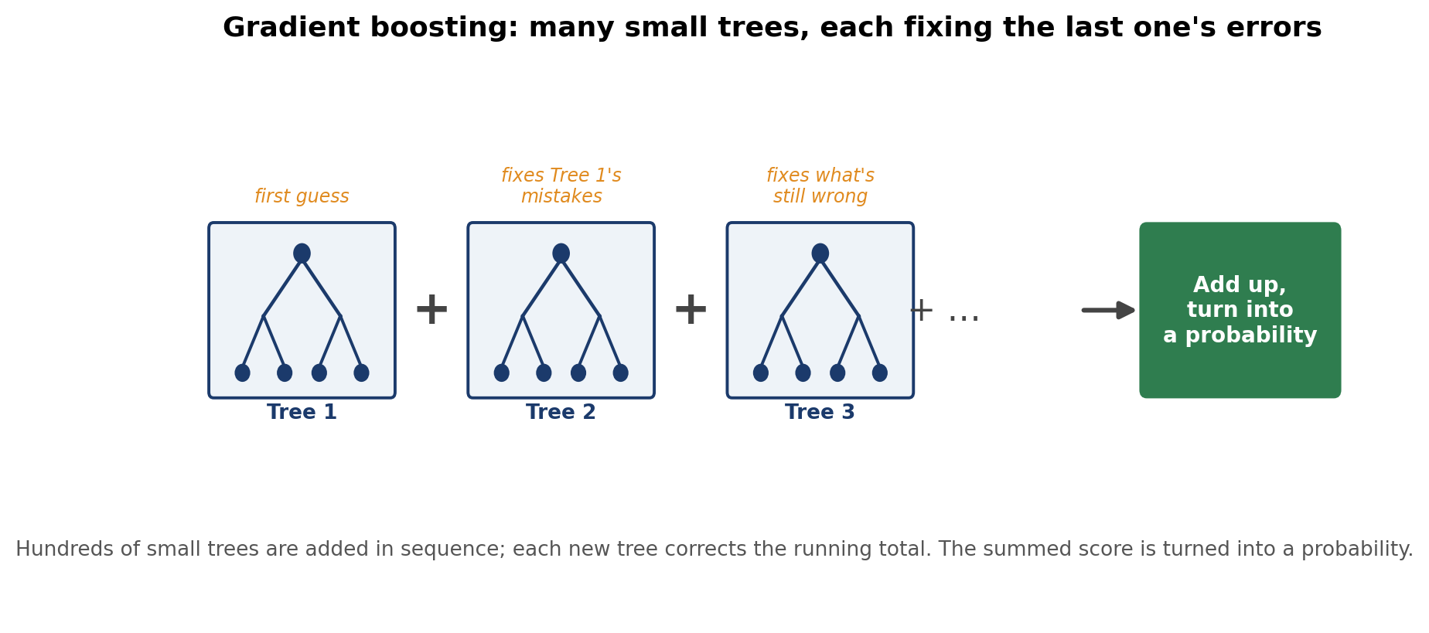
Figure 3. Gradient boosting: hundreds of simple trees are added together, each correcting the running total left by the trees before it. For this project the combined scores are turned into three competing probabilities (standing / straight / diagonal).
Performance is summarised with macro-AUC - the natural three-class version of the AUC score. It asks, for each state in turn, “how well does the model separate this state from the other two?”, then averages. As before, 0.50 is chance and 1.00 is perfect.

5 What the model looks at: the features
Each 2 s epoch is reduced to a large feature vector of interpretable single-trial measures. We reuse the four families from the step-type pipeline, each computed per channel and per 62.5 ms (1/16 s) time bin:
- Amplitude - the mean potential within each bin: the binned single-trial ERP.
- Slopes - the within-bin temporal gradient (first derivative), indexing the rate of change rather than the absolute level.
- Spectral power - single-trial band power from a Morlet-wavelet time-frequency decomposition, summarised in the canonical bands (delta, theta, alpha, beta, gamma).
- Source estimates - a distributed inverse solution (eLORETA) projected onto the fsaverage template cortex and parcellated with the Destrieux atlas (aparc.a2009s, ~150 ROIs).
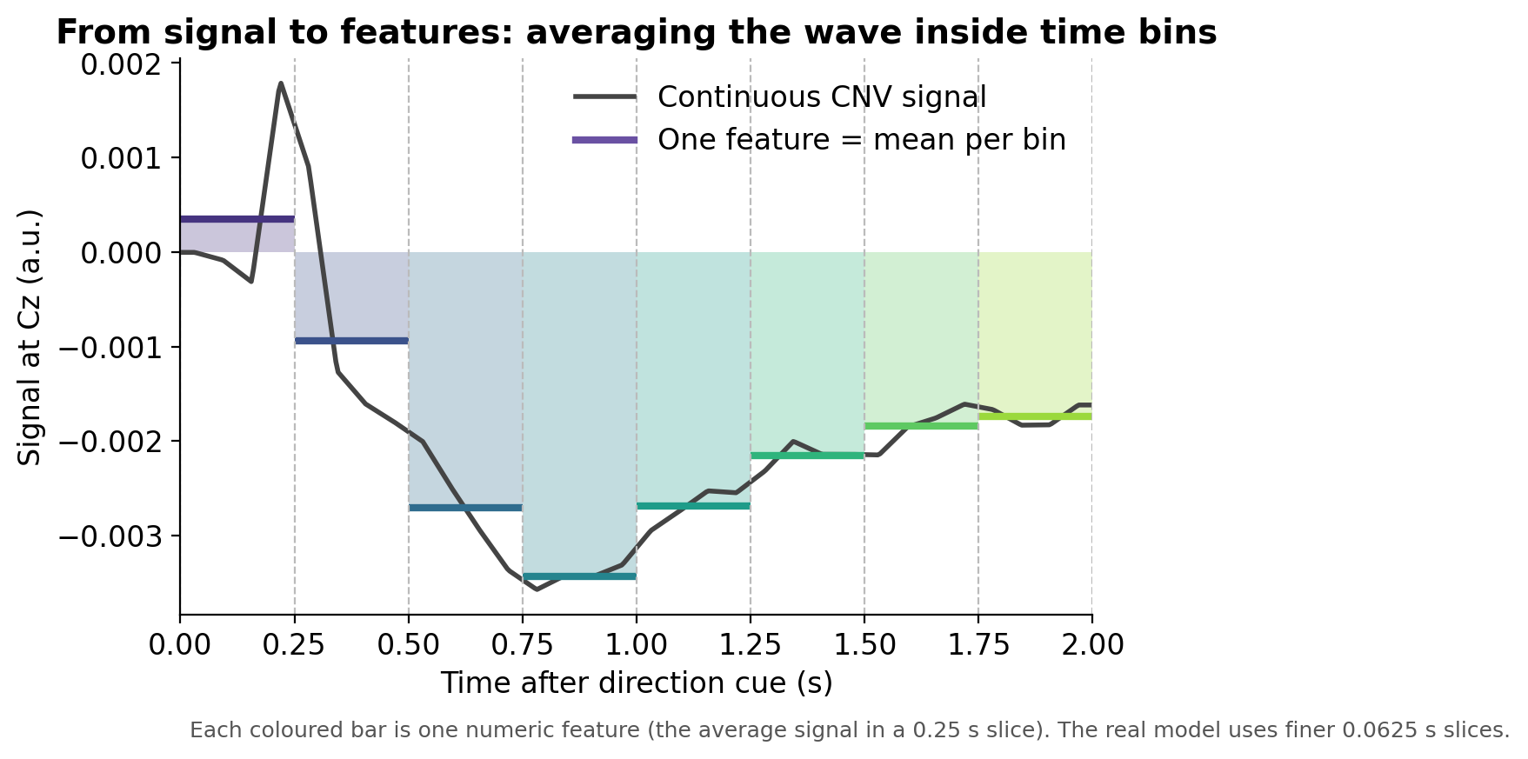
Figure 4. Turning a continuous waveform into features. Each 2 s epoch is divided into non-overlapping 62.5 ms bins and summarised per bin; across channels, bins, bands and source ROIs this yields ~19,500 candidate features per epoch.
A note on referencing - CSD (surface Laplacian)
The scalp-electrode features (amplitude, slopes, power) are computed not on the raw average-referenced potentials but on their current source density (CSD) transform - the surface Laplacian of the scalp field. CSD is a reference-free spatial high-pass filter that sharpens the topography of superficial radial generators and suppresses volume-conducted and far-field activity; it is expressed here in arbitrary units. The trade-off is that, as a spatial second derivative, CSD also amplifies high-spatial-frequency and broadband noise - which is why the grand-average display below (Figure 5) is drawn from the average-reference (uV) epochs rather than the CSD ones, even though the classifier's window features use CSD.
The novel block - a per-epoch foot-SEP. Because the sole is stimulated throughout, we added a fifth feature family unique to this project, read from the average-reference (non-CSD) epochs - the vertex foot-SEP is a deep, largely tangential paracentral generator that the surface Laplacian would attenuate. For each analysis epoch we average the SEPs of its own in-epoch pulses (~4 per 2 s window), baseline-correct (-50 to 0 ms), and read fixed a-priori vertex components - an early positivity (P50, 40-50 ms window) and the dominant negativity (N90, 75-90 ms window; grand-average trough ~65-75 ms), plus peak-to-peak and RMS over 15-130 ms, across the vertex montage [Cz, C1, C2, FCz, CPz], with the read window starting >=15 ms to exclude the stimulus artifact. (P50/N90 are latency-defined labels for the vertex foot-SEP peaks, not the canonical tibial-nerve P37/N45 nomenclature - plantar cutaneous stimulation evokes a later, sub-uV complex.) The block is leakage-safe by construction: every epoch's SEP is built only from that epoch's own pulses, never a per-condition average broadcast across trials.
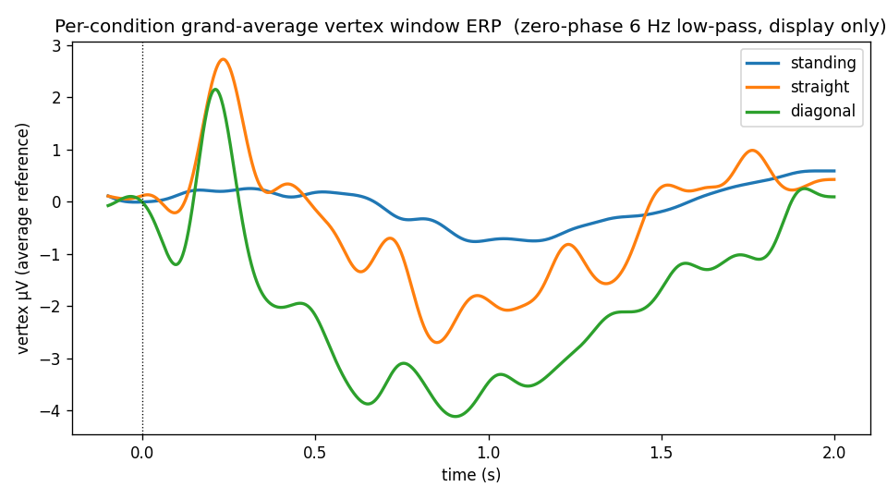
Figure 5. Grand-average vertex window ERP per state (average reference, uV; zero-phase 6 Hz low-pass for display), across all thirty-two participants. Standing (blue) stays near baseline, whereas both stepping states show a large early positivity (~0.2 s, around response / gait onset) followed by a sustained negativity that is deepest for diagonal. The two stepping waveforms share a similar early positivity but diverge through the sustained negativity; at the single-trial level, though, quiet stance is trivially separable whereas straight vs diagonal remains subtle. The classifier's window features are the CSD transform of these signals; the display is in uV for legibility.
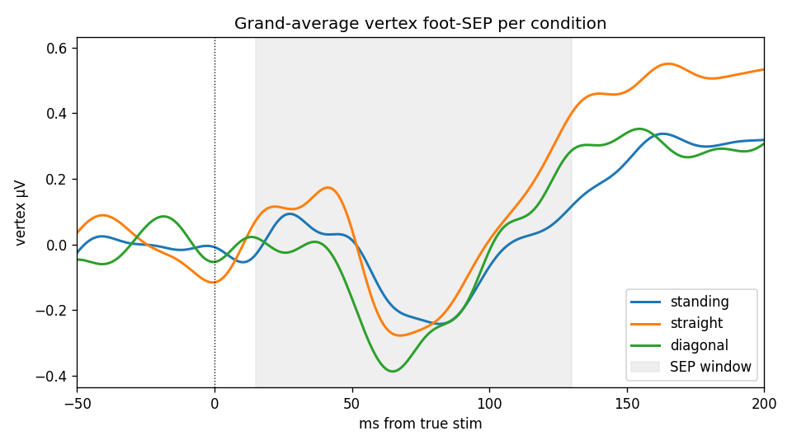
Figure 6. Grand-average vertex foot-SEP per state (average reference, uV), time-locked to the true (offset-corrected) pulse. The evoked complex is low-amplitude (sub-uV): a weak P50 positivity and a dominant N90 trough. The three states are near-identical - consistent with the ablation (Section 7), where the SEP block adds nothing beyond the window features.

6 How the model is built and tested
The testing machinery is identical to the step-type project, because honesty matters more than any single number. Two principles run through it: never let the model see the data it will be scored on, and trim the ~19,500 raw features down to the few dozen that matter, doing both inside each training fold so nothing leaks.
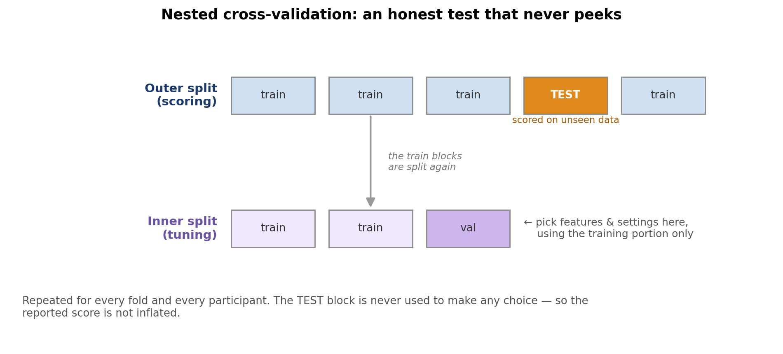
Figure 7. Nested cross-validation. An outer split sets aside a test block used only for the final score; all choices are made on a separate inner split. Because the test block is never used to make a choice, the score is not inflated.
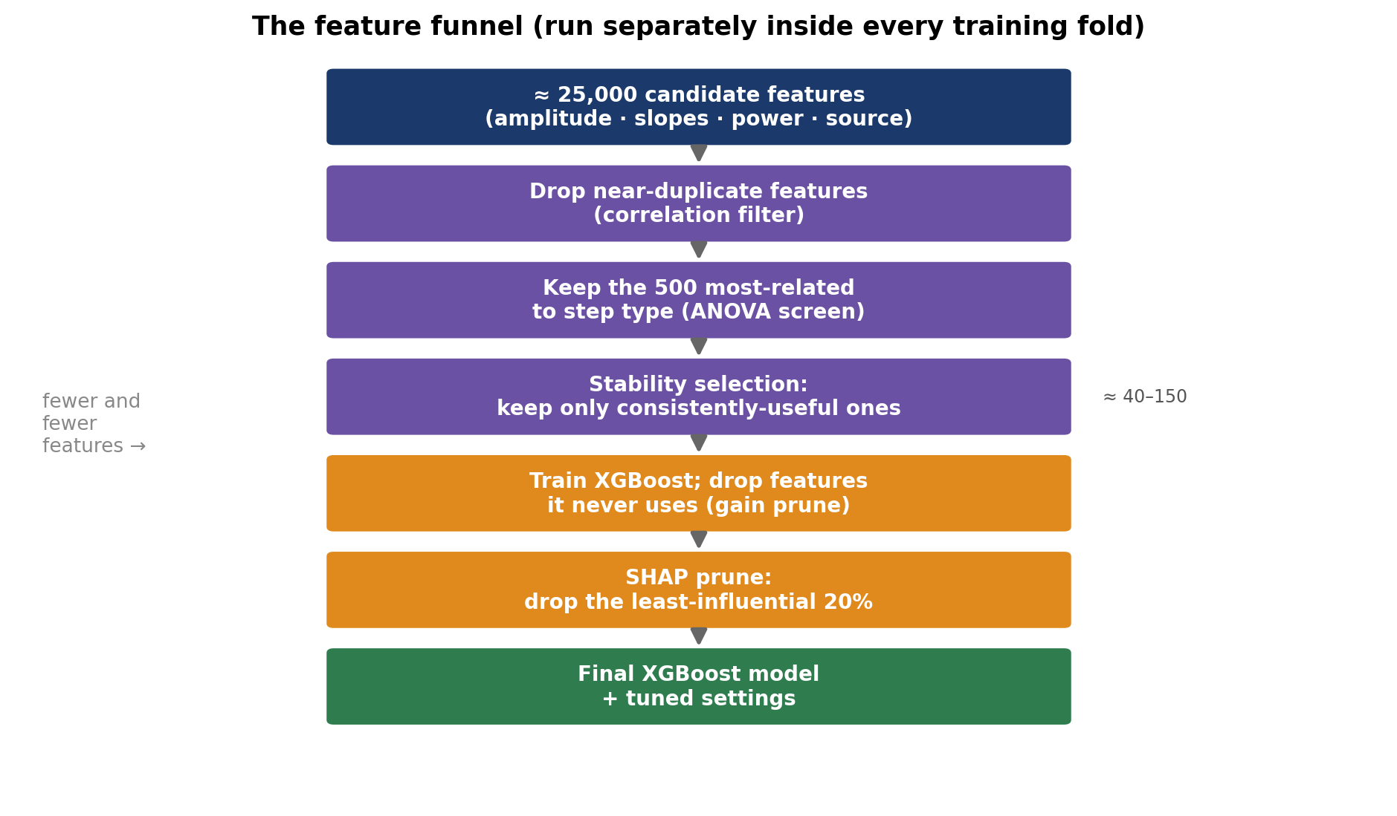
Figure 8. The feature funnel, applied fresh inside every training fold: from ~19,500 candidates down to a few dozen, via a correlation filter, a quick statistical screen, stability selection, and gain pruning. The three-class run uses a multiclass-safe version of each step.
To keep the three states evenly matched, the standing windows are down-sampled to the number of stepping trials, and the cross-validation is stratified so every split contains all three states. Each per-person model is then scored on held-out epochs it never saw.

7 Results: which states are separable, and what helps
The headline numbers come from all thirty-two participants with the full honest test. To find out which features actually matter, we ran the same analysis four times, each with a different feature set - an ablation. This is the most informative result in the report.
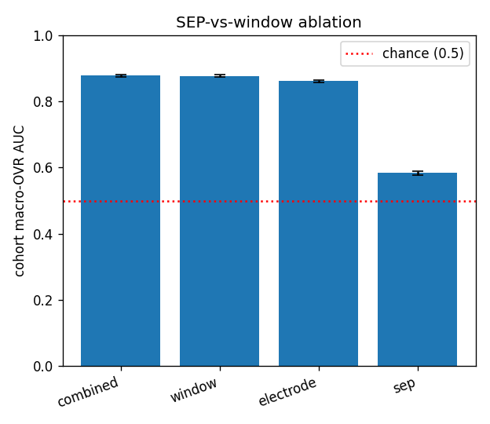
Figure 9. The ablation. Each bar is the cohort macro-AUC for a different feature set (chance = 0.50, dashed). The full set (combined) and the set without the foot-SEP (window) are identical; dropping the eLORETA source features too (electrode) costs a small but real ~0.015 macro-AUC. The foot-SEP on its own (sep) lands only modestly above chance.
Feature set | What's included | Macro-AUC | 3-way accuracy
Combined | everything (scalp + brain-source + foot-SEP) | 0.878 | 73%
Window | scalp + brain-source (no foot-SEP) | 0.877 | 73%
Electrode | scalp features only (amplitude, slopes, power) | 0.862 | 71%
SEP only | just the foot-stimulation feature | 0.584 | 40%

Two clean answers
Does the new foot-SEP feature add anything? No. Combined and Window score identically (0.878 vs 0.877), so once the ordinary scalp features are present, the foot-SEP is redundant - although on its own it does carry a weak signal (0.58). Do the expensive brain-source features earn their keep? Yes, modestly - removing them drops the score by 0.015 (0.877 to 0.862), and more tellingly it costs ~4 points of accuracy on the hard straight-vs-diagonal distinction (63/61% to 59/57%). In an early 8-person preview this gap looked negligible; across the full cohort the brain-source contribution is small but consistent.
The confusion matrix shows where the accuracy comes from: rows are the true state, columns are the model's guess, and the diagonal counts correct calls.
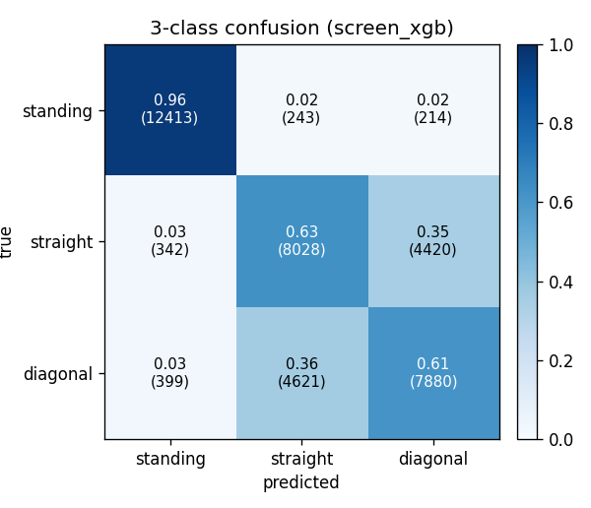
Figure 10. Three-by-three confusion matrix across all thirty-two participants. Standing is identified almost perfectly (~96% correct). The errors concentrate in the bottom-right block: straight and diagonal steps are most often confused with each other (~61-63% correct each), not with standing.
So the three states are not equally easy. Per-class accuracy is about 96% for standing, 63% for straight, and 61% for diagonal. Standing is trivially separable from movement; the genuinely hard sub-problem - telling a straight step from a diagonal one - is exactly the original step-type question, and it sits modestly above its own two-way chance line.
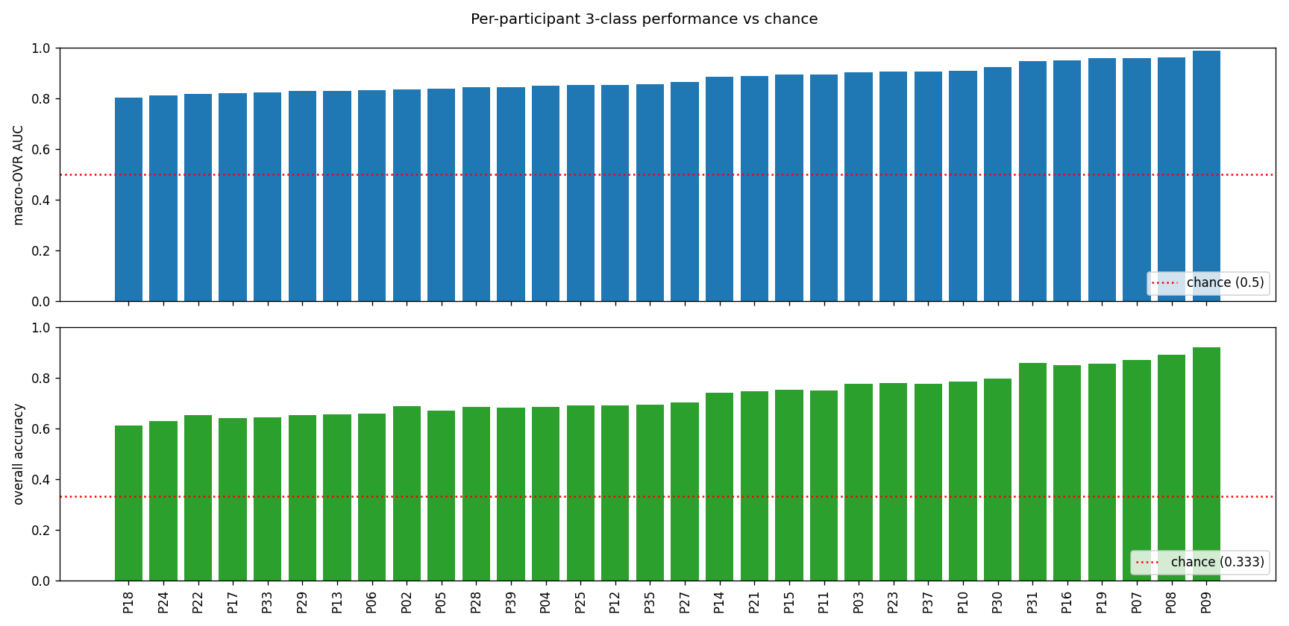
Figure 11. Each participant's own model. Top: three-class macro-AUC (chance 0.50, dashed). Bottom: overall accuracy (chance 0.333, dashed). Every participant is clearly above chance on both measures, with the usual person-to-person variation.
The honesty check
An overfit model scores far higher on its own tuning data than on unseen data. Here the inner-vs-outer gap is only 0.05, and every participant clears chance on the truly held-out epochs - so the 0.878 figure is a fair, not inflated, estimate for the full 32-participant cohort.

8 An honest caveat: the standing-stepping movement asymmetry
Read this before over-interpreting standing
Near-perfect detection of standing should not be read as near-perfect decoding of a cortical state. Because the foot-stimulation train is continuous and matched across all three states (Section 3), it is not a between-state confound here - and we additionally blank the +/-12 ms stimulus-artifact intervals before extracting the window features. What still separates standing from stepping is the obvious factor: gross movement. Stepping entails whole-body motion, and with it postural EMG, motion and cable artifact, and genuine sensorimotor cortical engagement; quiet stance has none of these. Some of the standing-stepping separability is therefore non-neural (movement-related artifact) rather than a pure motor-state readout - an asymmetry no reference scheme fully removes.
This is precisely why the straight-vs-diagonal contrast is the scientifically clean one: both are stepping, with matched movement and matched stimulation, so any separation there reflects genuine direction-related sensorimotor activity - the original step-type signal, now embedded in the three-class setting. Partitioning the standing result into movement-related artifact versus true motor-state signal (e.g. via EMG / accelerometer regressors or artifact-matched controls) is the natural next check.

9 Summary and next steps
In summary: a single 2 s EEG epoch separates quiet stance, straight stepping and diagonal stepping well above chance (macro-AUC 0.878, accuracy 73% vs 33% chance), under an honest nested cross-validation estimate. Standing is near-ceiling - subject to the movement-asymmetry caveat above - while the meaningful, artifact-matched problem is straight vs diagonal. The ablation was decisive: the per-epoch foot-SEP adds nothing beyond the window features, whereas the eLORETA source estimates give a small but consistent lift (+0.015 macro-AUC) to the hard straight-vs-diagonal distinction.
Where this goes next:
- The full 32-participant cohort is complete. Ablation-guided production feature set: keep the eLORETA source block (a small, consistent lift to straight-vs-diagonal) and drop the foot-SEP block (redundant against the window features).
- Partition the standing result into movement-related artifact versus genuine motor-state signal - e.g. with EMG / accelerometer regressors or artifact-matched controls - since the continuous, matched stimulation already rules out a stimulation-rhythm explanation.
- Focus on straight-vs-diagonal, the artifact-matched core problem, and relate it back to the CNV step-type findings.

Glossary (modelling & statistics)
Feature - A single number summarising one aspect of an epoch (e.g. band power at one channel in one time bin).
Macro-AUC - Macro-averaged one-vs-rest area under the ROC curve: for each state, how well it separates from the other two, then averaged. 0.50 = chance, 1.00 = perfect.
Accuracy - Fraction of epochs assigned the correct state. Chance is 1/3 (33%) for three balanced classes.
Ablation - Re-running the analysis with feature blocks removed, to isolate each block's contribution.
Confusion matrix - A table of true versus predicted state; the diagonal counts correct calls, the off-diagonal the errors.
Overfitting - When a model fits its training data rather than a generalisable rule - high internal scores, poor held-out scores.
Nested cross-validation - An outer split scores the finished model; a separate inner split makes all tuning and feature-selection choices, so the reported score is not inflated.
XGBoost - The classifier used here: an additive ensemble of gradient-boosted decision trees.

