EEG - MOTOR STATE - MACHINE LEARNING

Reading Motor State
from Brain Activity
Telling apart three states - standing, stepping straight, and stepping diagonally - from EEG, with one model per person. A companion to the straight-vs-diagonal step-type project.

Prepared by: [your name]
For: [supervisor name]
Affiliation: Sunnybrook Research Institute
Date: June 2026 - full 32-participant cohort

What's in this report
Open in Word and choose Update Field to build the contents.

1 The short version
This is the three-way sibling of the step-type project. Instead of asking straight or diagonal?, it asks a broader question: from a two-second window of EEG, can we tell whether a person is standing still, stepping straight, or stepping diagonally? Each person gets their own model, tested only on their own held-out data.
0.88 | 73% | 32
average score (macro-AUC), where 0.50 = chance | three-way accuracy (chance = 33%) | participants (full cohort), each with their own model

HEADLINE
Across all thirty-two participants, the model separates the three motor states with an average macro-AUC of 0.878 (chance = 0.50) and 73% accuracy (chance = 33%), and it does so honestly - the gap between its optimistic internal score and its real held-out score is tiny (0.05). Standing is almost always identified correctly; telling a straight step from a diagonal one is the hard part. A controlled comparison (Section 7) shows a planned foot-stimulation feature adds essentially nothing on top of the basic scalp features, while the brain-source feature adds a small but real boost to the hard straight-vs-diagonal distinction.

2 What the project is trying to do
The step-type project showed that the brain's preparation signal carries a faint trace of which way a person is about to step. This project widens the lens from two step-types to three motor states: standing still, stepping straight, and stepping diagonally. The motivation is the same - to read movement-related information directly from brain activity - but the three-way version is a stepping stone toward decoding a richer set of states.
Because there are now three possible answers, a model that guessed randomly would be right only one third (33%) of the time. Anything reliably above that means the EEG genuinely distinguishes the states. We keep the project's core principle: one model per person, each judged only on data it has never seen.

3 The three states and where the data come from
The data come from two separate EEG recordings per participant, which between them supply the three states. Throughout, a single two-second slice of the 64-sensor recording is called an epoch - one example the model learns from.
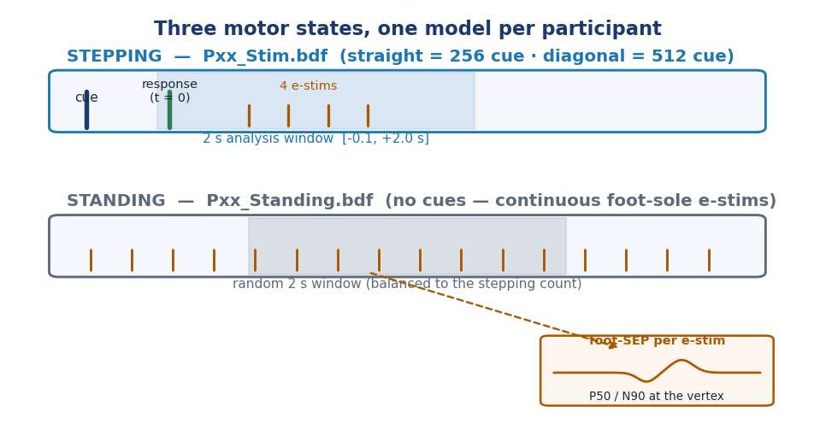
Figure 1. How the three states are defined. Stepping (top, from the Stim recording): after a cue tells the person which way to step, we lock a 2-second window to their response; straight and diagonal come from two different cues. Standing (bottom, from the Standing recording): there are no cues, so we cut random 2-second windows from the continuous recording. In both recordings the sole of the foot is gently electrically stimulated every half-second (orange ticks), which evokes a tiny brain response (inset) used as an optional extra feature.
- Stepping straight / diagonal - from the Stim recording. A cue tells the person the direction; ~2 s later they step. We take the 2-second window locked to their response, exactly as in the step-type project (~40 of each per person).
- Standing - from the Standing recording. The person simply stands; with no cues, we cut non-overlapping 2-second windows from the continuous recording and balance their number to the stepping trials, so the three states are evenly represented.
One quirk of this study is that throughout both recordings, the sole of the foot receives a gentle electrical pulse roughly twice a second. Each pulse evokes a small, brief response in the brain's sensory areas - a somatosensory evoked potential (SEP) - which we explored as an extra source of information (Section 5).

4 The prediction engine: a 3-way XGBoost model
As in the step-type project, the workhorse is XGBoost - a model built from many small decision trees (yes/no flowcharts over the measured numbers) added together, each new tree correcting the previous ones' mistakes. The only change for this project is the output: instead of one probability (“diagonal?”), the model now produces three probabilities that add to 100% - one per state - and predicts whichever is largest.
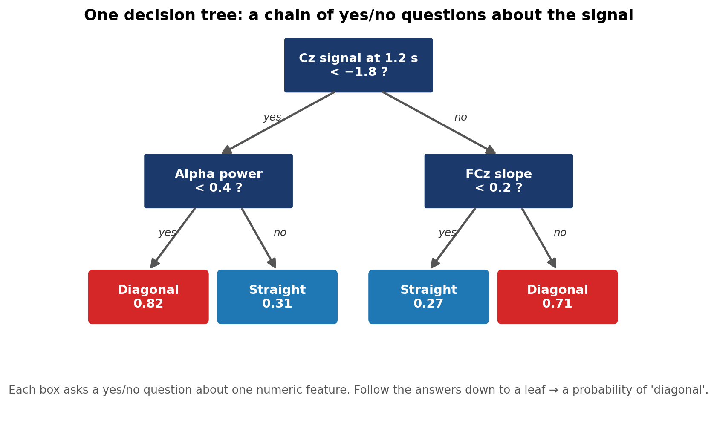
Figure 2. A single decision tree - the building block. Each box asks a yes/no question about one measurement; following the answers leads to a verdict. The model invents its own thresholds from the continuous data.
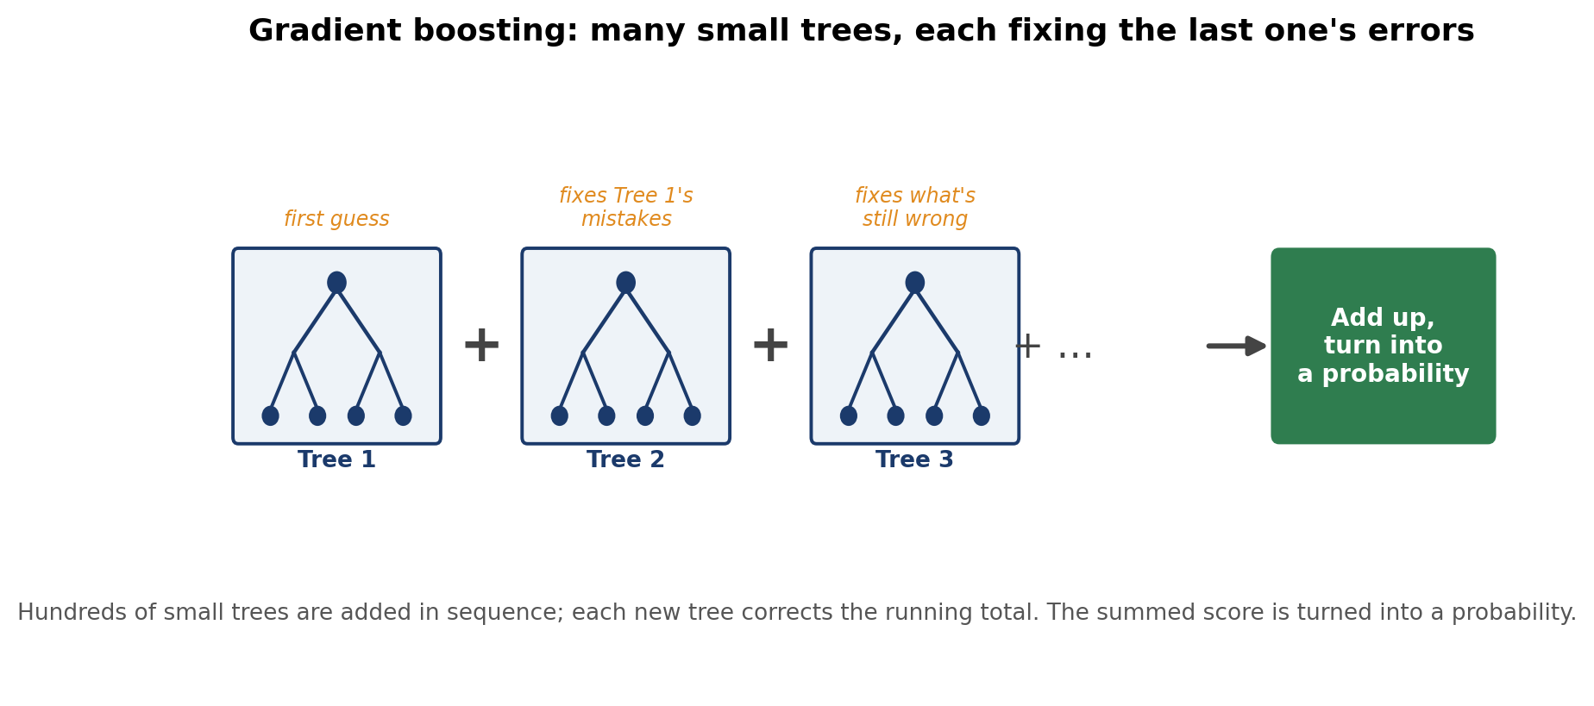
Figure 3. Gradient boosting: hundreds of simple trees are added together, each correcting the running total left by the trees before it. For this project the combined scores are turned into three competing probabilities (standing / straight / diagonal).
Performance is summarised with macro-AUC - the natural three-class version of the AUC score. It asks, for each state in turn, “how well does the model separate this state from the other two?”, then averages. As before, 0.50 is chance and 1.00 is perfect.

5 What the model looks at: the features
Each 2-second epoch is summarised into a long list of features - interpretable numbers describing the brain signal. We reuse the four families from the step-type project, computed by chopping the window into short time bins (each ~1/16 s):
- Amplitude - how high or low the signal sits at each sensor and time-slice.
- Slopes - whether the signal is rising or falling, and how steeply.
- Power (frequency bands) - the strength of the brain's rhythms (delta ... gamma).
- Source localisation - an estimate (via eLORETA) of where in the brain the activity arises, across ~150 regions.
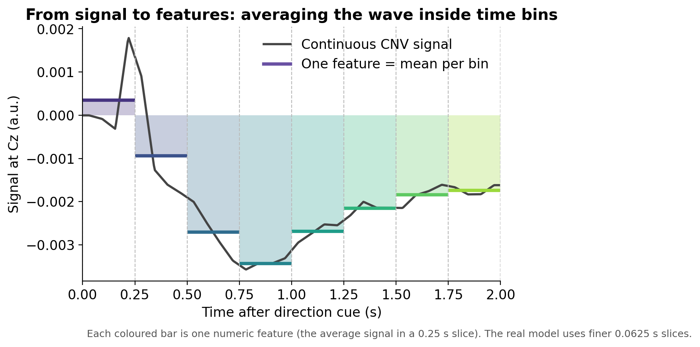
Figure 4. Turning a continuous wave into numbers. The window is chopped into short equal time-slices and the signal in each is summarised - every bar becomes one feature. Repeated over every sensor, band and brain region, this yields roughly 19,500 candidate features per epoch.
The new ingredient - a foot-stimulation feature (“SEP”). Because the foot is being stimulated throughout, we added a fifth, novel feature family unique to this project: for each epoch we average the tiny brain responses to the ~4 foot-pulses that fall inside it, and measure the size and timing of the two characteristic peaks (around 50 and 90 ms after the pulse) over the vertex sensors. Critically, each epoch's SEP is built only from its own pulses - never shared across trials - so it cannot secretly leak the answer.
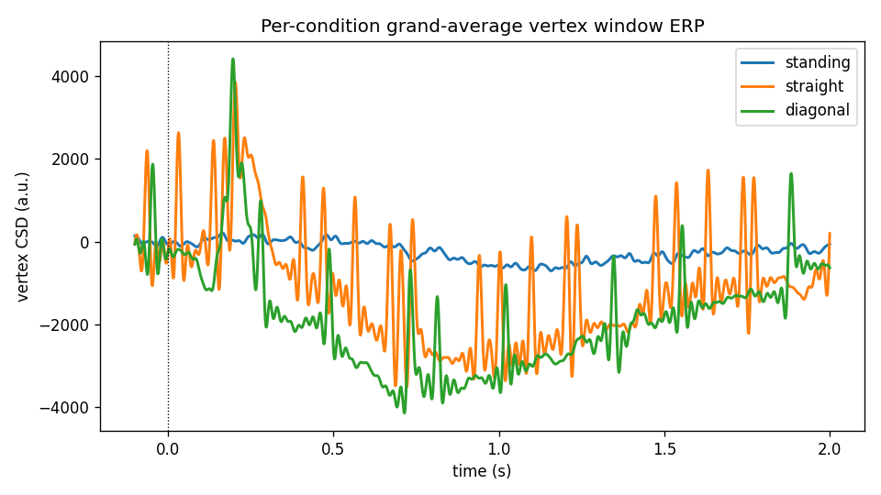
Figure 5. The average brain signal over the 2-second window at the top of the head, for each state, across the thirty-two participants. Standing (grey) sits apart from the two stepping states; straight (blue) and diagonal (orange) overlap heavily - a first visual hint that standing is easy to spot but the two step types are hard to tell apart.
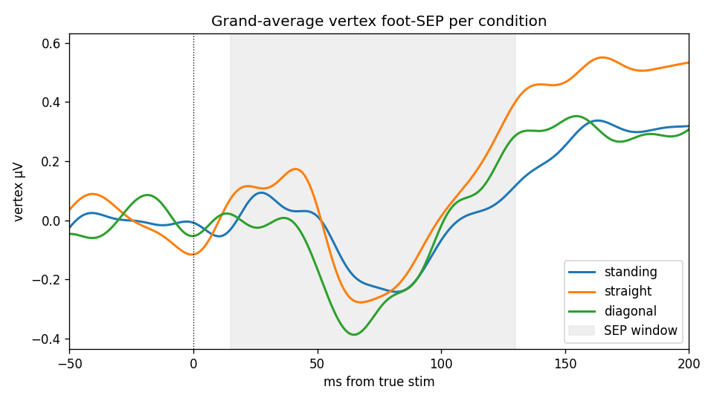
Figure 6. The foot-stimulation response (SEP) at the vertex, averaged across participants, for each state. The traces differ only modestly between states - consistent with the result (Section 7) that this feature adds little once the ordinary scalp features are present.

6 How the model is built and tested
The testing machinery is identical to the step-type project, because honesty matters more than any single number. Two principles run through it: never let the model see the data it will be scored on, and trim the ~19,500 raw features down to the few dozen that matter, doing both inside each training fold so nothing leaks.
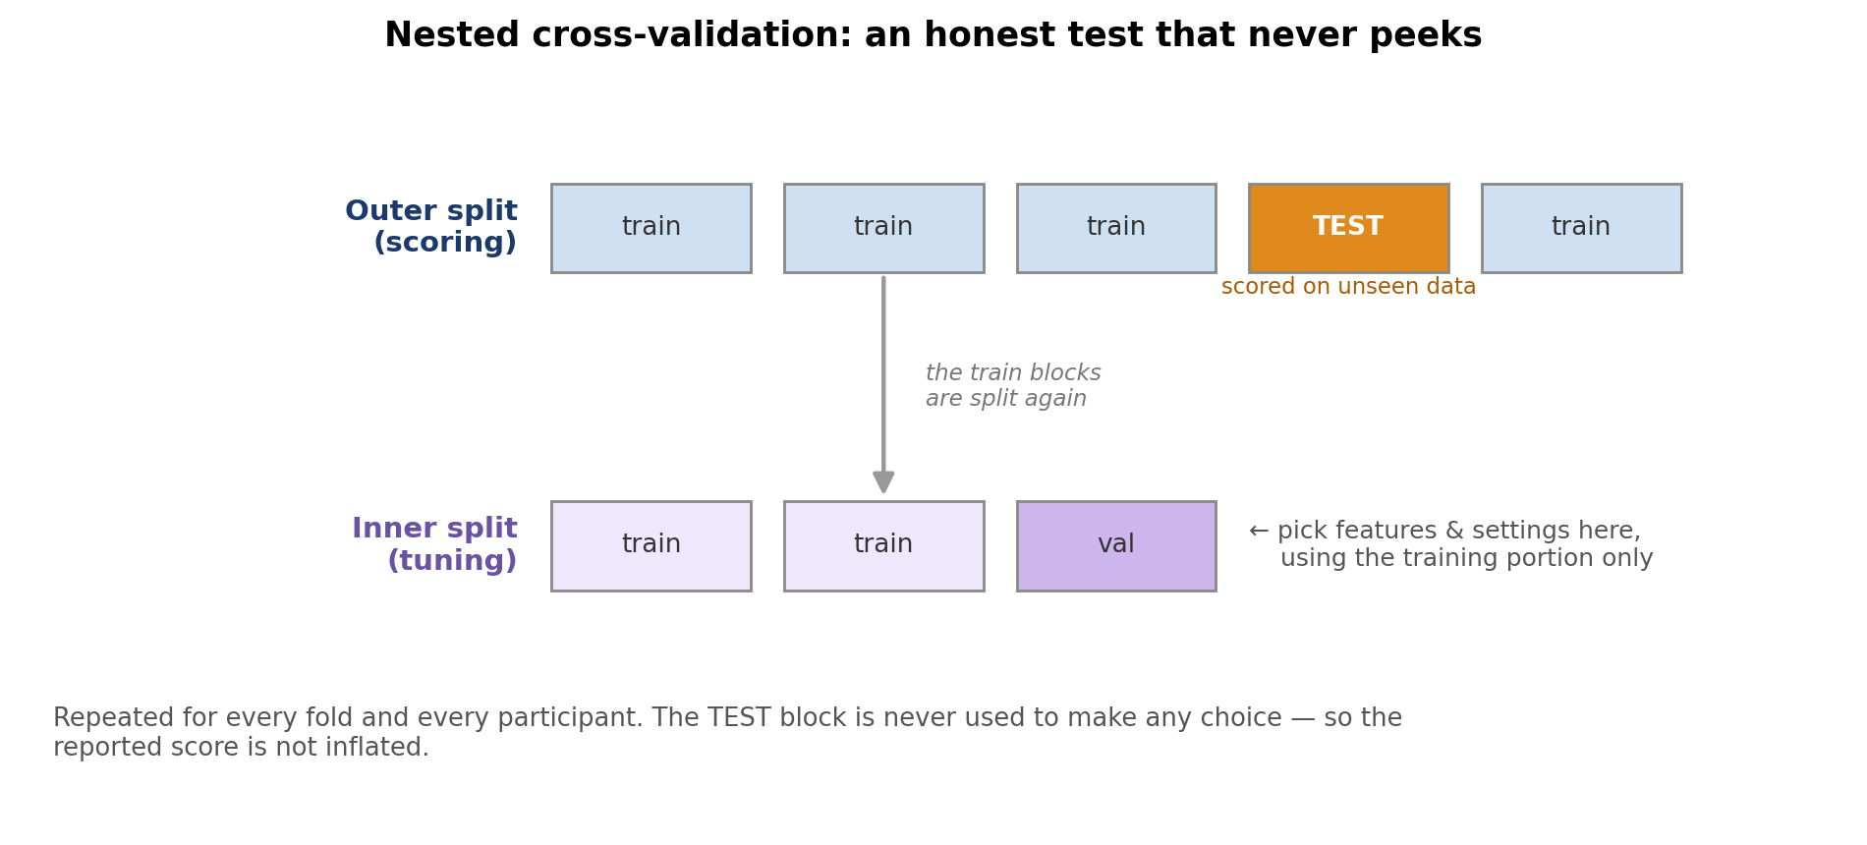
Figure 7. Nested cross-validation. An outer split sets aside a test block used only for the final score; all choices are made on a separate inner split. Because the test block is never used to make a choice, the score is not inflated.
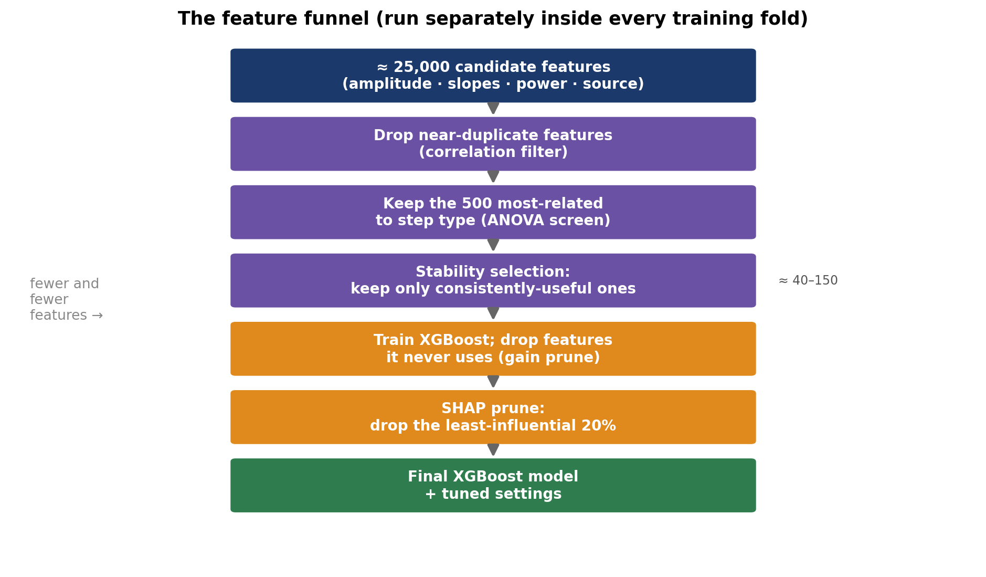
Figure 8. The feature funnel, applied fresh inside every training fold: from ~19,500 candidates down to a few dozen, via a correlation filter, a quick statistical screen, stability selection, and gain pruning. The three-class run uses a multiclass-safe version of each step.
To keep the three states evenly matched, the standing windows are down-sampled to the number of stepping trials, and the cross-validation is stratified so every split contains all three states. Each per-person model is then scored on held-out epochs it never saw.

7 Results: which states are separable, and what helps
The headline numbers come from all thirty-two participants with the full honest test. To find out which features actually matter, we ran the same analysis four times, each with a different feature set - an ablation. This is the most informative result in the report.
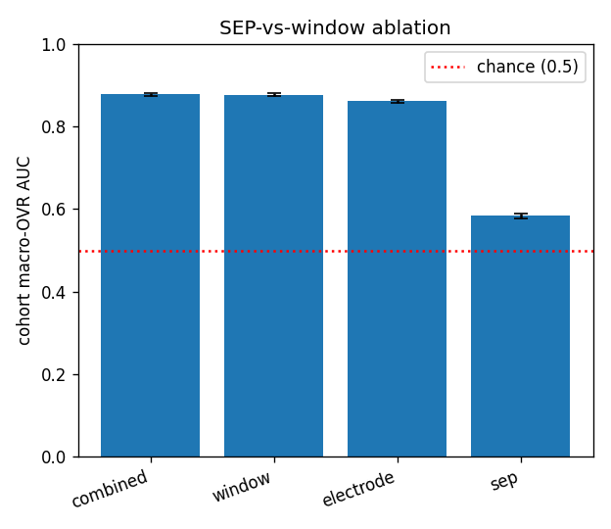
Figure 9. The ablation. Each bar is the cohort macro-AUC for a different feature set (chance = 0.50, dashed). The full set (combined) and the set without the foot-SEP (window) are identical; dropping the brain-source features too (electrode) costs a little. The foot-SEP on its own (sep) lands only modestly above chance.
Feature set | What's included | Macro-AUC | 3-way accuracy
Combined | everything (scalp + brain-source + foot-SEP) | 0.878 | 73%
Window | scalp + brain-source (no foot-SEP) | 0.877 | 73%
Electrode | scalp features only (amplitude, slopes, power) | 0.862 | 71%
SEP only | just the foot-stimulation feature | 0.584 | 40%

TWO CLEAN ANSWERS
Does the new foot-SEP feature add anything? No. Combined and Window score identically (0.878 vs 0.877), so once the ordinary scalp features are present, the foot-SEP is redundant - although on its own it does carry a weak signal (0.58). Do the expensive brain-source features earn their keep? Yes, modestly - removing them drops the score by 0.015 (0.877 to 0.862), and more tellingly it costs ~4 points of accuracy on the hard straight-vs-diagonal distinction (63/61% to 59/57%). In an early 8-person preview this gap looked negligible; across the full cohort the brain-source contribution is small but consistent.

The confusion matrix shows where the accuracy comes from: rows are the true state, columns are the model's guess, and the diagonal counts correct calls.
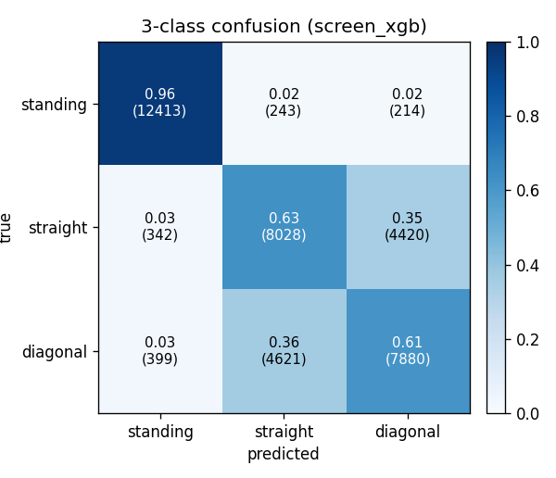
Figure 10. Three-by-three confusion matrix across all thirty-two participants. Standing is identified almost perfectly (~96% correct). The errors concentrate in the bottom-right block: straight and diagonal steps are most often confused with each other (~61-63% correct each), not with standing.
So the three states are not equally easy. Per-class accuracy is about 96% for standing, 63% for straight, and 61% for diagonal. Standing is trivially separable from movement; the genuinely hard sub-problem - telling a straight step from a diagonal one - is exactly the original step-type question, and it sits modestly above its own two-way chance line.
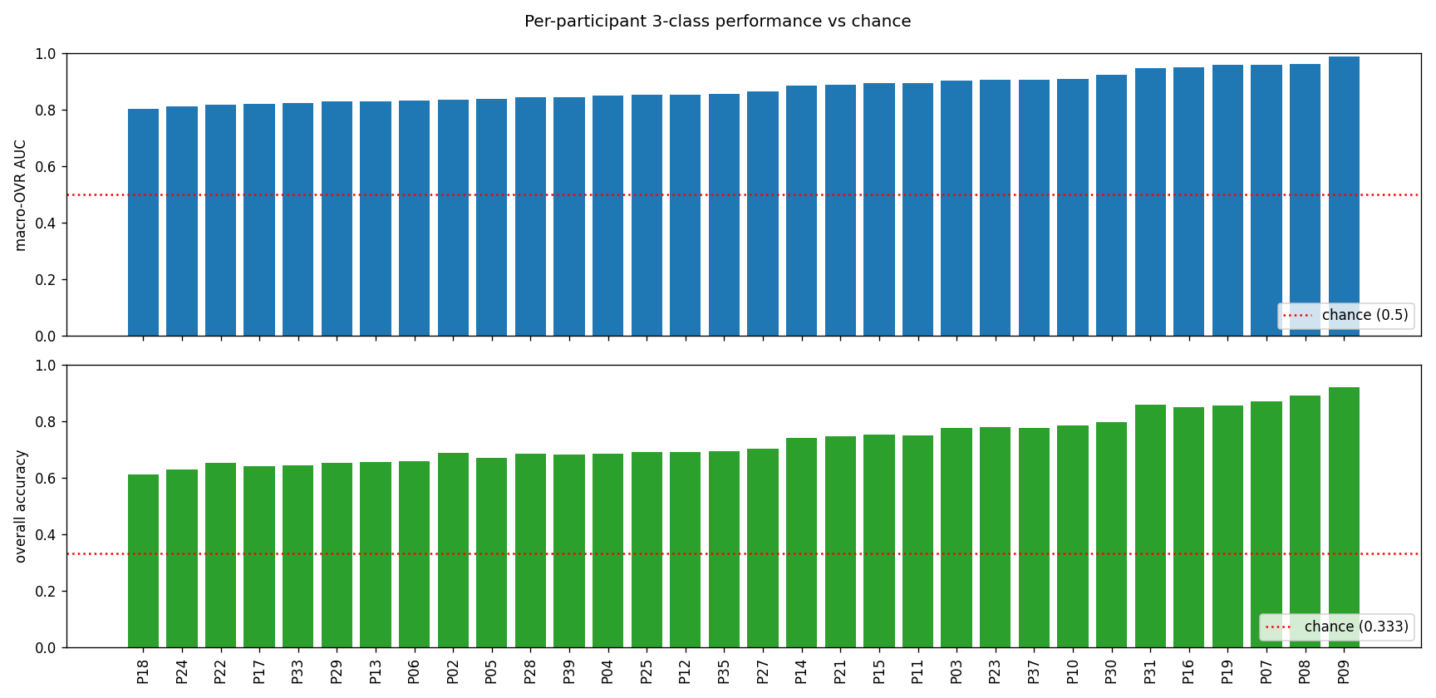
Figure 11. Each participant's own model. Top: three-class macro-AUC (chance 0.50, dashed). Bottom: overall accuracy (chance 0.333, dashed). Every participant is clearly above chance on both measures, with the usual person-to-person variation.
THE HONESTY CHECK
A model that is overfitting scores far higher on its own tuning data than on unseen data. Here the gap between the two is only 0.05, and every participant clears chance on the truly held-out epochs. The 0.88 figure is a real, not inflated, estimate for the full cohort.

8 An honest caveat: the stimulation-rhythm confound
READ THIS BEFORE OVER-INTERPRETING STANDING
Standing being identified almost perfectly is partly too easy. During standing the foot is stimulated in a steady half-second rhythm; during stepping the pulses come in a short cluster and then stop. That difference in stimulation rhythm - not necessarily brain state - can by itself separate standing from stepping. We actively blank the electrical-pulse artefacts before computing features, but the blanking pattern itself still differs between the states, so some of the standing performance may reflect the experiment's structure rather than the brain.
This is why the straight-vs-diagonal comparison is the scientifically clean one: both are stepping, with the identical pulse structure, so any separation there is genuine movement-related brain signal. A planned stimulation-artefact-only control will quantify how much of the standing result is confound versus real motor state.

9 Summary and next steps
In plain terms: a 2-second EEG window distinguishes standing, straight stepping, and diagonal stepping well above chance (macro-AUC 0.88, accuracy 73% versus 33%), with an honest test. Standing is easy (with the confound caveat above); separating the two step types is the hard, meaningful part. The controlled comparison was decisive: the new foot-SEP feature adds nothing beyond the basic scalp measurements, whereas the brain-source features give a small but real boost to the hard straight-vs-diagonal distinction.
Where this goes next:
- The full cohort is complete (all 32 participants). The ablation's guidance for a production feature set: keep the brain-source features (a small, consistent lift to straight-vs-diagonal) and drop the foot-SEP block (redundant).
- Run the stimulation-artefact control to pin down how much of the standing result is the rhythm confound versus genuine motor state.
- Focus on straight-vs-diagonal, the confound-free core problem, and connect it back to the step-type project's findings.

Plain-language glossary
EEG - Recording the brain's electrical activity with sensors on the scalp.
Epoch / trial - One ~2-second recording across all sensors - one example for the model.
Motor state - Here, one of three: standing, stepping straight, or stepping diagonally.
Feature - A single number summarising one aspect of an epoch.
SEP (somatosensory evoked potential) - The brain's small response to a touch/stimulation of the body - here, the electrical pulse to the sole of the foot.
Macro-AUC - The three-class performance score: for each state, how well it is separated from the other two, averaged. 0.50 = chance, 1.00 = perfect.
Accuracy - The fraction of epochs whose state the model gets exactly right. Chance here is 1/3.
Ablation - Re-running the analysis with parts of the feature set removed, to see what each contributes.
Confusion matrix - A table of true state versus predicted state; the diagonal counts correct calls.
Overfitting - When a model memorises its training data instead of learning a general rule.
Cross-validation - Repeatedly holding out part of the data as an unseen test to estimate real-world performance fairly.
XGBoost - The model used here: hundreds of small decision trees added together, each correcting the previous ones' mistakes.

