**《数据库系统概论》实习报告**

|  |  |  |  |  |  |
| --- | --- | --- | --- | --- | --- |
| **学院：** | 数学与统计学院 | **姓名：** |  | **学号：** |  |
| **专业：** | 信息与计算科学（嵌入） | **日期：** | 2020.10.12 | | |

**注：**

1. **文件以电子版形式交给各班班长，班长于下次上课时交给任课老师；**
2. **文件统一命名为：”学号+姓名+作业序号”，如“20171314007张三2”；**
3. **文件只接受doc或docx格式，不接受pdf、wps等格式。**

**习题：**

1, 在stu数据库中，建立学生表student(sno,sname,sage)，sno为主码，sname取唯一值，

数据如下：

数据如下:

student:

s1 zhao 19

s2 qian 23

s3 sun 34

s4 li 31

s5 zhou 23

s6 wu 12

s7 zheng 20

s8 wang 21

course:

c1 math 6

c2 physics 4

c3 english 4

c4 DB 2

c5 law 3

sc:

s1 c1 70

s1 c3 65

s1 c4 NULL

s2 c1 54

s2 c2 67

s2 c5 80

s3 c2 88

s3 c4 92

s4 c5 24

s4 c2 80

s5 c1 75

s5 c2 NULL

s6 c3 65

s7 c2 54

s8 c1 90

s8 c5 87

**代码：**

create database students;

use students;

create table student

(

sno char(2),

sname char(20),

sage smallint

);

insert into student values

('s1', 'zhao', 19),

('s2', 'qian', 23),

('s3', 'sun', 34),

('s4', 'li', 31),

('s5', 'zhou', 23),

('s6', 'wu', 12),

('s7', 'zheng', 20),

('s8', 'wang', 21);

create table course

(

cno char(2),

cname char(20),

credit smallint

);

insert into course values

('c1', 'math', 6),

('c2', 'physics', 4),

('c3', 'english', 4),

('c4', 'DB', 2),

('c5', 'law', 3);

create table sc

(

sno char(2),

cno char(2),

grade smallint

);

insert into sc values

('s1', 'c1', 70),

('s1', 'c3', 65),

('s1', 'c4', NULL),

('s2', 'c1', 54),

('s2', 'c2', 67),

('s2', 'c5', 80),

('s3', 'c2', 88),

('s3', 'c4', 92),

('s4', 'c5', 24),

('s4', 'c2', 80),

('s5', 'c1', 75),

('s5', 'c2', NULL),

('s6', 'c3', 65),

('s7', 'c2', 54),

('s8', 'c1', 90),

('s8', 'c5', 87);

**结果截图：**

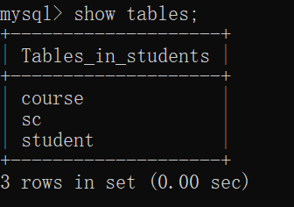

2，查询选修math的总人数；

**代码：**

select count(distinct sno)

from sc

where cno='c1';

**结果截图：**

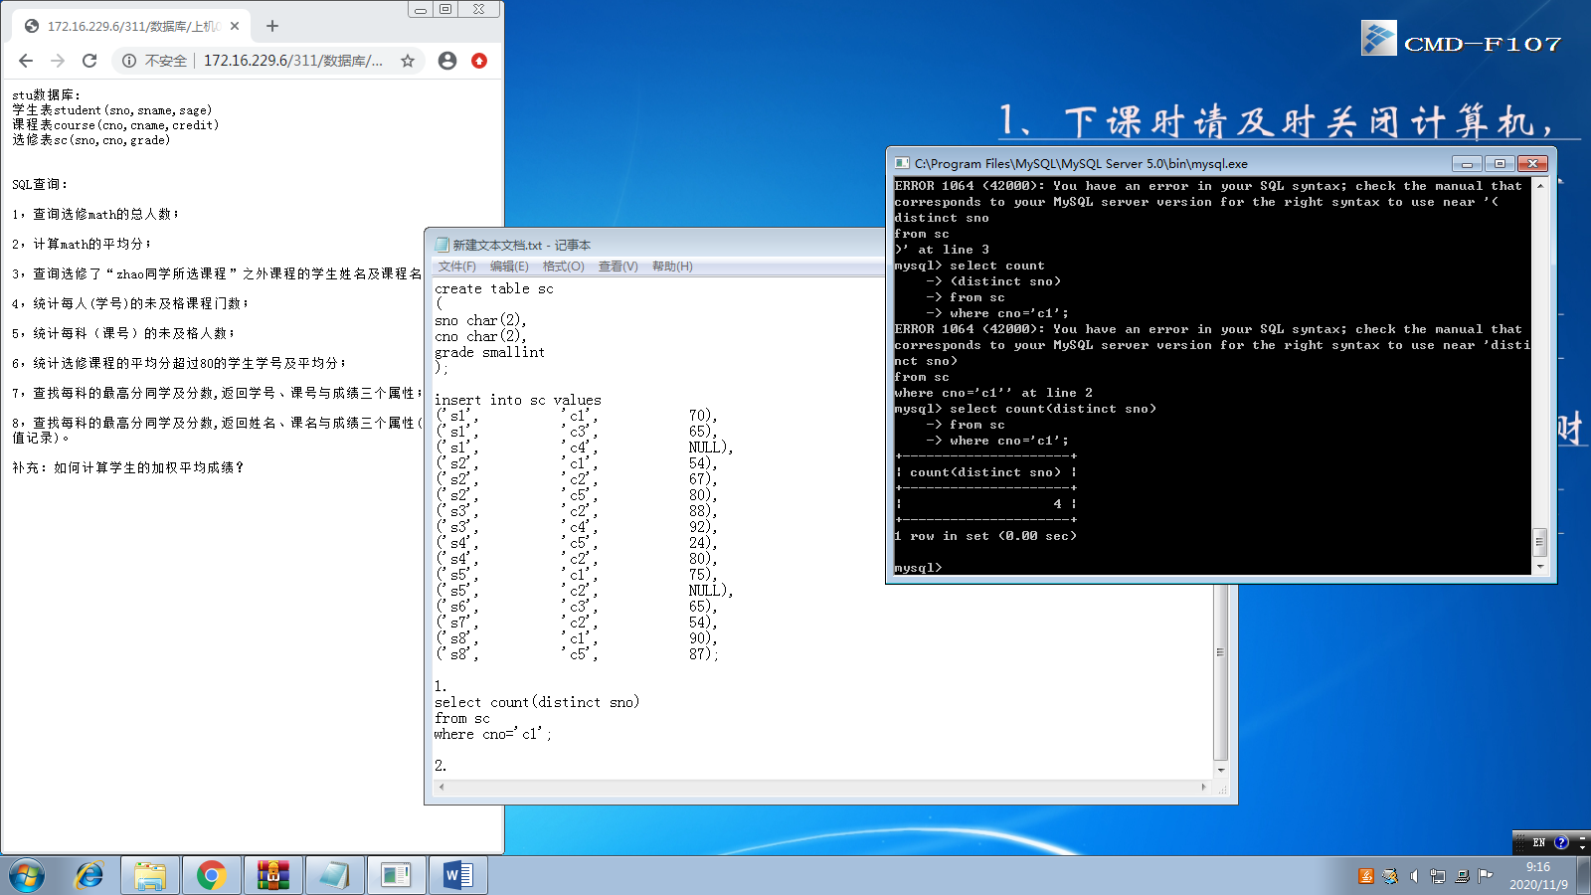

3，计算math的平均分；

**代码：**

select avg(grade)

from sc

where cno='c1';

**结果截图：**

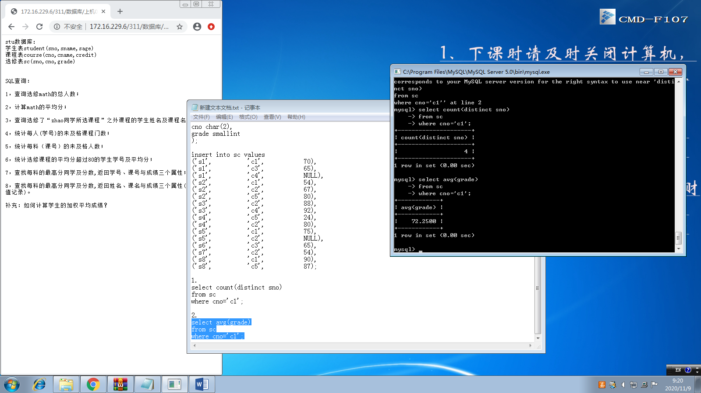

4，查询选修了“zhao同学所选课程”之外课程的学生姓名及课程名

**代码：**

select sname,cname

from student,course

where sno in (

select distinct sno

from sc

where cno not in (

select distinct cno

from sc

where sno = 's1'

)

)

and cno not in(

select distinct cno

from sc

where sno = 's1'

);

**结果截图：**

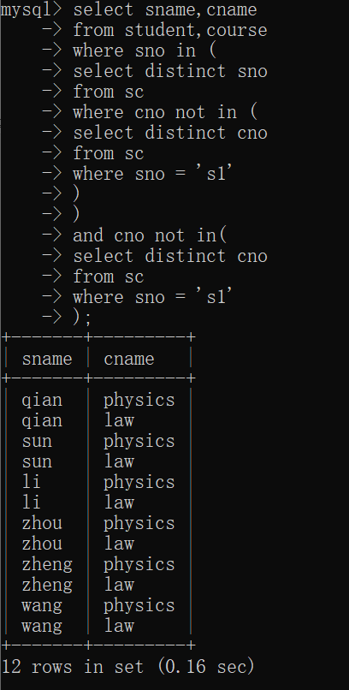

5，统计每人(学号)的未及格课程门数；

**代码：**

select sno,count(cno)

from (select sno,cno

from sc

where grade<60)

as sc1

group by sno;

**结果截图：**

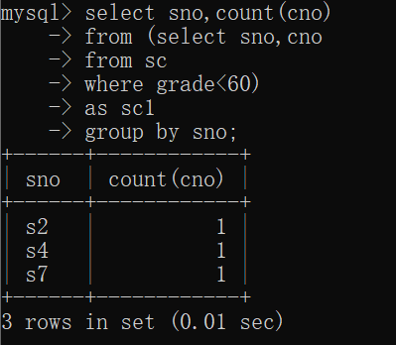

6，统计每科（课号）的未及格人数；

**代码：**

select cno,count(sno)

from (select sno,cno

from sc

where grade<60)

as sc1

group by cno;

**结果截图：**

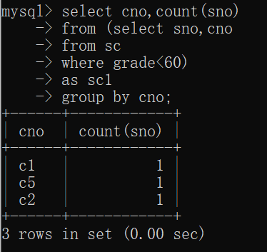

7，统计选修课程的平均分超过80的学生学号及平均分；

**代码：**

select sno,avg(grade)

from sc

group by sno

having avg(grade)>80;

**结果截图：**

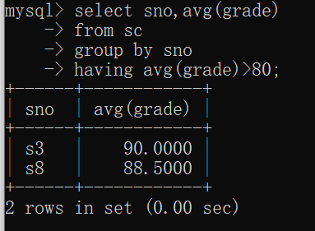

8，查找每科的最高分同学及分数,返回学号、课号与成绩三个属性;

**代码：**

select sno,cno,max(grade)

from sc

group by cno

having max(grade);

**结果截图：**

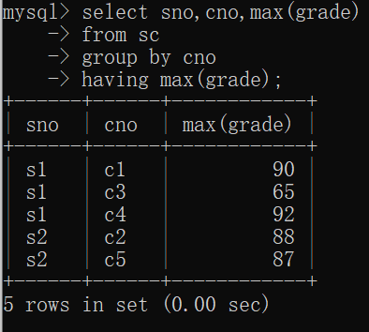

9，查找每科的最高分同学及分数,返回姓名、课名与成绩三个属性(注:排除空值记录)。;

**代码：**

select sname,cname,max(grade)

from student,course,sc

where student.sno=sc.sno and

course.cno=sc.cno

group by cname

having max(grade);

**结果截图：**

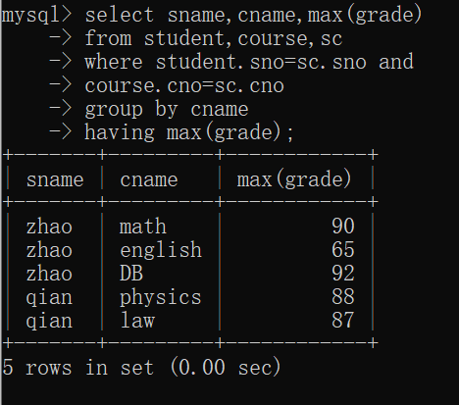

10，如何计算学生的加权平均成绩;

**代码：**

select sno,sum(sm)/sum(credit)

from (

select sno,grade*credit sm,credit

from course,sc

where course.cno=sc.cno

group by sno

)

as sc1

group by sno;

**结果截图：**

