General Instruction
- You are required to develop features for an Online Student Portal using the CodeIgniter 4 framework.
- Use the existing project structure you have been developing in your laboratory exercises.
- You may use your previous code (e.g., authentication system) as a starting point.
- Version Control is Mandatory. You must make at least 3 meaningful commits during the exam, with descriptive messages. Your commit history will be checked.
- Write clean, readable, and well-structured code. Comments are encouraged for clarity.
- The use of Bootstrap for basic styling is expected, but not the primary focus.

Problem Scenario

The university wants to enhance its Online Student Portal. Your task is to implement new features and security measures. The system has three user roles: Student, Teacher, and Admin. You will be building upon the authentication system developed in previous labs.

Examination Tasks

Task 1: Announcements Module Scenario
The admin needs a way to post announcements that are visible to all logged-in users.

Task:
  - Create a new controller named Announcement.php.
  - Inside the controller, create a method named index().
  - The index() method should fetch all announcements from a database table (you will create this table in Task 2) and pass them to a view.
  - Create a view file announcements.php that displays the announcements in a list (title, content, date posted).
  - Configure a route so that accessing /announcements triggers the index()
method in the Announcement controller.

Expected Output
    - An accessible page at /announcements that lists announcement data (even if the table is empty).

Task 2: Database Schema and Data Population (25 points) Scenario
The portal needs a new table to store announcements and a table for student grades.

Task:
- Generate and write a migration file named CreateAnnouncementsTable
that creates an announcements table with the following fields:
  - id (Primary Key, Auto Increment)
  - title (VARCHAR)
  - content (TEXT)
  - created_at (DATETIME)
- Create a model named AnnouncementModel.php that is properly configured to interact with the announcements table.

- In the Announcement controller's index() method, use the AnnouncementModel to fetch all announcements, ordered by created_at in descending order (newest first).
- Create a seeder that inserts at least two sample announcements into the
announcements table. Run this seeder.

Evaluation Criteria:
- Correct migration schema and successful execution. (10 pts)
- Properly defined Model. (5 pts)
- Correct use of the Model in the Controller to fetch and order data. (5 pts)
- Successful creation and execution of the seeder. (5 pts)


Task 3 Enhanced Authentication and Role-Based Redirection (30 points) Scenario
The current login system redirects all users to a single dashboard. This needs to be improved for a better user experience and security.

Task:

- Modify the login() method in your Auth controller.
- After a successful login, instead of redirecting everyone to /dashboard, redirect users based on their role:
  - Students should be redirected to /announcements.
  - Teachers should be redirected to a /teacher/dashboard.
  - Admins should be redirected to a /admin/dashboard.
- Create the dashboard() method inside a new Teacher.php controller. For now, this method should simply load a view teacher_dashboard.php with the text Welcome, Teacher!.
- Create the dashboard() method inside a new Admin.php controller. For now, this method should simply load the view admin_dashboard.php with the text Welcome, Admin!.
- Configure routes for /teacher/dashboard and /admin/dashboard.

Evaluation Criteria:
  - Successful redirection logic based on session role data. (15 pts)
  - Correct creation of two new role-specific controllers and methods. (10 pts)
  - Proper route configuration for the new dashboards. (5 pts)

Task 4 Implementing a Filter for Authorization (30 points) Scenario
Currently, any logged-in user can access any page by typing the URL. This is a critical security flaw.

Task:
- Generate a new filter named RoleAuth.
- Inside the filter, write code that checks the user's session.
  - If the user's role is admin, they are allowed to access any route starting with /admin.
  - If the user's role is teacher, they are only allowed to access routes starting with /teacher.

  - If the user's role is student, they are only allowed to access routes starting with /student and the /announcements route.
  - If a user tries to access a route not permitted for their role, redirect them to the /announcements page with an error flash message “Access Denied: Insufficient Permissions".
- Register the RoleAuth filter in app/Config/Filters.php. Then, apply this filter to the appropriate route groups in app/Config/Routes.php to protect the /admin/* and /teacher/* routes.

Evaluation Criteria:
  - Correct filter creation and logical implementation of role checks. (15 pts)

  - Proper registration of the filter in the configuration. (5 pts)
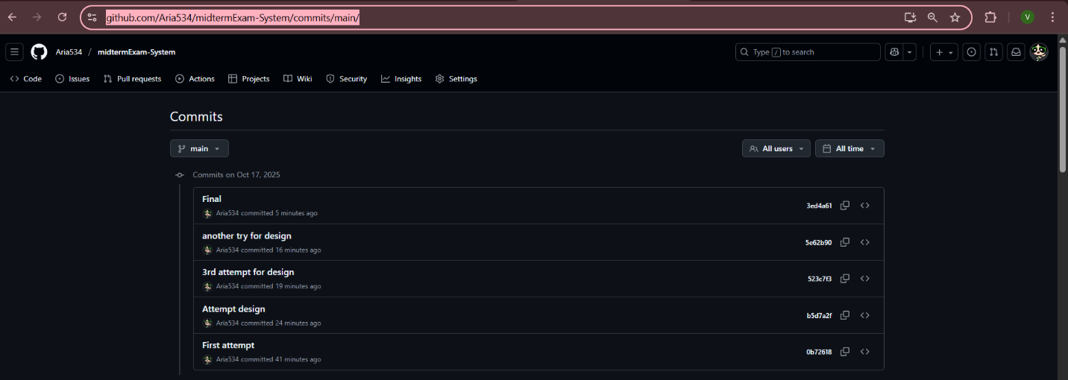
  - Successful application of the filter to route groups effectively restrict ing access. (10 pts)

https://github.com/Aria534/midtermExam-System/commits/main/

