**Aria Javani**

**9725303**

**1:**

$0.5≤1-\left(\frac{365-1}{365}\right)\left(\frac{365-2}{365}\right)…\left(\frac{365-n}{365}\right)→n=23→number of students=24$

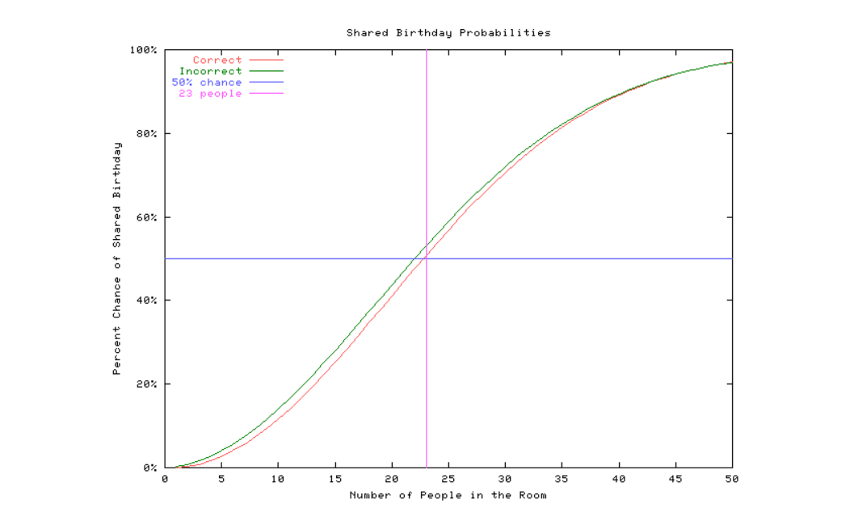

$P\left(at least one collision\right)=1-\left(\frac{N-1}{N}\right)\left(\frac{N-2}{N}\right)…(\frac{N-K+1}{N})$

$P\left(at least one collision\right)=1-\left(\frac{2^{n}-1}{2^{n}}\right)\left(\frac{2^{n}-2}{2^{n}}\right)…\left(\frac{2^{n}-r}{2^{n}}\right)=1-\left(1-\frac{1}{2^{n}}\right)\left(1-\frac{2}{2^{n}}\right)…\left(1-\frac{r}{2^{n}}\right)≈1-\left(e^{-\frac{1}{2^{n}}}\right)\left(e^{-\frac{2}{2^{n}}}\right)…\left(e^{-\frac{r}{2^{n}}}\right)=1-e^{-\frac{1+2+…+r}{2^{n}}}=1-e^{-\frac{r\left(r+1\right)}{2^{n+1}}}→0.5=e^{-\frac{r\left(r+1\right)}{2^{n+1}}}→\ln\left(2\right)=\frac{r\left(r+1\right)}{2^{n+1}}→r^{2}+r-\ln\left(2\right).2^{n+1}=0→{\left(random numbers-1\right)}^{2}+{\left(random numbers)-1\right)}^{}-\ln\left(2\right).2^{n+1}=0→random numbers=\frac{-1±\sqrt{1+{\ln\left(2\right)2}^{n+3}}}{2}+1=\frac{1+\sqrt{1+{\ln\left(2\right)2}^{n+3}}}{2}$

**2:**

$ϵ=0.5$:

64-bit : $\frac{1+\sqrt{1+{\ln\left(2\right)2}^{64+3}}}{2}≈2^{32}.2ln⁡(2)$

128-bit : $\frac{1+\sqrt{1+{\ln\left(2\right)2}^{128+3}}}{2}≈2^{65}.2ln⁡(2)$

160-bit : $\frac{1+\sqrt{1+{\ln\left(2\right)2}^{160+3}}}{2}≈2^{80}.2ln⁡(2)$

$ϵ=0.1$:

64-bit : $\frac{1+\sqrt{1+{\ln\left(\frac{10}{9}\right)2}^{64+3}}}{2}≈2^{32}.2ln⁡(\frac{10}{9})$

128-bit : $\frac{1+\sqrt{1+{\ln\left(\frac{10}{9}\right)2}^{128+3}}}{2}≈2^{65}.2ln⁡(\frac{10}{9})$

160-bit : $\frac{1+\sqrt{1+{\ln\left(\frac{10}{9}\right)2}^{160+3}}}{2}2^{80}.2ln⁡(\frac{10}{9})$

**3.1:**

Depending on how great P is, it can be collision resistant or not.

**3.2:**

Since there is no straight and feasible way to compute input having he output, we have to check every number to invert an ouput thus this function is considered as a one way function.

**4:**

**4.1:**

Since the attacker knows $x$ and $H(x)$ is also available, he can easily reverse the sum by this property: $a=b⊕c→c=a⊕b$ and thus find the key. After acquiring the key he can easily encrypt his own text($x'$).

With OTP is the find the key too, though he has to do it every time.

**4.2:**

It’s not possible. We can’t compute the $MAC_{k_{2}}$ without knowing its key, so we can’t neither find the whole key(unless the random generator of key stream is too short) nor encrypt our text.

**5:**

**6.1:**

$total data={10}^{6}\frac{bit}{s}.\left(2h×60min×60s\right)s=72×{10}^{8}bit=0.9Gbyte$

It’s a reasonable amount of data to store.

**6.2:**

$total count of keys attacker can find in a month=30×24×\frac{60}{10}=4320$

so in order to prevent the attacker from complete decryption before one month we have to use this many key in the duration of the movie(2h) $key generation rate=\frac{4320}{2×60×60}=0.6\frac{key}{s}→one key every 1.6s$

**7:**