**Aria Javani**

**9725303**

**1.**

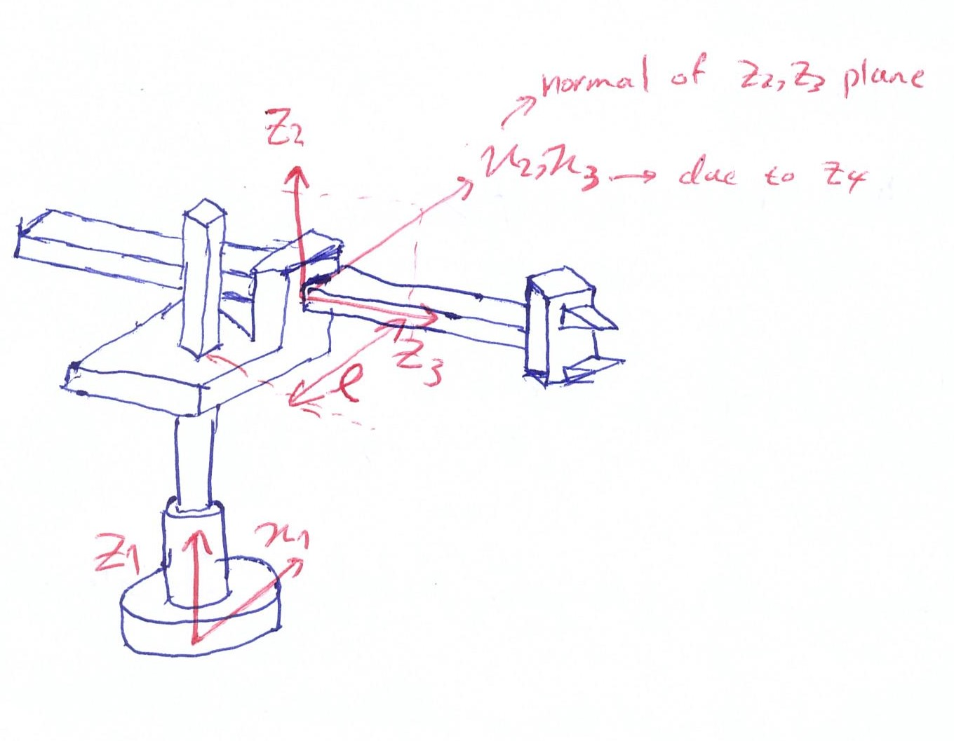

|  |  |  |  |  |
| --- | --- | --- | --- | --- |
| i | $$α_{i-1}$$ | $$a_{i-1}$$ | $$d_{i}$$ | $$θ_{i}$$ |
| 1 | 0 | 0 | 0 | $$θ_{1}$$ |
| 2 | 0 | $$l$$ | $$d_{2}$$ | 0 |
| 3 | $$90°$$ | 0 | $$d_{3}$$ | 0 |

$${}_{3}^{0}{T :wrist to origin transformation}$$

$${}_{3}^{0}{T={}_{1}^{0}T{}_{2}^{1}T{}_{3}^{2}T}$$

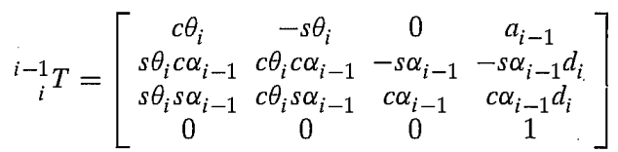

$${}_{1}^{0}T=\left[\begin{matrix}\cos{θ_{1}} & -sin{θ_{1}} & 0 & 0 \\ \sin{θ_{1}} & \cos{θ_{1}} & 0 & 0 \\ 0 & 0 & 1 & 0 \\ 0 & 0 & 0 & 1\end{matrix}\right]$$

$${}_{2}^{1}T=\left[\begin{matrix}1 & 0 & 0 & l \\ 0 & 1 & 0 & 0 \\ 0 & 0 & 1 & d_{2} \\ 0 & 0 & 0 & 1\end{matrix}\right]$$

$${}_{3}^{2}T=\left[\begin{matrix}1 & 0 & 0 & 0 \\ 0 & 0 & -1 & -d_{3} \\ 0 & 1 & 0 & 0 \\ 0 & 0 & 0 & 1\end{matrix}\right]$$

$${}_{3}^{1}T=\left[\begin{matrix}1 & 0 & 0 & l \\ 0 & 0 & -1 & -d_{3} \\ 0 & 1 & 0 & d_{2} \\ 0 & 0 & 0 & 1\end{matrix}\right]$$

$${}_{3}^{0}T=\left[\begin{matrix}\cos{θ_{1}} & 0 & \sin{θ_{1}} & l\cos{θ_{1}+d_{3}\sin{θ_{1}}} \\ \sin{θ_{1}} & 0 & -\cos{θ_{1}} & l\sin{θ_{1}}-d_{3}\cos{θ_{1}} \\ 0 & 1 & 0 & d_{2} \\ 0 & 0 & 0 & 1\end{matrix}\right]$$