**Aria Javani**

**9725303**

**1.** webots file has been attached.

**2.**

Reachable workspace is a disc of radius $l$ (maximum length that robot arm can be extended to). Dextrous workspace is only one point (at the center of Reachable disc).

**3.**

Subspace is a plane with $z=0$. workspace is a disc which mentioned in the previous part. The subspace considering having $x,y$ relative to the base frame ${}_{2}^{0}{T=}\left[\begin{matrix}\frac{y}{\sqrt{x^{2}+y^{2}}} & 0 & \frac{x}{\sqrt{x^{2}+y^{2}}} & x \\ \frac{-x}{\sqrt{x^{2}+y^{2}}} & 0 & \frac{y}{\sqrt{x^{2}+y^{2}}} & y \\ 0 & -1 & 0 & 0 \\ 0 & 0 & 0 & 1\end{matrix}\right]$

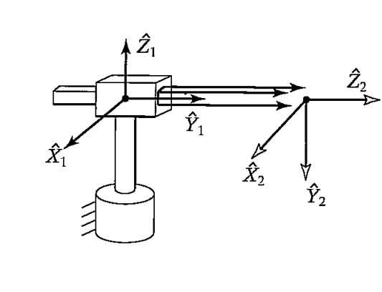

we need to find $θ$ for first joint and $r$ for the second joint (third joint is more complex and needs the orientation of target).

$$r=\sqrt{x^{2}+y^{2}}$$

$$θ=\tan^{-1}{(\frac{y}{x})}$$

**4.** Controller and robot files are attached. Explanation is given in the video.