**Stephen J. R. Smith Faculty of Engineering & Applied Science**

**MREN-372: Numerical Methods and Optimization**

LAB-01: MATLAB Based Circuit Simulator

Aria Maz | 20278460

Ahmed Iqbal | 20272366

February 7, 2024

Please find the Lab 1 Work Check-list in Figure 1.

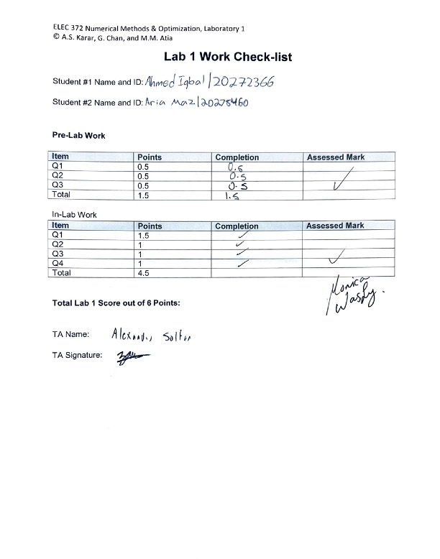

Figure 1: Checked off and signed lab 1 Work Check-list.

# Prelab)

## Question 1)

Figure 2: Netlist description for the circuit diagram.

## Question 2)

Figure 3: Matrices A, b and x solved for using the circuit element stamp method.

## Question 3)

Figure 4: System of equations solved manually to obtain the voltages at nodes 1, 2 and 3.

# MATLAB Output)

## Question 2)

>> q2

Matrix A:

0.0867 -0.0500 -0.0167

-0.0500 0.1643 -0.1000

-0.0167 -0.1000 0.1167

Vector b:

5.5000

0

-5.0000

## Question 3)

>> solveVoltages

Node Voltages:

V1 = 40.368852 V

V2 = -21.516393 V

V3 = -55.532787 V

## Question 4)

>> q4

Node Voltages:

V1 = 25.806871 V

V2 = 5.710306 V

V3 = -107.297792 V

V4 = -173.471424 V

V5 = -47.660841 V

V6 = -101.203083 V

V7 = 56.497815 V

V8 = -5.001924 V

V9 = -33.263158 V

V10 = 68.462881 V

# MATLAB Code)

## Question 1)

The function shown below is in a script named “mappNETLIST.m”, accepts some filename, and outputs the matrices A and b.

function [A, b] = mappNETLIST(filename)

% Open the file

fid = fopen(filename, 'r');

% Initialize a counter for the maximum node number

maxNode = 0;

% First pass to determine the size of matrices A and b

while ~feof(fid)

line = fgetl(fid);

tokens = strsplit(line);

% Check node numbers and update maxNode if necessary

n1 = str2double(tokens{2});

n2 = str2double(tokens{3});

if n1 > 0

maxNode = max(maxNode, n1);

end

if n2 > 0

maxNode = max(maxNode, n2);

end

end

% Close and reopen the file to reset the read position to the beginning

fclose(fid);

fid = fopen(filename, 'r');

% Initialize matrix A and vector b with the correct size

A = zeros(maxNode);

b = zeros(maxNode, 1);

% Read the file line by line and update A and b

while ~feof(fid)

line = fgetl(fid);

tokens = strsplit(line);

% Determine the type of component (Resistor or Current Source)

type = tokens{1}(1);

n1 = str2double(tokens{2});

n2 = str2double(tokens{3});

value = str2double(tokens{4});

% Update the matrices A and b based on the component type

if type == 'R'

% For resistors, update A matrix

G = 1 / value; % Conductance is the inverse of resistance

if n1 ~= 0

A(n1, n1) = A(n1, n1) + G;

end

if n2 ~= 0

A(n2, n2) = A(n2, n2) + G;

end

if n1 ~= 0 && n2 ~= 0

A(n1, n2) = A(n1, n2) - G;

A(n2, n1) = A(n2, n1) - G;

end

elseif type == 'I'

% For current sources, update b vector

if n1 ~= 0

b(n1) = b(n1) - value; % Current entering node n1, assumed negative

end

if n2 ~= 0

b(n2) = b(n2) + value; % Current leaving node n2, assumed positive

end

end

end

% Close the file

fclose(fid);

end

## Question 2)

The netlist description shown below is in a text file named “Netlist_Fig2.txt” and represents the circuit shown in Fig. 2 of the Lab-01 PDF.

R1 0 1 50

R2 1 2 20

R3 3 1 60

R4 2 0 70

R5 2 3 10

Ia 0 1 5.5

Ib 3 0 5

The script shown below is in a m-file named “q2.m”, applies the mappNETLIST function to the “Netlist_Fig2.txt” file, and outputs matrices A and b.

[A_Fig2, b_Fig2] = mappNETLIST('Netlist_Fig2.txt');

disp('Matrix A:');

disp(A_Fig2);

disp('Vector b:');

disp(b_Fig2);

## Question 3)

The script shown below is in a m-file named “solveVoltages.m”, which employs the mappNETLIST function and evaluates then outputs the unknown node voltages for the circuit in Fig. 2 of the Lab-01 PDF.

[A, b] = mappNETLIST('Netlist_Fig2.txt');

x = A\b;

disp('Node Voltages:');

fprintf('V1 = %f V\n', x(1));

fprintf('V2 = %f V\n', x(2));

fprintf('V3 = %f V\n', x(3));

## Question 4)

The script shown below is in a m-file named “q4.m”, applies the mappNETLIST function to the “Netlist_Example.txt” file (a netlist schematic for a circuit shown in Fig. 4 of the Lab-01 PDF), and evaluates then outputs the unknown node voltages.

[A, b] = mappNETLIST('Netlist_Example.txt');

node_voltages = A\b;

disp('Node Voltages:');

for i = 1:length(node_voltages)

fprintf('V%d = %f V\n', i, node_voltages(i));

end

Applying the mappNETLIST function to the netlist description formatted in a text file produces the same results as the manually calculated values for matrix A, b, and x in the prelab, as portrayed in Table 1. The manual results for matrix A are expressed as an exact value fraction and are calculated to an accuracy of two decimals but are equivalent to the MATLAB simulation output values.

Table 1: Simulated contents of matrices A and b compared with the manual calculation in the Pre-lab (Q2).

|  |  |
| --- | --- |
| Manual Calculation Values | MATLAB Output Values |
|  |  |

This lab consisted of creating a MATLAB-based circuit simulator starting from a netlist description. Through analysis of a circuit diagram, a netlist containing the components, connecting nodes, and parameter values can be created to determine node voltages through the circuit element stamp method. This requires solving a system of linear equations; hence, describing the KCL equations as a matrix is necessary. More specifically, the resistors are defined as Matrix A; current sources are defined as Vector B; node voltages are defined as Matrix X (for simplicity, only DC circuits are analyzed). Within MATLAB, a function is coded that takes in a netlist, creates the matrices, and outputs the node voltages. The group learned the advantages of using matrices, the circuit element stamp method, and simulation software for solving systems of linear equations and how they can be used in applications such as circuit analysis.