# How To Enjoy Luxury Hotel Perfectly By Analyzing Hospitality Data?

## Introduction

It’s impossible to quantify how much devastation that coronavirus has rained on the world and Hospitality has been one of those suffering the most. Speaking of booking luxury hotel, pricing must be the one cared by most of consumers.

People may already have travel plan long time before they take the annual leave. The lead time to book a room could vary based on diverse personalities. However, other than personal reasons, are you sure it’s the best time to book a room? What is the possibility that you would cancel it? In addition to pricing, what’re main difference between different hotel types?

Therefore, I used data from ***Science Direct*** to take a closer look at those topics.

The data has been described with Hotel Demand Data in article. Consisting of 2 hotel type datasets, it covers 31 variables describing the 119,390 observations, including:

Customer Arrival Date, Average Daily Rate, Lead Time, Is Canceled, Rome Type, etc.

## PART 1: How was the daily rate fluctuating during the whole year?

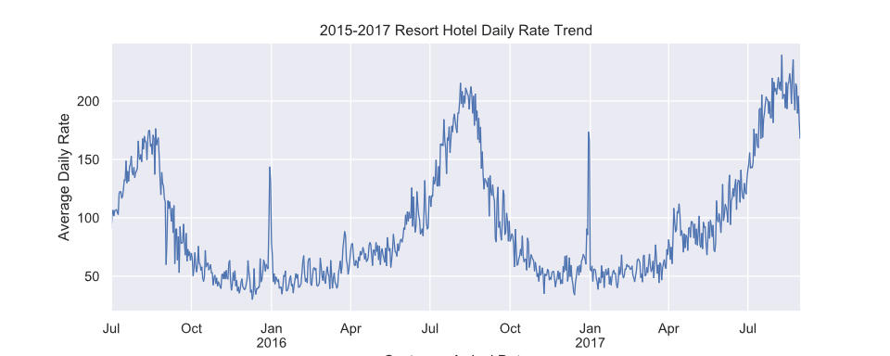

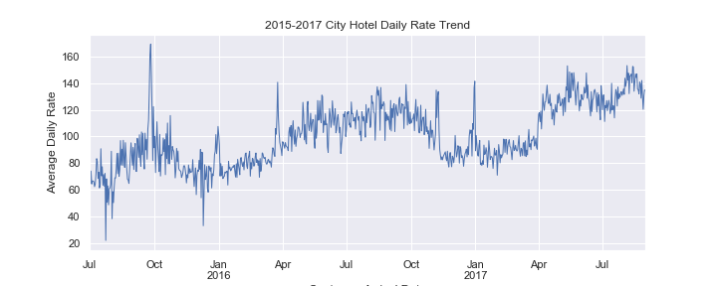

Compared to city hotel, there’s much more fun with resort hotel’s daily rate trend during the year. It varies more among different seasons. Surprisingly, the resort hotel daily rate in low season is even cheaper than booking a normal city hotel. Both hotels show some stable annual trend though different.

If you have to travel in a peak season, city hotel could be a good option; but if not, booking a resort hotel with less money is a great deal.

## PART 2: What’s the major different between two types?

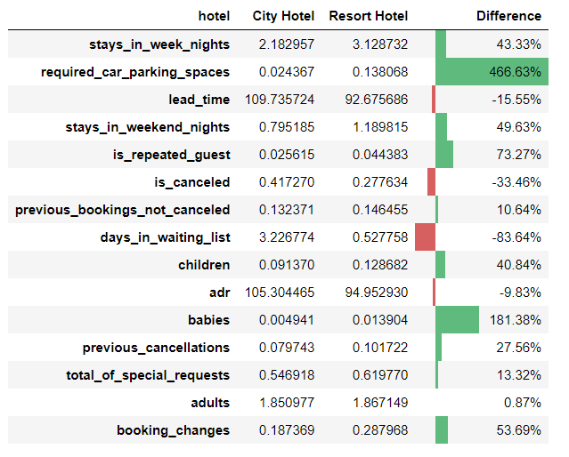

Not believing they just differ in price, I selected some topics I feel most interested to make detailed comparison between 2 types. Interestingly, it’s more common that babies show in a resort hotel! Customers have significantly more demand for parking spaces in a resort hotel, probably because most tourists rent cars for traveling. Before starting this research, I thought the majority of repeated guests should belong to city hotel since booking a resort hotel room for tourists seems like one-time activity, however, it is just the opposite.

## PART 3: How likely are you going to cancel your bookings?

The cancelation rate is up to 37%. Such a high cancelation rate intrigued me to guess the most influential factors. Then lead time, price and deposit type something in my mind at the very beginning. To get a better understanding and make data science work, I applied several supervised models to predict. After feature selection, data cleaning and model implementation including logistic regression, decision tree and random forest classifier, I chose the best-performing model to observe the key roles affecting people’s behavior.

After careful model selection by looking at prediction accuracy, I decided to move forward with random forest classifier with an accuracy score of 85%. As the feature importance results demonstrate, lead time and price are top rankings in their better performance in random forest training process, which is what I expected. Noticeably, other key factors are: number of nights of staying in week days, number of previous cancellations, month, adults, required car parking spaces, etc.

## Conclusion

In this article, we took a look at how to enjoy luxury hotels according to Hotel Demand Data from ***Science Direct***.

1. We did a completed analysis for whole year hotel rate trend for both hotel types, which showed that both hotels have an annual regular trend with different level of fluctuation. It’s a good deal to book a resort hotel in low season and a city hotel in peak season.
2. We then analyzed how different in other features between two hotels. As a result, parking space requirement, babies and days in waiting list are leading roles setting them apart.
3. Finally, we explored cancellation rate through building machine learning models and figuring out key features. We found that number of nights of staying in week days, lead time, number of previous cancellations, month, adults, required car parking spaces topped the list.