Outlook Journal Updates

We will have two Public Folders
1- Contacts Public Folder
2- Journal Public Folder
Both folders will be link to each other on Customer/Contact field.

1-Contacts Public Folder

We should have a public folder that show all Aria’s contact grouped by Customer, with ability to search by customer.
The view also should have some contact important fields such as Phone and Fax.

-Folder Updates.
For current existing Customer/Contact data we will have a Fix program that will go throw all customer and contacts in Aria27 and update the Outlook by creating a record in outlook for each customer’s contact.
Note : Before running this program, we should make sure that the data in customer.dbf and contact.dbf is correct.

Any new active customer added in Aria27, should also update the contact public folder.
In order to do this, we need to add a new field in Contact file for Entry Id (cEntryId Char (70) ) which will be our link between Aria and Outlook, this field will be updated throw the Outlook and upon saving, this field is a unique object’s Id.
Description of this field is :
When an object is saved, a MAPI system assigns it a permanent, unique, read only ID string that does not changed from one MAPI session to another.
This ID string represent in the Outlook object model as EntryId property.

The steps at which the update happened:
-Upon creating a new record in CustProf file, (in order screen).
-Upon modifying the active customer information, (in customer screen).
When the order status changed from Bid to Open in sales order screen, in addition of creating a customer profile record (see CP#101772) we will create a record in the Outlook for each Customer/Contact.
Also when the Customer’s address or name was changed in customer screen we should do the corresponding change in Outlook, based on EntryId field .

-The suggested form layout and the needed field:
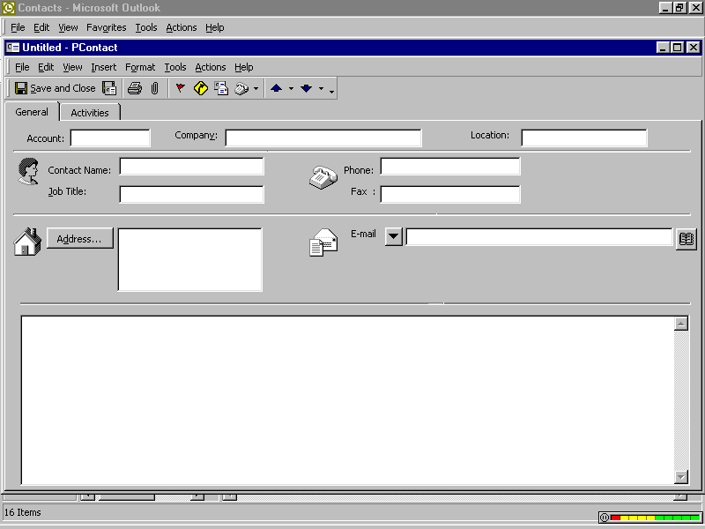

The GENERAL folder will show all important Customer/Contact information.
The ACTIVITIES folder will show all Customer/Contact journal entries.

Outlook Field | Aria Field
Account | CONTACT.Account
Company | CUSTOMER.BtName
Location (Department) | CUSTOMER.Store
Contact (Full Name) | CONTACT.Contact
Job Title | CONTACT.Title
Business Phone | CONTACT.Phone
Business Fax | CONTACT.Fax
E Mail | CONTACT.Email (new field)
Business Address | CUSTOMER.cAddress1
Business Address Street | CUSTOMER.cAddress2
Business Address City | CUSTOMER.cAddress3
Business Address State | CUSTOMER.cAddress4
Business Address Zip | CUSTOMER.cAddress5
Business Address Country | CUSTOMER.cAddress6
Notes | CONTACT.mNotes

2-Journal Public Folder
We should have a public folder for Customer/Contact journal entries (transaction), and view this journal entries grouped by Customer, also we can see this journal entries throw the Contacts folder in Activity Page in that form.

The journal types is :
1 – Proposal Journal Entry.
Journal entry type : [ Document ]
2 – Calls Journal Entry.
Journal entry type : [ Phone Call ]
3 – On-Site Visit (Training/Consulting) Journal Entry.
Journal entry type : [ Meeting ]
4 – E-Mail Journal Entry.
Journal entry type : [ E-mail message ]

We will describe each one separately next in this document.

The journal From fields
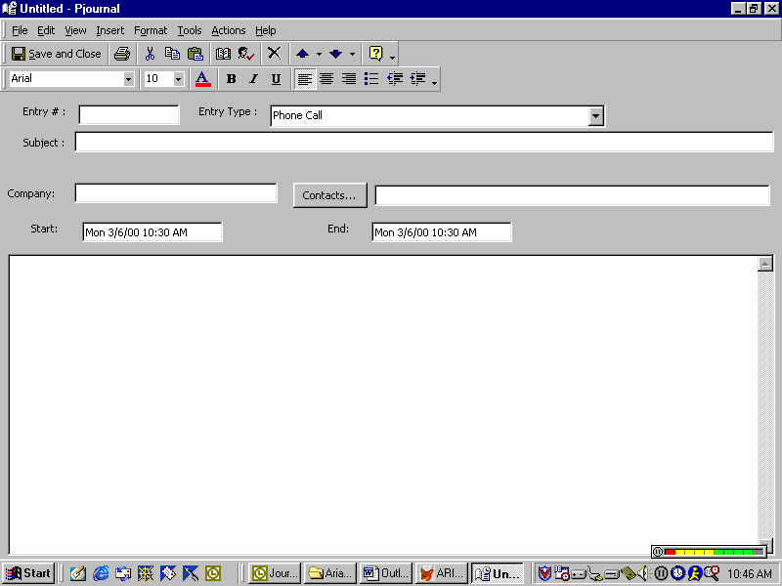

Entry Number | Journal entry number use Category field.
Entry Type | The available entry type is: [ Document ],[ Phone Call ],[ Meeting ], [ E-mail message ],[Conversation],[Fax]
Subject | Journal entry Subject
Company | Company Name
Contacts | Contacts
Start | Start date and time
End | End date and time
Notes | Journal entry notes

2.1 – Proposal Journal Entry.
Journal entry type : [ Document ]
When creating the customer profile at the step on changing the Proposal order status from Bid to Open and in addition to crating the Customer/Contact record in outlook we will create a journal entry for this Proposal (Initial or Additional service) ,

We will need a new field in ORDHDR file for EntryId , same as it described in Contact section in this document, it will be used to link the Order with the corresponding record in journal. Note that any Order (except Bid) for this customer should have a record in journal.
The entry # should contain the Order #.
The memo in journal should have the items of this proposal listed as in license agreement print form (see CP#101771) but without amounts figures.
Entry Number | ORDHDR.Order
Entry Type | [ Document ]
Subject | Word -> ‘Initial Proposal or Proposal for Additional service’
Company | Order Customer Name  (ORDHDR.Account -> CUSTOMER.BtName)
Contacts | All Customer’s Contacts separated by ‘;’
Start | ORDHDR.Start
End | ORDHDR.Complete
Notes | All Order lines (items), listed at the same layout as in Proposal Print form.

-Canceling this Order should also update the journal entry by Putting word CANCELED at the top of the journal entry Memo.
You will update the journal entry record that has the same EntryId as in the Canceled Order header record.

2.2 – Calls Journal Entry.
Journal entry type : [ Phone Call ]
We have two types of calls [Aria’s Support Calls and Call Back Request from WEB].
For Aria’s Support Calls, The calls screen should be modified by adding a process to update the Outlook by creating a corresponding journal entry.
Same should be done for Call request from web (in corresponding screen).

We will need a new field in SUCALLHD.dbf file for EntryId , same as it described in Contact section in this document, it will be used to link the Call with the corresponding record in journal, this important in case of modifying a call information so we can track a call record in outlook.
If the call is just created, then the new journal entry will be created, any modification in this call later will update the journal entry.
The important call information will update the following outlook fields,
The rest of the call information will be placed at the memo.
Entry Number | SUCALLHD. cIncdntId
Entry Type | [ Phone Call ]
Subject | Call Summary, SUCALLHD. cCalSumry
Company | Call Customer Name  (SUCALLHD. cCust_ID -> CUSTOMER.BtName)
Contacts | SUCALLHD.cCalPersn
Start | Call Open (Date + Time)
End | Call Close (Date + Time)
Notes | Rest Call information (Shown in screen)

-A physical call that any body has with any customer , should be recorded in the Public Journal folder as a Conversation Journal Type.
All previous information will be entered manually except the Entry # will be left empty and the entry type will be selected as [Conversation].

2.3 – On-Site Visit (Training/Consulting) Journal Entry.
Journal entry type : [ Meeting ]
-It should be entered by (Training/Consulting) people (created in Public Journal folder or synchronized) and he should record and describe all in journal memo field

Entry Number | Empty
Entry Type | [ Meeting ]
Subject | On-Site Visit (Training/Consulting)
Company | Customer Name
Contacts | All Customer’s Contacts separated by ‘;’
Start | Start (Date + Time)
End | End (Date + Time)
Notes | Manually will be described (Training/Consulting)
2.4 – E-Mail Journal Entry.
Journal entry type : [ E-mail message ]
Any e-mail messages that comes from or sent to customer should be recorded in the public journal folder.
The outlook should automatically take a copy from this message in public journal folder.
It will be done by adding additional code in READ method if it From customer or in REPLY and FORWARD methods if it To customer to make this process.

Once the message was read or replied or forwarded, the object method will ask you :
“Would you lick to keep a copy for this e-mail in public journal folder”,Y/N
If ‘No’ selected then nothing will be copied, but if it ‘Yes’ then, it will take the message e-mail address and search on this e-mail in our existing contacts, if it found then it will take this contact customer and show it in mover screen.
There is a (Mover) screen will appear, it will show all customer in the source and the found one in the target, if the e-mail does not found in any contact the target will be empty.
You will have two buttons in this mover screen <OK> and <Cancel> and you could not proceed with Ok without selecting at least one customer.
Note that if the method is Read and Contact found, you can do a copy without displaying a dialog message and mover.

Then the program should go throw all selected customers (in target site) and create a new journal entry for each customer as follows:

Entry Number | Aria’s Person Initials
Entry Type | [ E-mail message ]
Subject | E-mail Subject
Company | Customer Name
Contacts | If Contact was found then put this contact name, Else put all Customer’s Contacts separated by ‘;’
Start | Send (Date + Time)
End | Received (Date + Time)
Notes | An e-mail message as an attachment.

