
Development Request
Aria Systems
To access the shipment information through the
Pick ticket screen.

CP # 102782

Development Cost
Customer signature
  Date signed
Payment Terms | 50 % due upon signing.  50% due upon delivery of the project.  (No work on this project will begin until the deposit is received)
Estimated completion time

Template Header
Product: | Aria27
Module: | AL
Customer name: | Cambio
Installed Modules: | AL, AP, AR, GL, IC, PO, RM, SM, SO, SR, EB, UP, AS
Parameters setting:

Objective:
To allow viewing the shipment information (Imported from UPS) through the pick tickets screen.

Description:

We need to do a trigger-based modification in our standard pick ticket screen in order to allow the user to view the shipment information, which is imported from UPS system (refer to CP # 102424)

Currently, the shipment information imported from UPS system is updated into a file named ARUPSSHP.DBF

This table holds the information of the pick tickets that have been shipped through UPS and exported to Aria.
It has a record for each pick ticket/carton.

We will do the following modification in the pick ticket screen in order to view the shipment information updated into ARUPSSHP.DBF:

- A new field will be added to the pick ticket screen as follows:

Shipment Status : It will be either Pending OR Shipped.

To find out the status of the shipment, the program will lookup the pick ticket being inquired in the ARUPSSHP file, if the pick ticket is found, that will indicate that it has been shipped. Therefore, the shipment status will be “Shipped”

If the pick ticket doesn’t exist in ARUPSSHP file, the status will be “Pending”

- We will add a new push button to the screen which will be labeled “Shipment
Details”
If the user clicks on this button, the below screen will be displayed.

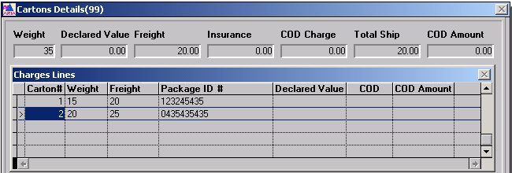

As shown above, this screen is similar to the gets displayed when clicking on the “Cartons” button located under “Charges” folder in the “Invoice sales order” screen.
The information displayed in this screen will be pulled from ARUPSSHP.DBF and will not be editable. In other words, the user will only be allowed to view this information without being able to do any modifications.
We will add a “Close” button to the above screen for the user to be able to close the screen.
The title of the above screen should be “UPS shipment details”
If the pick ticket being displayed doesn’t have records in ARUPSSHP file, the above browse screen will be empty.
The following table shows how each field in the above screen will be updated:

Added by Ash
We will not add the shipment status field to the standard Pick Ticket screen. Instead we will add an option to the pick ticket screen with a title “Shipment Information” which will open a custom screen that has both shipment status and shipment detail.

Number | Field Label | Field Meaning-Semantics | Field Format
1 | Carton # | This will show the carton #.
2 | Weight | This will show the weight of the carton. It will be pulled from ARUPSSHP.Cweight
3 | Freight | This is pulled from ARUPSSHP.Cfreight
4 | UPS Tracking # | In the above screen, the field is labeled “Package ID #”. We need to label it “UPS Tracking # “instead.
5 | Declared value | This is pulled from “Cdecl_val” field.
6 | COD | This will be pulled from “Ccod” field.
7 | COD Amount | This will be pulled from “Ccode_amt” field.
8 | Total ship | This will show the total qty of the pick ticket.

