
Development Request
Aria Systems
Pick Ticket

New Program Template Description

New Program Template

New Program Header
Product: | Aria 2.7
Module: | AL2
Customer name: | Cathy Daniels
Installed Modules: | Al2, AP2, AR2, AS2, EB2, GL2, HR2, IC2, MA2, MF2, PW2, SM2, SO2, SR2, UP2
Parameters setting:

System Setting Report:
We need to get a list of all system settings.
You can export the system settings through Aria 2.7 as follows:
Select the menu “User” then the Menu Option “Settings” then the submenu option “Export System Settings” then finally write down the file name to which settings will be saved.

Details Section
Pick Ticket Selection Grid
Screen Objective: Need to print total units to pick for multi store orders and also selection grid will give user option to print bulk for styles for single store orders.

Existing Initial situation Printing pick ticket from the output menu

Description (Processing): Cathy Daniels needs to enhance the way they currently print Pick Tickets in Aria 2.7. They will need an option to print the total style color units needed to be picked for a multi store order. They will have a total of two selection grids to choose from. The first will be the default selection grid that we are currently using. The second selection grid they can choose from will be “Multi Orders”. They need this because they want to be able to print total style color units for single store orders.

A- For the default selection gird
The selection grid will remain the same but the form layout will have these changes.
1- Should eliminate the boxes on the form because they want more then 5 style colors to be printed on the pick ticket paper.
2- All the stores will be added to the top of the pick ticket form for multi store orders. Keep in mind that there could be 100 stores in a multi store order.
3- The total bulk of units needs to be shown for each style color along with each breakdown for store
EX. (If this multi store order was for 3 stores and each store is receiving the same breakdown, then the form should show the total units (Bulk Units) and also the breakdown for each store. You can refer to the form layout that I have posted at the end of the specs.
4- The bottom part of the current pick ticket form will be removed.
EX. Were the BOL, shipvia, weight, Freight information was currently being printed.

B- New selection grid
- Option to select only one account at a time
- Transaction list to select range of orders at a time
- Option to print pick tick by line number or by style number

When doing the logic to print Bulk Units information for single store orders on the pick ticket form the program must follow this logic.

1- Separate different season groups together.
EX. Fall2001, Winter 2001, Spring 2002 orders might be in the range of orders selected. The program should separate these orders accordingly.
2- Separate the like total qty orders
EX. 96 qty, 108 qty, 72 qty total quantity orders should be separate accordingly
3- Separate by Ship Via
EX. If UPS Consignee is the ship via of some of the orders and UPS ground is the ship via of some of the orders and Peps is the ship via of some of the orders then they should be separated accordingly
4- Separate by the same size ratio
EX. S M L XL S M L XL
1 2 2 1 2 1 1 2
If the size ratio is different then those orders need to be separated accordingly
The form layout from this selection grid will be the same as the one we will be printing for default selection grid.

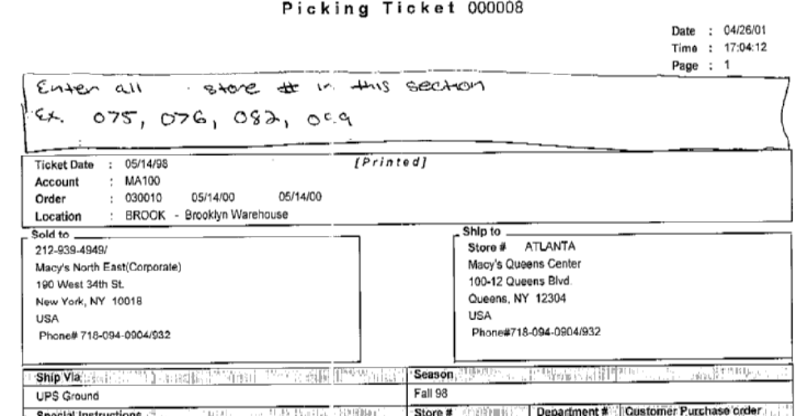
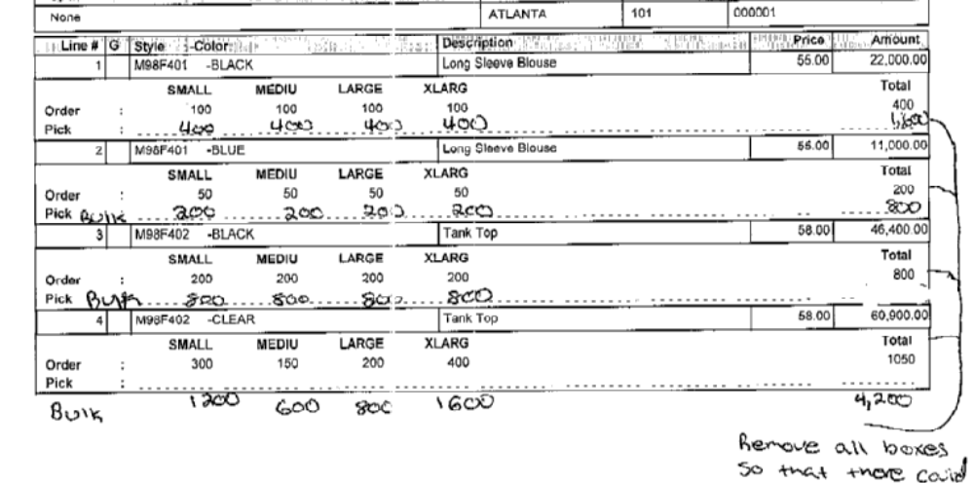
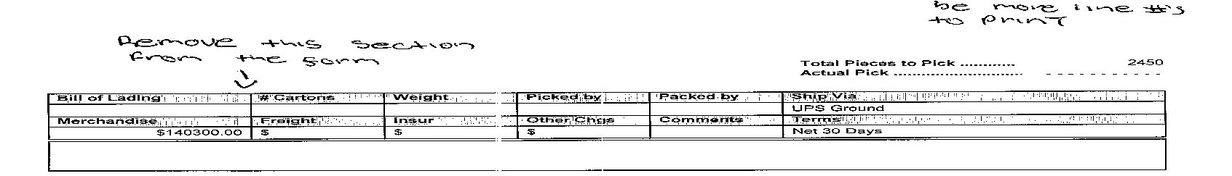

************************Modifications to Pick Ticket*****************************

--In the selection grid we will add another option for the user to select two different form layouts that they can choose to print.

--The reason for adding a new layout is because the range of the orders selected to print pick tickets for can have many different size ratio and none of the ratios may be similar to one another. So for example you may have a multi store order that the user selected to print from and none of the stores have the same total quantity and none of the stores have the same size breakdown for those styles. So in this case the user does not want to print a new sheet for all those stores. They will choose the second layout form.

- The first layout will be what the program is currently printing
- The second layout will be as follows:

  - The header will remain the same as the first layout
  - The bulk field will be removed for each style color size and placed at the end. (Will be define later on in the specs)
  - The form layout will be specific for every store number
(Example: The program will but all the styles for that store and then it will add a new header just displaying the new store number)
  - For every store it will have a new line for every Style Color displaying the Order quantity and the Picked quantity for each size. Once done displaying all the styles for that Store it will display the new store number and then display all the styles that where ordered for that style.
  - If the user selected a range of orders from the selection grid then the user will receive a new page for every new order number
  - Once done displaying all the information for every store the program is going to a new page and displaying the bulk quantity for the styles that they selected in the range of orders.
(Example: Once done displaying all the individual store quantities the program will go to a fresh page and display all the styles and the total bulk for all sizes for the range of orders.)

