
Development Request
Aria Systems
Custom Cut and Sold screen –
For Manufacturing and Importing styles

Custom Cut and Sold screen –
For Manufacturing and Importing styles

Header
Product: | ARIA 27
Module: | IC
Customer name: | Cathy Daniels
Installed Modules: | AL,AP,AR,AS,EB,GL,IC,MA,MF,PDM,PW,SM,SO,SR,UP
Parameters setting: | Set up file will be sent to IC module

Details Section
Add-in Name : Custom Cut and Sold report to include Importing styles..
Add-in Objective : We would like this custom report to show figures for Importing styles as well.

Existing Initial situation: Currently the Cut and sold report that has been customized prints figures for only Manufacturing style.

Description ( Processing ) :
- We would like the report to print the following figures in the report for the Importing style.

The Figures mentioned below, have a formulas that will apply for Importing style.
The following is the layout :

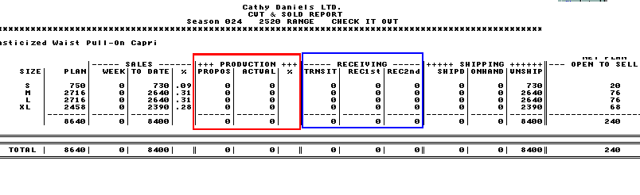
FORMULA required for the IMPORTING style described in steps.:

During Style PO creation for the style.:
PROPOS | This field should be populated with the quantity of Styles the PO’s have been created for.
ACTUAL | This field should be “0” at this time.
During Style PO SHIPMENT for the style.: (In transit stage- When they make a shipment for that style-color)
PORPOS | This field gets reduced by the quantity added to a shipment
ACTUAL | This field is added with the quantity in Shipment.
INTRANSIT | This field is added with the quantity in Shipment.
During the RECEIVING session:
PROPOS | Does not change.
ACTUAL | ACTUAL does not change in this case. It still stays the same.
INSTRANIT | This field gets reduced by the quantity in the Receiving session.
REC1ST / REC2ND | These field(s) get updated with the quantity received for that style-color

NOTE: Important thing to remember is when the user does a Receiving for that style-color, the “ACTUAL” does not reduce, but the In-transit does, and the Received quantity goes up.

Constraints ( Global ) :
This formula should apply to Importing styles, the Manufacturing styles, will still use the formula calculation as they used to

Option Grid :
In addition to the existing Option grid. We should let the user filter based on Domestic and Importing style. Since they have both Manufacturing and Style Po module. We should provide them the standard option grid seen in the Cut and Sold screen allowing user to filter Domestic and Non domestic styles.

Field | Values
Domestic / Imported | Domestic
Domestic / Imported | Imported
Domestic / Imported | Both

Development Cost
Customer signature
  Date signed
Payment Terms | 50 % due upon signing.  50% due upon delivery of the project.  (No work on this project will begin until the deposit is received)
Estimated completion time | 6 –8 weeks from the date of signing this document

As per Farrukh conversation the Actual field in case of there is receiving on the PO will be = in transit+ rec1st + rec2nd

