
Development Request
Aria Systems
Custom Invoice BOL# printout for EIL10

Custom program ID – 102549
Spec written by - Sadaf F.

Custom Invoice BOL# printout for EIL10

Program Header
Product: | Aria27
Module | AR
Customer name: | EIL10
Installed Modules: | AL,AP,AR,AS,EB,GL,IC,MA,MF,PO,RM,SM,SO,SR,UP
Parameters setting: | <None related to custom entry>

Details Section
Add-in Name : Customization to show BOL# on Invoice screen and Invoice printout

Add-in Objective :
Customization to show BOL# on – 2 places

1. The Invoice screen Charge folder.
2. Custom Invoice Printout.

Description ( Processing ) :
1. User would like the Invoice to reflect the BOL # on the Custom invoice in the following marked position. Illustrated in Fix 1.1
The Invoice Print out program should check to see any if there is any BOL# populated in the filed (INVHDR.bol_no). If so the BOL# should be printed in the illustrated area of Figure 1.1
2. Also User would like the BOL# field on the Invoice Charges screen to Populate with the same field information mentioned in point# 1.

Constraints ( Global ) :
We would need to check for Empty status of field (bol_no) in Database InvHdr.

Figure 1.1

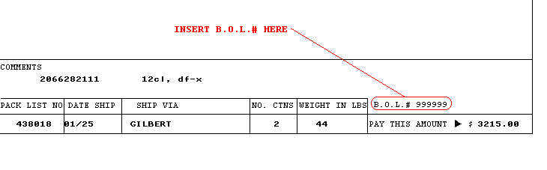

Development Cost | $420.00
Customer signature
  Date signed
Payment Terms | 50 % due upon signing.  50% due upon delivery of the project.  (No work on this project will begin until the deposit is received)
Estimated completion time | 6 –8 weeks from the date of signing this document

