
Development Request
Aria Systems
Program Add-In Template Description

Program Add-in Template Description

Program Add-in Template

Program Add-in Header
Product: | Aria 27
Module: | PO
Customer name: | Tip Top Computers
Installed Modules: | AL, AR, IC, PO, SO, SR
Parameters setting: | Multi- Warehouse

Details Section
Add-in Name : Amendments to Shipment Entry Screen .
Add-in Objective : the user needs to be able to add Second Quality items to a PO thru the shipment screen

Existing Initial situation: Shipment Entry Screen

Description ( Processing ) :

- Have a new parameter in PO Setup as follows:

“show balance of PO when entering shipments ? y/n”

if set to Yes then the system functions as standard – if set to No then when
entering a new PO Line onto a shipment – do not show the balance to left to send but have the input fields set to zero.

- When entering a Shipment Line (i.e. a PO line) – when a Style PO Line is highlighted have an option in the Options Menu – “Add second quality lines”

If this is selected then a box comes up on the screen showing the Seconds Style that is attached to the Style/Colour Line highlighted and the user can key in quantities against each size bucket. This record is then added to both the shipment and the original PO.

If no Second Style has been setup – the user should be informed and taken back to the Shipment Detail Line.

Questions 10/20/2002:
- Regarding point # A, could you please give us more detail about “do not show the balance to left to send but have the input fields set to zero”. What do you mean by balance? It would by much helpful if you send us a snapshot of the screen and highlight the balance that you are talking about.
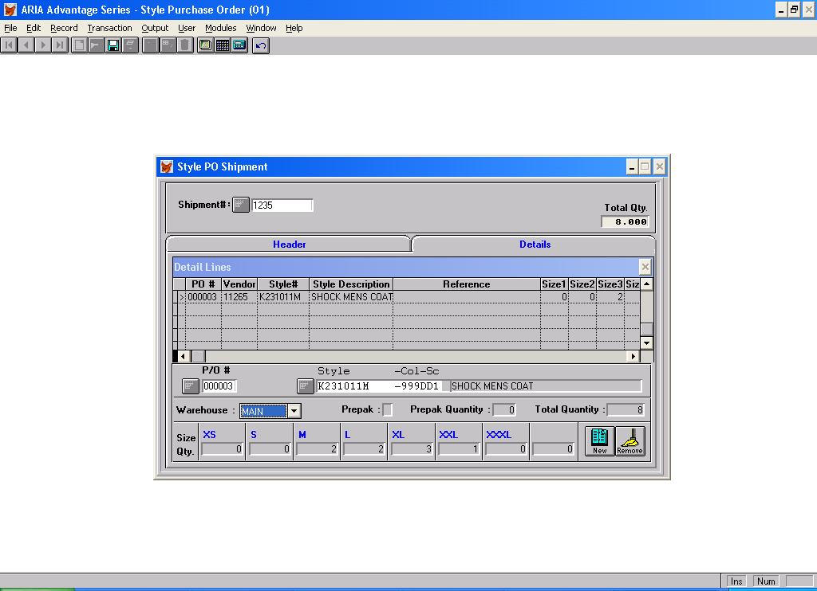

If you look at the shipment entry screen above you will see that the bottom line is:

Qty 0 0 2 2 3 1 0 0 – which is the balance on the POSLN record that is yet to be entered onto a shipment – what the client wants is this fields to be set to zero – so they have to enter all the figures.

- Regarding point # B, you mentioned “Seconds Style that is attached to the Style/Color Line highlighted”, Do you mean the link in the special folder in the style screen?

Yes this is exactly what I mean.
Also if your request is to add a second quality style to a PO that has been created for a first quality style then this will not be applicable as our system has been design to create one style quality per PO. Please clarify.

I was able to create a POSLN in Foxpro for a Second Quality Style . this then appeared in the Enter Shipment Record Browse for PO Lines and I was able to add it to the shipment – Further more I was able to go into Receive PO – Receive by Shipment – and when I selected the Second Quality style the Line Quantity Screen came up and I was able to enter the Second Quality Style into Inventory and everything updated fine. So there is no reason not to able to add a Second Quality Style at this level – the only control is the CSTYGRADE field in POSLN which can be left as value “1” - as it seems to have no effect in the system

3- What I meant is that you can add a second quality style to a PO that has been created for a second quality style You can not add a second quality style to a PO that has been created for a first quality style. Please confirm.

No – I need to add a Second Quality Style to an existing PO – as I said I was able to do this and follow this through by forcing an second quality style onto a PO that had first quality styles in Foxpro and then could process it as a shipment and then receive it into inventory through the Receive PO – Receive Shipment screen.

What I am saying is that there appears to be no logical reason in Aria for not allowing First and Second Quality styles on the same PO ? as Aria processes them perfectly once they are both on a Style PO.

- Furthermore, I have confused how the link for a second quality style will work. You have mentioned that you will link a second quality style through the style screen and this will be done for only first quality, in other words you can link a second quality style for a first quality style. Could you please explain this part with an example.

I do not understand the question and if the answer to the first point 3) is OK then seems irrelevant

