Software Specifications Document (SSD)
Add the Inventory Declaration Screen to the EDI Enhancement

Profile
Title | Add Inventory Declaration to EDI
Tracking #
Product Line | 2.7, 4XP
Module(s) | EDI
Entity Type (Screen/Report) | SCREEN
Entity(s) | Inventory Declarations
Customer
Date Created | 07 / 04 / 2005
Author | TWY
Date Edited | 07 / 03 / 2005
Editor | TWY
Analysis | Approved By | TWY
Analysis | Approval Date | MM / DD / YYYY
Conceptual Design | Approved By | TWY
Conceptual Design | Approval Date | MM / DD / YYYY
Detailed Design | Approved By | TWY
Detailed Design | Approval Date | MM / DD / YYYY

Table of Contents
Profile 1
Table of Contents 2
Document Sections 3
Versions 3
Vision 4
Stakeholders 4
Needs 5
CFN – Customer Functional Needs 5
CTC – Customer Technical Needs 5
AFN – Aria Functional Needs 5
ATC – Aria Technical Needs 5
ATT – Aria Testing Needs 5
AMT – Aria Marketing Needs 5
ADT – Aria Documentation Needs 5
AST – Aria Supplementary Needs 5
Project Scope 5
1. In/Out Domains 5
2. Project Phases 5
Entity Features 6
User Interface (UI) 6
Option Grid 6
Use Cases 6
UI Rules 7
Option Grid Rules 7
Application Tier 8
Database Design 9
Testing Cases 9

Document Sections
Section | Included?
Analysis
Vision
Stakeholders
Needs *
Customer Functional Needs
Customer Technical Needs
Aria Functional Needs
Aria Technical Needs
Aria Testing Needs
Aria Marketing Needs
Aria Documentation Needs
Supplementary Needs
Project Scope
Conceptual Design
Entity Features | Yes
User Interface (UI)
Option Grid
Use Cases
Detailed Design
UI Rules
Option Grid Rules
Application Tier
Database Design
Testing Cases
* At least one of the two functional needs sections must be filled.

Versions
Ver # | Date | Modified By | Sections Change Tracking
Ver # | Date | Modified By | New | Deleted | Changed
0.1 | MM/DD/YYYY

Vision
- To let the user to make the inventory Declartion within the EDI module
- To include the Inventory Declaration into EDI

Stakeholders
Role | Category | Description | Comments
UK Branch | Partner

* The category can be one of the following:
- User
- Sponsor
- Customer
- Partner
- Other

Needs

CFN – Customer Functional Needs

- The inventory declaration report first
- User makes selection then run and it creates the Ma3 file
- this is the file that they are sending at the moment thru the KEWILL EDI system
- They need to have two more criteria added to the selection grid
- the file to be sent as it is, no need another modifications
“NICKDELL: no modifications I don’t think”
- The Actual needs is to generate this kind of files from the EDI module
- This transaction is for a specific trading partner Marks and Spencer

The following changes will be in the Screen of the Inventory Declaration
As Said “NICKDELL: can we have the criteria to select styles, season series and purchasing groups in EDI”

Notice that the Arai ERP application and the EDI are intergraded

“NICKDELL: how are you getting on with the picking ticket? “

AHZ: now show me the related info for the pick ticket
NICKDELL: 200572 was the recieummary picking ticket
Issue# 200568 was the availability report according to my spread sheet

- Style created
- ORDER taken
- P.O. to factory
- Receive some of the PO
- Send inventory declaration file to say how h stock in warehouse
- Receive picking tickets from MARKS AND SPENCER
- Pick stock
- Send ETOS file to MARKS AND SPENCR 3rd party warehouse
- Invoice picking ticket
NICKDELL said: “that is the cycle”
NICKDELL: The sending of the declaration onwards may happen 30 time to 1 style
NICKDELL: as MARKS AND SPENCER call off goods 3 times a week

ETOS File Definition
ETOS File is a file to tell MARKS AND SPENCERS warehouse what is being delivered so that they can prepare the warehouse

CTC – Customer Technical Needs

The Customer need to generate a file for MARK AND SPENCER *.MS3

This will use the .MS3 layout file as per the notes and sample attached. The MS3 file always has 5 header records - Y50, TYP, SDT, CDT and FIL which can be ignored.

The next record has the heading ORD – if this is set to 0000 – search for the next ORD record.

The ORD record is followed by a PLD record which holds the following:

Position 10-17 holds the style SKU number – which relates back to the SPCK_LIN.SKU field – you will have to create another key in this file (TYPE + ACCOUNT + SKU) in order to link.

Position 25-30 holds the number to be used as the Aria Picking Ticket No – Use the System Date as the Picking Ticket Date. Ignore the PIC records and the quantity picked can be found in position 23-32 of the PTR record.

In order to find the Sales Order to update you take the SKU number to find the Style and then find the earliest Sales Order that has open quantities for that SKU and use it. If the total picked is greater than the quantity open on that order and there is another order with an open quantity for that SKU – then put the balance to that order. If no more orders are available then over allocate on the order that has an open qty and increase the Order – OPEN and BOOKED.AFN – Aria Functional Needs
[Write Aria functional needs here, if any. Otherwise omit this section]

ATC – Aria Technical Needs
[Write Aria technical needs here, if any. Otherwise omit this section]

ATT – Aria Testing Needs
[Write Aria Testing needs under the following subsections, if any. Otherwise omit this section]

- Performance Standards
- Usability Measures
- Integration Testing

AMT – Aria Marketing Needs
[Write Aria Marketing needs here, if any. Otherwise omit this section]

ADT – Aria Documentation Needs
[Write Aria Documentation needs here, if any. Otherwise omit this section]

AST – Aria Supplementary Needs
[Write Aria Supplementary needs here, if any. Otherwise omit this section]

Project Scope

In/Out Domains
- This Project concerning on an add-in module to let the customer of UK “LOW” to let EDI support the *.MS3 file from MARK & SPENCER

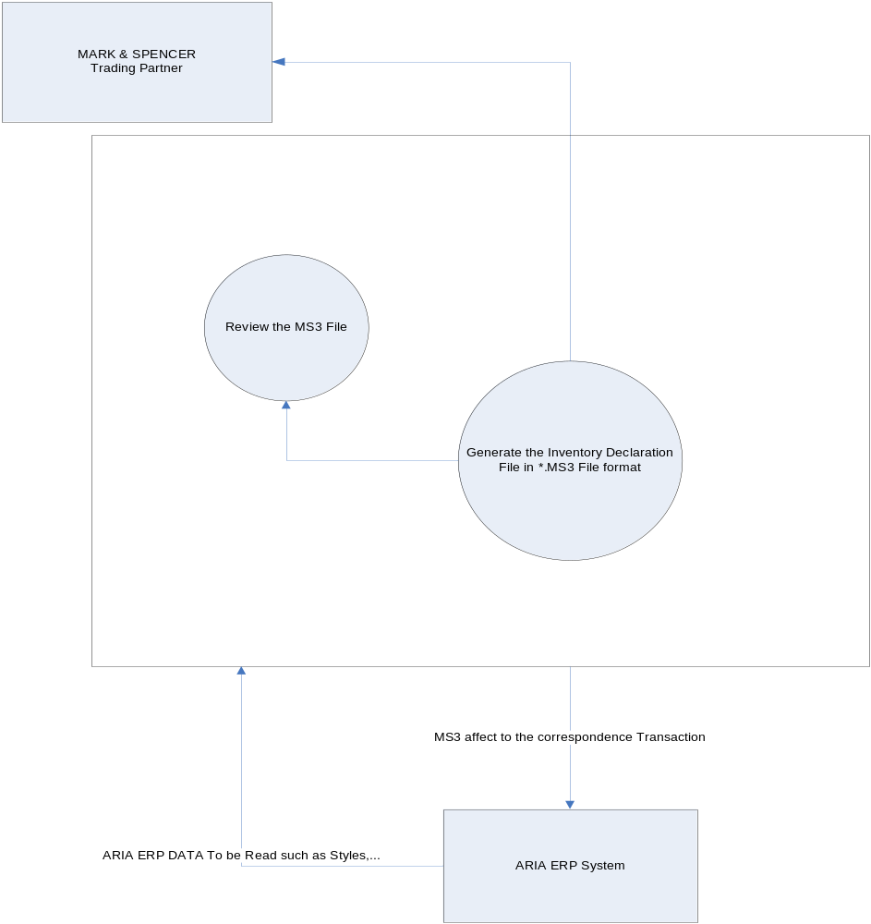

Project Phases
This project has a special Characteristics that the Customer needs already developed in an old version of FOXPRO 2.6 that based on the non visual development environment so we have the following phases:

- Study the current situation in the Custom program of Inventory Declaration
- Write down the Structure of the Code we need in

Entity Features
[Write the required system features here. This section must explain in details any modifications required based on the needs given above.]

User Interface (UI)

___________________________________________________________________

Choose a Path

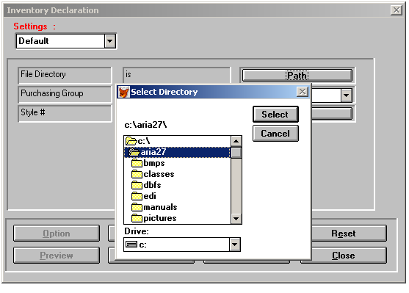

___________________________________________________________________

___________________________________________________________________
Choose the Purchasing Group

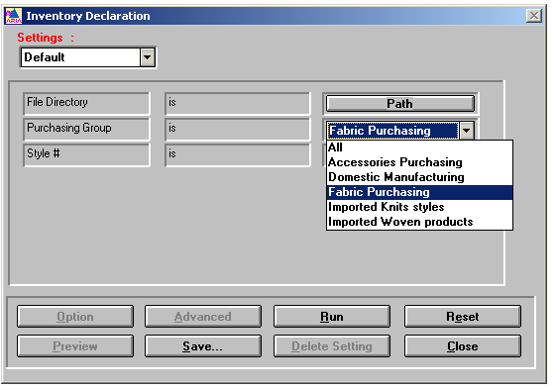
___________________________________________________________________

Select a Style or List of Styles

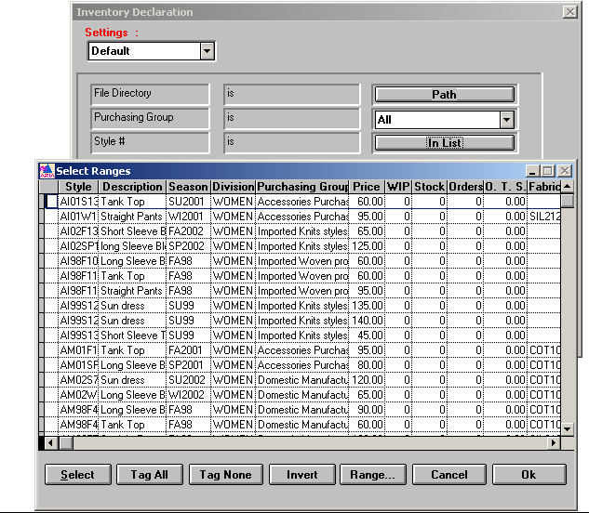

User needs the following:
“the criteria to select styles, season series and purchasing groups in EDI“
Example of Inventory Declaration File generated using Aria 2.7 Custom Program

X5012068035505 AVLHDR NT57 0776850 050330111303
TYP 2000 AVLHDR
SDT T57 07768
CDT 4151
FIL 1 1 050330
ARF 10405 050330 050330
AVD 1 0106400828 1 0 0 0
AVD 2 0106400842 1 0 0 0
AVD 3 0106400873 1 0 0 0
AVD 4 0106400903 1 0 0 0
AVD 5 0106400934 1 0 0 0
AVD 6 0106400965 1 0 0 0
AVD 7 0106400835 1 0 0 0
AVD 8 0106400866 1 0 0 0
AVD 9 0106400897 1 0 0 0
AVD 10 0106400927 1 0 0 0
AVD 11 0106400958 1 0 0 0
AVD 12 0106400989 1 0 0 0
AVD 13 0106400996 1 0 0 0
AVD 14 0106400859 1 0 0 0
AVD 15 0106400880 1 0 0 0
AVD 16 0106400910 1 0 0 0
AVD 17 0106400941 1 0 0 0
AVD 18 0106400972 1 0 0 0
AVD 19 0105805525 1 0 0 0
AVD 20 0105805549 1 0 0 0
AVD 21 0105805570 1 0 0 0
AVD 22 0105805600 1 0 0 0
AVD 23 0105805631 1 0 0 0
AVD 24 0105805662 1 0 0 0
AVD 25 0105805532 1 0 0 0
AVD 26 0105805563 1 0 0 0
AVD 27 0105805594 1 0 0 0
AVD 28 0105805624 1 0 0 0
AVD 29 0105805655 1 0 0 0
AVD 30 0105805686 1 0 0 0
AVD 31 0105805693 1 0 0 0
AVD 32 0105805556 1 0 0 0
AVD 33 0105805587 1 0 0 0
AVD 34 0105805617 1 0 0 0
AVD 35 0105805648 1 0 0 0
AVD 36 0105805679 1 0 0 0
AVD 37 0103605615 1 0 0 0
AVD 38 0103605639 1 0 0 0
AVD 39 0103605660 1 0 0 0
AVD 40 0103605691 1 0 0 0
AVD 41 0103605721 1 0 0 0
AVD 42 0103605752 1 0 0 0
AVD 43 0103605622 1 0 0 0
AVD 44 0103605653 1 0 0 0
AVD 45 0103605684 1 0 0 0
AVD 46 0103605714 1 0 0 0
AVD 47 0103605745 1 0 0 0
AVD 48 0103605776 1 100 0 0
AVD 49 0103605783 1 0 0 0
AVD 50 0103605646 1 0 0 0
AVD 51 0103605677 1 0 0 0
AVD 52 0103605707 1 0 0 0
AVD 53 0103605738 1 0 0 0
AVD 54 0103605769 1 0 0 0
AVD 55 0105805341 1 0 0 0
AVD 56 0105805365 1 0 0 0
AVD 57 0105805396 1 0 0 0
AVD 58 0105805426 1 0 0 0
AVD 59 0105805457 1 0 0 0
AVD 60 0105805488 1 0 0 0
AVD 61 0105805358 1 0 0 0
AVD 62 0105805389 1 0 0 0
AVD 63 0105805419 1 0 0 0
AVD 64 0105805440 1 0 0 0
AVD 65 0105805471 1 0 0 0
AVD 66 0105805501 1 0 0 0
AVD 67 0105805518 1 0 0 0
AVD 68 0105805372 1 0 0 0
AVD 69 0105805402 1 0 0 0
AVD 70 0105805433 1 0 0 0
AVD 71 0105805464 1 0 0 0
AVD 72 0105805495 1 0 0 0
AVD 73 0106400644 1 0 0 0
AVD 74 0106400668 1 0 0 0
AVD 75 0106400699 1 0 0 0
AVD 76 0106400729 1 0 0 0
AVD 77 0106400750 1 0 0 0
AVD 78 0106400781 1 0 0 0
AVD 79 0106400651 1 0 0 0
AVD 80 0106400682 1 0 0 0
AVD 81 0106400712 1 0 0 0
AVD 82 0106400743 1 0 0 0
AVD 83 0106400774 1 0 0 0
AVD 84 0106400804 1 0 0 0
AVD 85 0106400811 1 0 0 0
AVD 86 0106400675 1 0 0 0
AVD 87 0106400705 1 0 0 0
AVD 88 0106400736 1 0 0 0
AVD 89 0106400767 1 0 0 0
AVD 90 0106400798 1 0 0 0
ATR 90 100 0 0
AFT 1

This file is the Inventory declaration report that is created by Aria Custom Program

Example of Pickticket

STX=ANA:1+5012068015509+5012068015509+000214:151533+NT20 11498093+EEEEEEEE+PICHDR' MHD=1+PICHDR:3'
TYP=1000+PICHDR'
SDT=:0114980'
CDT=:4151'
FIL=1+3+000209'
MTR=6'
MHD=2+PICKER:3'
ORD=0000'
PLD=1+:02211558+++0+073'
PIC=1+1+:9987++++0'
PIC=1+2+:9990++++0'
PTR=1+2+0'
MTR=7'
MHD=3+PICKER:3'
ORD=0000'
PLD=1+:03925553+++0+073'
PIC=1+1+:9987++++128'
PIC=1+2+:9990++++1320'
PTR=1+2+1448'
MTR=7'
MHD=4+PICKER:3'
ORD=0000'
PLD=1+:04319474+++0+073'
PIC=1+1+:9987++++12235'
PIC=1+2+:9990++++4250'
PTR=1+2+16485'
MTR=7'
MHD=5+PICKER:3'
ORD=0000'
PLD=1+:05667390+++0+073'
PIC=1+1+:9987++++240'
PIC=1+2+:9990++++1788'
PTR=1+2+2028'
MTR=7'
MHD=6+PICKER:3'
ORD=0000'
PLD=1+:05667406+++0+073'
PIC=1+1+:9987++++43'
PIC=1+2+:9990++++5440'
PTR=1+2+5483'
MTR=7'
MHD=7+PICKER:3'
ORD=0000'
PLD=1+:08113276+++0+073'
PIC=1+1+:9987++++65'
PIC=1+2+:9990++++5832'
PTR=1+2+5897'
MTR=7'
MHD=8+PICKER:3'
ORD=0000'
PLD=1+:08267856+++0+073'
PIC=1+1+:9987++++3080'
PIC=1+2+:9990++++4044'
PTR=1+2+7124'
MTR=7'
MHD=9+PICKER:3'
ORD=0000'
PLD=1+:08853639+++0+073'
PIC=1+1+:9987++++671'
PIC=1+2+:9990++++1558'
PTR=1+2+2229'MTR=7'
MHD=10+PICKER:3'
ORD=0000'
PLD=1+:08853707+++0+073'
PIC=1+1+:9987++++332'
PIC=1+2+:9990++++5092'
PTR=1+2+5424'
MTR=7'
MHD=11+PICTRL:1'
PFT=9'
MTR=3'
END=11'¬¬¬¬¬¬¬¬¬¬¬¬¬¬¬¬¬¬¬¬¬¬¬¬¬

___________________________________________________________________

Option Grid
# | Item | Operator | Value

Use Cases
Scenario | Step # | Description | # | User Actions | System Action
 | 1 |  | 1
 |  |  | 2
 |  |  | 3
 | 2 |  | 1
 |  |  | 2
 |  |  | 3

UI Rules
Ser. | Screen Object | Attribute | Value
1 |  | Description
 |  | Control Type
 |  | Source
 |  | Caption
 |  | Visible | [default is True]
 |  | Enabled | [default is True]
 |  | Mandatory | [default is False]
 |  | Tab Sequence
 |  | Default Value
 |  | List of Values (LOV) | [usually by having a list button that calls a lookup file]
 |  | Validations
 |  | Post-Object Processing | [Actions to be done with a certain event (button pressed, field exited, list option selected…etc)]
 |  | … | [Add any additional attributes you need]
2

Option Grid Rules
Ser. | Grid Item | Attribute | Value
1 |  | Description
 |  | Control Type
 |  | Default Value
 |  | Action
 |  | Source
 |  | Browse fields
 |  | Validations
 |  | Suppress condition
2

Application Tier
ICINVDC.PRG Structure
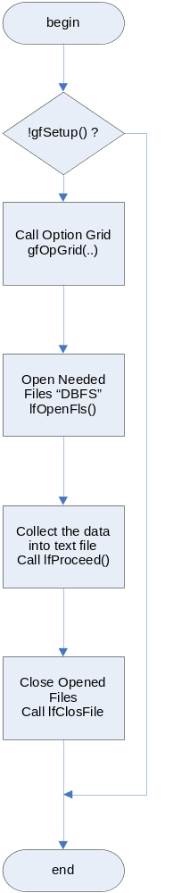

ALIMPLW.PRG

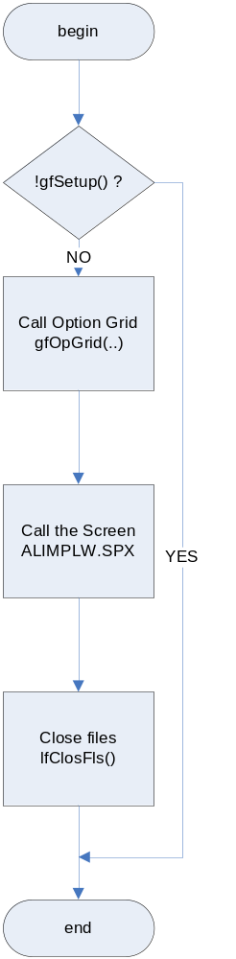

- Class Description

- Class Responsibilities

- Relationships with Other Classes:

Related Class | Relation  (Based on/ Depends On/ Uses)
- Special Requirements

- Class Interface (Properties/Controls/Methods/Events)
Properties:
# | Name | Description | Data Type
Class Controls:
# | Control Name | Description | Init Properties
Methods:
# | Name |  |  | Description
1
 | Method Signature
 | Parameters |  |  |  |  |  | Return
 | # | Name | Description |  | Opt? | Default | Value | Condition
2
 | Method Signature
 | Parameters |  |  |  |  |  | Return
 | # | Name | Description |  | Opt? | Default | Value | Condition
Events:
# | Control Name | Control Event | Action

Database Design
[Describe the system database modifications here, if any. Otherwise omit this section.]

Testing Cases
Test Setup:

# | Test Settings
1
2

Test Cases:

Test | Repeat by Setting?  (Y/N) | Test Actions | Test Results | OK?  (Y/N)

