
Development Request
Aria Systems
Changes on the P/O program

Custom Program # 102225:

Changes on the P/O program

New Program Template

New Program Header
Product: | Aria27 – state the product name.
Module: | PO
Customer name: | GMA
Installed Modules: | All Aria Modules except PS
Parameters setting: | Single Currency, multi warehouse

System Setting Report:
No need for these settings.

Details Section
Description (Processing):

We will add a new trigger for GMA in the P/O program to do the following:
- In the detail folder add a new bar in the option menu to edit the pack’s fields for the current P/O line. (The user defined fields that we added before in CP # 102223)
- If the user select to edit them we will open a new screen that contains 5 user defined fields defaulted from the style file, this fields are:
- Inner Pack
- Master Pack
- Length
- Depth
- Width
- Master Pack Cube (Length*Depth*Width/1728)
- Master Pack Weight
The user can modify these fields, if he/she didn’t modify this fields or even didn’t open this screen, the program will update the POSLN file with the same values from the style file.
The new screen will be as follows:

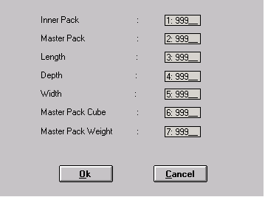

Customer Approval: ___________________ Date: _________

Cost : $ 1500.00
Estimated time : 8 weeks from signing the specs

