
Development Request
Aria Systems
Custom Pick Ticket Form

CP #: 102261

Custom P/T Form

Report Template

Template Header
Product: | Aria27
Module: | AL
Customer name: | GMA.
Installed Modules: | All Aria modules except PS.
Parameters setting : | Single Currency

Report Details
Report Name: P/T form
Report Objective ( Purpose ):
To print the data of the Pick Tickets.

Description:
The form will print some P/T data as clarified in the layout.
The form will be a Laser/Landscape form; each P/T will have 2 copies.
Each P/T contains of several packs. So the P/T will print by pack, i.e. :
Pack_Id 1 style1 Size1
Size2
Style2

Pack_Id 2 style1
Style2
Style3

We will print at the footer of the last page of each Pick ticket the order’s notepad and some boxes that will be filled manually, which is:
- PICK
- CHECK
- WHS
- LABELS
- CARTONS
- FREIGHT
- BOL #
- MISC $
- INSUR $
- OTHERS $

Report Layout

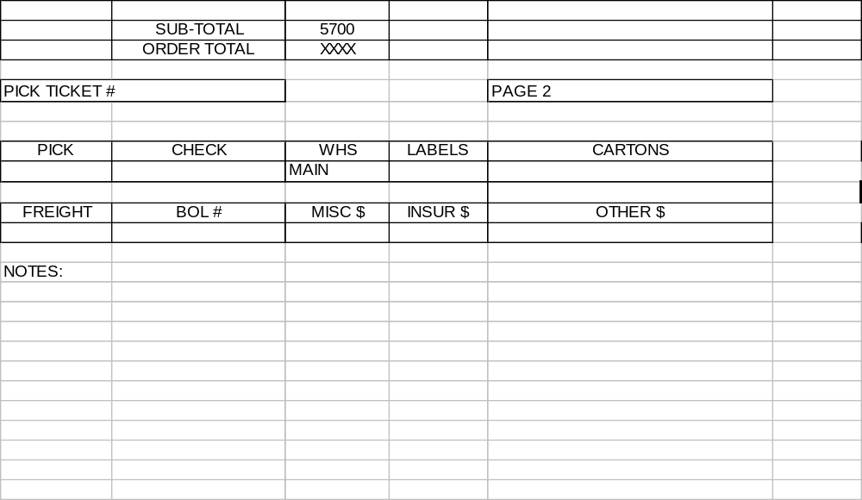

Layout Description
Number | Field Label | Field Meaning-Semantics | Field Format
1 | PICK TICKET # | P/T # | C(6)
2 | Ship To | Customer Ship to Address | C
3 | Bill To | Customer name & Bill to address | C
4 | Date | Date of printing (Today) | Date
5 | Bar code | The Bar Code number of the P/T
6 | Start Date | Order Start date | Date
7 | Cancel Date | Order Completion date | Date
8 | IN STORE/DC DATE | If the customer’s priority = ‘1’ then print the completion date else leave it empty. | Date
9 | Date | Printed date | Date
10 | Customer PO# | Customer P/O # | C(10)
11 | Confirmation # | Order # | C(6)
12 | Bulk # | Bulk order # (OrdHdr.cFromOrder) | C(6)
13 | Dept # | Department no. | C(5)
14 | Comments | Order note1+note2 | C(40)
15 | Terms | Terms description | C(10)
16 | Store # | Store | C(10)
17 | Season | Hard coded “YEAR AROUND” | C(11)
18 | ROUTING INSTRUCTIONS | ShipVia code | C(6)
19 | Pack #/SKU # | Pack_Id, or style sku # | C(6)
20 | PRE-PACK | Xx1 packs of xx2 pieces, will be computed as follows :  Xx1=Units/no of pieces per pack  Xx2= no of pieces per pack | C(20)
21 | UNITS | Style size qty | N(6)
22 | Style # | Style code | C(12)
23 | Description | Style descritpion | C(30)
24 | Color | Style/color | C(6)
25 | PCS PER PK | Pieces per pack per style | C(2)
26 | QTY | No. of packs * pcs per pk | C(6)
27 | Size | Qty per size ( It will be empty if the style has only one size) | C(6)
28 | Units Shipped | Untis shiiped from this P/t | C(6)
29 | Itemized UPC code | Style UPC | C(13)
30 | UPC # | Pack’s UPC # | C(13)
31 | Sub-Total | Page total | C(8)
32 | Order-Total | Order Total (printed on the last page) | C(8)
33 | DUNN | Customer Duns# | C(11)
34 | PICK | Leave empty to be filled manually
35 | CHECK | Leave empty to be filled manually
36 | WHS | Leave empty to be filled manually
37 | LABELS | Leave empty to be filled manually
38 | CARTONS | Leave empty to be filled manually
39 | FREIGHT | Leave empty to be filled manually
40 | BOL # | Leave empty to be filled manually
41 | MISC $ | Leave empty to be filled manually
42 | INSUR $ | Leave empty to be filled manually
43 | OTHER $ | Leave empty to be filled manually
44 | Notes | Order Note pad (will be printed only on the last page of the P/T) | $Number – US Dollar
Group By Options:
- Group by PIKTKT
Order By Options: Order by Piktkt+Pack_id+Style
Option Grid Parameters: It is the parameters available for the user to Customize the Presentation and the Contents Option of the report .

Option Grid :
We will use the standard option grid for P/T form but we will add a new option filter on the S/O#, if the user select a specific order, we will print all the P/T done for this SO.

Customer Approval : ---------------------------- Date : ------------

Cost : $ 1750.00

Estimated completion date : 6 weeks from the date of signing

