

Development Request
Aria Systems

Supply Type on UCC 128 for Stub and Pack Level

CP# 102410

Program Add-in Template Description

Program Add-in Template

Program Add-in Header
Product: | Aria 27
Module: | AS
Customer name: | GMA
Installed Modules: | Al2, AP2, AR2, GL2, IC2, MA2, MF2, PO2,RM2,SO2, SO2, SR2, UP2,SY2, SM2, SP2, EB2,.
Parameters setting:

System Setting Report:
We need to get a list of all system settings.
You can export the system settings through Aria 2.7 as follows:
Select the menu “User” then the Menu Option “Settings” then the submenu option “Export System Settings” then finally write down the file name to which settings will be saved.

Details Section
Add-in Name : Supply Type and Pack Level Stub
Add-in Objective : SUPPLY TYPE FIRST PART: They can use single UCC 128 for stub and UCC 128 both, like 9 X 4 label. Three inch for Stub and 6 inch for UCC128. PACK LEVEL SECOND PART: They want stub should print multi pack information

Existing Initial situation: You need to print UCC 128 labels with the stub (Detailed label). Follow the following steps.
1: Run Aria EDI
2: Go to Output
3: Go to UCC 128 Shipping label
4: Select Account -------, Location ---------, Port name---------.
5: If Print Detailed Label is flagged then new customization needed.

Description ( Processing ) :
SUPPLY TYPE FIRST PART: They can use single UCC 128 for stub and UCC 128 both, like 9 X 4 label. Three inch for Stub and 6 inch for UCC128.
PACK LEVEL SECOND PART: They want stub should print multi pack information. We need to print
In this screen you can:
Current UCC 128 screen:
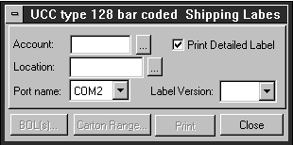

1: You can add the pull down menu for Supply Type:

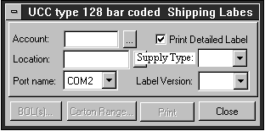

- Start to your description from the initial existing condition.
- Describe the processing of the Add-in sequentially, step after another.
- Briefly, Describe the processing paths/ combinations (e.g. Cutting ticket could be generated from sales order or by it self )

Supply Type:
It should have two options:
A: Single Detailed Label
B: Separate Detailed Label.

Design of the Supply Type should look like this:

We have to modify our program for Single Detailed labels.

A: Single Detailed Label:
What is the difference between single label and separate label? Currently we are creating the detailed label as a separate label because we get all the headers for Partners then lines for Partners label, then headers for detailed and lines for detailed. For Example
H1 :XXXXXXXXXXX
H2 :XXXXXXXXXXX
H3 :XXXXXXXXXXX
L1 :XXXXXXXXXXX
L2 :XXXXXXXXXXX
L3 :XXXXXXXXXXX

H1 :XXXXXXXXXXX
H2 :XXXXXXXXXXX
H3 :XXXXXXXXXXX
L1 :XXXXXXXXXXX
L2 :XXXXXXXXXXX
L3 :XXXXXXXXXXX

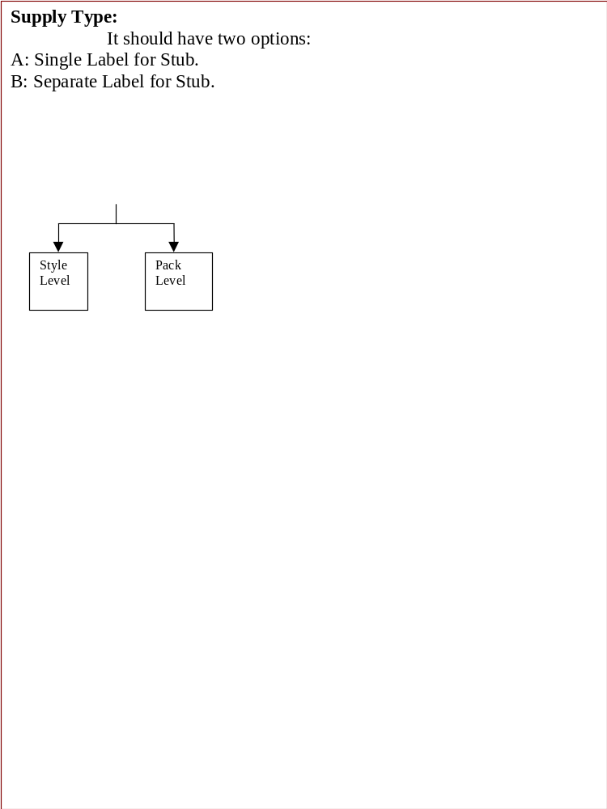

Supply Type:

Single Detailed Label
Separate Detailed Label

Style Level
Pack Level
Style Level
Pack Level

Partners UCC 128 Label (FED) for separate labels

Detailed Label (XX1) for separate labels

We need in our Single Detailed Label, should be like the following structure. We will merge both labels in to one while text file looks like one format but originally we combine two labels into one. We will use the different format name also which is XX2 , in the SYCASNLB file for the version.
{H1 :XXXXXXXXXXX
H2 :XXXXXXXXXXX
H3 :XXXXXXXXXXX
H4 :XXXXXXXXXXX
H5 :XXXXXXXXXXX
H6 :XXXXXXXXXXX}

{L1 :XXXXXXXXXXX
L2 :XXXXXXXXXXX
L3 :XXXXXXXXXXX
L4 :XXXXXXXXXXX
L5 :XXXXXXXXXXX
L6 :XXXXXXXXXXX}

Second set of UCC 128 label.

{L1 :XXXXXXXXXXX
L2 :XXXXXXXXXXX
L3 :XXXXXXXXXXX
L4 :XXXXXXXXXXX
L5 :XXXXXXXXXXX
L6 :XXXXXXXXXXX}

In the above case we will print the set of line for all the cartons again and again but only one header.

Points of merging two separate labels into a Single Detailed Label format:
1: Take header of Partners UCC 128 Label (FED)
2: Remove the close braces “}“ from the format of partners header.
3: Take header of detailed label (XX2).
4: Put the close braces “}” and header will close.
5: Take lines of Partners UCC 128 Label (FED).
6: Remove the close braces “}“ from the format of partners Lines.
7: Take lines of Detailed Label (XX2).
8: Put the close braces “}” and header will close.

Header of Partners UCC 128 Label (FED) for Single Detailed labels

Header of Detailed label (XX2) for Single Detailed Labels

Lines of Partners UCC 128 Label (FED) for Single Detailed labels

Lines of Detailed Label (XX2) for Single Detailed labels.

Lines of Partners UCC 128 Label (FED) for Single Detailed labels

Lines of Detailed Label (XX2) for Single Detailed labels.

PACK LEVEL SECOND PART:
They want stub should print multi pack information.
Following are the list of new variable we need:
1: We need to check the order is packed in that box has a pack_id like we do on the ASN file but if there is no pack then we will pick up the style color in the same variable.
2: Then we will do the same thing for total qty for that pack or style color.
3: Then we will do the same thing for UPC of that pack or style color.

Constraints ( Global ) :
General constraints on the whole process and you cannot map it to certain step , here the place to write it down.

Consequences (Side Effects) :
State any effect on other program / screen / report due to implementing the required processing and result, or any cautions I should take for future upgrade.
- If you feel that any step is going to affect other modules and programs , a question should be sent to the technical people in Cairo .
- If you discovered such effects please write them down indicating each module in program separately and its effects .

Note :
If this Add-in contains the development of a new branching screen, please use the “New Program Template” to hold this requirement.

Development Cost  Specs Cost: | $1000.00  $ 840.00 ( 6 hr X 140)
Customer signature | Date signed
Payment Terms | 50 % due upon signing.  50% due upon delivery of the project.  (No work on this project will begin until the deposit is received)
Estimated completion time | 6 –8 weeks from the date of signing this document

