
Development Request
Aria Systems
New Custom Style Classification Screen For GMA

Custom Program # 102452

Custom Style Classification Screen

Screen Template

Custom Style Classification Screen
Product: | Aria 2.7
Module: | IC
Customer name: | GMA
Screen Name: | Style Classification Screen.
Installed Modules: | All modules except PS.
Parameters setting:

Details Section
Screen Name: Style Classification.
Existing Initial situation: The Style Classification located in the IC2 module.

Screen Objective: Add new screen into option menu to assign Department, Category, Class or sub class1 or sub class2 or sub class3 to the selected style, also Add a trigger to the style program to disable the style group field, and we will let the user to assign Department or Group.
The reason is that in the add mode (when we add a new style) there is no Dept linked yet to the
Style and we need to be able to select the Group based on the Dept. In the
Edit mode, you can show the Dept saved in ICDEPTHD file according to the
Group assigned to the style being edited.

Description:

We will make a change in our standard style screen based on a trigger for GMA only; we will add new option in the option menu.

The new option call Style Classification this option we will call a custom screen style classification, this screen will allow to add or modify a specific Department, group, Category, Class, and sub class… and we will disable the style group in the style screen based on a trigger for GMA.

We will get the department and group for the selected style from the custom table ICDEPTDT for selected style and show all department from the codes file in case we add a new style, and the user can select a department from the popup and we will show all group related to this department from the new file call icClasSetp.

- In view mode
When the user gets into the screen for first time in the view mode we will disable all fields.

- In add or edit mode
When the user get into the screen in edit or add mode, we will Enable all field and let the user select a department first, and then selected group not all groups, the groups that we assign to this department before in the old screen (Assign Group to Department) and after the user select a group we will show the category not all category, the category that we assgn to this group before that in the new screen Classification Setup (Regard’s Custom Program # 102451), so when the user try to select category we will let the user select all categories for a specific group and so on.

After the user choose a category we will let the user to select class from class popup and get all classes for selected category, also after user select a class we will let the user to select sub class from the sub class popup and show all sub classes related to the selected class and so on.

Custom Style Classification Screen layout

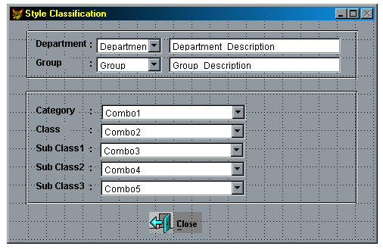

Layout Description
Number | Field Label | Field Name | Field Meaning-Semantics & Constraints and business rules behind the field
1 | Department | Dept | Department code for selected style (you will found the department in the IcDeptHd file for the selected style).
2 | Department Description | CdeptDesc | Department description for active department (you will found the department description in the IcDeptHd file for the selected style).
3 | Group | cStyGroup | Group code for active style (you will get the groups from the classification setup file (New file icClasSetp) for this department only, again for this department only).
4 | Group Description |  | Group description for active group (you will get the description from the codes file).
5 | Category | cStyCatg | Category code + Category description (you will get the categories from the classification setup file (New file icClasSetp) for this Department/Group only, again for this Department/Group only).
6 | Class | cStyClass | Class code + Class Description (you will get the categories from the classification setup file (New file icClasSetp) for this Department/Group/Category only, again for this Department/Group/Category only).
7 | Sub Class1 | cstysbclas | Sub Class1 + Sub Class1 Description (you will found in the style file as a user defined fields), also you will get the categories from the classification setup file (New file icClasSetp) for the selected Department/Group/Category/Class.
8 | Sub Class2 | Cstysbcls2  (NEW) | Sub Class1 + Sub Class1 Description (you will found in the style file as a user defined fields), also you will get the categories from the classification setup file (New file icClasSetp) for the selected Department/Group/Category/Class/Sub Class1.
9 | Sub Class3 | Cstysbcls3  (NEW) | Sub Class1 + Sub Class1 Description (you will found in the style file as a user defined fields), also you will get the categories from the classification setup file (New file icClasSetp) for the selected Department/Group/Category/Class/ Sub Class1/ Sub Class2.

You should save all this fields into user–Define fields that already exist in the style file, except the 2 new fields (NEW), Also we need to validate that the user has selected a Department and a Group in this new screen before saving any new style. A proper message should show
Up if these fields are left empty. The Category, Class and SubClass are Optional (no need to validate them if empty).

Customer Approval: _____________________ Date : ________

Cost : $ 1000

Estimated time : From 6 - 8 weeks from signing the specs

