
Development Request
Aria Systems
Custom Style Order Form in Excell

Custom Program #: 102535
Customer: GMA10

Custom Style Order from in Excell

Report Template

Template Header
Product: | Custom Style Order Form-Option Grid and an Excell generated form
Module: | AR
Customer name: | GMA
Installed Modules: | AP AR GL SR SO PO MA MF IC AL RM SM
Parameters setting :

System Setting Report:

Report Details
Report Name: Custom Style Order Form
Report Objective ( Purpose ): Create Aria2.7 native report based on selected filters by department, group, category, class and subclass. Enable user to extract data to Excel component with customized title and headings.

Description: Report is requested by sales rep in GMA.
The result Excel sheet should comprise all the information needed to be e-mailed to customer and returned back with ordered quantity.
Currently there is a template Excel order form that is filled in manually. The process is time consuming and quite inefficient since allocated styles are
copied from Inventory Excel sheet and pasted in the order form.
To improve performance of placing orders with customer, sales rep will be searching for particular style number and color using specific filtering criteria’s like department, group, category, class and subclass. The output would be extracted to Excel format with specific for customer header and footer. (The order form example is attached).
Detailed part of the report should be presented with the records carrying information for the style code, particular color, description of the product and price per piece.
Customer would fill quantity and total information.
Records are to be grouped by categories, for instance, ladies bags, kids beach bags, ladies sunglasses.
Grand total information will complete the report.
The source table resides on GMA SQL Server. It is stored in DB01 database with the name SLSPRDDATA.

Report Layout
- Company information should appear as a header on the left top part of the form. It represents headquarter and distribution center address, fax and telephone number. Should vary depending on applied company.
- User should be able to put optional title that reflects chosen criteria.
For example – Sunglasses Order Form
- Customer part of the form should be presented by means of empty outlined sections. These sections should be filled later with customer information related to the terms of shipment, date, order No., shipping and billing address and so on.
The purpose is to simplify the process of filling up the form by customer and at same time get document that provides all the needed information.
- Detailed part is divided in to 6 columns. Column names are Style, Color, Description, Price, Quantity and Total.
First 4 columns should represent the data from result report.
Quantity and Total columns will be filled by customer for each style record.
- Records might be grouped by any of chosen criteria.
- Total line should show total quantity and amount.
- Order form ends with signature section and grand total section.
- Exporting data to Excel should be accurate and detailed values have to correspond and be lined up to the column’s names.

Hidden Data Filters:

Layout Description
Number | Field Label | Field Meaning-Semantics | Field Format
1 | STYLE | Style code
2 | COLOR | Color of the particular style
3 | CDESC | Style description
4 | PRICEA | Price per piece

Group by Options: Group by Department, Group, Category, Class or Subclass
Sort by Options: Style code in ascending order

Note: Styles might be grouped by any of the criteria and consequently sorted within this group.

Option Grid Parameters: User should be able to customize report by several criteria. Each of the criteria’s will consequently narrow the output for report.
Main parameters are: department, group, category, class, subclass, style range.
Also user should be able to put optional title.

Presentation Parameters: The option grid parameters related to the report layout.
Parameter Label | Parameter Description (effects) | Operator | Valid Values
Print Customized  Title | This title will be optional and should be based on user choice. |  | Will type the title

Filter Parameters: The option grid parameters related to data filters.

Parameter Label | Description | Operator | Valid Values
DEPT | Allows printing styles within  particular department |  | Department description, like Spring Bags
CSTYGROUP | Allows searching for styles  within particular group |  | Group description, like Beach Kits
CCATG | Allows printing styles by category |  | Category description
CCLASS | Allows printing styles by class |  | Class description
CSUB_CLASS | Allows printing styles by subcategory |  | Subcategory description
STYLE | Allows printing range of styles | Between | Style code

Note: User should be able to pull up needed styles by either narrowing search criteria from department to related groups, categories, classes and subclasses or by getting all the styles that belong to particular criteria.
In both cases output could be restricted with the criteria of range of styles.

Here is the order form example with sample date.

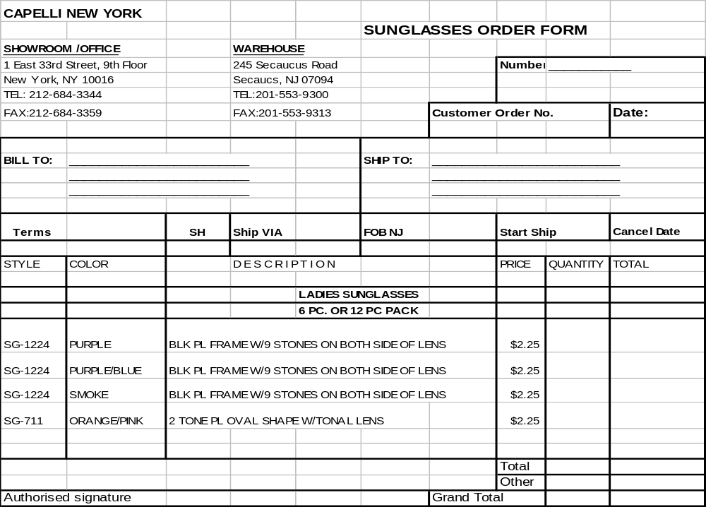

Development Cost | $ 1800
Customer signature

Date signed
Payment Terms | 50 % due upon signing.  50% due upon delivery of the project.  (No work on this project will begin until the deposit is received)
Estimated completion time | 6 weeks.

