
Development Request
Aria Systems
Custom Modifications to Pack Screen for GMA
Custom Program#: 102561

Custom Modifications to Pack Screen for GMA

Program Add-in Template

Program Add-in Header
Product: | Custom Pack Screen for GMA
Module: | IC
Customer name: | GMA
Installed Modules: | AP AR GL SR SO PO MA MF IC AL RM SM
Parameters setting:

System Setting Report:
See attached GMAsetup.txt

Details Section
Add-in Name: Custom Pack Screen for GMA

Add-in Objective:
Do major modifications to custom program 101945; the Pack header and the Pack details; these changes will affect the backend database files as well as the pack creation screen:
Pack Header:
Price: Insure that the price is the accumulation of the prices of component styles.
Color: Select color from color codes
Size: Select an appropriate size from the scale file.
Pack Detail:
Price: Save the price of component styles.

Existing Initial situation: In custom program 101945 the pack is created as a collection of one or more styles/colors/sizes; the user can create a generic pack, or create pack for a specific customer. Then selects individual styles and enter their quantities, which are referred to as the pack breakdown. The pack quantity is the sum of the quantities of individual styles. The price and color are entered as free format. Besides, the user can create different version for the same pack_id.

Description (Processing):
In this customization we would like to request the following.

- Initially: In custom program 101945:
- The user can assign color as free format, and price as an amount.
- There are no prices on the pack details level.
- There is no size for a pack.
- Spck_hdr is indexed on (type + account + pack_id + cpkversion) and this makes a unique pack, now we need to index on (type + account + pack_id + cpkcolor + cPckSize + cpkversion) and this should make a unique pack.

- Our Request: Be able to add color and size for a pack and do price calculation.

- Processing: The following fields are to be added to spck_hdr:
# | Field Name | Type | LENGTH | USAGE
1 | CPckSize | CHAR | 3 | STORE THE SCALE CODE + SIZE COUNTER (SCALE FILE)
2 | nPckClPr | NUMERIC | (8,2) | STORE THE CALCULATED PACK PRICE, BASED ON THE SUM(QTY*STYLE PRICE) OR THE WEIGHTED AVG.
3 | LPckReCal | LOGICAL |  | TO MARK THE PACK AS RECALCULATED WHENEVER THE USER RECALCULATES THE PRICE
4 | nPckQty | NUMERIC | (7,0) | TO STORE THE TOTAL PACK QUANTITY.
5 | LPckPrPiec | LOGICAL |  | TO FLAG THE PRICE OF THE PACK AS PER PIECE

Remove the field Lassorted from spck_hdr.dbf because according to the business rules ASSORTED pack and RANGE pack mean the same thing.
Add the below field to spck_lin:
# | Field Name | Type | LENGTH | USAGE
1 | Pck_Price | NUMERIC | (8,2) | STORE THE PRICE OF INDVIDUAL STYLE (GET PRICE FROM STYLE FILE)

Indices on spck_hdr.dbf:
We don’t see the aim behind creating a new index on (type + account + pack_id + cpkversion)

We recommend deleting the third index and modifying the first two indices into:
1- (type + account + pack_id + cpkcolor + cPckSize + cpkversion)
2- (type + account + style + pack_id + cpkcolor + cPckSize + cpkversion)
If this is not possible please advise why.
Note: The below screen (Custom Pack Screen for GMA) was designed from scratch using visual fox pro.
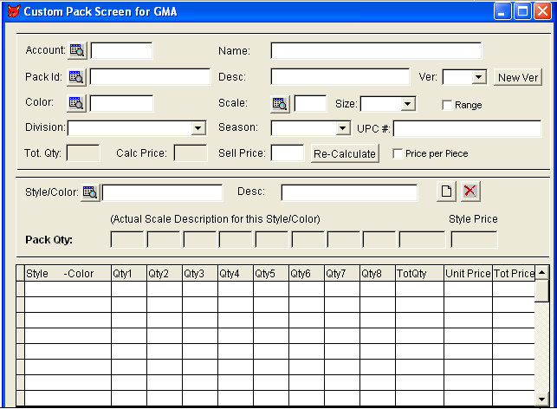
Screen Functionality: This screen is a customization of C101945.
# | Field | Notes | Example
1 | Scale | After the user selects a specific scale code, the size popup gets populated with corresponding sizes. Upon save spck_hdr.size is updated with Scale code (1 char) + size counter (2 chars) | Scale code A has 3 sizes: S, M, L with corresponding size counters 01, 02, 03. When the user selects scale code A, the size popup gets populated with S, M, L and upon save if the user selects M, the spck_hdr.size will be updated with ‘A02’

# | Field | Notes | Example
2 | Size | Is filled with convenient sizes from scale file each time a user selects a scale code. | Scale code A has 3 sizes: S, M, L When the user selects scale code A, the size popup gets populated with S, M, L.
3 | Color | This is a mandatory field it shouldn’t be left blank; the default value is hard coded as “ASSORTED”. The user can browse and select from available color codes; the browse screen should display both the color code and description.
4 | Sell Price | This is the selling price of the pack which will be used anywhere we refer to this pack; like invoice or order. By default it is zero, when the user enters a valid price (>= 0), and clicks “Re-Calculate” the program should proceed as follows: if value entered = 0 then assign 0 as the price of all individual styles else calculate the weighted average price for individual styles and update them correspondingly, besides updating the calculated sell price field.
6 | Calc price | This is the pack-calculated price. Disabled by default and contains the accumulated price of individual styles, when the user clicks “Re-Calculate” the price this field will be updated with the calculated price.
7 | Style | After entering a valid style / color display size scale description for each size bucket. | If the scale linked to this style has SMALL, MEDIUM, LARGE as sizes then update the labels for the pack qty with these values.
8 | Style Price | Originally it is the Style default price (priceA), the user can change it to a new value (>= 0). Whenever the user changes this field, this has to reflect on the pack-calculated price. When this field gets focus, its value has to be subtracted from the pack calculated price, and when it loses focus the current value has to be added back to the sell price. | See below, Calculation of prices using weighted Average.
9 | Amount (in Pack grid) | Is Style (totQty * Price) this should not be saved but used to display the amount only.
10 | range | All the functionality behind the assrt field is to be added to this field (refer to C101945).
11 | Price per Piece | To mark the pack price as per piece; should be defaulted to .T.
12 | Tot Qty | Save this amount to spck_hdr.nPckQty
13 | UPC # | Not enabled, always display the UPC for the selected pack. Look Up the UPC # for this pack from styleUPC.dbf
14 | Ver | This is the pack version, it should be populated with all available versions for this pack, by default it is the first version. In the View mode when the user changes the version the data should be refreshed accordingly to reflect the correct components for this version.

# | Button | Notes | Example
1 | Re-Calculate | Originally disabled. When the user enters one or more styles, this button should be enabled.  After the user hits this button:  If “Sell Price” is zero then price of the pack and corresponding prices of individual styles must be updated to zero.  Else if the “Price per Piece” is checked then the “Sell Price” is assigned to all the prices of individual styles.  Else calculate prices of component styles based on the weighted average; see below.

Calculation of prices (weighted Average):
The program will compute the selling price of each individual style/color (order line) based on a weighted average using the style master price.

Selling price of style/color = (selling price of style/color divided by
Sum of all prices of all style/colors in that
Pack multiplied by the Pack's selling price)

For example:
Pack ID | Pack selling price | Style/color in Pack | Price from style master | Qty | Total
2130K | $ 11 | H125 | $ 4.60 | 3 | $ 13.80
 |  | H140 | $ 7.90 | 2 | $ 15.80
 |  |  |  | Actual Pack Price | $ 29.60

Total of style master price for all style/colors in the pack is $ 29.60

Following will be the price of each style/color in the pack:

H125 = ((4.60/29.60) * 11) == 1.71
H140 = ((9.90/29.60) * 11) == 2.94

The computed price will be rounded to 2 decimal places.

Upon Saving:
If “Price per Pack” is checked then
The program will assign the “Sell Price” to all individual styles
Else if the sell price is different from zero then
The program will sum the computed Price*Qty of each style/color and compare it with the selling price of the PACK defined in the Pack file. Referring to the above example the calculated price = ((3*1.71) + (2*2.94)) = $ 11.01 and price of the PACK = $11 (entered by the user).

If the price matches exactly, then nothing more will be done.

Else if there is a difference due to rounding, then
Notify the user and ask whether to use the assigned price ($ 11) or the calculated price ($ 11.01) and update the price of the PACK accordingly, i.e. if user wants to assign the calculated price then sell price = $ 11.01.

Note: when applying the above formula we need to avoid division by zero i.e. if the actual pack price is zero, then we can’t divide.

