
Development Request
Aria Systems
Bill of Lading Batch Processing screen

Custom Program C#200536

Screen Template

Product: | Aria 2.7
Module: | EDI
Customer name: | GMA
Screen Name: | Bill of Lading Batch Processing
Installed Modules: | All modules except PS.
Parameters setting: | (see the Setting file)

Details Section
Screen Name: Bill of Lading Batch Processing
Existing Initial situation:

The current Bill of Lading screen in Aria EDI module allows generating only one BOL at the time for a specific Account, Store, Ship Via and Location. Besides, the user has to assign the Packing Lists to the BOL manually.
This is very time consuming process in case of multi-store orders with hundreds of stores.

Screen Objective:
- To generate BOL’s by batch processing using the Order#.
- Assign the applicable Packing Lists to the generated BOL#’s automatically.

Description:

To accomplish the above goal, a new screen will be designed to create Bill of Ladings for a specific sales order# and assign the open Packing Lists to each BOL in an automated process.

Screen Flow:

Generate Bill of Lading#

Select Order#
Collect Packing Lists
BOL Information

Select Open Bill Lading#

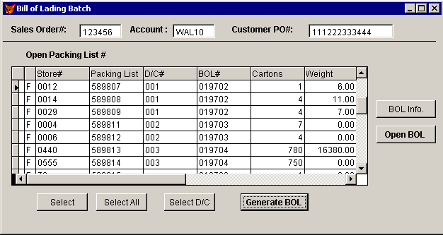

- Once the screen is opened, it’ll allow the user to select a specific sales order# or Account and Customer PO#. Search ability should be available to seek Open or Hold orders for a selected Account.
- If the user selected Completed or Canceled orders, the screen will reject. Only Open or Hold order status should be allowed. Also, if no P/L’s found for the selected order the screen should reject showing a proper message.
- After selecting a valid order#, the screen will collect the related open Packing Lists. Only open P/L ‘s that are not assigned yet to any BOL should show up: {Pack_hdr.Status <> ‘C’ AND Pack_hdr.Bill_ladg is Empty} .

- The P/L‘s will be sorted in the browse by: {DC# + Store# + Packing List#}. Note that the DC# may be empty in some cases if the Store is not assigned to a DC (Customer.Dist_ctr field will be empty in this case).

- D/C# column will display the distribution center code assigned to the store (Customer.Dist_ctr).

- BOL# column will be initially empty until the user either generates or selects BOL#, then it’ll reflect the assigned BOL# to each Packing List.

- Cartons and Weight columns will display the total cartons/weight for each Packing List.

Buttons and Functionality:

- Select and Select All will allow the user either selecting individual P/L or all P/L’s in the browse. A check box to the left should indicate if the record is selected or not.

- Select D/C will select all Packing Lists related to the chosen D/C in one click.

- Generate BOL button is the main screen functionality that will create Bill of Lading #’s and assign to each BOL the appropriate P/L’s based on the following logic:

- One BOL# will be created for Packing List(s) related to the same: D/C, Location and Ship Via. If the D/C field is empty, then a BOL# will be created for each Store, Location and Ship Via.
- The functionality used to create the BOL record will be similar to the function used currently in the manual Packing List to generate and assign BOL#.
- BOL lines should reflect the assigned P/L’s and BOL header should reflect totals weight, cartons and pieces for the assigned P/L’s.

- Open BOL button will check for the existence of any Open BOL that matches the P/L’s regarding the: {Account, D/C (or Store#), Location and Ship Via}. If any matches found, the following screen will open:

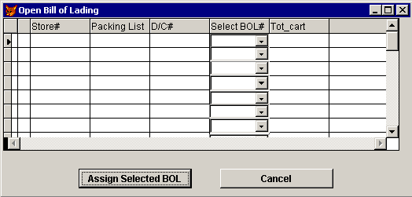

- The grid will display any open Packing List sorted by D/C + Store.

- Select BOL# drop down will display any open BOL#’s (Bol_hdr.Status <> ‘C’) that match the Packing List regarding the Account, D/C (or Store#), Location and Ship Via.

- Assign Selected BOL button will link and assign the selected P/L‘s to the selected BOL#. This function should be similar to the one used in manual Packing List screen when we choose to assign P/L to existing BOL#.

- The assigned BOL’s should show up in the main screen and the corresponding P/L’s should be excluded if the user decided to Generate new BOL’s.

- Cancel button will return to the previous main screen, so the user can generate new BOL’s if he wants to.

- BOL Info button will just inquire the selected BOL information after the user generates or selects the BOL#’s. This will call the standard BOL screen in Aria EDI module to show the BOL info in details.

