Enhancement Requirement – Consolidated Invoice

Actual Situation
- The system allows the user to create consolidated invoices for a specific customer if the “Consolidated Invoices” option is set to “Yes” from the customer screen.
- The consolidated invoice printout shows the customer’s Ship To address and prints invoice details for each store rather than consolidating by DC.

Goal
- The purpose of this enhancement is to allow creation of consolidated invoices per DC.

Limitations of the Project
- **

Suggested Solution and Resources allocated.
- Add a new setting for the customer to specify whether the invoice is consolidated by DC or not.
- Modify both the invoice printout and the 810 transaction to consolidate invoices by DC based on the customer setting.

Questions related to the solution:
- Is the ASN affected?

Phases and Implementation
- Modify the customer screen
- Modify Invoice from Order screen
- Modify the invoice printout
- Modify the 810 transaction

Customer Screen:

We need to add a new option to allow the user to specify whether the invoices are consolidated by DC. This option should be enabled when the user selects “Consolidated Invoices = Yes”; by default the “Consolidate by DC” option is checked and the user can uncheck it.

Invoice from Order Screen:

Add a new field on the invoice header to mark the invoice as “Consolidate by DC”, by default the value of this field should be updated from customer file. However, the user can change it.
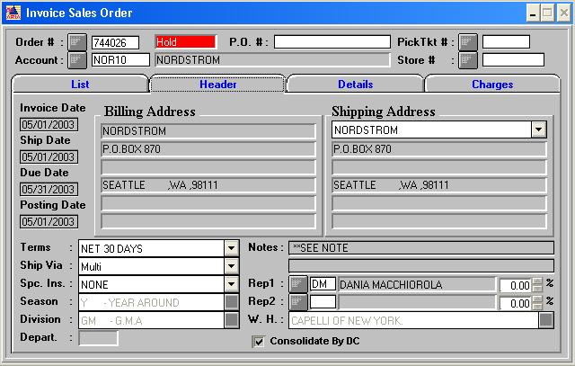
When this field is unchecked the system will use the standard consolidated invoice technique.
For multi store orders and incase the invoice header is marked as “Consolidate by DC” we need to group the stores by DC and consequently create one consolidated invoice for each DC instead of creating one invoice for all stores (see below image), since in the example order we have 2 DC’s the system should create 2 invoices; one for each DC.

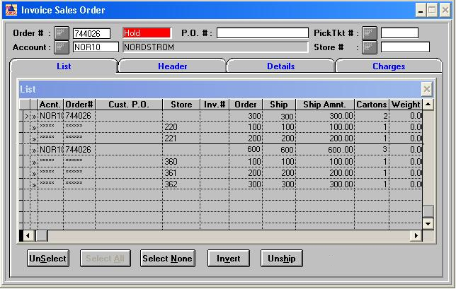

Invoice printout:
The “Ship To” address should always be that of the DC unless the invoice is “direct to store”. Incase the invoice header is marked as “Consolidate by DC” the invoice should be consolidated by DC; see example below:
Invoice NOT marked as “Consolidate by DC”:
PO 123456, shipped to DC 36 (each of the below stores is linked to this DC)
Invoice #1 Store 360 10 units $100
Invoice#2 Store 361 10 units $100
Invoice#3 Store 362 10 units $100
Invoice MARKED as “Consolidate by DC”:
PO 123456, shipped to DC 36
Invoice#1 Store 36 30 units $300

EDI 810 transaction:
Same conditions of the invoice printout apply to the 810 document. Besides, both the “Ship to” (N1-ST field) and the “Buying Party” (N1-BY field) should read the DC number (ship to location). It is very important to list the DC as the store number (N1-BY field) on the invoice. For “direct to store” shipments, both fields would read the store number; always invoice according to the ‘ship to’ destination.
Note: the ASN should not be affected by these changes.

