
Development Request
Aria Systems
Custom SKU Screen for GMA
Custom Program#: 102566

Custom SKU Screen for GMA

Program Add-in Template

Program Add-in Header
Product: | Custom SKU Screen for GMA
Module: | IC
Customer name: | GMA
Installed Modules: | AP AR GL SR SO PO MA MF IC AL RM SM
Parameters setting:

System Setting Report:
See attached GMAsetup.txt

Details Section
Add-in Name: Custom SKU Screen for GMA

Add-in Objective:
Be able to create SKU’s for packs; a unique pack is designated by type + account + + pack_id + cpkcolor + cPckSize. Please refer to custom program # 102561.

Existing Initial situation In the standard SKU screen the user can create SKU’s for Style/color/Size, we need to use the same concept but apply this on packs i.e. be able to create SKU’s for packs. However; we don’t need to create SKU’s for generic packs nor for pack versions i.e. different pack versions must have same SKU and that’s why we refer to a unique pack by (type + account + pack_id + cpkcolor + cPckSize ) rather than (type + account + pack_id + cpkcolor + cPckSize + cpkversion).

Description (Processing):
In this customization we would like to request the following.

- Initially: In SKU screen we can create SKU’s for styles.

- Our Request: Be able to create SKU’s for packs based on pack_id + Color + Size, using the same technique applied in standard SKU screen.

- Processing:
1- We need to make sure that same SKU is not assigned twice. Example if SKU 123 is assigned to Style A – Blue and if the user tries to assign SKU 123 to Pack P then the system should give him a warning message, saying that SKU is already assigned to Style A and prevent him from saving.
2- When the user creates a SKU for a pack, we need to save the pack_id in spck_hdr.style, to maintain the index for search purposes (type + account + style + pack_id + cpkcolor + cPckSize + cpkversion).

Note: The below screen (Custom SKU Screen for GMA) was designed using visual fox pro, it represents the portion of the new SKU screen where the changes take place.
Case SKU type = “Style”:
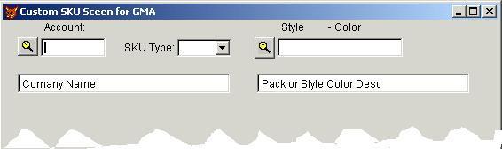
Style
Case SKU type = “Pack”:
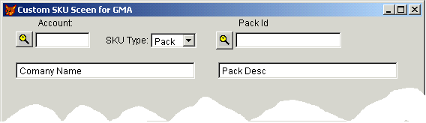
Screen Functionality:
# | Field | Notes | Example
1 | SKU Type | - Should be populated with 2 values (“Pack”, “Style”), the default value is “Style”  - When the user selects Pack, the “Style - Color” label changes to “Pack Id” and the user should be able to browse/select packs rather than styles, consequently the description should be that of the pack.

Anything else should work the same like in the standard screen.

Development Cost | $ 900.00
Customer signature | Date signed
Payment Terms | 50 % due upon signing.  50% due upon delivery of the project.  (No work on this project will begin until the deposit is received)
Estimated completion time | 6 –8 weeks from the date of signing this document

