
Development Request
Aria Systems
Inquire Style/Pack by UPC# or SKU Screen
Custom Program#: 200334

Enhance the “Inquire Style/Pack by UPC#” Screen

Program Add-in Template

Program Add-in Header
Product: | Inquire Style/Pack by UPC# or SKU Screen for GMA
Module: | IC
Customer name: | GMA
Installed Modules: | AP AR GL SR SO PO MA MF IC AL RM SM
Parameters setting:

System Setting Report:
See attached GMAsetup.txt

Details Section
Add-in Name: Inquire Style/Pack by UPC# or SKU Screen for GMA

Add-in Objective:
This screen is an enhancement of the standard Inquire Style/Pack by UPC# screen. We need to be able to:
- Inquire about packs/styles using UPC or SKU
- Display pack color/Size. A unique pack is designated by type + account + pack_id + cpkcolor + cPckSize (Refer to C102561).

Existing Initial situation: In the standard Inquire Style/Pack by UPC# screen the user can search UPC’s for Styles or Packs. The pack had no color/size attributes. Besides; according to our requirements, we only generate UPC for generic packs.

Description (Processing):
In this enhancement we would like to request the following.

- Initially: The screen allowed inquiry on Style or Pack using the UPC#. Originally, packs had neither color nor size. The user could not search by SKU.

- Our Request: Be able to inquire on styles and/or packs using either UPC or SKU besides, we need to display color/size for packs.

- Processing: The user should be able to enter UPC/SKU by hand or browse and select an existing UPC/SKU. When the user selects the style option i.e. inquires about a style; if UPC option is selected then
Change the “SKU” caption to “UPC#”
The user should be able to enter/browse for exiting style UPCs
Else if SKU option is selected then
Change the “UPC#” caption to “SKU”
The user should be able to enter/browse for existing style SKUs
For anything else screen should work the same way as the standard.
For packs (See screen below); when the user selects the pack option:
If UPC option is checked then
Change the “SKU” caption to “UPC#”
The UPC browse should contain UPCs for packs
Hide the account field
Else if the SKU option is selected
Change the “UPC#” caption to “SKU”
The use should be able to enter/browse for existing pack SKUs
Unhide the account field

Note: The below is a modification to the standard Inquire Style/Pack by UPC# screen. The Screen reflects the case of UPC for a pack.
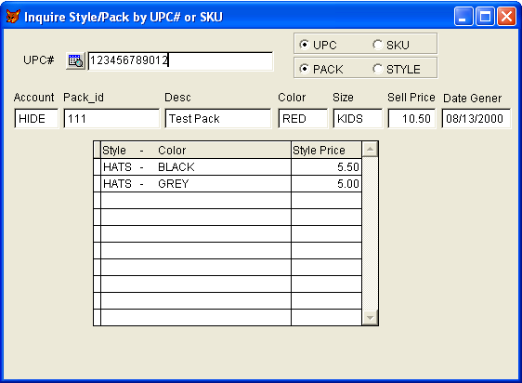

Development Cost | $.00
Customer signature

Date signed
Payment Terms | 50 % due upon signing.  50% due upon delivery of the project.  (No work on this project will begin until the deposit is received)
Estimated completion time | 6 –8 weeks from the date of signing this document

